

|  |  |
| --- | --- |
| **ASSIGNMENT** | |
| **Course Code** | ESC101A |
| **Course Name** | Mechanical and Manufacturing |
| **Programme** | B.Tech |
| **Department** | CSE |
| **Faculty** | FET |

#### 

|  |  |
| --- | --- |
| **Name of the Student** | Satyajit Ghana |
| **Reg. No** | 17ETCS002159 |
| **Semester/Year** | 02/2018 |
| **Course Leader/s** | Vijayakumar S. |

|  |  |  |  |  |  |  |  |  |
| --- | --- | --- | --- | --- | --- | --- | --- | --- |
| **Declaration Sheet** | | | | | | | | |
| Student Name |  | | | | | | | |
| Reg. No |  | | | | | | | |
| Programme |  | | | | | Semester/Year |  | |
| Course Code |  | | | | | | | |
| Course Title |  | | | | | | | |
| Course Date |  | | to | |  | | | |
| Course Leader |  | | | | | | | |
| **Declaration**  The assignment submitted herewith is a result of my own investigations and that I have conformed to the guidelines against plagiarism as laid out in the Student Handbook. All sections of the text and results, which have been obtained from other sources, are fully referenced. I understand that cheating and plagiarism constitute a breach of University regulations and will be dealt with accordingly. | | | | | | | | |
| Signature of the Student | |  | | | | | Date |  |
| Submission date stamp  (by Examination & Assessment Section) | |  | | | | | | |
| Signature of the Course Leader and date | | | | Signature of the Reviewer and date | | | | |
|  | | | |  | | | | |

# **Contents**

____________________________________________________________________________

**Declaration Sheet** ii

**Contents** iii

**List of Figures** iv

**Question No. 1** 5

A1.1 Introduction to renewable and fossil fuel energy sources used for electric power generation: 5

A1.2 Current and future energy utilization scenario of fossil fuels and renewable energy resources in India: 6

A1.3 Challenges involved in replacing fossil fuels with renewable energy sources as prime electric power generation sources: 7

A1.4 Justification of the stance taken with conclusion: 8

**Question No. 2** 9

B.1.1 Detailed estimation of the energy consumption for your selection: 9

B.1.2 Surveying the commercially available panels and find their specifications: 10

B.1.3 Justify the implementation of PV system considering the present expenses on the electricity: 12

**Question No. 3** 13

B.2.1 Indicated power: 13

B.2.2 Mechanical efficiency: 14

B.2.3 Cost of fuel for travel between the cities: 14

B.2.4 Cost benefit, considering LPG as the alternative fuel having Z% higher efficiency compared to petrol: 15

**Question No. 4** 16

B.3.1 Discuss the need for energy storage systems: 16

B.3.2 Survey and list the different energy storage systems: 16

B.3.3 Discuss the form of energy stored in each system listed in B3.2: 18

B.3.4 Explain any one energy storage system with a neat diagram: 19

**Question No. 5** 21

B.4.1 Survey of various boilers used in sugarcane industries: 21

B.4.2 Explanation of the processes that uses steam in sugarcane industries: 21

B.4.3 Construction and working of such boilers: 22

# **List of Figures**

____________________________________________________________________________

|  |  |  |
| --- | --- | --- |
| **Figure No.** | **Title of the figure** | **Pg.No.** |
| Figure A1.1 | Fossil Fuelled Plant | 5 |
| Figure A1.2 | Fossil Fuel Powered Steam Turbine Electricity Generation | 5 |
| Figure A1.3 | Solar Panel Power Output and Efficiency | 9 |
| Figure B1.1 | Consumption of households across India | 10 |
| Figure B1.2 | Appliance Ownership in metros | 10 |
| Figure B3.1 | Mylar-Film, oil filled capacitor | 18 |
| Figure B3.2 | Illustration of principle | 19 |
| Figure B3.3 | Pumped Storage Hydro Electricity | 20 |
| Figure B4.1 | Lancashire Boiler | 23 |
|  |  |  |

# **Question No. 1**

**Solution to Question No. 1 part A:**

## A1.1 Introduction to renewable and fossil fuel energy sources used for electric power generation:

**Fossil Fuels:**

Fossil fuel power plants burn carbon fuels such coal, oil or gas to generate steam that drives large turbines that produce electricity. These plants can generate electricity reliably over long periods of time. However, by burning carbon fuels they produce large amounts carbon dioxide, which causes climate change. They can also produce other pollutants, such as sulphurous oxides, which cause acid rain.

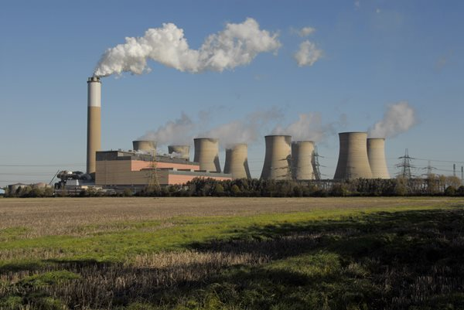

Figure A1.1 Fossil Fuelled plant

Fossil fuel plants require huge quantities of coal, oil or gas. These fuels may need to be transported over long distances. The price of fuels can rise sharply at times of shortage, leading to unstable generation costs.

Fossil fuelled plants use either coal (60%), oil (10%)or gas (30%) in purpose designed combustion chambers to raise steam. These are all non-renewable resources whose supply will ultimately be exhausted. The energy content of these fuels and their variants is shown on the Energy Resources page

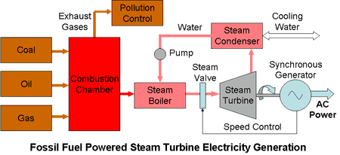

Figure A1.2 Fossil Fuel Powered Steam Turbine Electricity Generation

Oil is probably the most convenient fuel and thirty years ago it accounted for 30% of the consumption but it has mostly been replaced by coal as oil prices have risen faster than the price of coal due to insecurities of supply. At the same time, the premium value of oil for transportation and chemical uses, rather than for just burning it to extract its calorific value, has also been recognized.

Coal is the least convenient. Its calorific content, on average, is less than half that of the other two fuels. Handling and transporting it is more difficult and it produces large quantities of residues, ash and greenhouse gases, some of which are toxic, depending on the quality of the coal.

**Renewable Energy Sources:**

Renewable energy is derived from natural processes that are replenished constantly. In its various forms, it derives directly from the sun, or from heat generated deep within the earth. Included in the definition is electricity and heat generated from solar, wind, ocean, hydropower, biomass, geothermal resources, and biofuels and hydrogen derived from renewable resources.

The cost of electricity generation from many renewables tends to be higher than other forms of generation, often requiring subsidies to compete with other forms of generation, although these costs are coming down.

A renewable electricity generation technology harnesses a naturally existing energy flux, such as wind, sun, heat, or tides, and converts that flux to electricity. Natural phenomena have varying time constants, cycles, and energy densities. To tap these sources of energy, renewable electricity generation technologies must be located where the natural energy flux occurs, unlike conventional fossil-fuel and nuclear electricity-generating facilities, which can be located at some distance from their fuel sources.

## A1.2 Current and future energy utilization scenario of fossil fuels and renewable energy resources in India:

Prime Minister Narendra Modi has said India has set a target of achieving 100 GW of solar power by 2022, which will be out of the total 175 GW the country plans to produce from renewable sources.

“In India, we have started the world's largest renewable energy expansion program. We will generate 175 GW of electricity from renewable sources of energy by 2022, of which 100 GW will be from solar power. We have already achieved 20 GW installed solar power,” Modi said here on Sunday at the International Solar Alliance (ISA) Summit that was co-hosted by French President Emmanuel Macron.

The ISA is a treaty-based coalition of 121 solar resource rich countries, which are located between the Tropic of Cancer and the Tropic of Capricorn, created to address their special energy needs and will provide a platform to collaborate on addressing the identified gaps through a common, agreed approach.

India will contribute $27 million to the ISA for creating the corpus, building infrastructure and recurring expenditure over a 5-year duration from 2016-17 to 2020-21. In addition, public sector undertakings of the government – Solar Energy Corporation of India (SECI) and Indian Renewable Energy Development Agency (IREDA) – have contributed $1 million each for creating the ISA corpus fund.

**(The Hindu, New Delhi, March 11, 2018)**

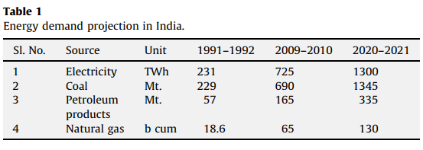

**Future of Renewable Energy in India :**

India, faced with twin challenges on energy and environmental front, has no option but to work towards increasing the role of renewable in the future energy systems. Renewable energy technologies vary widely in their technological maturity and commercial status. In India, renewable energy is at the take-off stage and businesses, industry, government and customers have a large number of issues to address before these technologies could make a real penetration. India with large renewable energy resources (solar PV, wind, solar heating, small hydro and biomass) is to set to have large-scale development and deployment of renewable energy projects

## A1.3 Challenges involved in replacing fossil fuels with renewable energy sources as prime electric power generation sources:

One of the biggest challenges in Renewable Energy development is the high initial cost of installation. While development of a coal based power plant requires around Rs 4 crore per MW, the investment required for wind and solar power-based plants is significantly higher. A wind based plant, with capacity utilization of 25%, requires an investment of Rs 6 crore per MW. The actual investment, at more efficient capacity utilization of 80%, works out to Rs 18 crore per MW. Similarly, the investment in a solar based plant, with a capacity utilization of 15%, is Rs 18 crore. The actual investment, at 80% capacity utilization, is around Rs 98 crore.

High cost associated with Renewable Energy projects necessitates further research and technological developments in this area. A comprehensive policy framework is necessary for accelerated growth of renewable energy in India.

Proper system planning and integration is another important aspect. Knowing the decentralized nature of Renewable Energy projects, the capacity and type of project is to be decided where availability of the energy source can be ensured. Most Renewable Energy systems are weather dependent; thus, factors like number of sunny days, wind condition, monsoon, tide level, supply of biomass, etc. play an important role in feasibility of the system. Plant availability is not predictable as in case of conventional plants.

Social acceptance of renewable-based energy system is still not very encouraging in urban India. Despite heavy subsidy being provided by the government for installation of solar water-heaters and lighting systems, its penetration is still very low. Manpower training is another grey area. Currently, the Indian power sector is facing severe trained manpower shortage. Skill upgradation of the existing manpower and training of new professionals are essential to achieve the goal of “power to all” by 2012.

**(Gopal Saxena, The Economic Times, 2011)**

## A1.4 Justification of the stance taken with conclusion:

Based on the present global economic growth rates, fossil fuel energy resources may last a generation or two, at the most, before they are exhausted. Therefore, the future of our energy needs lies in renewable energy resources. The use of these resources, rather than an increase in fossil fuel supplies, should be encouraged through new diplomacy that takes into account the needs and resources of all concerned. Given the vast potential of renewables in India, all it needs is comprehensive policies and an investor friendly regime to be global leader in clean and green energy.

Renewable Energy has a very bright future ahead of it, short-term clouds notwithstanding, and supporting technologies such as storage and smart grids (which add real-time visibility, control, and flexibility) are also becoming more and more affordable. Ultimately, it is the improved frameworks that will most help RE scale sustainably.

# **Question No. 2**

**Solution to Question No. 1 part B:**

## B.1.1 Detailed estimation of the energy consumption for your selection:

Census and nationwide surveys like NSSO rounds and IHDS provide some observations on electricity consumption at the household. Not all of India’s household are electrified. Even some of the electrified households do not use electricity either because it is too expensive for them or because there is no reliable supply. According to the census and surveys, more than 90% of urban households use electricity as their primary source of lighting. This can be considered as a proxy for regular use of electricity. However, the number varies between 55 to 74% for the rural areas.

The NSSO’s data on households’ monthly electricity consumption shows that about 20% of the electrified households in India consume less than 30 units of electricity per month while about 80% consume less than 100 units per month. In the urban areas, about 60% of the households consume less than 100 units per month, while the number for rural households consuming less than 100 units is 90%.

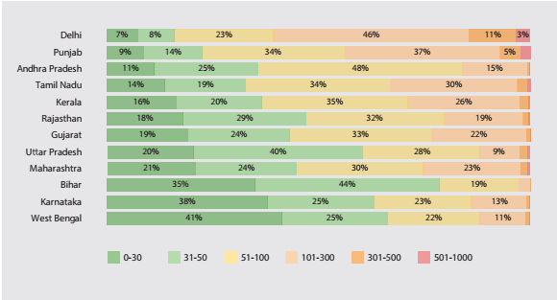

Figure B1.1 Consumption (in units) of households across different states in India Source : NSSO 2014

A household consuming 30 units would typically use about one tube-light, one incandescent bulb, and a ceiling fan. A household consuming about 100 units would typically use about 4 tube-lights, 2 CFLs, a TV, 4 fans, a small refrigerator, and small kitchen appliances. We assume typical usage hours and efficiency levels of appliances as discussed in subsequent sections. **(Residential Electricity Consumption in India: What do we know ?, 2016)**

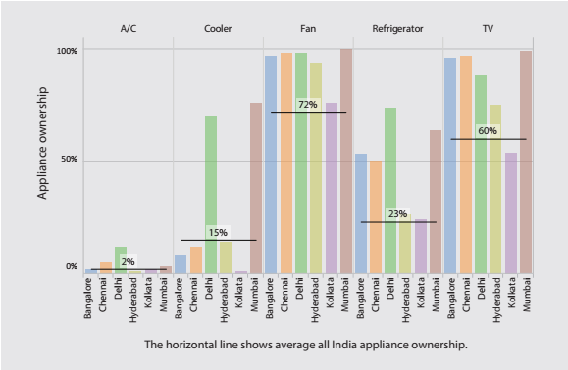

Figure B1.2 Appliance ownership in metros Source : Desai & Vanneman, 2015

## B.1.2 Surveying the commercially available panels and find their specifications:

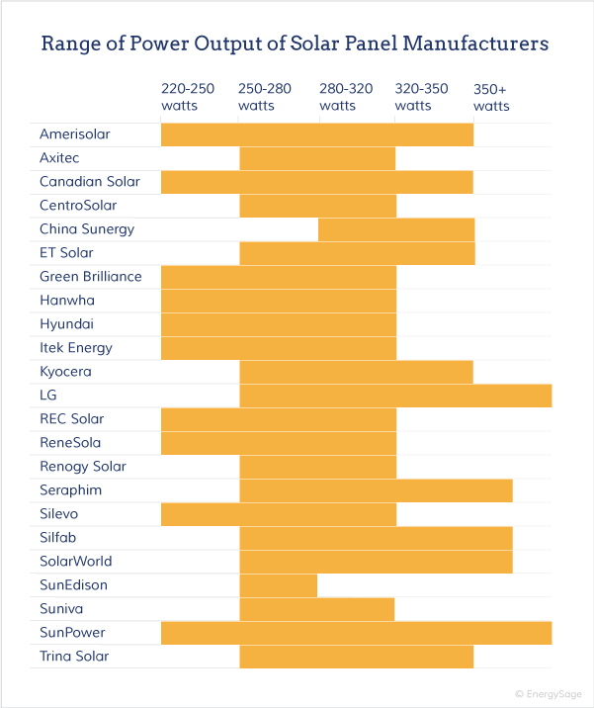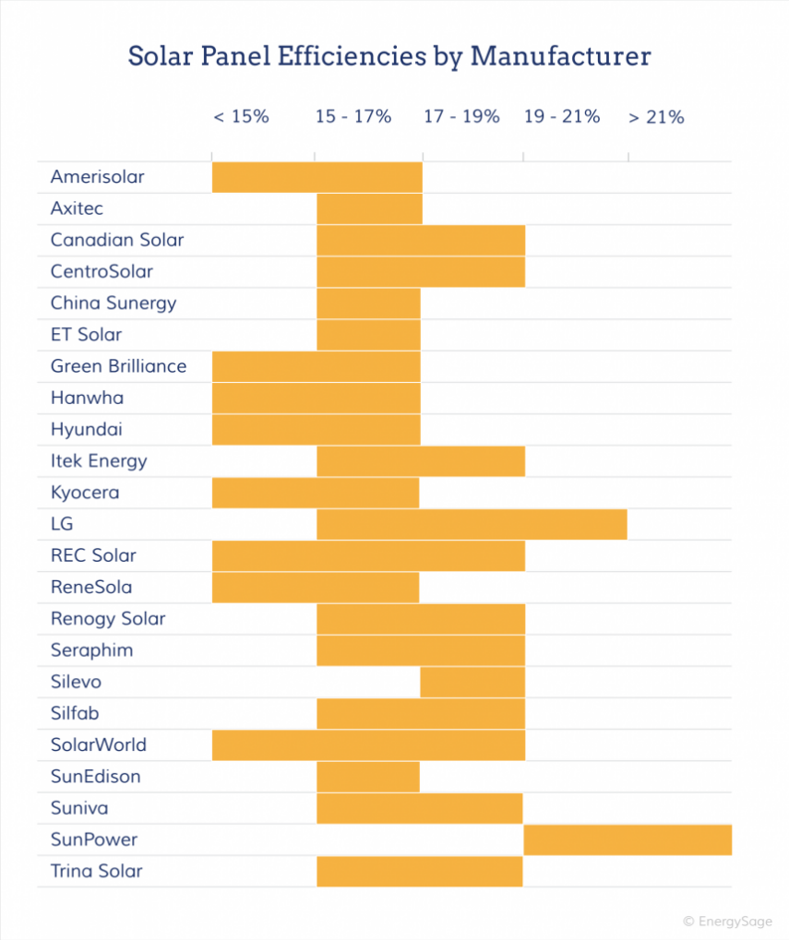

Figure B1.3 Solar Panel Power Output and Efficiencies of various manufacturers

In practical terms, a solar panel system with a total rated capacity of 5kW (kilowatts) could be made up of either 20 250-Watt panels or 16 300-Watt panels. Both systems will generate the same amount of power in the same geographic location.

The electricity generated by a solar PV system is governed by its rated power output, but it’s also dependent on other factors such as panel efficiency and temperature sensitivity, as well as the degree of shading that the system experiences and the tilt angle and azimuth of the roof on which it’s installed. As a general rule of thumb, it makes prudent financial sense to install a solar system with as much power output as you can afford (or that your roof will accommodate). That will ensure you maximize your savings and speed up the payback period of your solar energy system.

Mechanical and General Specifications:

* Dimensions : Given in inches and/or millimeters, a module’s size determines how many can fit in a given space, whether on a roof or on a ground- or pole-mount. If rack information is also known, the number of rows and each row length can be determined, based on the space intermodule clips add between modules
* Area and Thickness : Simply width times length, the area of a module is useful for checking power density (watts per ft.2), The frame thickness determines what rack components to use, like slip-in racks, or the required size of end and intermodule clips.
* Weight : Most permitting authorities will ask for basic structural engineering data for roof-mounted PV arrays, and there will be a limit to the weight that can be added to a roof structure.
* Backsheet : Most crystalline modules have a plastic backing material that seals the cells against environmental infiltration. The most common material is Tedlar, a polyvinyl fluoride film. This backsheet is the fragile underbelly of the module, and care must be taken not to scratch it.
* Cells : Cells will be either monocrystalline, polycrystalline, ribbon silicon, thin-film, or even multiple silicon layers, such as with Sanyo’s HIT module. Electrical characteristics, efficiencies, and appearance vary by cell type

Modules can have variable numbers of cells (usually between 36 and 108), with each crystalline cell operating at around 0.5 VDC, wired in series or series-parallel configurations. For example, a 72-cell module with all cells in series will operate at a voltage of about 36 volts. But a 72-cell module with two series strings of 36 cells paralleled will operate at about 18 V, perfect for charging a 12 V battery.

**(Rebekah Hren, 2011)**

## B.1.3 Justify the implementation of PV system considering the present expenses on the electricity:

Governments in many countries provide a capital subsidy for the investment made for rooftop solar power plants. The subsidy calculation is illustrated in this table for an assumed capital subsidy of 30%.

|  |  |
| --- | --- |
| Savings from capital subsidy | |
| Item | Rs |
| Cost of a 100kW rooftop solar plant | 60000000 |
| Subsidy @30% of actual cost | 18000000 |
| Net cost after subsidy benefit | 4200000 |

The range for a 1 KW system quoted at the expo by various solutions providers is between Rs. 1.20 lakhs to Rs. 1.8 lakhs.

Small solar systems of Rs. 45,000 promise to run three lights, a couple of fans and a TV. Newer products in the sub Rs.25,000 range and an intermediate system at Rs. 75,000 are soon to be announced.

Tamil Nadu, which has a stall by its Energy Development Agency at the expo, so far seems more focused on government-run street lighting and green home schemes, than on consumer-level subsidies. The manufacturers are clear that without a transparent subsidy scheme that help consumers shift to solar - without the need to approach government departments to avail the subsidy - it may not make major impact.

Other sidelights of the expo are small panels of 3 watts, 5 watts and so on, at a price point of Rs.60 per watt. So if you have a Direct Current bulb, such as an LED, you can get a light running for a total cost of Rs. 300 for the panel, and Rs. 400 or so for the bulb. There are AC-DC fans also which can be plugged into a solar panel, or run off the mains. These go for about Rs. 4,200.

# **Question No. 3**

**Solution to Question No. 2 part B:**

**Given Data:**

|  |  |
| --- | --- |
| Distance travelled $S$ | : 525 km |
| Average speed $v$ | : 65 km/hr |
| Number of cylinder $k$ | : 3 |
| Engine capacity $V$ | : 1.2 L = 0.0012 $m^{3}$ |
| Break power $b_{p}$ | : 50 kW |
| Speed $N$ | : 6200 rpm |
| Diameter of cylinder $D$ | : 0.073 m |
| Fuel consumption $m_{f}$ | : 3.2 kg/hr |
| Indicated mean effective pressure $p_{mi}$ | : 1.25 MPa |

## B.2.1 Indicated power:

The indicated power is given by,

$$i_{p}=\frac{p_{mi}LANk}{60}$$

Where,

$p_{mi}$ is the mean effective pressure

$L$ is the length of the cylinder

$A$ is the area of the cylinder

$k$ is the number of cylinder

$N$ is the speed in rpm

$L$, i.e. the length of the cylinder is not given and needs to be calculated,

Since the capacity of each cylinder is known,

$$\frac{0.0012}{3}=0.0004 m^{3}$$

The volume of the cylinder is given by,

$$V=\frac{πD^{2}L}{4}$$

$$L=\frac{4V}{πD^{2}}$$

$$L=\frac{4×0.0004}{π×{0.073}^{2}}=0.095 m$$

Now substituting all the values,

$$i_{p}=\frac{1.25×{10}^{6}×0.095×π×{0.073}^{2}×6200×3}{60×4×2}$$

$$i_{p}=77037.27602 W$$

## B.2.2 Mechanical efficiency:

Mechanical Efficiency is defined as the ratio of brake power and indicated power,

$$η=\frac{b_{p}}{i_{p}}$$

Therefore,

$$η=\frac{50000}{77037.27602}=0.649036$$

Therefore, the Mechanical Efficiency of the engine is $64.9036\%$

## B.2.3 Cost of fuel for travel between the cities:

Given that Fuel consumption per hour $m_{f}=3.2\frac{kg}{hr}$, the amount of fuel consumed during the round trip from cities A to B is.

$$fuel consumed=journey time×fuel consumtion per hr$$

$$journey time=\frac{S}{v}=\frac{525}{65}=8.076923 hours$$

So, now

$$fuel consumed=8.076923×3.2=25.84615 kg$$

Taking density of petrol as $0.77\frac{kg}{L}$, the volume of fuel consumed

$$V=\frac{25.84615}{0.77}=33.56643 L$$

Taking the Price of Petrol as $₹73.60 /litre$ (Bangalore, 11-March-2018)

The total cost of journey on fuel is,

$$73.6×33.56643= ₹ 2470.4893$$

## B.2.4 Cost benefit, considering LPG as the alternative fuel having Z% higher efficiency compared to petrol:

Since the value of Z is assumed to be zero, the Engine running on Petrol or LPG will have no difference in their fuel consumption efficiency and therefore both the engines will consume the same amount of fuel.

Taking the Price of LPG as $₹41.69/L$ (Bangalore, 10-March-2018)

The total cost of journey on fuel is,

$$41.69× 33.56643= ₹ 1399.3844$$

Therefore, the cost benefit is:

$$2470.4893-1399.3844= ₹ 1071.1049$$

# **Question No. 4**

**Solution to Question No. 3 part B:**

## B.3.1 Discuss the need for energy storage systems:

We need a secure, reliable electricity supply 24 hours a day. We also need to make more use of renewable energy resources, such as solar and wind, to reduce our reliance on non-renewable fossil fuels such as oil and gas. But, it’s not so easy to just switch over to using solar and wind for all our energy needs. The clouds pass the sun and the wind gusts fast and slow. This means that solar power and wind power are not always available when needed.

Recently the power landscape has shifted towards greater use of renewable energy in the form of wind and solar. Although this type of power generation is more sustainable, it makes delivering reliable power, on demand, a major challenge.

Wind and solar power installations generate power only intermittently and with a highly variable output. When the wind is blowing or the sun is shining, excess power should be stored and made available during suboptimal generating conditions or during peak demand. This requirement has led to greater demand for alternative energy storage facilities to support the grid.

Such fundamental changes in the architecture and controllability of the grid calls for smart, efficient power transmission and distribution networks. These require the storage of energy at appropriate times and locations, both to balance generation with consumption and to maintain grid stability.

## B.3.2 Survey and list the different energy storage systems:

Storage Technologies for Power Quality Applications:

Power quality applications require rapid response – often within less than a second – and include transient stability and frequency regulation. As with the other applications, the timescales of discharge may vary; but this class of services typically requires discharge times of up to about 10 minutes and nearly continuous cycling. Technologies for these applications include flywheels, capacitors, and superconducting magnetic energy storage

(SMES).

* Flywheels: Flywheels store energy in a rotating mass. Flywheels feature rapid response and high efficiency, making them well-suited for frequency regulation. Several flywheel installations have been planned or deployed to take advantage of high prices in frequency regulation markets **(Lazarewicz 2009)**
* Capacitors: Capacitors store electricity in an electric charge. Capacitors have among the fastest response time of any energy storage device, and are typically used in power quality applications such as providing transient voltage stability. However, their low energy capacity has restricted their use in longer time-duration application. A major research goal is to increase their energy density and increase their usefulness in the grid (and potentially in vehicle applications).
* Superconducting Magnetic Energy Storage (SMES): SMES stores energy in magnetic field in a coil of a superconducting material. SMES is similar to capacitors in its ability to respond extremely fast, but is limited by the total energy capacity. This has also restricted SMES to “power” applications with extremely short discharge times. Several demonstration projects have been deployed.
* High-Energy Batteries: For many batteries, there is considerable overlap between energy management and the shorter-term applications discussed previously. Furthermore, batteries can generally provide rapid response, which means that batteries “designed” for energy management can potentially provide services over all the applications and timescales discussed. Several battery technologies have been demonstrated or deployed for energy management applications. In addition to the chemistries discussed previously, the commercially available batteries targeted to energy management include two general types: high-temperature batteries and liquid electrolyte flow batteries.
* Pumped Hydro Storage (PHS): PHS uses conventional pumps and turbines and requires a significant amount of land and water for the upper and lower reservoirs. PHS plants can achieve round-trip efficiencies that exceed 75% and may have capacities that exceed 20hours of discharge capacity. Environmental regulations may limit large-scale above-ground PHS development. However, given the high round-trip efficiencies, proven technology, and low cost compared to most alternatives, conventional PHS is still being pursued in a number of locations.

## B.3.3 Discuss the form of energy stored in each system listed in B3.2:

* 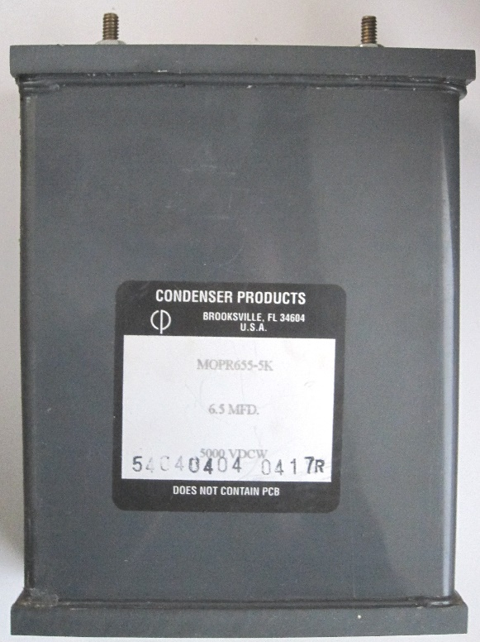Capacitors store energy in an electrostatic field between their plates. Given a potential difference across the conductors an electric field develops across the dielectric, causing positive charge (+Q) to collect on one plate and negative charge (-Q) to collect on the other plate. If a battery is attached to a capacitor for a sufficient amount of time, no current can flow through the capacitor. However, if an accelerating or alternating voltage is applied across the leads of the capacitor, a displacement current can flow. Besides capacitor plates, charge can also be stored in a dielectric layer.

Figure B3.1 Mylar-Film, oil-filled capacitor has very low inductance.

* Flywheel energy storage (FES) works by accelerating a rotor (flywheel) to a very high speed and maintaining the energy in the system as rotational energy. When energy is extracted from the system, the flywheel's rotational speed is reduced as a consequence of the principle of conservation of energy; adding energy to the system correspondingly results in an increase in the speed of the flywheel.
* Superconducting Magnetic Energy Storage: stores energy in a magnetic field created by current flowing through a superconducting coil. It uses the fact that a current will continue to flow in a superconductor even after the voltage across it has been removed. Once the superconducting coil is charged, the current will not decay and the magnetic energy can be stored indefinitely.
* High Energy Batteries such as Lithium-Ion, Lithium-Polymer and Nickle-Cadmium, store the energy in the form of Chemical Potential Energy, which when can produce high amount of current for suitable use.
* Pumped-storage hydroelectricity (PSH), or pumped hydroelectric energy storage (PHES), is a type of hydroelectric energy storage used by electric power systems for load balancing. The method stores energy in the form of gravitational potential energy of water, pumped from a lower elevation reservoir to a higher elevation. Low-cost surplus off-peak electric power is typically used to run the pumps. During periods of high electrical demand, the stored water is released through turbines to produce electric power. Although the losses of the pumping process makes the plant a net consumer of energy overall, the system increases revenue by selling more electricity during periods of peak demand, when electricity prices are highest.

## B.3.4 Explain any one energy storage system with a neat diagram:

A flexible, dynamic, efficient and green way to store and deliver large quantities of electricity, pumped-storage hydro plants store and generate energy by moving water between two reservoirs at different elevations. During times of low electricity demand, such as at night or on weekends, excess energy is used to pump water to an upper reservoir. The turbine acts as a pump, moving water back uphill. During periods of high electricity demand, the stored water is released through turbines.

A pumped-storage plant works much like a conventional hydroelectric station, except the same water can be used over and over again. Water power uses no fuel in the generation of electricity, making for very low operating costs.

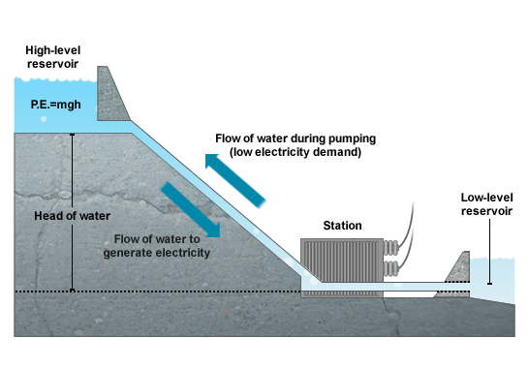

Figure B3.2 Illustration of Principle

* Upper reservoir

When power from the plant is needed, water stored in an upper reservoir is released into an underground tunnel.

* Intake tunnel

The water rushes down the intake tunnel.

* Turbines

The force of the water drives huge turbines, which are underground at the base of a dam. The spinning turbines are connected to large generators, which produce the electricity.

* Discharge tunnel

The water then flows through a discharge tunnel into a lower reservoir.

* Recharging

When demand for electricity is low, the turbines spin backward and pump the water back up into the upper reservoir to make it available to generate electricity when it's needed.

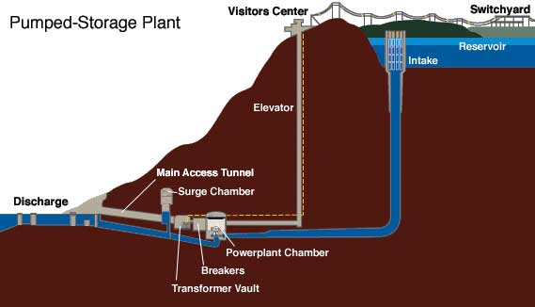

Figure B3.3 Pumped Storage Hydro Electricity

Pumped Hydro Storage is at present the only utilised method of large-scale grid energy storage. It comprises 3% of global installed power capacity installed and 97% of global installed electrical energy storage. PHS has a time response from a few seconds to a few minutes, a large scale output and storage capacity with hourly to daily output durations. It can be used to provide substantial benefits to the energy system including frequency control, ramping/load levelling and peak shaving, load following, and provision of stand by reserve. Due to the low energy density of pumped storage schemes they are really only applicable for large scale grid applications.

# **Question No. 5**

**Solution to Question No. 4 part B:**

## B.4.1 Survey of various boilers used in sugarcane industries:

**Biomass fuel boiler**

* Biomass fuel steam boiler is the best choice for sugar mill. Is a traveling grate type steam boiler that can burn both coal and biomass fuel. The large quantity of biomass fuel in sugar industry could be reused and save much cost for industry. A high combustion efficiency can be reached with advanced designed chain grate by adjusting the running speed to a suitable value. The ash of biomass fuel could be reused. This boiler can be started and stopped at any time, which is more flexible. Besides, it has the features of high power output, high combustion efficiency, stable operation, wide range of overload adjustment, etc. So it is widely used in sugar mill.

**Gas oil fuel steam boiler**

* Besides the biomass fuel boiler, gas fired steam boiler or oil fuel steam boiler can also be used in rice factory. With packaged style, the boiler is easy to transport and install. It can get the capacity of 6~35t/h under pressure1~2.5Mpa, temperature 193~300℃. The boiler can burn natural gas, heavy oil, LPG, coke oven gas, etc. It has also many advantages such as large combustion chamber, strong load adaptability, safe and reliable operation, long service life, environmental friendly and so on.
* When choosing a steam boiler for sugar mill, the boiler quality, fuel, after sale service, environment requirement and some other factors should be taken into account so that the industry can get more profit.

## B.4.2 Explanation of the processes that uses steam in sugarcane industries:

In a sugar cane mill, after the cane is crushed to remove the juices, the fibrous cane left behind is known as bagasse. The bagasse produced in a sugar factory is normally used for the generation of steam. For each 10 tonnes of sugarcane crushed, a sugar factory produces nearly 3 tonnes of wet bagasse as a by-product. Bagasse is burned to generate steam onsite which is used in the sugar process itself and to generate electricity. The bagasse produces enough energy to allow the mill to be self-sufficient with respect to fuel and electricity. Depending on the mill’s efficiency, location and local electricity grid, electricity may also be exported for additional revenue. The steam used directly in the sugar mill process for thermal energy is for juice heating and evaporation.

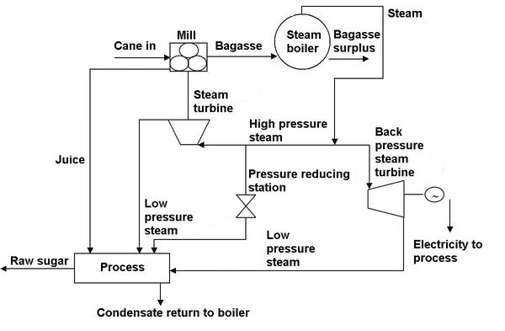

When burning fuel in the boiler furnace, live steam is produced and supplied to the turbine. Typical steam generation pressure is in the 20 to 40 barg region. The turbine drives an electrical generator which generates power for the factory and the steam leaving the turbine exhaust flows to the heating equipment for sugar manufacture. This is known as combined heat and power (CHP). The power requirement of the mill during the sugar season being met by the backpressure turbine generator set, whilst during the non-season from the grid.

## B.4.3 Construction and working of such boilers:

The Lancashire boiler is used to drive steam turbines, locomotives, marines etc. it is used in the industries like paper industries, textile industries, sugar industries, tire industries and etc.

**Principle:**

This boiler works on the basic principle of heat ex-changer. It is basically a shell and tube type heat ex-changer in which the flue gases flow through the tubes and the water flows through shell. The heat is transfer from flue gases to the water through convection. It is a natural circulation boiler which uses natural current to flow the water inside the boiler.

**Construction:**

This boiler is similar a shell and tube type heat ex-changer. It consist a large drum of diameter up to 4-6 meter and length up to 9-10 meter. This drum consist two fire tube of diameter up to 40% of the diameter of shell. The water drum is placed over the bricks works.

Three spaces create between the drum and the bricks, one is at bottom and two are in sides as shown in figure. Flue gases passes through the fire tubes and side and bottom space. The water level inside the drum is always above the side channels of flue gases, so more heat transfer to the water. The drum is half filled with water and the upper half space for steam. The Furnace is located at one end of the fire tubes inside the boiler. The low brick is situated at the grates (space where fuel burns) which does not allow to un-burned fuel and ash to flow in fire tubes. The boiler also consist other necessary mountings and accessories like economizer, super heater, safety valve, pressure gauge, water gauge, etc. to perform better.

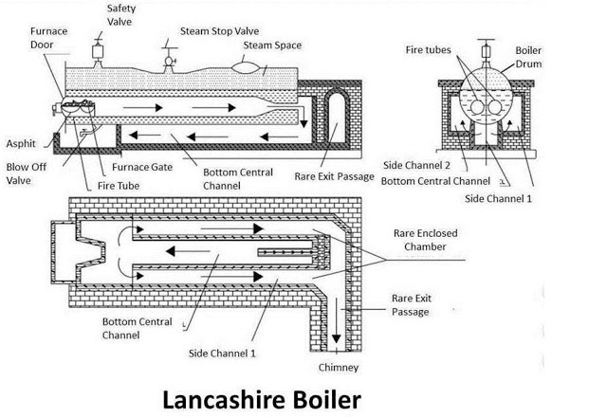

Figure B4.1 Lancashire Boiler

**Working:**

The Lancashire boiler is a shell and tube type heat ex-changer. The fuel is burn at the grate. The water is pumped into the shell through the economizer which increases the temperature of water. Now the shell is half filled with water. The fire tube is fully immersed into the water. The fuel is charged at the grate which produces flue gases. These flue gases first passes through the fire tube from one end to another. This fire tubes transfer 80-90% of total heat to the water. The backward flue gases passes from the bottom passage where it transfer 8-10% heat to water. The remaining flue gases passes from the side passage where it transfer 6-8% of heat to water. The brick is the lower conductor of heat, so work as heat insulator. The steam produces in drum shell it taken out from the upper side where it flows through super heater if required. So the steam produce is taken by out for process work.

**Bibliography**

________________________________________________________________________________

1. Aditya Chunekar, Sapekshya Varshney, Shantanu Dixit: Residential Electricity Consumption in India: What do we know? December 2016.