

|  |  |
| --- | --- |
| **ASSIGNMENT** | |
| **Course Code** | ESC102A |
| **Course Name** | Elements of Electronics Engineering |
| **Programme** | B.Tech |
| **Department** | CSE |
| **Faculty** | FET |

#### 

|  |  |
| --- | --- |
| **Name of the Student** | Satyajit Ghana |
| **Reg. No** | 17ETCS002159 |
| **Semester/Year** | 02/2018 |
| **Course Leader/s** | Mr. Bharath Kumara |

|  |  |  |  |  |  |  |  |  |
| --- | --- | --- | --- | --- | --- | --- | --- | --- |
| **Declaration Sheet** | | | | | | | | |
| Student Name |  | | | | | | | |
| Reg. No |  | | | | | | | |
| Programme |  | | | | | Semester/Year |  | |
| Course Code |  | | | | | | | |
| Course Title |  | | | | | | | |
| Course Date |  | | to | |  | | | |
| Course Leader |  | | | | | | | |
| **Declaration**  The assignment submitted herewith is a result of my own investigations and that I have conformed to the guidelines against plagiarism as laid out in the Student Handbook. All sections of the text and results, which have been obtained from other sources, are fully referenced. I understand that cheating and plagiarism constitute a breach of University regulations and will be dealt with accordingly. | | | | | | | | |
| Signature of the Student | |  | | | | | Date |  |
| Submission date stamp  (by Examination & Assessment Section) | |  | | | | | | |
| Signature of the Course Leader and date | | | | Signature of the Reviewer and date | | | | |
|  | | | |  | | | | |

# **Contents**

____________________________________________________________________________

**Declaration Sheet** ii

**Contents** iii

**Question No. 1** 5

A.1 Construction and properties of GaAs, Si and Ge diodes: 5

A.2 Discussion on the advantages and limitations of GaAs, Si and Ge diodes in high speed electronics: 6

A.3 Justification of stance with conclusion: 7

**Question No. 2** 8

B.1.1 Obtain an expression for the output voltage $Vout$ if the input voltage $Vin=Vm sinωt V$. Assign appropriate values for $Vm$ and $ω$. Assume R1 and R2 values in the range of $100 Ω$ to $100kΩ$: 8

B.1.2 Calculate the value of $Vout$. Sketch the four cycle of the output waveform with calculated $Vout$ values for the given input, if the diodes D1, D2, D3, D4 and D5 used are silicon diodes: 9

B.1.3 Simulate the given circuit for the given input using a suitable standard software tool and obtain the input and output waveforms: 10

B.1.4 Obtain the transfer characteristics of the circuit: 11

**Question No. 3** 13

B.2.1 Design a suitable circuit to convert AC input to an output suitable to operate audio power amplifier by using diode and Zener diode without using a step down transformer: 13

B.2.2 Verify the designed circuit using a standard software tool: 13

B.2.3 Discuss the specifications of components of the designed circuit: 14

**Question No. 4** 15

B.3.Design a circuit using diode, resistor and capacitor to obtain a shifted output as shown in figure 2. The square wave having peak-to-peak voltage of 40V and frequency range $100Hz to 100kHz$: 15

B.3.2 Verify the designed circuit using a suitable simulator and explain the results: 15

B.3.3 Discuss the specifications of the components used for the design: 18

B.3.4 Comment on the effect of capacitor and resistor values on the output waveform: 19

**Question No. 5** 20

B.4.1 Identify the configuration of the BJT: 20

B.4.2 Calculate the circuit currents $IB, IC$ and $IE$. Consider $VCB=1 V$ and $VEE=7.5V$: 20

B.4.3 Comment on the effect of voltage $VCB$ on the current $IE$: 20

B.4.3 Comment on the effect of voltage $VEE$ on the current $IB$: 21

**List of Figures**

____________________________________________________________________________

|  |  |  |
| --- | --- | --- |
| **Figure No.** | **Title of the figure** | **Pg.No.** |
| Figure B1.1 | Clamper Circuit | 8 |
| Figure B1.2 | Positive Half Cycle | 8 |
| Figure B1.3 | Negative Half Cycle | 9 |
| Figure B1.4 | Output Waveform | 10 |
| Figure B1.5 | Circuit Simulation | 10 |
| Figure B1.6 | Input and Output | 11 |
| Figure B1.7 | Transfer Characteristics | 12 |
| Figure B2.1 | Rectifier Circuit | 13 |
| Figure B2.2 | Simulation | 13 |
| Figure B3.1 | Clamper Circuit | 16 |
| Figure B3.2 | Input Waveform | 16 |
| Figure B3.3 | Output Waveform | 16 |
| Figure B3.4 | During positive half cycle | 17 |
| Figure B3.4 | During negative half cycle | 17 |
|  |  |  |
|  |  |  |

# **Question No. 1**

**Solution to Question No. 1 part A:**

## A.1 Construction and properties of GaAs, Si and Ge diodes:

Gallium Arsenide (GaAs) is a compound semiconductor: a mixture of two elements, Gallium (Ga) and Arsenic (As). Gallium is a byproduct of the smelting of other metals, notably aluminum and zinc, and it is rarer than gold. Arsenic is not rare, but is poisonous.

Various methods are used for the fabrication of Gallium Arsenide (GaAs). Out of all the methods, the main growth technique that is used is the liquid-encapsulated Czochralski (LEC) growth of GaAs crystals from high purified pyrolytic boron nitride (PBN) in high pressure.

The GaAs crystals can be easily achieved from the above method as the liquid-encapsulated Czochralski material grow in the <100> direction. As a results, round (100) wafers with very large diameters are obtained. The wafers that are grown in the <100> orientation is usually selected as they have semi-insulating properties and are also known to be thermally stable.

Since the <110> cleavage planes are at a right angle, square chips can be obtained with a diamond scribe and break. This means that by adhering to the <100> growth plane most of the difficulties that occur while cutting and handling of the chips can be reduced.

The methods for making GaAs wafers is very similar to the preparation of silicon wafers. First of all, the As- grown boules are grinded to a precise diameter and then incorporatied with orientation flats. This is followed by the following steps.

Wafering using a diamond ID saw, Edge rounding, Lapping, Polishing and Wafer Scrubbing.

**(Arun, CircuitsToday, 2011)**

Under normal operation, current flows through the base-to-emitter in SiGe HBTs and is proportional to the collector current by 1/Beta of the transistor (typically between 100-300). This means that the base-to-emitter diode junction is turned on and will generate more noise than a GaAs FET where the gate-to-source voltage is well below the diode turn-on voltage (under normal bias condition for low noise operation).

## A.2 Discussion on the advantages and limitations of GaAs, Si and Ge diodes in high speed electronics:

Unlike silicon cells, Gallium Arsenide cells are relatively insensitive to heat. Alloys made from GaAs using Al, P, SB, or In have characteristics complementary to those of GaAs, allowing great flexibility. GaAs is very resistant to radiation damage. This, along with its high efficiency, makes GaAs very desirable for space applications. However, GaAs does nave drawbacks; the greatest barrier is the high cost of a single-crystal GaAs substrate.

Silicon has three major advantages over GaAs for integrated circuit manufacture. First, silicon is abundant and cheap to process in the form of silicate minerals. The economies of scale available to the silicon industry has also hindered the adoption of GaAs.

In addition, a Si crystal has a very stable structure and can be grown to very large diameter boules and processed with very good yields. It is also a fairly good thermal conductor, thus enabling very dense packing of transistors that need to get rid of their heat of operation, all very desirable for design and manufacturing of very large ICs. Such good mechanical characteristics also make it a suitable material for the rapidly developing field of nanoelectronics. Naturally, GaAs surface cannot withstand the high temperature needed for diffusion; however a viable and actively pursued alternative as of the 1980s was ion implanation. **(Morgan, D.V., Board K 1991).**

The higher electron mobility for GaAs show promise for high speed devices and circuits. The direct gap allows for emission of photons in LED’s and LASER devices

|  |  |  |
| --- | --- | --- |
|  | **Silicon** | **GaAs** |
| Minority Carrier Lifetime | $$3×{10}^{-3}$$ | $${1×10}^{-8}$$ |
| Electron Mobility | $$1500$$ | $$8000$$ |
| Hole Mobility | $$600$$ | $$400$$ |
| Energy Gap (eV) | $$1.12 (indirect)$$ | $$1.43 (direct)$$ |
| Vapor Pressure | $$1×{10}^{-8} @ 930C$$ | $$1 @ 1050 C$$ |

GaAs has higher electron mobility giving devices with improved radio frequency performance or higher speed digital devices.

**(Dr. Lynn Fuller, 2001)**

Another advantage of GaAs is that it has a direct band gap, which means that it can be used to absorb and emit light efficiently. Silicon has an indirect bandgap and so is relatively poor at emitting light.

As a wide direct band gap material with resulting resistance to radiation damage, GaAs is an excellent material for outer space electronics and optical windows in high power applications.

Because of its wide bandgap, pure GaAs is highly resistive. Combined with a high dielectric constant, this property makes GaAs a very good substrate for Integrated circuits and unlike Si provides natural isolation between devices and circuits. This has made it an ideal material for monolithic microwave integrated circuits, MMICs, where active and essential passive components can readily be produced on a single slice of GaAs.

GaAs has different processing technology from Silicon IC technology including: MBE, no oxide growth, encapsulation to prevent loss of arsenic at temperatures above 400 $°$ C.

The main semiconductor device made is the MESFET.

Optical LED’s and LASER’s can be made in GaAs or related III-V semiconductors.

## A.3 Justification of stance with conclusion:

Some electronic properties of gallium arsenide are superior to those of silicon. It has a higher saturated electron velocity and higher electron mobility, allowing gallium arsenide transistors to function at frequencies in excess of 250 GHz. GaAs devices are relatively insensitive to overheating, owing to their wider energy bandgap, and they also tend to create less noise (disturbance in an electrical signal) in electronic circuits than silicon devices, especially at high frequencies. This is a result of higher carrier mobilities and lower resistive device parasitics. These superior properties are compelling reasons to use GaAs circuitry in mobile phones, satellite communications, microwave point-to-point links and higher frequency radar systems. It is also used in the manufacture of Gunn diodes for the generation of microwaves.

When coming to Silicon and Germanium, they are pure elements, and due to its lower band gap they cannot be used in High Speed Devices at higher frequencies of $20GHz$ unlike the Gallium Arsenide Semiconductors.

The uses of GaAs are varied and include being used in some diodes, field-effect transistors (FETs), and integrated circuits (ICs). GaAs components are useful in at ultra-high radio frequencies and in fast electronic switching applications. The benefit of using GaAs in devices is that it generates less noise than most other types of semiconductor components and, as a result, is useful in weak-signal amplification applications.

# **Question No. 2**

**Solution to Question No. 1 part B:**

## B.1.1 Obtain an expression for the output voltage $V_{out}$ if the input voltage $V_{in}=V_{m} \sin{ωt} V$. Assign appropriate values for $V_{m}$ and $ω$. Assume R1 and R2 values in the range of $100 Ω$ to $100kΩ$:

The given circuit is a dual clipper circuit, to analyze the output waveform the positive and the negative half cycles of the input are analyzed separately. Assuming the Diodes are normal Silicon Diodes with a Forward Voltage of $0.7 V$,

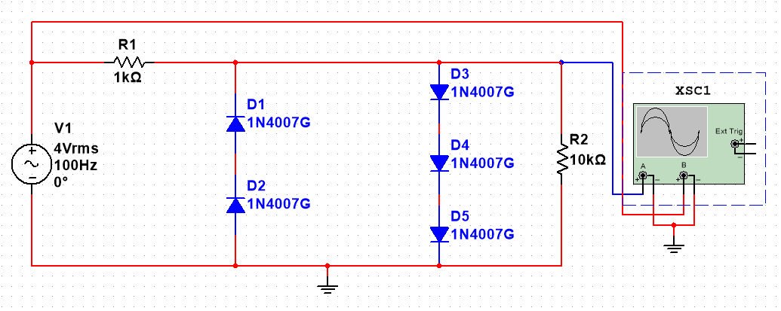

Figure B1.1 Clamper Circuit

During the positive half cycle of the input, D1 and D2 are reverse biased, D3, D4 and D5 are forward biased, hence replacing them with their constant voltage drop model,

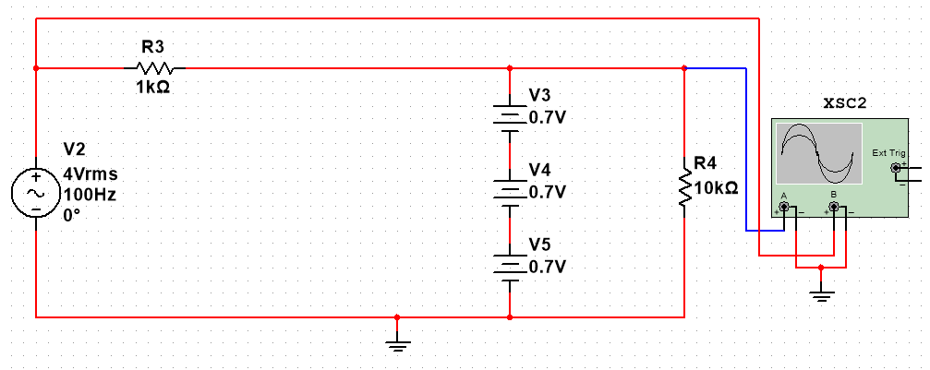

Figure B1.2 Positive Half Cycle

The Output Voltage will be due to only the Forward Voltage of the Diodes,

$$V_{0}=0.7 V+0.7 V+0.7 V=2.1 V$$

During the negative half cycle of the input, D1 and D2 are forward biased while D3,D4, and D5 are reversed biased, hence replacing them with their constant voltage drop models,

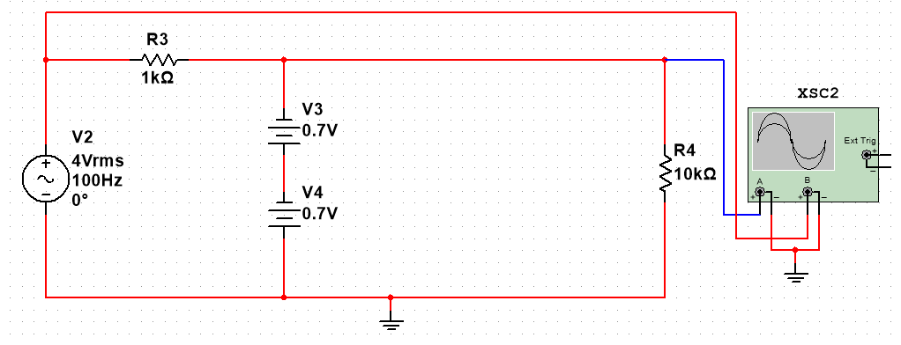

Figure B1.3 Negative Half Cycle

The output Voltage will be due to the Forward Voltage of D1 and D2, hence

$$V_{o}=-0.7V-0.7V= -1.4 V$$

Assuming the Input Waveform Equation is ${V_{i}= V}_{m}\sin{ωt}$

The Output Waveform Equation will be a piecewise function

$$V_{o}= \left\{\begin{aligned}2.1 V ; V_{i}≥2.1V \\ V_{i}; -1.4 V≤ V_{i}≤2.4 V \\ -1.4 V ;{ V}_{i}≤1.4V\end{aligned}\right.$$

## B.1.2 Calculate the value of $V_{out}$. Sketch the four cycle of the output waveform with calculated $V_{out}$ values for the given input, if the diodes D1, D2, D3, D4 and D5 used are silicon diodes:

Since the output is a piece wise function, the graph can be plotted of the same piecewise function obtained in B1.1. which has $V_{max}=2.1 V$ and $V_{min}= -1.4 V$.

MATLAB Code for sketching the output

idx = 1;

func = @(x) 4.*sin(x);

for i = 0:0.001:10

if func(i) > 2.1

y(idx) = 2.1;

idx = idx + 1;

elseif func(i) < -1.4

y(idx) = -1.4;

idx = idx + 1;

else

y(idx) = func(i);

idx = idx + 1;

end

end

x = 0:0.001:10;

plot(x,y,'LineWidth',2);

hold on;

fplot(func, [0 10]);

legend('output', 'input')

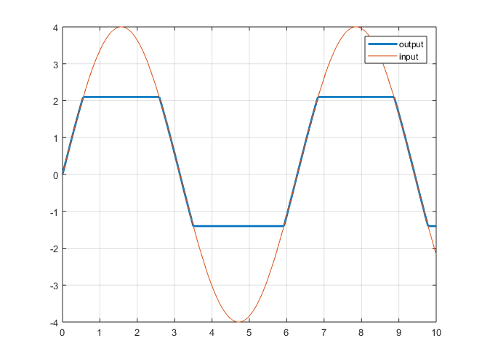

Figure B1.4 Output Waveform

## B.1.3 Simulate the given circuit for the given input using a suitable standard software tool and obtain the input and output waveforms:

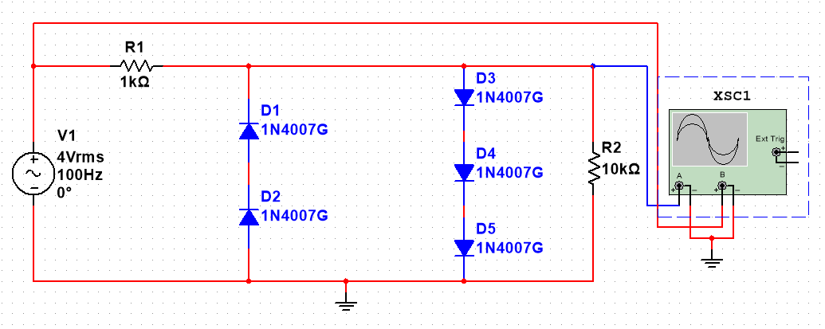

Figure B1.5 Circuit Simulation

Taking the Input Voltage as Sine Wave with $V_{rms}=4V$ and Frequency $f=100 Hz$

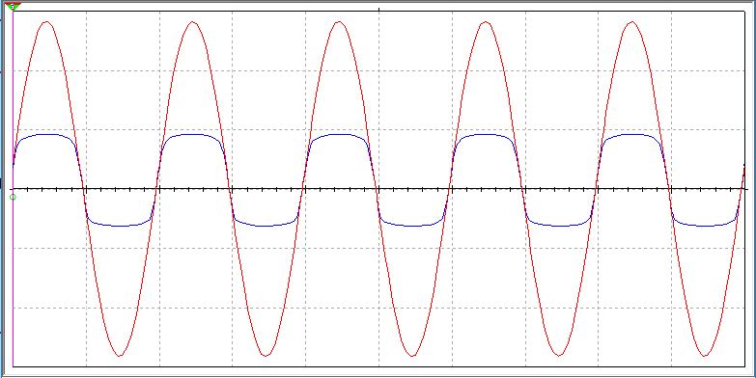

Figure B1.6 Input and Output Waveform

The input waveform is indicated in red while the output waveform is in blue

## B.1.4 Obtain the transfer characteristics of the circuit:

From the Piecewise function,

for $V > 2.1 V$, $V_{o} = 2.1V$, hence the transfer characteristic will be a straight line parallel to $x axis$ and passing through $y = 2.1$,

for $V< -1.4 V$, $V_{o}= -1.4$, hence the transfer characteristic will be a straight line parallel to $x axis$ and passing through $y= -1.4$.

for $-1.4V≤V_{i}≤2.1V$, the input signal is directly proportional to the output signal, and hence the transfer characteristic will be a proportional line $y=x$ from $x= -1.4 to x=2.1$.

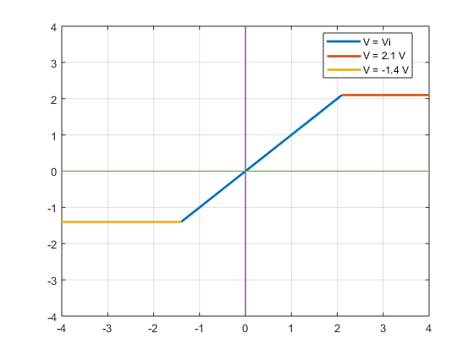

Figure B1.7 Transfer Characteristics

# **Question No. 3**

**Solution to Question No. 2 part B:**

## B.2.1 Design a suitable circuit to convert AC input to an output suitable to operate audio power amplifier by using diode and Zener diode without using a step down transformer:

Since the output needs to be a DC form and the input is AC, a Rectifier Circuit is needed, for which the Full Wave Bridge Rectifier is used. The ripples from the output of the Rectifier is removed and then the voltage is dropped down to the suitable voltage by using a Zener Diode.

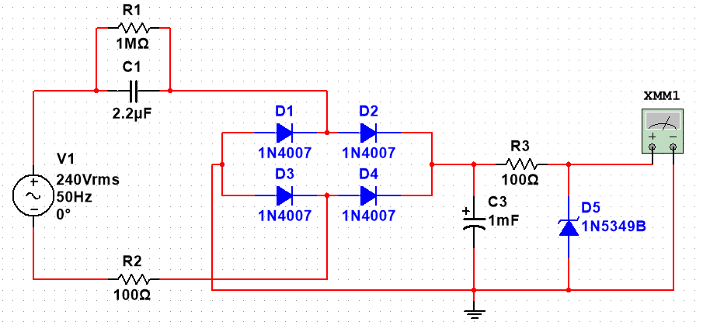

Figure B2.1 Rectifier Circuit

## B.2.2 Verify the designed circuit using a standard software tool:

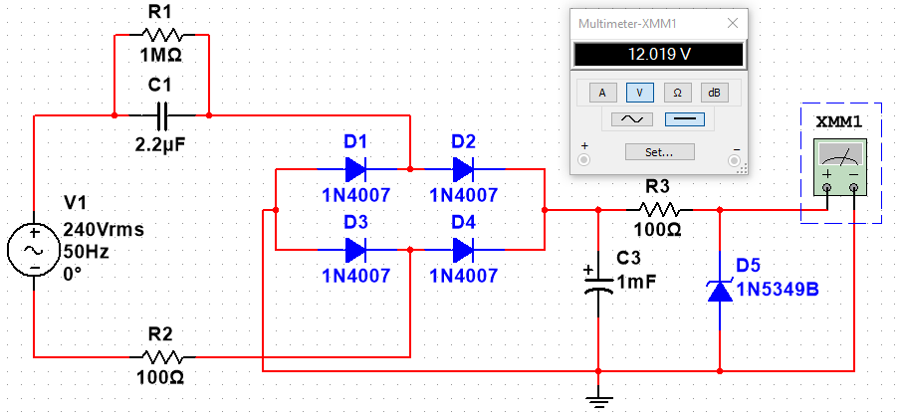

Figure B2.2 Simulation

## B.2.3 Discuss the specifications of components of the designed circuit:

* **V1** : AC Source with $V_{rms}=240V$, sinusoidal wave and Frequency $f=50Hz$.
* **D1, D2, D3, D4** : 1N4007 Diodes General Purpose Rectifier Diodes, manufactured by ON Semiconductors. Which has Low Forward Voltage Drop and High Surge Current Capability.
  + Absolute Maximum Ratings
    - Peak Repetitive Reverse Voltage : 1000 V
    - Average Rectified Forward Current : 1.0 A
    - Non-Repetitive Peak Forward Surge Current : 30 A
    - Storage Temperature Range : -55 to +175 $°$ C
    - Operating Junction Temperature : -55 to +175 $°$ C
  + Electrical Characteristics
    - Forward Voltage : 1.0 A
    - Maximum Full Load Reverse Current : 30 $μ$ A at Tj = 25 $°$ C
    - Total Capacitance : 5 pF
* **C1** : 2.2uF X-Rated Capacitor
  + Rated Voltage : 400V
  + Tolerance : $±$ 10%
  + Material Type : Ceramic Capacitor
* **R2** : 100 $Ω$ 1W Power Resistor
* **C3** : 1mF Electrolytic Capacitor
  + Rated Voltage : 400V
* **R3** : 100 $Ω$ Resistor
* **D5** : 1N5349B Zener Diode
  + Electrical Characteristics
    - Zener Voltage : 12 V @ IZT = 100mA
    - Zener Impedence : 125 $Ω$
    - Maximum Steady State Power Dissipation : 5 W
    - Operating and Storage : -65 to 200 $°$ C
    - Leakage Current Max : 2 $μ$ A
    - Surge Current : 7.5 A
    - Maximum Regulator Current : 395 mA
    - Forward Voltage : 1.2 V

# **Question No. 4**

**Solution to Question No. 3 part B:**

## B.3.Design a circuit using diode, resistor and capacitor to obtain a shifted output as shown in figure 2. The square wave having peak-to-peak voltage of 40V and frequency range $100Hz to 100kHz$:

The Range of Frequency for operation of the Clamper Circuit is $100Hz to 100kHz$, hence the time period of the square wave is in the range of $10ms to 0.01ms$, the Capacitor that will be used for the circuit should not discharge quickly when the diode is off, i.e. $τ>\frac{T}{2}$ where $τ$ is the time constant and $T$ is the time period of the square wave. Assuming that the capacitor charges/discharges in $5τ$, then $5τ≫\frac{T}{2}$ for a correct output waveform.

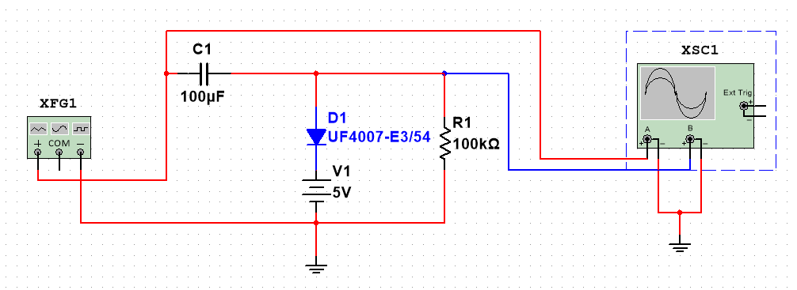

Figure B3.1 Clamper Circuit

$$τ=100×{10}^{3}×100×{10}^{-6}=10s$$

$$5×10s≫2ms$$

Hence the values of $C_{1}$ and $R_{1}$ can be used for such circuit.

## B.3.2 Verify the designed circuit using a suitable simulator and explain the results:

Taking the value of the maximum voltage of the output during the positive half cycle as $\left(5V-V_{D}\right)=V_{0}$

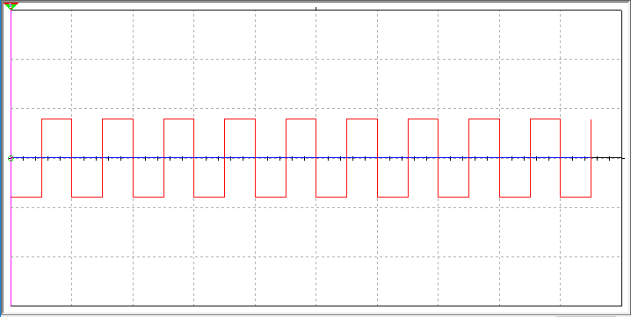

Figure B3.2 Input Waveform

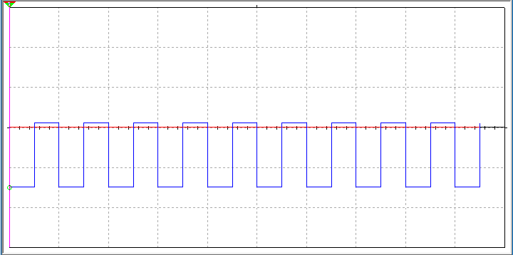

Figure B3.3 Output Waveform

The explanation is done by taking the value of $V_{0}$ = 5V which is the maximum voltage of the output during the positive half cycle.

During the positive Half Cycle D1 is Forward Biased and the hence replacing the circuit with a constant voltage drop model of Forward Voltage 0.7V.

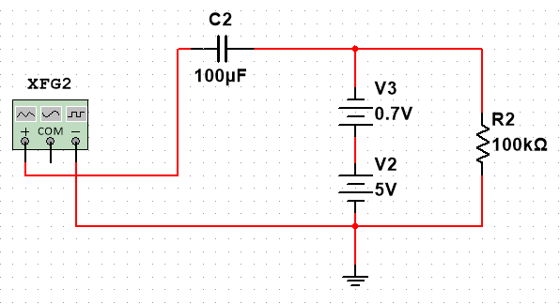

Figure B3.4 During positive half cycle

The Output Voltage by applying KVL is :

$$V_{0}=5-0.7=4.3 V$$

The Charge on the Capacitor can also be calculated by using KVL

$$V_{i}-V_{c}+0.7V-5V=0$$

The input voltage during the positive half cycle is +20V

$$V_{c}=20-4.3=15.7 V$$

During the negative Half Cycle D1 is Reverse Biased and the hence replacing the circuit with a constant voltage drop model, which will be open circuit.

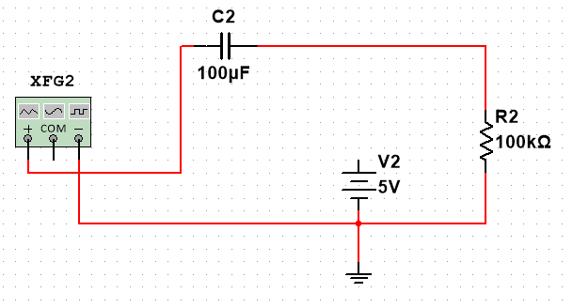

Figure B3.5 During negative half cycle

Applying KVL on the loop,

$$V_{i}+V_{o}+V_{c}=0$$

$$20+V_{c}=-V_{o}$$

$${-V}_{o}=20+15.7$$

$$V_{o}= -35.7 V$$

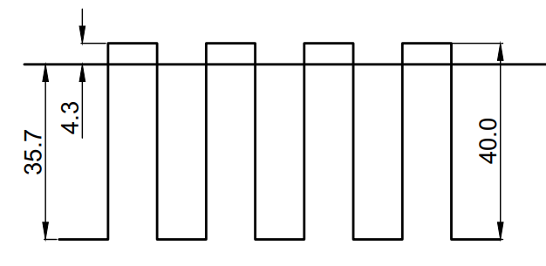

## B.3.3 Discuss the specifications of the components used for the design:

* **XFG1 :** Digital Function Generator, to generate the 40V p-p 1kHz Signal
* **C1 :** 100uF Capacitor
  + Voltage Rating : 50V
  + Frequency Rating : 1kHz
* **V1 :** DC Power Source
* **R1 :** 100 k $Ω$ Resistor
* **D1 :** UF4007-E3/54 Ultra Fast Diode, Low Forward Voltage Drop, High Surge Current Capability, High Current Capability, Glass-Passivated Junction
  + Absolute Maximum Ratings
    - Maximum Repetitive Reverse Voltage : 1000 V
    - Average Rectified Forward Current : 1.0 A
    - Non-Repetitive Peak Forward Surge Current : 30 A
    - Storage Temperature Range : -65 to +150 $°$ C
    - Operating Junction Temperature : -65 to +150 $°$ C
  + Electrical Characteristics
    - Maximum Forward Voltage : 1.7 V
    - Maximum Reverse Recovery Time : 75 ns
    - Maximum Reverse Current at Rated VR : 10 $μA$@ 25 $°$ C
    - Maximum Total Capacitance : 17 pF

## B.3.4 Comment on the effect of capacitor and resistor values on the output waveform:

If the values of the resistor or the capacitor are changed then the output waveform is affected, since the value of $τ$ or the charging/discharging time constant is changed, if the capacitor is discharged before the half cycle is completed the output waveform will not be linear and the capacitor discharge curve shows up in the output. This will make the output distorted and unusable, also the efficiency and ripple factor of the output increases.

# **Question No. 5**

**Solution to Question No. 4 part B:**

## B.4.1 Identify the configuration of the BJT:

It is common-collector configuration because (ignoring the power supply battery) both the signal source and the load share the collector lead as a common connection point. The transistor is a n-p-n transistor, the base current $I_{B}$ is in input current and the emitter current $I_{E}$ is the output current.

## B.4.2 Calculate the circuit currents $I_{B}, I_{C}$ and $I_{E}$. Consider $V_{CB}=1 V$ and $V_{EE}=7.5V$:

Assuming the Resistance $R_{B}=25 kΩ$ and $R_{E}=50 kΩ$

And given that $V_{CB}=1 V$ and $V_{EE}=7.5 V$

From the relation $I_{B}=\frac{V_{CB}}{R_{B}}$

$$I_{B}=\frac{1}{25×{10}^{3}}=0.04 mA$$

From the relation $I_{B}=\frac{V_{EE}}{R_{E}}$

$$I_{E}=\frac{7.5}{50×{10}^{3}}=0.150 mA$$

From the relation $I_{B}+I_{C}=I_{E}$

$$I_{C}=I_{E}-I_{B}$$

$$I_{C}=0.150-0.04=0.110 mA$$

## B.4.3 Comment on the effect of voltage $V_{CB}$ on the current $I_{E}$:

The input characteristics of a common collector configuration are quite different from the common base and common emitter configurations because the input voltage VBC is largely determined by VEC level. Here,

$$V_{EC}=V_{EB}+V_{BC}$$

$$V_{EB}=V_{EC}-V_{BC }$$

The input characteristics of a common-collector configuration are obtained between inputs current IB and the input voltage $V_{CB}$ at constant output voltage $V_{EC}$. Keep the output voltage $V_{EC}$ constant at different levels and vary the input voltage $V_{BC}$ for different points and record the $I_{B}$ values for each point. Now using these values we need to draw a graph between the parameters of $V_{BC}$ and $I_{B}$ at constant VEC.

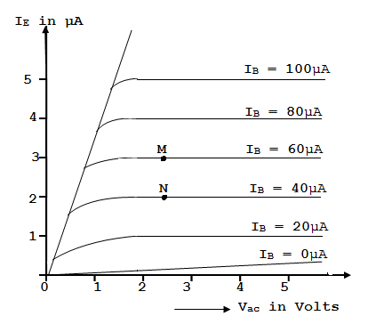

## B.4.3 Comment on the effect of voltage $V_{EE}$ on the current $I_{B}$:

The operation of the common collector circuit is same as that of common emitter circuit. The output characteristics of a common collector circuit are obtained between the output voltage $V_{EC}$ and output current $I_{E}$ at constant input current $I_{B}$. In the operation of common collector circuit if the base current is zero then the emitter current also becomes zero. As a result no current flows through the transistor

If the base current increases then the transistor operates in active region and finally reaches to saturation region. To plot the graph first we keep the $I_{B}$ at constant value and we will vary the $V_{EC}$ value for various points, now we need to record the value of $I_{E}$ for each point. Repeat the same process for different $I_{B}$ values. Now using these values we need to plot the graph between the parameters of $I_{E}$ and $V_{CE}$ at constant values of $I_{B}$. The below figure show the output characteristics of common collector.

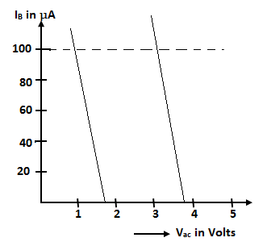

**Bibliography**

________________________________________________________________________________

1. Morgan, D. V.; Board, K. (1991). An Introduction To Semiconductor Microtechnology (2nd ed.). Chichester, West Sussex, England: John Wiley & Sons. p. 137.
2. Arun, Gallium Arsenide (GaAs) Fabrication (2011), CircuitsToday,

<http://www.circuitstoday.com/gallium-arsenide-gaas-fabrication> Accessed Date : 10-March-2018

1. Dr. Lynn Fuller, Gallium Arsenide Devices, Technologies & Integrated Circuits, Rochester Institute of Technology, Rochester, NY.