

|  |  |
| --- | --- |
| **ASSIGNMENT** | |
| **Course Code** | ESC101A |
| **Course Name** | Mechanical and Manufacturing |
| **Programme** | B.Tech |
| **Department** | CSE |
| **Faculty** | FET |

#### 

|  |  |
| --- | --- |
| **Name of the Student** | Satyajit Ghana |
| **Reg. No** | 17ETCS002159 |
| **Semester/Year** | 02/2018 |
| **Course Leader/s** | Vijayakumar S. |

|  |  |  |  |  |  |  |  |  |
| --- | --- | --- | --- | --- | --- | --- | --- | --- |
| **Declaration Sheet** | | | | | | | | |
| Student Name | Satyajit Ghana | | | | | | | |
| Reg. No | 17ETCS002159 | | | | | | | |
| Programme | B.Tech | | | | | Semester/Year | 02/1st | |
| Course Code | ESC101A | | | | | | | |
| Course Title | Elements of Mechanical Engineering | | | | | | | |
| Course Date |  | | to | |  | | | |
| Course Leader |  | | | | | | | |
| **Declaration**  The assignment submitted herewith is a result of my own investigations and that I have conformed to the guidelines against plagiarism as laid out in the Student Handbook. All sections of the text and results, which have been obtained from other sources, are fully referenced. I understand that cheating and plagiarism constitute a breach of University regulations and will be dealt with accordingly. | | | | | | | | |
| Signature of the Student | |  | | | | | Date |  |
| Submission date stamp  (by Examination & Assessment Section) | |  | | | | | | |
| Signature of the Course Leader and date | | | | Signature of the Reviewer and date | | | | |
|  | | | |  | | | | |

# **Contents**

____________________________________________________________________________

**Declaration Sheet** ii

**Contents** iii

**List of Figures** iv

**Question No. 1** 5

A.1 Introduction to mechanical joints and their applications: 5

A.2 Advantages and limitations of permanent and temporary mechanical joints taking one example of each: 6

A.3 Justification for your stance and conclusion: 7

**Question No. 2** 8

B.1.1 Different types of couplings and their applications: 8

B.1.2 Description of the selected coupling assembly with photo: 9

B.1.3 Relevance of the coupling for the selected device with justification: 10

**Question No. 3** 12

B.2.1 Chain drive and its applications: 12

B.2.2 Explanation of the working of selected chain drive with its specifications: 13

B.2.3 Calculation of the length of the chain drive: 14

B.2.4 Verification of the actual length with the calculated chain length: 14

**Question No. 4** 15

B.3.1 Geometrical specifications about gears of selected sugarcane machine: 15

B.3.2 Speed ratio of the gears involved in the machine: 16

B.3.3 Illustration of the power transmission with sketches and photos: 17

**Question No. 5** 19

B.4.1 Illustration of the selected component: 19

B.4.2 Functionality: 19

B.4.3 Explanation of operations and their sequence along with the tools/machine required to fabricate the selected component: 20

# **List of Figures**

____________________________________________________________________________

|  |  |  |
| --- | --- | --- |
| **Figure No.** | **Title of the figure** | **Pg.No.** |
| Figure B1.1 | A representative clamp coupling | 8 |
| Figure B1.2 | Automotive Drive Shaft | 9 |
| Figure B1.3 | Exploded view of universal joint | 10 |
| Figure B2.1 | Chain Drive | 12 |
| Figure B2.2 | Chain Drive | 13 |
| Figure B3.1 | Gear Train view of the sugarcane crusher | 15 |
| Figure B3.2 | Sugarcane Crusher | 17 |
| Figure B3.3 | Illustration of Gear System Implemented | 17 |
| Figure B3.4 | Side View of the Sugarcane crusher | 18 |
| Figure B4.1 | Disc Brakes of an Automobile Vehicle | 19 |
| Figure B4.2 | Cast and final shape of brake discs | 20 |
| Figure B4.3 | CNC Lathe | 21 |
|  |  |  |

# **Question No. 1**

**Solution to Question No. 1 part A:**

## A.1 Introduction to mechanical joints and their applications:

Mechanical joints are structural attachments within an electronic rack, enclosure, case, shelf, or housing and are material sensitive. Mechanical joints may be either permanent or semi-permanent. A permanent mechanical joint could be brazed, welded, adhesively bonded, chemically joined, riveted, or mechanically upset. Semi-permanent mechanical joints involve the application of mechanical fasteners and permit the mechanical joint to be attached and detached during service.

Mechanical joints may involve two or more metal elements, two or more nonmetallic elements, or a mixture of both metallic and nonmetallic elements.

For metallic fused joints the metals must be suitable to the joining method, and filler materials which are carefully selected achieve the joint, such as welding rod alloy materials or brazing materials. The dominant considerations include temperature range (will the material properties be altered by the temperatures required by the fusing process?), relative thermal expansion to avoid residual stresses, and avoidance of materials which in combination will lead to galvanic corrosion. If the metals gain their strength properties by being heat treated after forming, the joint materials may require annealing prior to fusing and heat treating after fusing.

Soldering metal parts together using conventional electronic lead–tin or lead-free solders is not a valid method by which to form a mechanical joint. Solder will creep under mechanical load, and if the mechanical load is continuously applied, the soldered joint will eventually creep to failure. Solder is a valid method for electrically bonding and environmentally sealing mechanical joints, such as riveted joints, which are designed to carry mechanical stress without the presence of the solder and where the solder is used for bonding or sealing and is not used to carry mechanical loads.

Nonmetallic (plastic) material joints may be formed by thermal bonding or ultrasonic welding identical formulations together (thermoplastics only) or by chemical fusing agents as recommended by the plastics manufacturer.

Mechanical joints involving a variety of materials (i.e., both metals and plastics) require careful materials selection, and the dominant characteristics of interest include thermal expansion, corrosion, creep, temperature range, and electrical conductivity. **(Myer Kutz, Mechanical Engineers’ Handbook)**

## A.2 Advantages and limitations of permanent and temporary mechanical joints taking one example of each:

Permanent Joints are very widely used in many different applications depending upon the advantages it would give to the structural support.

For the permanent joint, let’s take the example of Welding, a permanent mechanical fastener. Welding is a fabrication or sculptural process that joins materials, usually metals or thermoplastics, by causing fusion, which is distinct from lower temperature metal-joining. A filler material is typically added to the joint to form a pool of molten material that cools to form a joint that is usually stronger than the base material.

For the temporary joint Bolted joints are a very good example, which are one of the most common elements in construction and machine design. They consist of fasteners that capture and join other parts, and are secured with the mating of screw threads.

Advantages of Temporary Joints

* They can be easily disassembled and assembled, thus the parts can be separated easily without the harming the parts of the products.
* Transportation becomes easier since the parts can be transported separately, hence also the size of the parts becomes small
* They are designed to take tension loads, this reduces the fatigue caused due to cyclic loads on the joints, which cannot be done in a permanent joint such as rivets/welds.
* Welded joints require a lot of heat, which melts the metal and joins it permanently, this heat can change the propertied of the heat-affected zone and create thermal stress, and also during welding a lot of toxic fumes is released. This is not the problem in temporary joints like bolting.
* Bolted joints aren’t specific to the parent material or its condition, whereas in permanent joints like welding the parent material needs to be clean, free of oils, and also it should be a metal that can be molted and welded.
* Bolts are easy to use, whereas welding requires a lot of skill and lot of time, since this joint is to be permanent any error made during it can cause devastating problems in the long run, by causing a threat to the structural framework.
* Bolts offer much better joint quality than a screw, mostly because the threads are more tightly controlled

Disadvantages of Temporary Joints

* Corrosion between a bolt and the parent material should be considered. This may not be a problem with welding and adhesive joints if the parent materials being welded are compatible.
* Complexity. A bolted joint adds to a part count - a bolt, a nut, washers, thread lubricant, thread locking compound. And the bolts, nuts, and washers come in specific sizes with specific threads, with specific hole sizes and tolerances, for specific applications - if you need a high quality joint, you've got to keep track of all that and make sure the right bolt is used in the right place and in the right way.
* They require holes, which introduce stress concentrations and more failure modes; drilling the holes may create cracks which will grow over time to cause failure. Welding and adhesive joints don't require holes. Also, welds and adhesive joints are continuous, so they don't concentrate load like a bolt does.
* Bolted joints require a gasket to seal a joint. A weld (if done properly) will be leak-proof.

## A.3 Justification for your stance and conclusion:

Joints are used to connect parts of a mechanism or machine. These mechanical joints can be temporary or permanent depending on whether the connection needs to be removed frequently or not removed at all. This determination is made by the designers and engineers of the machinery with the maintenance of the machinery taken into consideration.

I would disagree to this context that “Permanent Mechanical Joints are always preferred over temporary mechanical joints”

There are quite a lot of disadvantages associated with permanent joints, along with some of its advantages, overall it boils down to the application of these joints. The weather and environmental conditions for example, the pressure and corrosion factors come into play. Permanent joints can take in a lot of pressure if done properly, while if we look at the form factor and the easiness of disassembly of the components Temporary joints are to be preferred. The parts are more easily transportable and this reduced the cost of manufacturing the components, IKEA for example is a MNC which makes furniture that come in parts and are to be assembled manually, this hugely reduces the cost for the furniture and also fulfills its purpose.

# **Question No. 2**

**Solution to Question No. 1 part B:**

## B.1.1 Different types of couplings and their applications:

Couplings are used to connect two shafts for torque transmission in varied applications. It may be to connect two units such as a motor and a generator or it may be to form a long line shaft by connecting shafts of standard lengths say 6-8m by couplings. Coupling may be rigid or they may provide flexibility and compensate for misalignment. They may also reduce shock loading and vibration. A wide variety of commercial shaft couplings are available ranging from a simple keyed coupling to one which

requires a complex design procedure using gears or fluid drives etc.

Different types of Coupling are:

1. Clamp or Split-muff coupling

It essentially consists of two half-cylinders which are placed over the ends of the shafts to be coupled and are held together by through bolt.

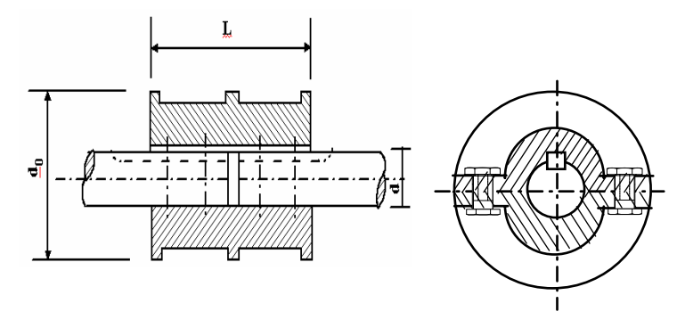

Figure B1.1: A representative clamp coupling Source : **(NPTEL)**

The advantages of this coupling is that assembling or disassembling of the coupling is possible without changing the position of the shaft.

The nuts are recessed into the bodies of the muff castings. This coupling may be used for heavy duty and moderate speeds.

1. Sleeve or Muff Coupling

One of the simple type of rigid coupling is sleeve coupling which consists of a cylinder sleeve keyed to the shaft to be connected. Normally sunk keys are used and in order to transmit the torque safely it is important to design the sleeve and the key properly. The key design is usually based on shear and bearing stresses. These are also known as Box Couplings.

These kinds of couplings are for semi-elastic purposes. They come at a lower cost and are easy to maintain. In combination with the Taper lock bush, they are easy to install.

**(NPTEL, IIT-KGP, Module: Couplings)**

1. Flange Coupling

It is a very widely used rigid coupling and consists of two flanges keyed to the shafts and bolted. In a bush pin type flange coupling, the rubber or leather bushes are used over the pins. The coupling has two halves dissimilar in construction. The pins are rigidly fastened by nuts to one of the flange and kept loose on the other flange. This coupling is used to connect shafts which have a small parallel misalignment, angular misalignment or axial misalignment. In this coupling the rubber bushing absorbs shocks and vibration during its operations.

This type of coupling is mostly used to couple electric motors and machines.

## B.1.2 Description of the selected coupling assembly with photo:

The Coupling assembly chosen is a Universal Joint which is a Driveshaft in Automobiles.

Universal joint is a positive mechanical joint used for connecting shafts, whose axes are inclined at an angle to each other. It is also known as universal coupling, U-joint, Cardan Joint and Hooke’s Joint. It compensates angular misalignment between the shafts in any direction.

Generally, in order to use universal joint, the inclination between the shafts should be less than 30°.

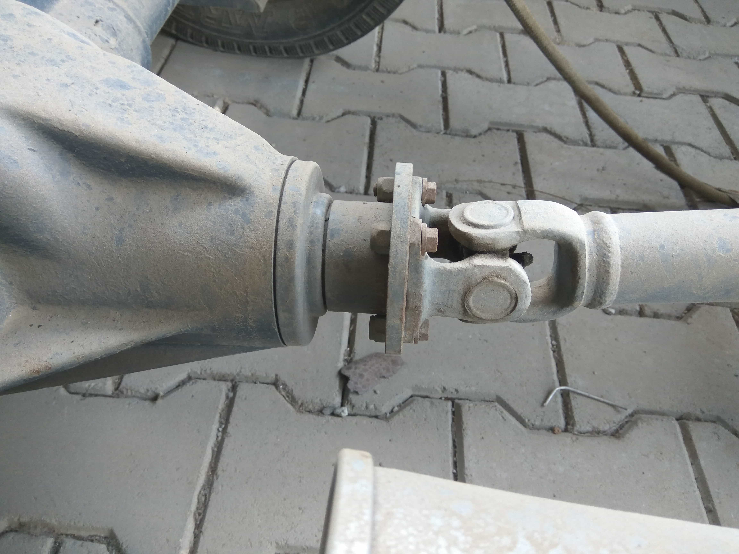

Figure B1.2: Automotive Drive Shaft of a four wheeler vehicle

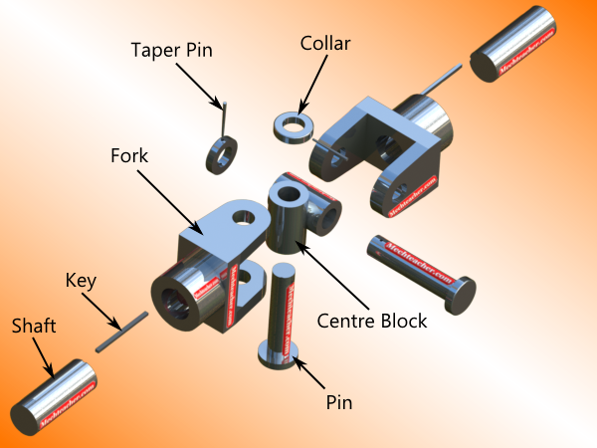

Figure B1.3: Exploded View of an Universal Joint (Source: mechteacher.com)

The two fork ends are assembled co-axially with respect to the centre block. The pins are assembled into the holes provided in the fork end. They are held in position by means of a collar and a collar pin.

## B.1.3 Relevance of the coupling for the selected device with justification:

An automobile may use a longitudinal shaft to deliver power from an engine/transmission to the other end of the vehicle before it goes to the wheels. A pair of short drive shafts is commonly used to send power from a central differential, transmission, or transaxle to the wheels.

Most of these vehicles have a clutch and gearbox (or transmission) mounted directly on the engine, with a drive shaft leading to a final drive in the rear axle. When the vehicle is stationary, the drive shaft does not rotate. Some vehicles, seeking improved weight balance between front and rear, use a rear-mounted transaxle.

The torque that is produced from the engine and transmission must be transferred to the rear wheels to push the vehicle forward and reverse. The drive shaft must provide a smooth, uninterrupted flow of power to the axles. The drive shaft and differential are used to transfer this torque

Functions of the Drive Shaft:

* First, it must transmit torque from the transmission to the differential gear box.
* During the operation, it is necessary to transmit maximum low-gear torque developed by the engine.
* The drive shafts must also be capable of rotating at the very fast speeds required by the vehicle.
* The drive shaft must also operate through constantly changing angles between the transmission, the differential and the axles. As the rear wheels roll over bumps in the road, the differential and axles move up and down. This movement changes the angle between the transmission and the differential.
* The length of the drive shaft must also be capable of changing while transmitting torque. Length changes are caused by axle movement due to torque reaction, road deflections, braking loads and so on. A slip joint is used to compensate for this motion. The slip joint is usually made of an internal and external spline. It is located on the front end of the drive shaft and is connected to the transmission. **(Jayanaidu, Analysis of a Drive Shaft for Automobile Applications)**

# **Question No. 3**

**Solution to Question No. 2 part B:**

## B.2.1 Chain drive and its applications:

A chain drive consists of an endless chain wrapped around sprocket wheels. The chain has a number of links connected by pins. The sprockets have teeth of special profile. Chains are used for power transmission and as conveyors. The chain drives have some features of both belt (flexibility of location of driver and driven) and gear drives (ruggedness). Chain drives are recommended for velocity ratio below 10:1, chain velocity 1550 m/min and power transmission up to 100 kW.

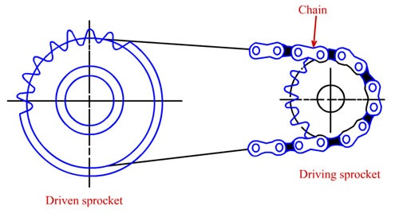

Figure B2.1: Chain Drive (Source: NPTEL)

A few applications of roller chains are listed below:

* Pedal roller of scucther.
* Drives from beater to plain and perforated drums and feed rollers on fine cleaner are through duplex roller chains.
* Drive from inclined lattice to feed apron and creel apron of bale opener through clutch.
* Motor to feed-roller, lap winding-roller, and tuft-feeder in high production carding machine.
* Duplex roller chain transmits motion from main shaft to lap rollers via bottom calender roller on sliver lap machine.
* Drive to shafts driving the flyers and bobbins on conventional roving machines.
* Drive to ring rail on ring spinning machines.
* Drive to creel rollers on drawing machines, and hank meters.
* Drives from beater to plain and perforated drums and feed rollers on fine cleaner are through duplex roller chains.
* Drive from inclined lattice to feed apron and creel apron of bale opener through clutch.
* Motor to feed-roller, lap winding-roller, and tuft-feeder in high production carding machine
* Duplex roller chain transmits motion from main shaft to lap rollers via bottom calender roller on sliver lap machine.
* Drive to shafts driving the flyers and bobbins on conventional roving machines.
* Drive to ring rail on ring spinning machines.
* Drive to creel rollers on drawing machines, and hank meters

## B.2.2 Explanation of the working of selected chain drive with its specifications:

The selected component is a part from a bicycle chain drive.

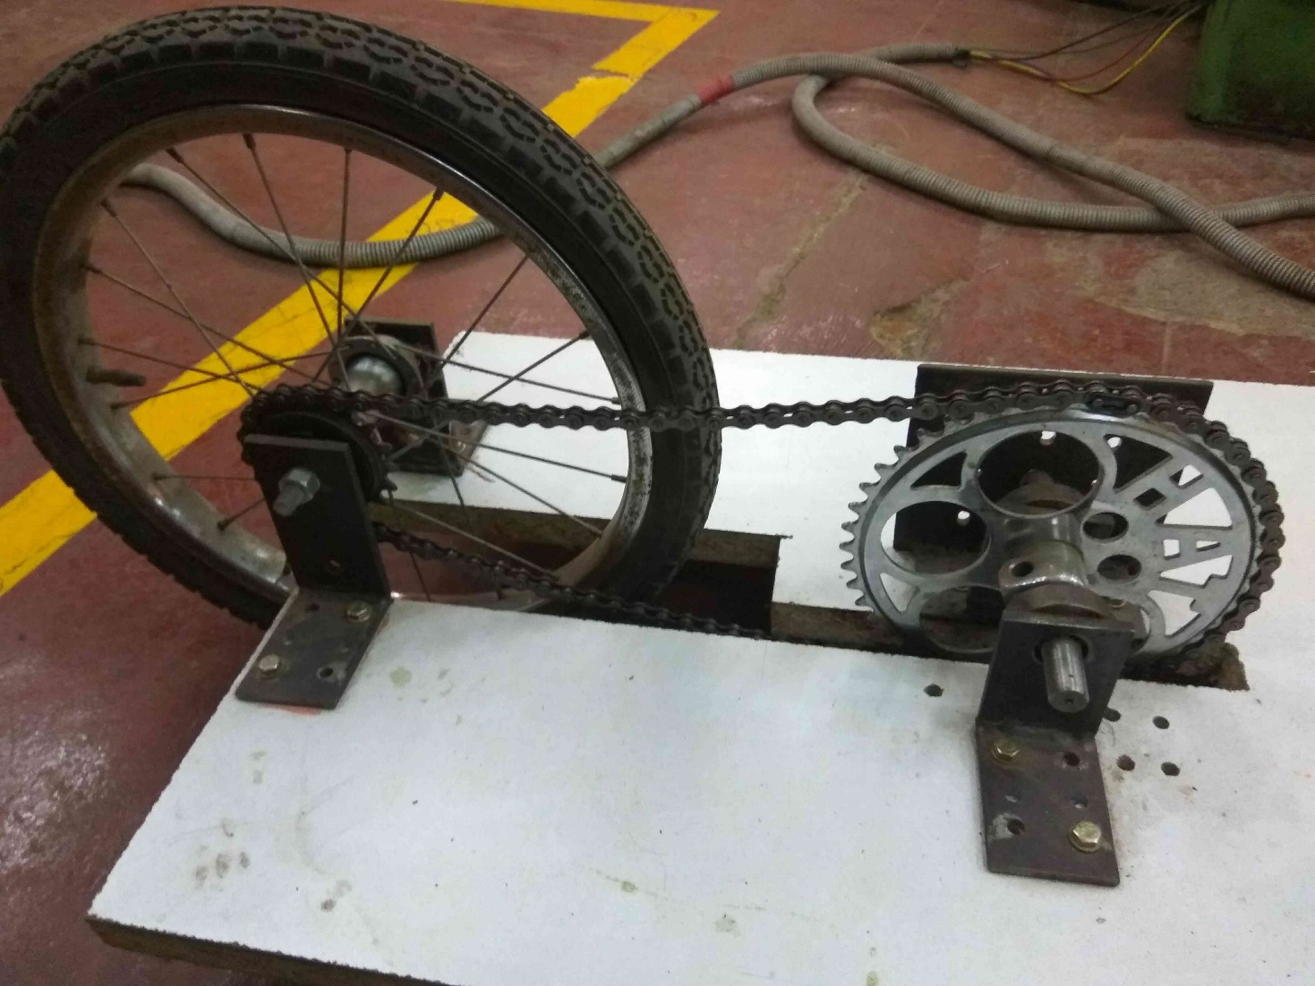

Figure B2.2: Chain Drive

A chain-drive system uses one or more roller chains to transmit power from a differential to the rear axle. This system allowed for a great deal of vertical axle movement (for example, over bumps), and was simpler to design and build than a rigid driveshaft in a workable suspension. Also, it had less unsprung weight at the rear wheels than the Hotchkiss drive, which would have had the weight of the driveshaft and differential to carry as well. This meant that the vehicle would have a smoother ride. The lighter unsprung mass would allow the suspension to react to bumps more effectively.

A bicycle chain is a roller chain that transfers power from the pedals to the drive-wheel of a bicycle, thus propelling it. Most bicycle chains are made from plain carbon or alloy steel, but some are nickel-plated to prevent rust, or simply for aesthetics.

Specifications:

* Pitch: 1/2” = 1.27 cm
* Number of Teeth in Driver Gear: 42
* Number of Teeth in Driven Gear: 18
* Center Distance: 39 cm
* Minimum Ultimate Tensile Strength: 1417 kg
* Measuring Load: 14 kg

## B.2.3 Calculation of the length of the chain drive:

The length of the chain is given by

Where,

Substituting the values,

## B.2.4 Verification of the actual length with the calculated chain length:

The Actual Chain length that was measured using a thread was which is close to the calculated values under very small margin of error of . The pitch was taken to be 0.5” which is cm.

# **Question No. 4**

**Solution to Question No. 3 part B:**

## B.3.1 Geometrical specifications about gears of selected sugarcane machine:

The chosen sugarcane machine is mainly made up of spur gears of different sizes, in total there are six gears that are used to transmit the power through the machine, and the seventh gear is connected to the motor with a belt drive to transmit power from the motor shaft to this gear drive system. The last two gears are connected to the crushers which also doubles as a shaft, both these crushers rotate in opposite directions and the sugarcane is fed in between these.

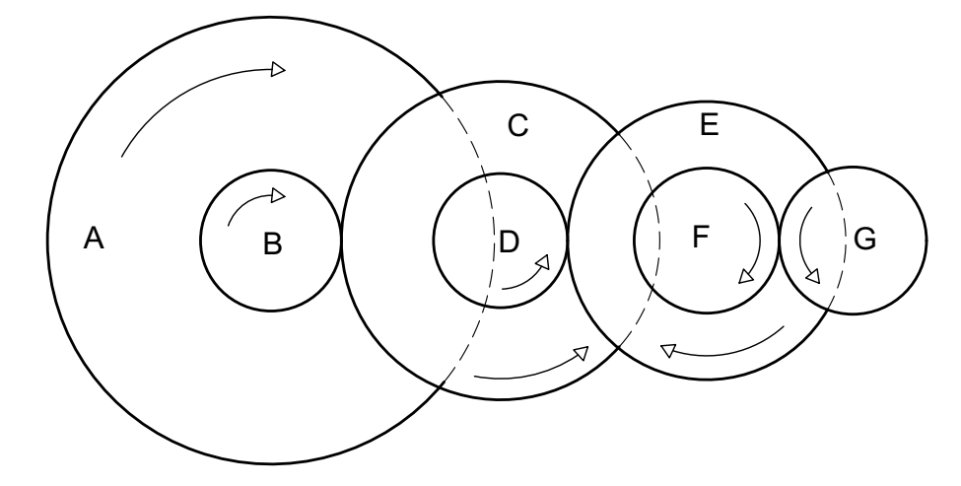

Figure B3.1: Gear Train View of the Sugarcane Crusher

Number of Teeth’s in Gears and Diameter

## B.3.2 Speed ratio of the gears involved in the machine:

From the Gear Train View and the Data taken,

Given

Taking

From

Speed Ratio of and

From

Speed Ratio of and

From

Speed Ratio of and

From

Speed Ratio of and

From

From

Speed Ratio of and

## B.3.3 Illustration of the power transmission with sketches and photos:

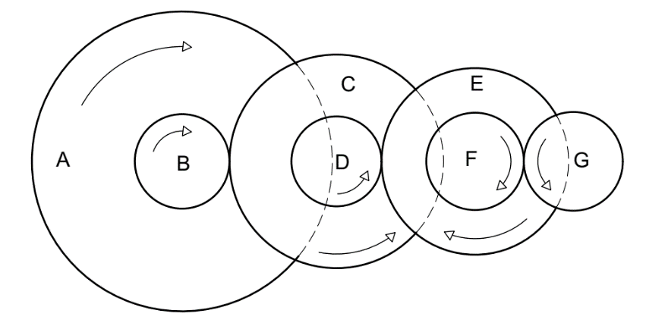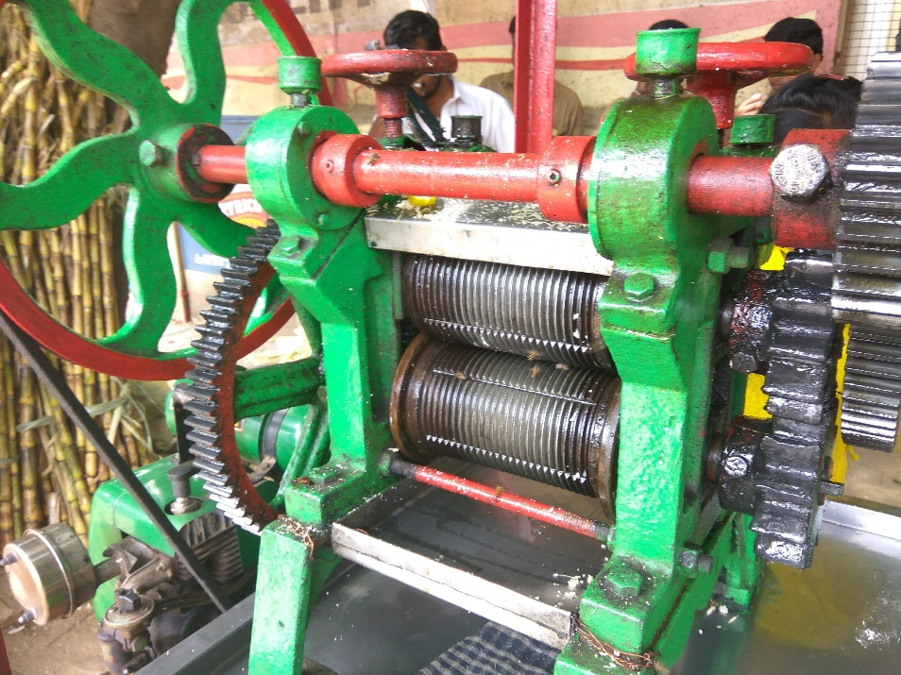

Figure B3.3: Illustration of the Gear System implemented

Figure B3.2: Sugarcane Crusher

The process of power transmission begins with the motor that runs on Kerosene, a fossil fuel, and has a rated power of , with . The Motor is attached to the first rotating gear A with a belt drive, this is now connected to Gear B using a shaft to the other side, then the power is transmitted to C, which is a compound gear with D, which is meshed with Gear E, Gear E and Gear F are compound gears, Gear F and G are meshed together and rotate in opposite directions with the same speed with huge amount of force/tension, leading to the extraction of juice from the sugarcane.

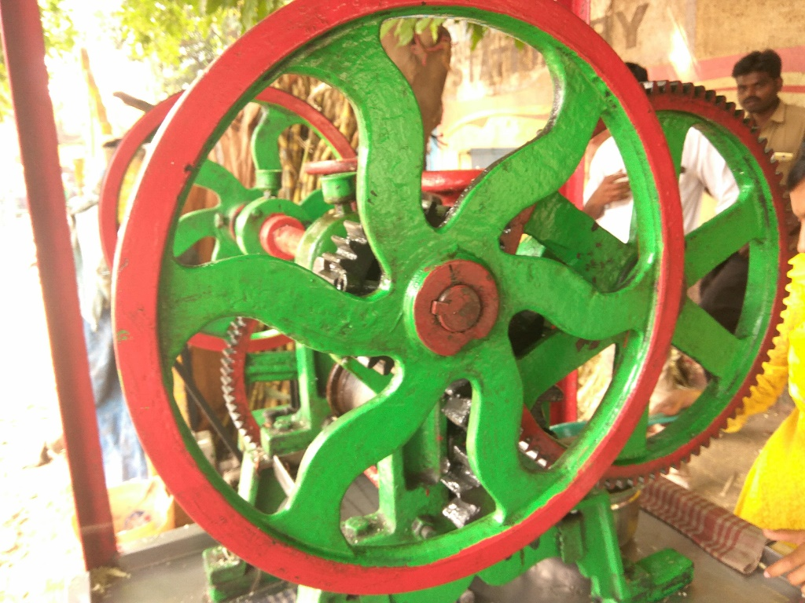

Figure B3.4: Side View of the Sugarcane Crusher

# **Question No. 5**

**Solution to Question No. 4 part B:**

## B.4.1 Illustration of the selected component:

The Selected component is a Brake Disc from an Automotive Vehicle. The brake disc is an important component of the brake system. If the brake system is to be able to decelerate the vehicle in safety and comfort at all times – bringing it to a complete stop if necessary

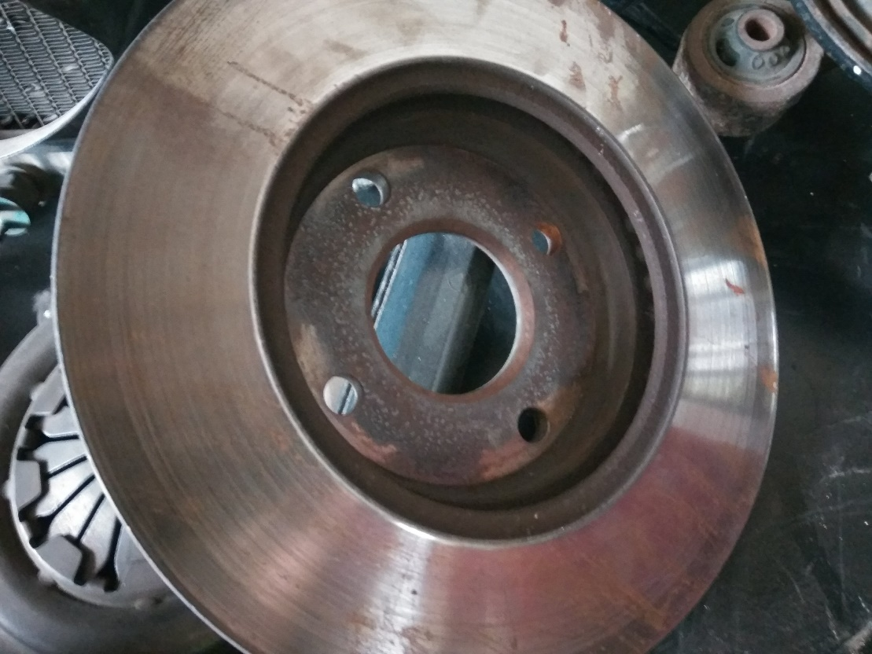

Figure B4.1: Disc Brakes of an Automobile Vehicle

## B.4.2 Functionality:

The brake disc is an important component of the brake system. If the brake system is to be able to decelerate the vehicle in safety and comfort at all times – bringing it to a complete stop if necessary – the brake disc must combine with the brake pads to generate a brake torque (a brake force). This torque is transmitted to the wheel hub and from there to the wheel rim. During braking, the vehicle's kinetic energy is converted into thermal energy due to friction between the brake pads and the brake disc, thereby enabling a reduction in speed to be achieved.

## B.4.3 Explanation of operations and their sequence along with the tools/machine required to fabricate the selected component:

Basic disc-shaping operations are performed semi-automatic machining groups composed of numerically-controlled turning lathes and CNC drilling machines interconnected with transfer lines. The two important operations that are done for shaping the Brake Discs are Turning and Drilling, Turning give the brake its flat surface, while Drilling give it the holes and the surface where the brake pads will lie that helps the vehicle to stop or slow down when needed.

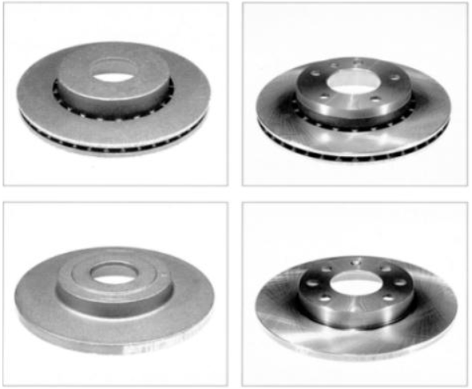

Figure B4.2: Cast and final shape of brake discs **(source : DAAAM International Scientific Book, pp 169)**

Sequence of Operations:

|  |  |  |
| --- | --- | --- |
| Operation | Operation Description | Stand |
| 10 | Shot blasting | Shot-blasting machine |
| 20 | Self-inspection, supervision inspection | Shot-blasting machine |
| 30 | Preliminary Turning | CNC turning lathe |
| 40 | Intermediate Turning | CNC turning lathe |
| 50 | Final Turning | CNC turning lathe |
| 60 | Self-inspection, supervision inspection | Inspection and measurement stand |
| 70 | Drilling | CNC drilling machine |

The initial shape of the disc is made by Iron Casting, Gray Cast Iron is melted at 1130 C to 1380 C, once the iron melts, and it is poured into the portion of the pattern that forms the pouring cup and sprue. As the metal enters the mold, the polystyrene foam is vaporized ahead of the advancing liquid, thus allowing the resulting mold cavity to be filled. The metal is allowed to cool down and solidify o form a solid brake disc.

The Surface of the Disc is now to be machined. Once this is achieved, brake disc must be drilled and slotted by the CNC machine. Holes have to be drilled on the surface, where the pads come in contact with the brake disc, and where the mounting points on the hub are. After that the brake disc has to be polished. Finally, brake disc needs to be anti-corrosion surface treated.

Turning operations are carried out on PCC job turning lathes manufactured by PITLER. These are two-chamber machines designed for dry machining, with a mobile electro-spindle of a vertical axis of rotation. The power of an AC motor incorporated in the electro-spindle is 72 kW, with a rotational speed range of 11.2 - 5400 min-1 and a maximum spindle torque of 860 Nm, whereas the allowable diameter of work pieces is 380 mm. **(DAAAM International Scientific Book, 2010, pp 169-176)**

Machines Required

1. CNC Lathe

Computer numerical controlled (CNC) lathes are designed to use modern carbide tooling and fully use modern processes. The machine is controlled electronically via a computer menu style interface

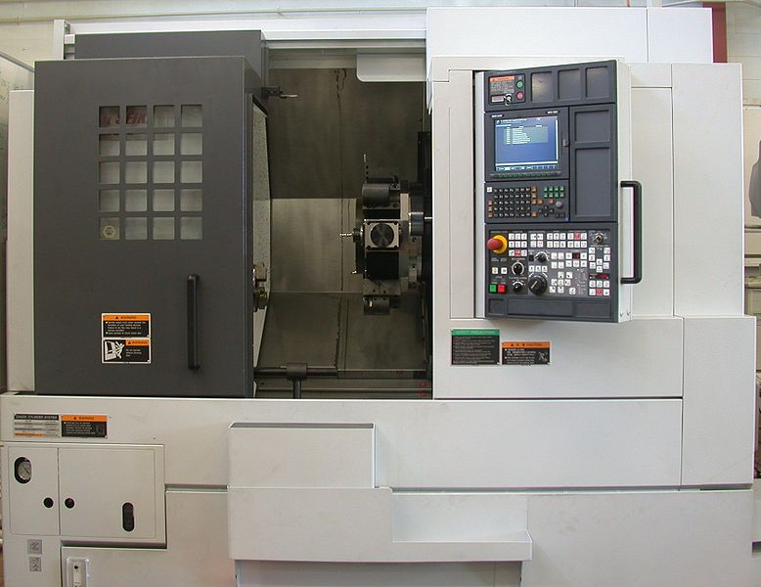

Figure B4.3: CNC Lathe **(Credits: Glenn McKechnie)**

1. CNC Drilling

In computer numerical control (CNC) machine tools a process called peck drilling, or interrupted cut drilling, is used to keep swarf from detrimentally building up when drilling deep holes (approximately when the depth of the hole is three times greater than the drill diameter). Peck drilling involves plunging the drill part way through the workpiece, no more than five times the diameter of the drill, and then retracting it to the surface.

**Bibliography**

________________________________________________________________________________

1. Myer Kutz, Mechanical Engineers’ Handbook, Materials and Engineering Mechanics pp 486-487.
2. Jayanaidu, Analysis of a Drive Shaft for Automobile

https://www.researchgate.net/publication/259391033_Analysis_of_a_Drive_Shaft_for_Automobile_Applications [accessed Apr 21 2018].

1. The Machining of Brake Discs, DAAAM International Scientific Book, 2010, pp 169-176