

|  |  |
| --- | --- |
| **ASSIGNMENT** | |
| **Course Code** | ESC102A |
| **Course Name** | Elements of Electronics Engineering |
| **Programme** | B.Tech |
| **Department** | CSE |
| **Faculty** | FET |

#### 

|  |  |
| --- | --- |
| **Name of the Student** | Satyajit Ghana |
| **Reg. No** | 17ETCS002159 |
| **Semester/Year** | 02/1st |
| **Course Leader/s** | Mr. Bharath Kumara |

|  |  |  |  |  |  |  |  |  |
| --- | --- | --- | --- | --- | --- | --- | --- | --- |
| **Declaration Sheet** | | | | | | | | |
| Student Name | Satyajit Ghana | | | | | | | |
| Reg. No | 17ETCS002159 | | | | | | | |
| Programme | B.Tech | | | | | Semester/Year | 02/1st | |
| Course Code | ESC102A | | | | | | | |
| Course Title | Elements of Electronics Engineering | | | | | | | |
| Course Date |  | | to | |  | | | |
| Course Leader |  | | | | | | | |
| **Declaration**  The assignment submitted herewith is a result of my own investigations and that I have conformed to the guidelines against plagiarism as laid out in the Student Handbook. All sections of the text and results, which have been obtained from other sources, are fully referenced. I understand that cheating and plagiarism constitute a breach of University regulations and will be dealt with accordingly. | | | | | | | | |
| Signature of the Student | |  | | | | | Date |  |
| Submission date stamp  (by Examination & Assessment Section) | |  | | | | | | |
| Signature of the Course Leader and date | | | | Signature of the Reviewer and date | | | | |
|  | | | |  | | | | |

# **Contents**

____________________________________________________________________________

**Declaration Sheet** ii

**Contents** iii

**Question No. 1** 4

A.1 Identification of an electronic application where MOSFETs and JFETs can be used: 4

A.2 Performance comparison between MOSFETs and JFETs for the identified application: 5

A.3 Conclusion with justification of stance: 6

**Question No. 2** 8

B.1.1 Design a voltage divider biasing circuit for the following specifications: 8

B.1.2 Simulate the designed circuit to obtain output characteristics for the input current range: 10

B.1.3 Draw a DC load line on the characteristics obtained in part B1.2 and determine the Q-Point: 11

**Question No. 3** 12

B.2.1 Design a circuit using a BJT which turns ON and OFF the LED at a frequency of F Hz: 12

B.2.2 Verify the designed circuit using a suitable simulator: 13

B.2.3 Determine the current flowing through the resistors when: 14

B.2.4 Discuss the specifications of the components used for the design: 15

**Question No. 4** 16

B.3.1 Circuit Design: 16

B.3.2 Calculate the Voltage and Frequency of the Waves: 16

B.3.3 Circuit Simulation: 19

B.3.4 Compare the Theoretical and Simulation Results: 21

**Question No. 5** 23

B.4.1 Design a 5-stage operational amplifier circuit to obtain voltage gains of 2, 4, -7, 5 and -9: 23

B.4.2 Calculate the output voltage of the amplifier when input voltage of 15mV is applied to the circuit: 24

B.4.3 Simulate the designed circuit and verify the output: 25

# **Question No. 1**

**Solution to Question No. 1 part A:**

## A.1 Identification of an electronic application where MOSFETs and JFETs can be used:

There are many applications where MOSFETs and JFETs can be used, one of them is switch.

**MOSFET used as a switch:**

In this circuit, using enhanced mode, an N-channel MOSFET is being used to switch the lamp for ON and OFF. The positive voltage is applied at the gate of the MOSFET and the lamp is ON ($V_{GS} = +V$) and at the zero voltage level the device turns off ($V_{GS}=0$). Using MOSFET to switch either inductive load or capacitive load protection is required to contain the MOSFET applications. If we are not giving the protection, then the MOSFET will be damaged. For the MOSFET to operate as an analog switching device, that needs to be switched between its cutoff region where $V_{GS} =0$ and saturation region where.

[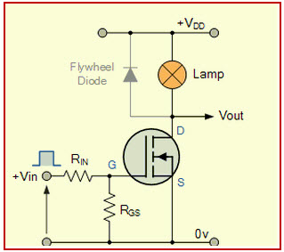](http://www.edgefxkits.com/blog/wp-content/uploads/MOSFET-Switch.jpg)

Figure A1.1 MOSFET as a Switch

**JFET used as a switch:**

In this circuit, an N-channel JFET is being used to switch the LED ON and OFF. The LED is connected between supply and source terminal through a resistor. Here resistor is used to limit the current through the LED. Gate terminal of the transistor is connected to the negative supply.

Zero voltage on the gate terminal makes current to flow through the LED because JFET is in saturation mode. Therefore, the LED becomes ON.

With a sufficient negative voltage on the gate terminal (about 3-4 volts), JFET drives into cut-off mode so the LED becomes turned OFF.

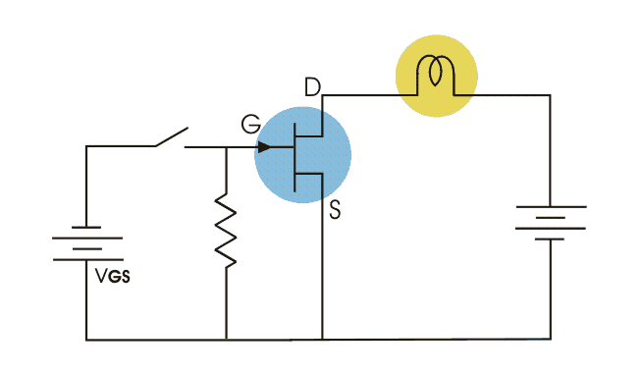

Figure A1.2 JFET as a Switch

## A.2 Performance comparison between MOSFETs and JFETs for the identified application:

Comparison between MOSFETs and JFETs

|  |  |  |
| --- | --- | --- |
|  | **MOSFET** | **JFET** |
| Basics | MOSFET is short for Metal Oxide Semiconductor Field Effect Transistor. whereas | JFET stands for Junction Field-Effect Transistor |
| Operating Mode | MOSFETs can operate in both depletion mode and enhancement mode. | JFETs can only be operated in depletion modes. |
| Input Impedance | MOSFETs offer higher input impedance than the JFETs which makes them much more resistive at the gate terminal, thanks to the metal oxide insulator. | JFETs have high input impedance on the order of ${10}^{10}Ω$ which makes them sensitive to input voltage signals |
| Gate Leakage Current | The gate leakage current for MOSFETs will be of the order of ${10}^{-12}$ $A$. | JFETs allow the gate leakage current on the order of ${10}^{-9} A.$ |
| Damage Resistance | MOSFETs are more susceptible to damage from electrostatic discharge because of the additional metal oxide insulator which reduces the capacitance of the gate making the transistor vulnerable to high voltage damages. | JFETs, on the other hand, are less susceptible to ESD damages because they offer higher input capacitance than MOSFETs. |
| Cost | MOSFETs are costly. | JFETs follow a simple, less sophisticated manufacturing process which makes them relatively cheaper than MOSFETs |
| Application | MOSFETs are mainly used for high noise applications such as switching and amplifying analog or digital signals, plus they are also used in motor control applications and embedded systems. | Electronic switches, buffer amplifier etc. |
| Terminals | It four-terminal semiconductor device. | It is a three-terminal semiconductor device. |

## A.3 Conclusion with justification of stance:

JFET and MOSFET are the two most mainstream field impact transistors usually utilized as a part of electronic circuits. Both JFET and MOSFET are voltage-controlled semiconductor devices used to amplify feeble signs utilizing an electric field impact. The name itself insights at the qualities of the device. While they share common attributes corresponding to amplifying and switching, they have what's coming to them of contrasts.

Some advantages of MOSFET over JFET :

* JFET is operated only in depletion mode, whereas MOSFET is operated in both depletion mode and enhancement mode.
* MOSFETs is somewhat easier to manufacture.
* MOSFET has higher speed of operation compared to JFETs.
* When JFET is operated with a reverse bias on the junction, the gate current IG is larger than it would be in a comparable MOSFET. The current caused by minority carrier extraction across a reverse-biased junction is greater, per unit area, than the leakage current that is supported by the oxide layer in a MOSFET. Thus MOSFET devices are more useful in electrometer applications than are the JFETs.
* According to the above made comparison and advantages, we can conclude that MOSFETs are better than JFETs. So, I strongly support the motion that MOSFETs are preferred over JFETs because of its advantages like.

# **Question No. 2**

**Solution to Question No. 1 part B:**

## B.1.1 Design a voltage divider biasing circuit for the following specifications:

Given,

$$V_{CC}=18 V$$

$$V_{CE}=9 V$$

$$I_{C}=7 mA$$

$$β=150$$

$$V_{E}=1V$$

Firstly we will find the required current viz. $I_{B}$& $I_{E}$

We know that,

$$I_{E}=\frac{β+1}{β}*I_{C}$$

$$⇒I_{E}=\frac{151}{150}*7$$

$$∴I_{E}=7.0466 mA$$

$$β=\frac{I_{E}}{I_{B}}$$

$$I_{B}=\frac{7.0466}{150}$$

$$∴I_{B}=0.047 mA$$

Now we need to find the respective resistance which are ${R_{1},R}_{2}$, $R_{E}$& $R_{C}$

Firstly,

$$R_{E}=\frac{V_{E}}{I_{E}}$$

$$R_{E}=\frac{1}{7.0466}$$

$$R_{E}=0.142 kΩ$$

Next we need to find $R_{C},$

We know that,

$$V_{CE}=V_{CC}-I_{C}*R_{C}$$

$$R_{C}=(18-10)/7$$

For finding the $R_{1} and R_{2}$ we need to know a small information viz.,

$$R_{2}=\frac{β}{10}×R_{E}$$

$$⇒R_{2}=\frac{150}{10}*0.142$$

$$∴R_{2}=2.130 KΩ$$

$R_{1}$ can be calculated by using Thevenin’s Method viz.,

$$R_{1}=R_{2}×\frac{V_{CC}-V_{B}}{V_{B}}$$

We need to find $V_{B}$ first viz.,

$$V_{B}=V_{BE}+V_{E}$$

$$V_{B}=0.7+1$$

$$V_{B}=1.7 V$$

Now,

$$R_{1}=2.130×\frac{18-1.7}{1.7}$$

$$R_{1}=20.422 KΩ$$

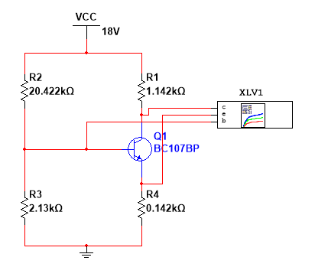

Figure B1.1 Circuit Design

## B.1.2 Simulate the designed circuit to obtain output characteristics for the input current range:

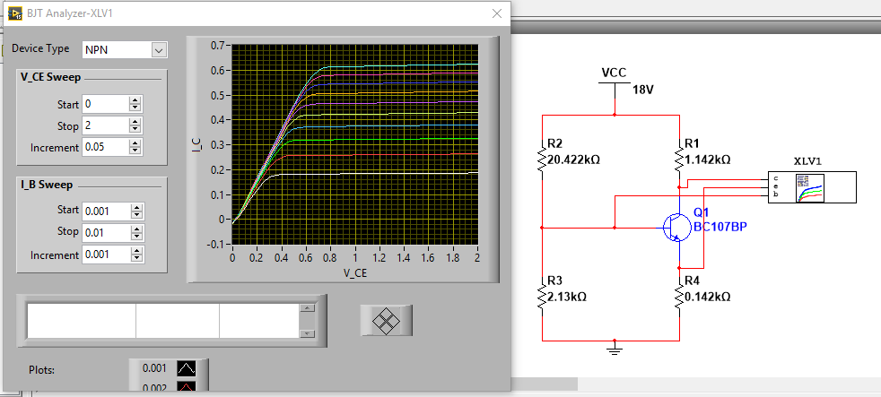

Figure B1.2 Simulation

The circuit was simulated in multisim, and the output characteristic curves were obtained by using a BJT analyzer.

$V_{CE}$ was varied from $0V$ to $2V$ in steps of $0.05V$ and the input current $I_{B}$ was varied from $0.001A$ to $0.01A$ in steps of $0.001A$

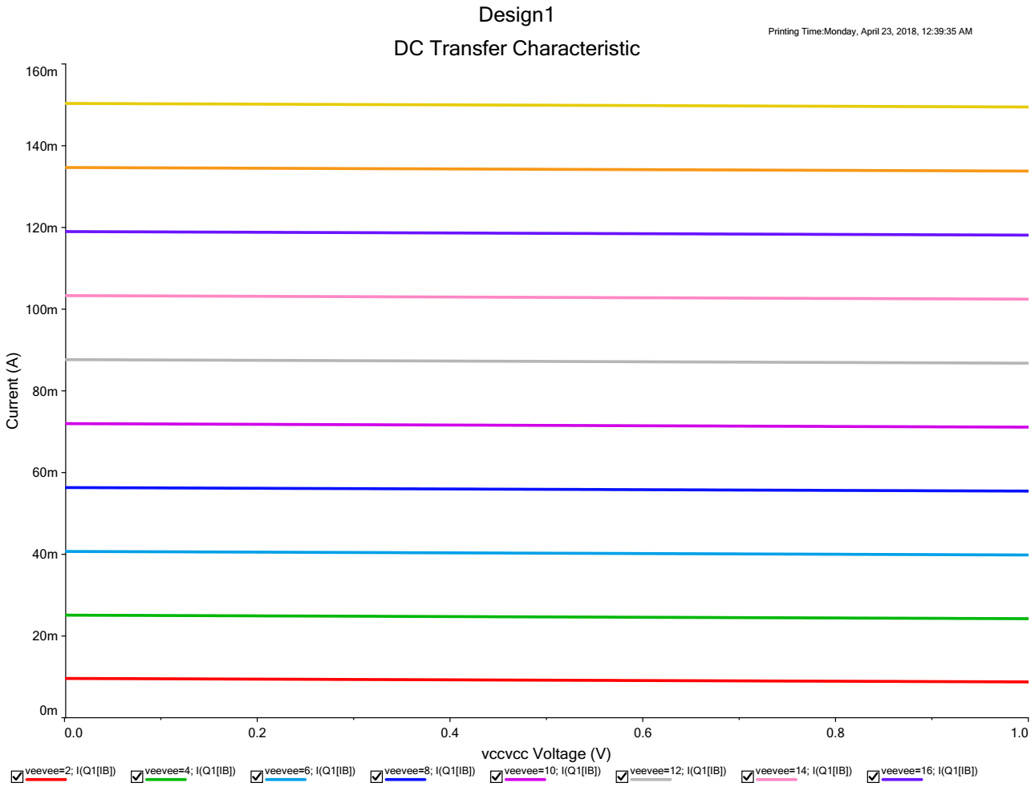

## B.1.3 Draw a DC load line on the characteristics obtained in part B1.2 and determine the Q-Point:



Using the DC Load line analysis in Multisim the DC Operating Point was found, which was $17.31 mA$.

# **Question No. 3**

**Solution to Question No. 2 part B:**

## B.2.1 Design a circuit using a BJT which turns ON and OFF the LED at a frequency of F Hz:

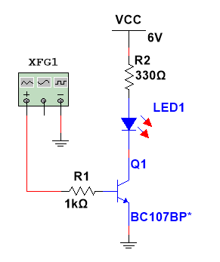

Figure B2.1 Circuit Design

LED: This is a standard 5 mm red LED. This type of LED has a voltage drop of 1.8 V and is rated at a maximum current of 20 mA.

R2: This 330 Ω resistor limits the current through the LED to prevent the LED from burning out. You can use Ohm’s law to calculate the amount of current that the resistor will allow to flow. Because the supply voltage is +6 V, and the LED drops 1.8 V, the voltage across R1 will be 4.2 V (6 – 1.8). Dividing the voltage by the resistance gives you the current in amperes, approximately 0.0127 A. Multiply by 1,000 to get the current in mA: 12.7 mA, well below the 20 mA limit.

Q1: This is a common NPN transistor. A BC107BP transistor was used here, but just about any NPN transistor will work. R1 and the LED are connected to the collector, and the emitter is connected to ground. When the transistor is turned on, current flows through the collector and emitter, thus lighting the LED. When the transistor is turned off, the transistor acts as an insulator, and the LED doesn’t light.

R1: This 1 kΩ resistor limits the current flowing into the base of the transistor. You can use Ohm’s law to calculate the current at the base. Because the base-emitter junction drops about 0.7 V (the same as a diode), the voltage across R1 is 5.3 V. Dividing 5.3 by 1,000 gives the current at 0.0053 A, or 5.3 mA. Thus, the 12.7 mA collector current (ICE) is controlled by a 5.3 mA base current (IBE).

XFG1: This switch controls whether current is allowed to flow to the base. Closing this switch turns on the transistor, which causes current to flow through the LED. Thus, closing this switch turns on the LED even though the switch isn’t placed directly within the LED circuit.

## B.2.2 Verify the designed circuit using a suitable simulator:

When the Input Voltage is OFF:

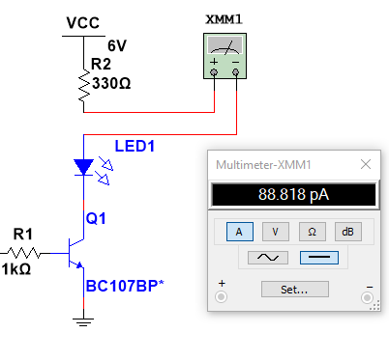

When the input Voltage is ON:

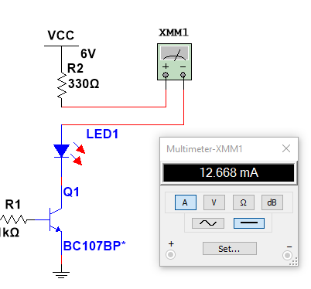

## B.2.3 Determine the current flowing through the resistors when:

1. LED is ON

When the LED is ON the switch or the input voltage is also ON, the base current $I_{B}$ can be found by using the Kirchoff voltage law on the Base Emitter Loop

$$6-I_{B}R_{B}-V_{BE}=0$$

Taking $V_{BE}=0.7V$

$$I_{B}=\frac{6-0.7}{1kΩ}=5.3 mA$$

Applying Kirchoff Voltage Law on the Collector Emitter Loop

$$I_{C}=\frac{6-1.8}{330Ω}=12.72 mA$$

Thus, the 12.7 mA collector current (ICE) is controlled by a 5.3 mA base current (IBE).

2. LED is OFF

When the LED is OFF the switch or the input voltage is also OFF, the base current $I_{B}$ is also zero, since there is no potential difference between the base and the emitter.

The Collector current is the current flowing through the LED,

$$β=\frac{I_{C}}{I_{B}}$$

Since $I_{B}=0,$

$$I_{C}=0$$

Hence there is negligible to no-current flowing through the LED, which is why the LED is OFF during this, when the input Voltage is set to zero or turned OFF like in this switch.

## B.2.4 Discuss the specifications of the components used for the design:

* Q1: Transistor
  + Polarity: NPN
  + Material of Transistor: Si
  + Maximum Collector Current: 0.1 A
  + Transition Frequency: 150 MHz
  + Collector Capacitance (Cc): 5 pF
  + Maximum Collector Power Dissipation (Pc): 0.3W
  + Maximum Collector-Base Voltage Vcb: 50 V
  + Maximum Collector-Emitter Voltage Vce: 45V
  + Maximum Emitter-Base Voltage Veb: 6V
  + Forward Current Transfer Ratio (hFE), MIN: 200
  + Max. Operating Junction Temperature (Tj): 175 C
* LED: It is a common LED with a Forward Voltage of 1.8 V
* R1 = $1kΩ$; R2 = $330Ω$, both these resistors are common carbon wound resistors with common tolerance values.

# **Question No. 4**

**Solution to Question No. 3 part B:**

## B.3.1 Circuit Design:

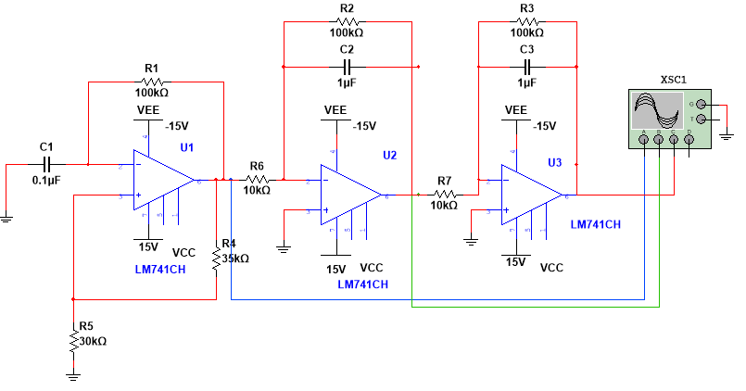

Figure B3.1 Circuit Design

## B.3.2 Calculate the Voltage and Frequency of the Waves:

1. Multivibrator Op-Amp – Square Wave Generator:

The first Op-Amp is a multivibrator circuit that outputs a square wave of a particular frequency.

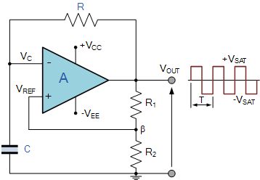

Frequency Calculation:

$$β=\frac{R_{2}}{R_{1}+R_{2}}$$

$$T=2RC\ln{\frac{1+β}{1-β}}$$

$$f=\frac{1}{T}$$

In the circuit $R_{1}=35kΩ, R_{2}=30kΩ$

$$β=\frac{30k}{30k+35k}=0.462$$

$$T=2×50kΩ×0.1μF×\ln{\frac{1+0.462}{1-0.462}}$$

$$T=10mS$$

$$f=\frac{1}{0.01}=100Hz$$

Voltage Calculation:

2. Integrator Op-Amp – Square Wave to Triangular Wave:

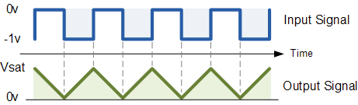

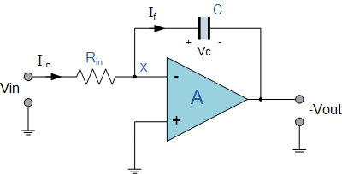

Voltage Calculation:

$$V_{out}=-\frac{1}{RC}\int_{0}^{\frac{T}{2}}{V_{in}dt}$$

$$V_{out}=\frac{1}{RC}×\frac{T}{2}×V_{in}$$

$$V_{out}=\frac{V_{in}}{2fRC}$$

$$V_{out}=\frac{13.86}{2×10×{10}^{3}×1×{10}^{-6}×100}$$

$$V_{out}=6.93V$$

Frequency Calculation:

The frequency of the Triangular Wave obtained will be same as of the input Square Wave, which is .

3. Integrator Op-Amp – Triangular Wave to Sine Wave



Voltage Calculation:

$$V_{out}=-\frac{1}{RC}\int_{0}^{\frac{T}{2}}{V_{in}dt}$$

$$V_{out}=\frac{1}{RC}×\frac{T}{2}×V_{in}$$

$$V_{out}=\frac{V_{in}}{2fRC}$$

$$V_{out}=\frac{6.93}{2×10×{10}^{3}×1×{10}^{-6}×100}$$

$$V_{out}=3.465V$$

Frequency Calculation:

The frequency of the Sine Wave obtained will be same as of the input Triangular Wave, which is $100 Hz$.

## B.3.3 Circuit Simulation:

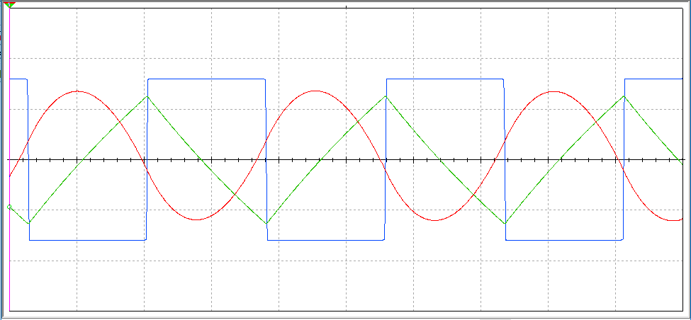

Figure B3.2 Circuit Simulation

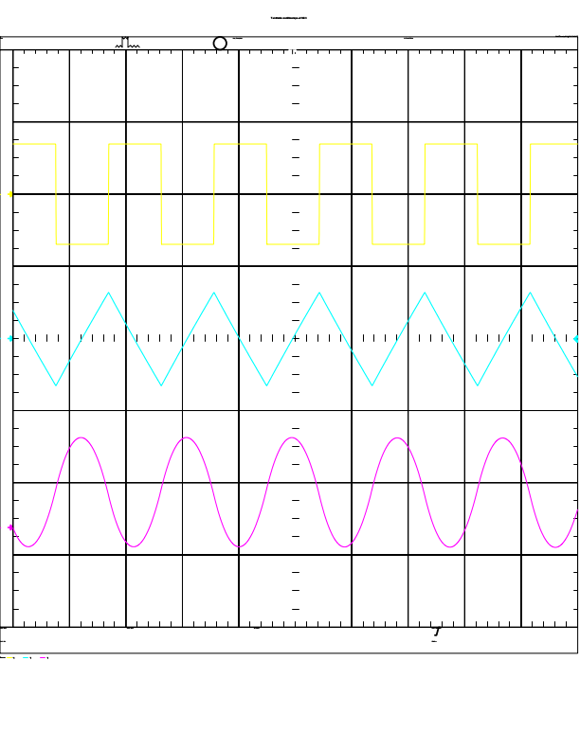

## B.3.4 Compare the Theoretical and Simulation Results:

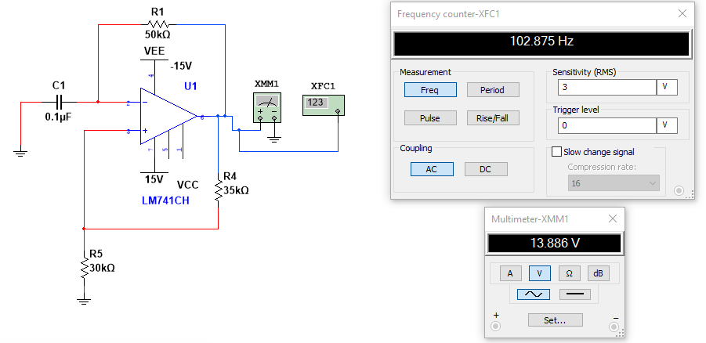

|  |  |  |  |
| --- | --- | --- | --- |
| Theoretical | | Simulated | |
| Voltage | Frequency | Voltage | Frequency |
| 13.860V | 100Hz | 13.886V | 102.875Hz |

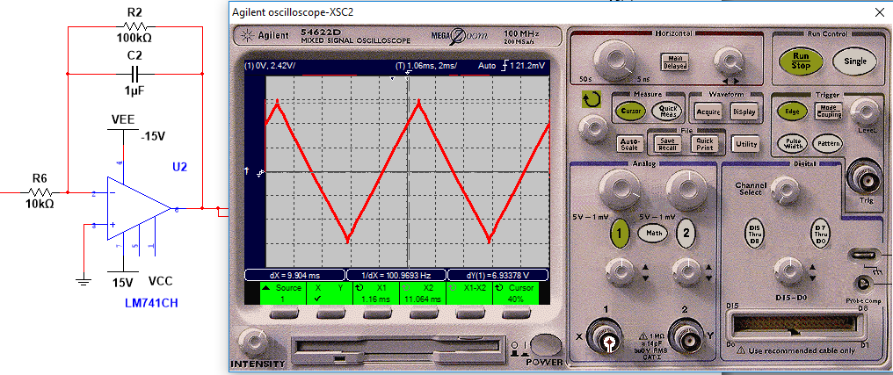

|  |  |  |  |
| --- | --- | --- | --- |
| Theoretical | | Simulated | |
| Voltage | Frequency | Voltage | Frequency |
| 6.930V | 100Hz | 6.933V | 100.9693Hz |

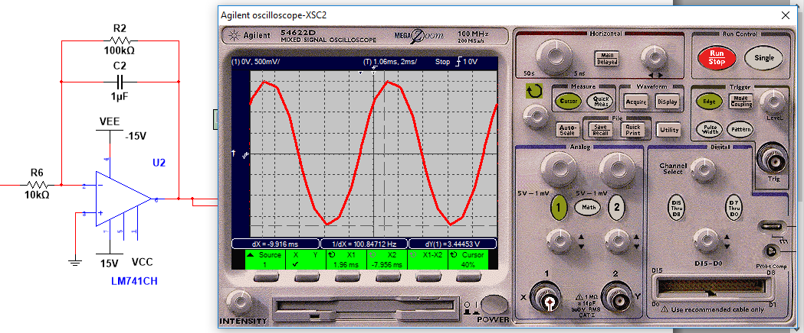

|  |  |  |  |
| --- | --- | --- | --- |
| Theoretical | | Simulated | |
| Voltage | Frequency | Voltage | Frequency |
| 3.465V | 100Hz | 3.444V | 100.847Hz |

# **Question No. 5**

**Solution to Question No. 4 part B:**

## B.4.1 Design a 5-stage operational amplifier circuit to obtain voltage gains of 2, 4, -7, 5 and -9:

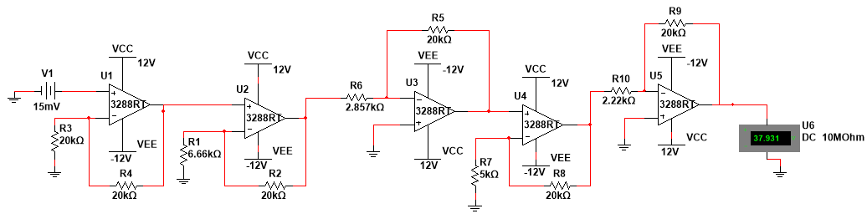

Figure B4.1 Multistage Amplifier

Assuming the value of $R_{f}=20kΩ$ for all calculations

Voltage Gain of 2:

This requires a non-inverting amplifier

$$A=\left(1+\frac{R_{f}}{R_{in}}\right)$$

$$2=1+\frac{20kΩ}{R_{in}}$$

$$R_{in}=20kΩ$$

Voltage Gain of 4:

This requires a non-inverting amplifier

$$A=\left(1+\frac{R_{f}}{R_{in}}\right)$$

$$4=1+\frac{20kΩ}{R_{in}}$$

$$R_{in}=6.66 kΩ$$

Voltage Gain of -7:

This requires an inverting amplifier

$$A= -\frac{R_{f}}{R_{in}}$$

$$-7=\frac{20kΩ}{R_{in}}$$

$$R_{in}=2.8571 kΩ$$

Voltage Gain of 5:

This requires a non-inverting amplifier

$$A=\left(1+\frac{R_{f}}{R_{in}}\right)$$

$$5=1+\frac{20kΩ}{R_{in}}$$

$$R_{in}=5kΩ$$

Voltage Gain of -9:

This requires an inverting amplifier

$$A=-\frac{R_{f}}{R_{in}}$$

$$-9=-\frac{20kΩ}{R_{in}}$$

$$R_{in}=2.2222kΩ$$

## B.4.2 Calculate the output voltage of the amplifier when input voltage of 15mV is applied to the circuit:

Given $V_{in}=15mV$

Op-Amp U1:

$$A=2$$

$$V_{o}=A×V_{in}$$

$$V_{o}=2×15mV$$

$$V_{o}=30mV$$

Op-Amp U2:

$$A=4$$

$$V_{o}=A×V_{in}$$

$$V_{o}=4×30mV$$

$$V_{o}=120mV$$

Op-Amp U3:

$$A=-7$$

$$V_{o}=A×V_{in}$$

$$V_{o}=-7×120mV$$

$$V_{o}=-840mV$$

Op-Amp U4:

$$A=5$$

$$V_{o}=A×V_{in}$$

$$V_{o}=5×840mV$$

$$V_{o}=-4.2V$$

Op-Amp U5:

$$A=-9$$

$$V_{o}=A×V_{in}$$

$$V_{o}=-9×-4.2V$$

$$V_{o}=37.8V$$

## B.4.3 Simulate the designed circuit and verify the output:

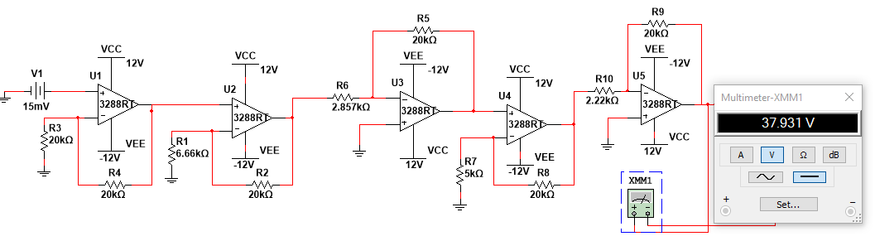

Figure B4.2 Simulation

The output obtained using Multisim simulation and the Op-Amp as 3288RT, was 37.931 V, the calculated theoretical value was 37.8, under the small margin of error, the output was verified.

**Bibliography**

________________________________________________________________________________