

|  |  |
| --- | --- |
| **ASSIGNMENT** | |
| **Course Code** | ESC103A |
| **Course Name** | Engineering Drawing |
| **Programme** | B.Tech |
| **Department** | CSE |
| **Faculty** | FET |

#### 

|  |  |
| --- | --- |
| **Name of the Student** | Satyajit Ghana |
| **Reg. No** | 17ETCS002159 |
| **Semester/Year** | 2ND/2017 |
| **Course Leader/s** | Mr.ARUN KARTHIK |
|  |  |

|  |  |  |  |  |  |  |  |  |
| --- | --- | --- | --- | --- | --- | --- | --- | --- |
| **Declaration Sheet** | | | | | | | | |
| Student Name | SATYAJIT GHANA | | | | | | | |
| Reg. No | 17ETCS002159 | | | | | | | |
| Programme | B.Tech | | | | | Semester/Year | 2ND/2017 | |
| Course Code | ESC103A | | | | | | | |
| Course Title | ENGINEERING DRAWING | | | | | | | |
| Course Date | -- | | to | | -- | | | |
| Course Leader | Mr.ARUN K | | | | | | | |
| **Declaration**  The assignment submitted herewith is a result of my own investigations and that I have conformed to the guidelines against plagiarism as laid out in the Student Handbook. All sections of the text and results, which have been obtained from other sources, are fully referenced. I understand that cheating and plagiarism constitute a breach of University regulations and will be dealt with accordingly. | | | | | | | | |
| Signature of the Student | |  | | | | | Date |  |
| Submission date stamp  (by Examination & Assessment Section) | |  | | | | | | |
| Signature of the Course Leader and date | | | | Signature of the Reviewer and date | | | | |
|  | | | |  | | | | |

# **Question No. 1**

**Solution to Question No. 1:**

## A.1: Development of 3D Book Concept

Description:

A 3D book is a concept where paper is cut out with one of the sides of the base attached to the sheet such that the cut central portion can be folded to form required objects that stand out of the plane sheet of paper when the sheet is opened.

Given to make a 3-D Book of a Prism of 5 sides with base length and axis height of .

Total Length in Development =

Since the object is closed from all sides the base face and the top face are added on each of the sides.

Scale is chosen to be i.e.

# **Question No. 2**

**Solution to Question No. 2:**

## B.1: Development of combination of objects:

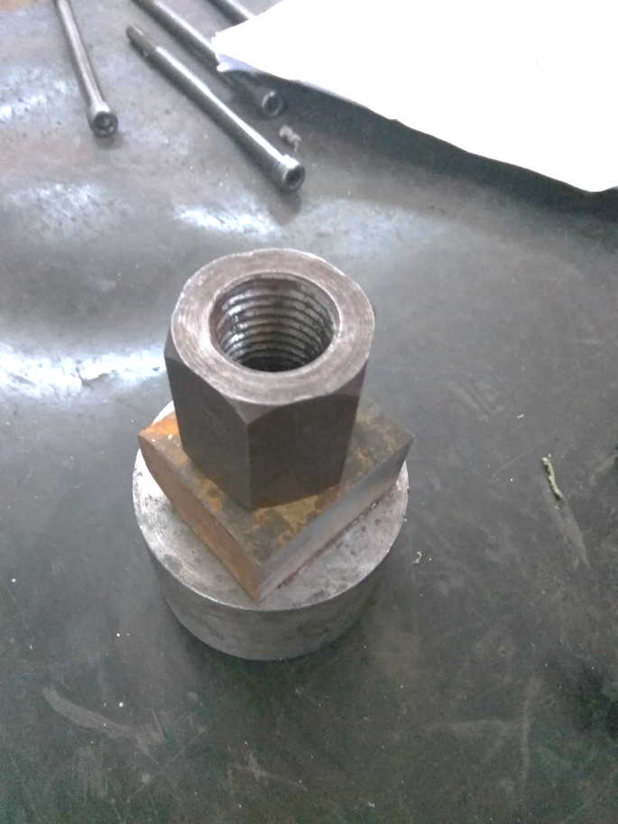Description:

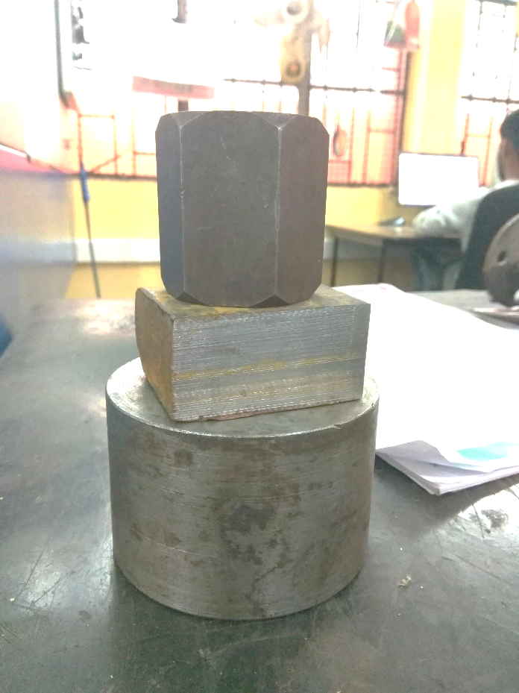

Figure 2 Front View

Figure 1 Top View

The combinatio of Objects chosen were, Cylinder, Square Prism and Hexagonal Prism of different dimensions. They were stacked upon each other and the Top and Front view of this stacked objects image was taken.

The Sequence of Stacking was , where the hexagonal prism was placed at the top.

Dimensions:

* Cylinder:
* Square Prism:
* Hexagonal Prism:

The Cylinder is resting on HP and axis of this cylinder is perpendicular to HP and parallel to VP, Square Prism is resting on top of the Cylinder and the base is at a distance 40mm from HP, the axis is perpendicular to HP, Hexagonal Prism is resting on top of the Square Prism and the base is at a distance 66mm from HP, the axis is perpendicular to HP.

The Total Lengths used in Development are as follows:

* Cylinder:
* Square Prism:
* Hexagonal Prism:

The Scale chosen for the development was , where , i.e. 1mm on the paper is 2mm in real world.