# Laboratory 6

Title of the Laboratory Exercise: String manipulation

1. Introduction and Purpose of Experiment

Students will be able to perform all string manipulations in assembly language

1. Aim and Objectives

Aim

To develop assembly language program to perform all string operations like inserting a byte, deleting a byte and copying a string as a sub-string

Objectives

At the end of this lab, the student will be able to

* + Identify instructions for performing string manipulation
  + Use indexed addressing mode
  + Apply looping instructions in assembly language
  + Use data segment to represent arrays

1. Experimental Procedure

1. Write algorithm to solve the given problem

2. Translate the algorithm to assembly language code

3. Run the assembly code in GNU assembler

4. Create a laboratory report documenting the work

1. Questions

Develop an assembly language program to perform the following

1. Copy the contents of MSG1 to MSG2
2. Copy the contents of MSG1 to MSG3 in reverse order
3. Copy the contents of MSG3 to MSG4 after ‘n’ th character in MSG4
4. Insert a byte in MSG1
5. Delete a byte in MSG1
6. Develop an assembly language program to compare two strings and print a message “Equal” if they are equal, “Not Equal” if they are not equal.
7. Calculations/Computations/Algorithms

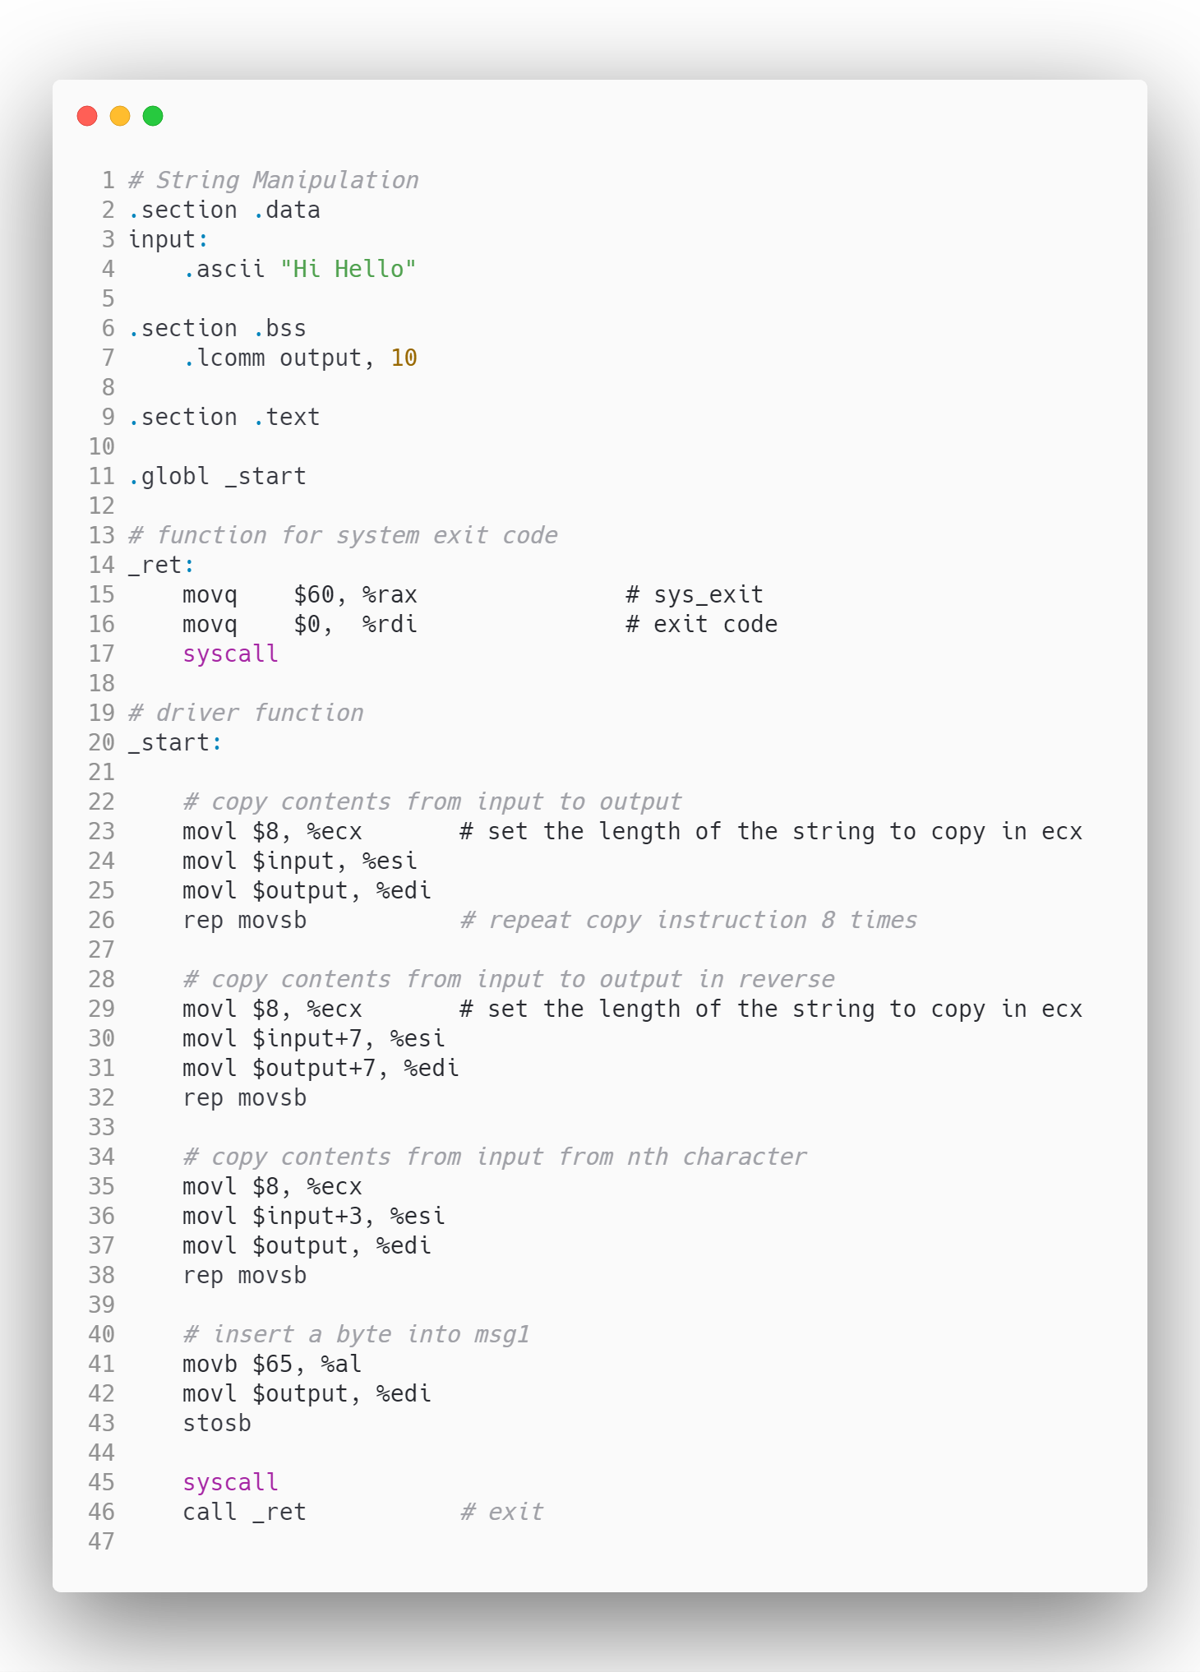

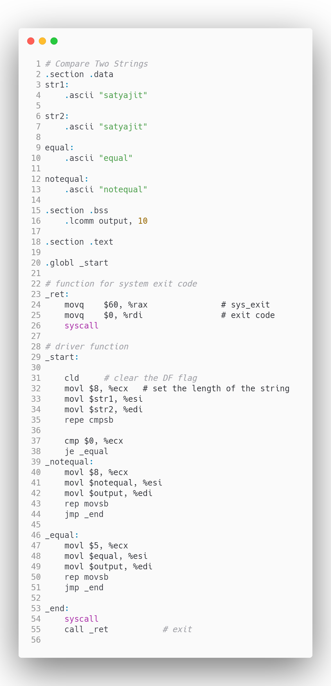

1. Presentation of Results

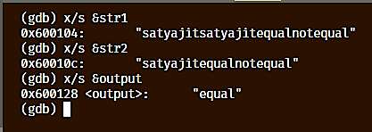

Figure 0‑1 String Comparison

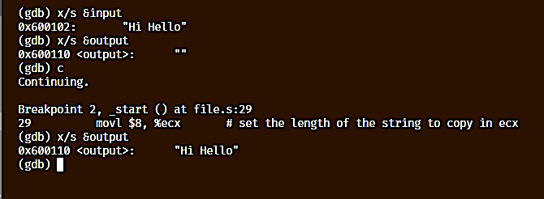

Figure 0‑2 String Copy from source to destination

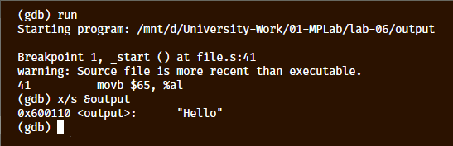

Figure 0‑3 String copy from position

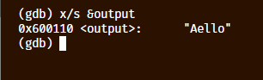

Figure 0‑4 Byte insertion into the string

1. Analysis and Discussions

|  |  |
| --- | --- |
| Code | movs |
| Example | movsb |
| Explanation | Performs:  Moves a byte from esi to edi  Description:  Moves the byte, word, or doubleword specified with the second operand (source operand) to the location specified with the first operand (destination operand). Both the source and destination operands are located in memory. The address of the source operand is read from the DS:ESI or the DS:SI registers (depending on the address-size attribute of the instruction, 32 or 16, respectively).  The address of the destination operand is read from the ES:EDI or the ES:DI registers (again depending on the address-size attribute of the instruction). The DS segment may be overridden with a segment override prefix, but the ES segment cannot be overridden. |

|  |  |
| --- | --- |
| Code | rep |
| Example | repe |
| Explanation | Performs:  Repeat string operation prefix  Description:  Repeats a string instruction the number of times specified in the count register ((E)CX) or until the indicated condition of the ZF flag is no longer met. The REP (repeat), REPE (repeat while equal), REPNE (repeat while not equal), REPZ (repeat while zero), and REPNZ (repeat while not zero) mnemonics are prefixes that can be added to one of the string instructions. The REP prefix can be added to the INS, OUTS, MOVS, LODS, and STOS instructions, and the REPE, REPNE, REPZ, and REPNZ prefixes can be added to the CMPS and SCAS instructions. (The REPZ and REPNZ prefixes are synonymous forms of the REPE and REPNE prefixes, respectively.) The behavior of the REP prefix is undefined when used with non-string instructions.  The REP prefixes apply only to one string instruction at a time. To repeat a block of instructions, use the LOOP instruction or another looping construct. |

1. Conclusions

Repeat Prefixes

|  |  |  |
| --- | --- | --- |
| **Repeat Prefix** | **Termination Condition 1** | **Termination Condition 2** |
| REP | ECX=0 | None |
| REPE/REPZ | ECX=0 | ZF=0 |
| REPNE/REPNZ | ECX=0 | ZF=1 |

Instruction such as movsb, movsl, are used to move bytes and words from source register to destination register, which are esi and edi respectively.

To repeat an instruction, rep instruction is used, this is used to make a loop like construct the copy strings, and also to compare strings.

1. Comments

1. Limitations of Experiments

The length of the string to be copied has to be known to know how many characters has to be copied.

2. Limitations of Results

The destination memory which is assigned in the uninitialized bss segment is fixed size, hence strings of larger sizes could overflow the memory.

3. Learning happened

The concept of strings and various string operations in assembly is learnt in this lab.

4. Recommendations

The source and destination registers should be carefully taken and the DF flag must be cleared using the cld instruction

Signature and date Marks