# Laboratory 9

Title of the Laboratory Exercise: Inline assembly language programs for code optimisation

1. Introduction and Purpose of Experiment

Students will create C programs with inline assembly code for code optimisation

1. Aim and Objectives

Aim

To develop inline assembly language program for code optimisation

Objectives

At the end of this lab, the student will be able to

* + Identify inline assembly language calls
  + Explain optimization of program by exploiting architectural features in target computer
  + Create C programs with inline assembly code

1. Experimental Procedure

1. Write algorithm to solve the given problem

2. Translate the algorithm to assembly language code

3. Run the assembly code in GNU assembler

4. Create a laboratory report documenting the work

1. Questions:

Develop a C program without inline assembly instructions and find out the code size and memory used for the program. Develop the C program with inline assembly instructions and find out the code size and memory used for the program. Compare the results.

1. Calculations/Computations/Algorithms

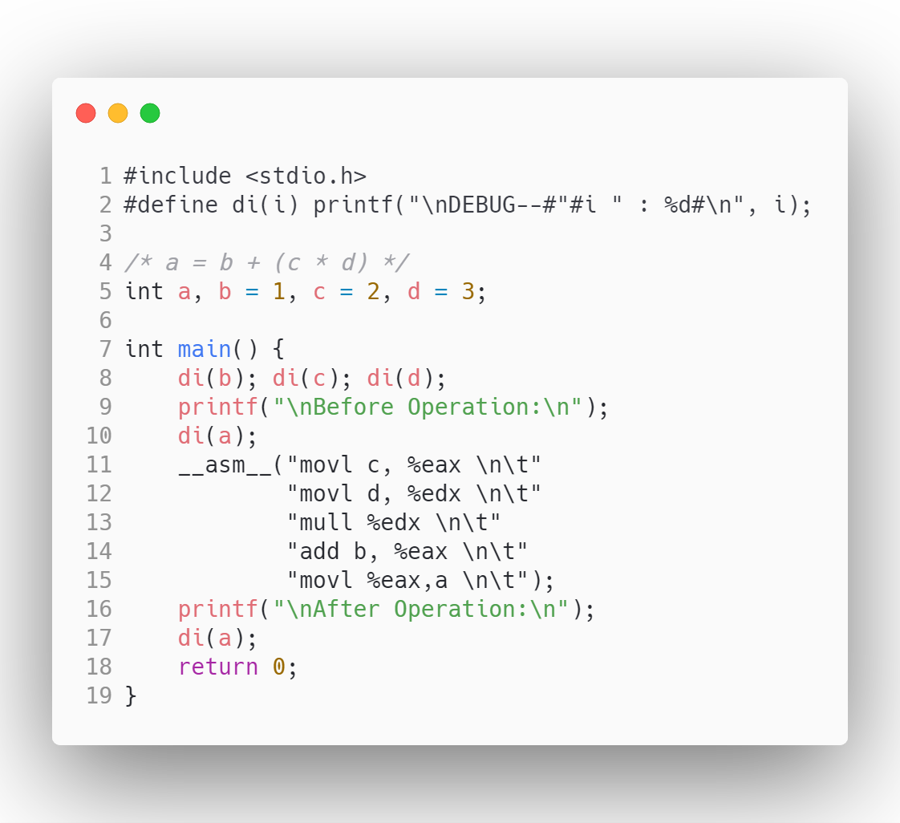

Figure 0‑1 Inline Assembly C Code

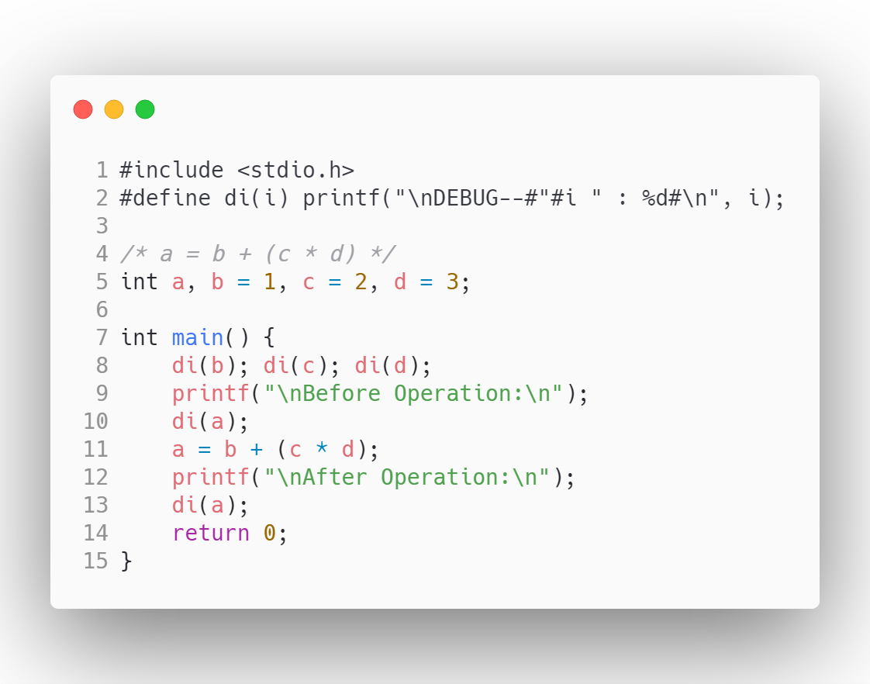

Figure 0‑2 Native C Code

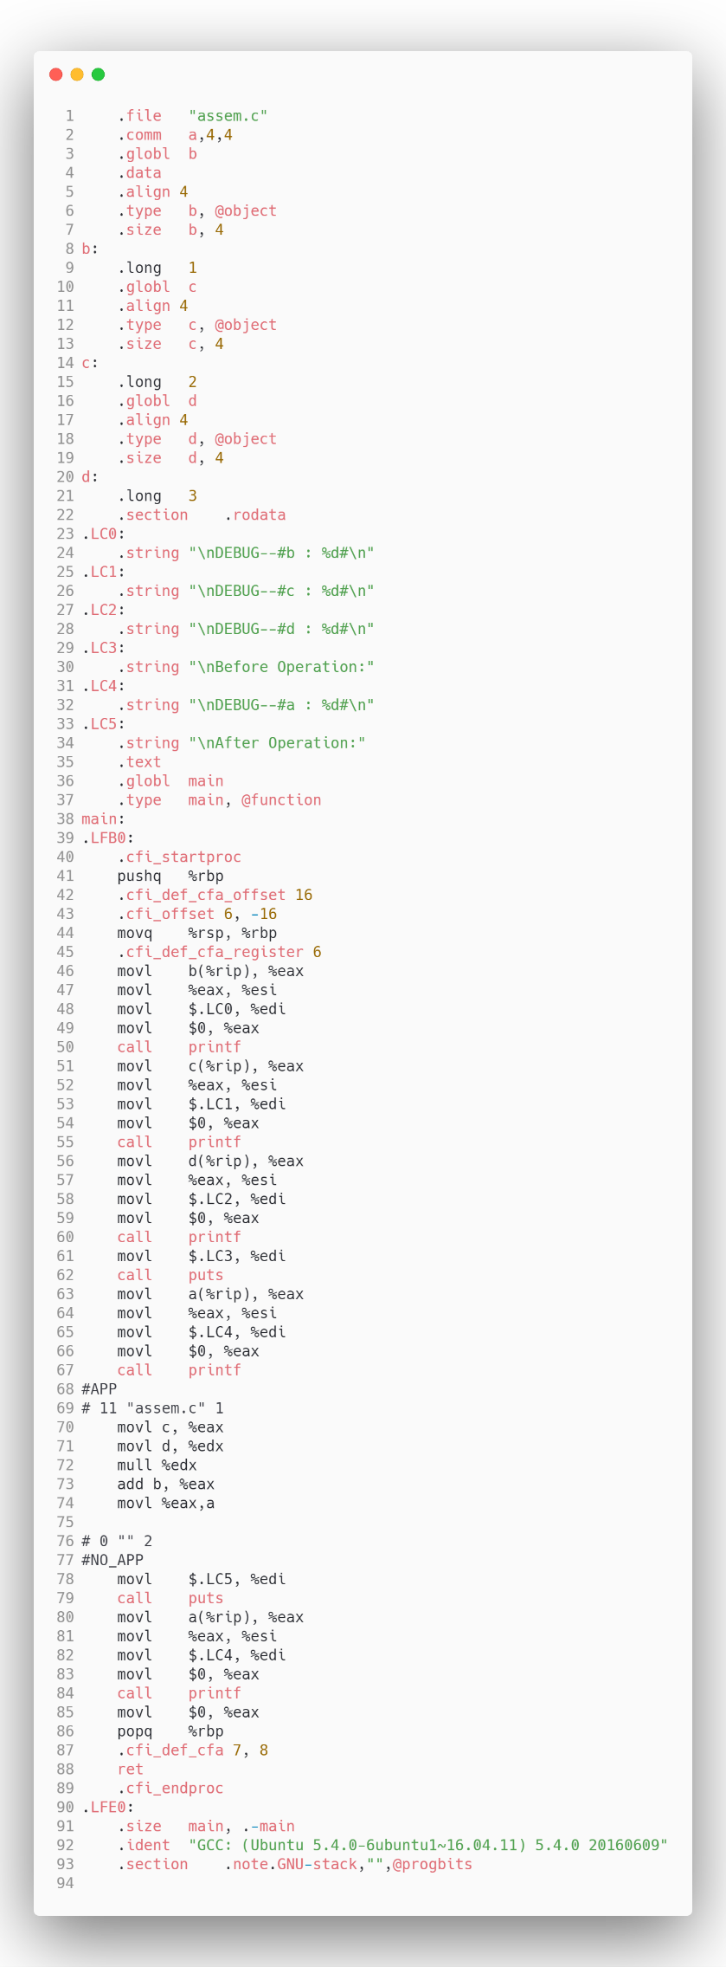 Figure 0‑3 Inline Assembly assembly code 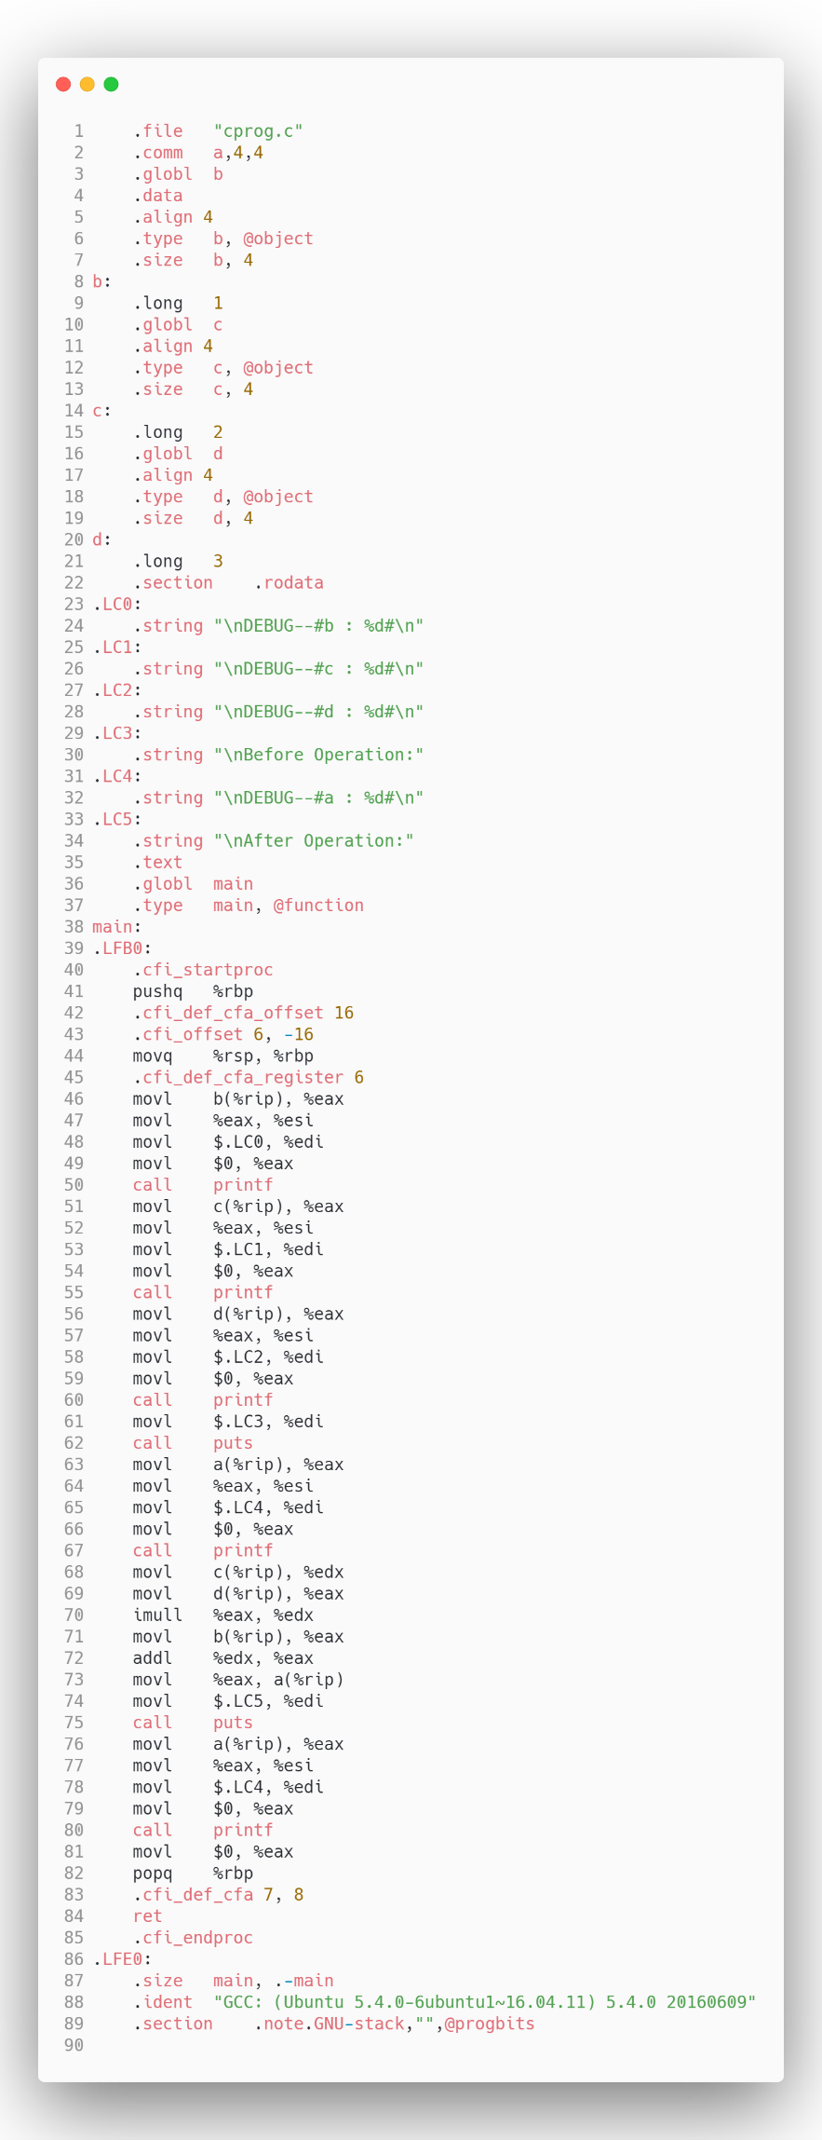 Figure 0‑4 Native C, assembly code

1. Presentation of Results

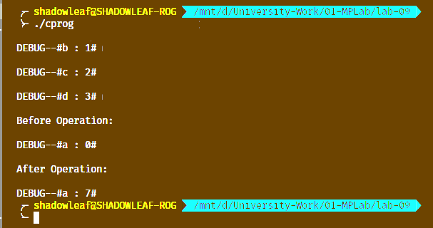

Figure 0‑5 Output of Native C Code

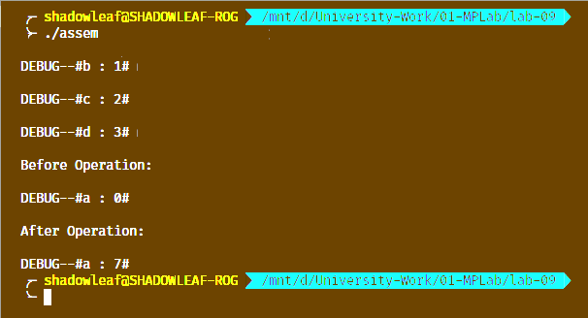

Figure 0‑6 Output of Inline Assembly

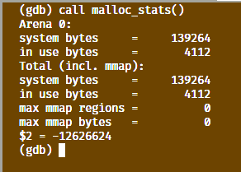

Figure 0‑7 Native C Code Memory Usage

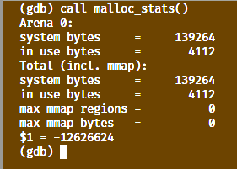

Figure 0‑8 Inline Assembly Memory Usage

1. Analysis and Discussions

The format of basic inline assembly is very much straight forward. Its basic form is

asm("assembly code");

Example.

asm("movl %ecx %eax"); /* moves the contents of ecx to eax */

__asm__("movb %bh (%eax)"); /*moves the byte from bh to the memory pointed by eax */

We can use __asm__ if the keyword asm conflicts with something in our program. If we have more than one instructions, we write one per line in double quotes, and also suffix a ‘\n’ and ‘\t’ to the instruction. This is because gcc sends each instruction as a string to as(GAS) and by using the newline/tab we send correctly formatted lines to the assembler.

If in our code we touch (ie, change the contents) some registers and return from asm without fixing those changes, something bad is going to happen. This is because GCC have no idea about the changes in the register contents and this leads us to trouble, especially when compiler makes some optimizations. It will suppose that some register contains the value of some variable that we might have changed without informing GCC, and it continues like nothing happened. What we can do is either use those instructions having no side effects or fix things when we quit or wait for something to crash. This is where we want some extended functionality. Extended asm provides us with that functionality.

1. Conclusions

Inline assembly can be used in C programs to write in low level language and have direct access to the CPU registers, this gives more control over the register’s memory.

If we compare the code size of the trans-piled assembly code from the c source code, we find that the inline assembly code takes a greater number of lines in assembly than the native c code trans-piled to assembly code.

The memory usage of both the programs are similar with little to no differences in memory usage.

1. Comments

1. Limitations of Experiments

The Experiment is limited to a very simple C program, hence concluding the results in difficult for the same.

2. Limitations of Results

Since the operations performed were very simple, there is little to no differences in the two codes, the inline assembly and native c code, although for complex codes, the results might differ.

3. Learning happened

We learnt how to disassemble a C code into its assembly code using gcc -S filename.c command.

4. Recommendations

To have a better comparison between the two types of codes, take a larger and complex c code and trans-pile it to its assembly code.

Signature and date Marks