# Laboratory 3 and 4

Title of the Laboratory Exercise Use Case and Sequence Diagrams

1. Introduction and Purpose of Experiment

Students will apply object oriented analysis and design for the given scenario for analysis of requirements and possible interactions

1. Aim and Objectives

Aim

* To study the given requirements and develop use case diagrams and Sequence diagrams

Objectives

At the end of this lab, the student will be able to

* + Explain the purpose of the sequence diagram
  + Identify the logical sequence of activities undergoing in a system, and represent them pictorially
  + Design and model a given use case using UML-sequence diagrams

1. Experimental Procedure

* Work in teams of 7 students
* Each team should read the problem statement and discuss the requirements as a group
* Each team will then create and confirm the design and document the design in an software architecture specifications document
* Each individual will then write their lab manual, documenting their observations

1. Calculations/Computations/Algorithms

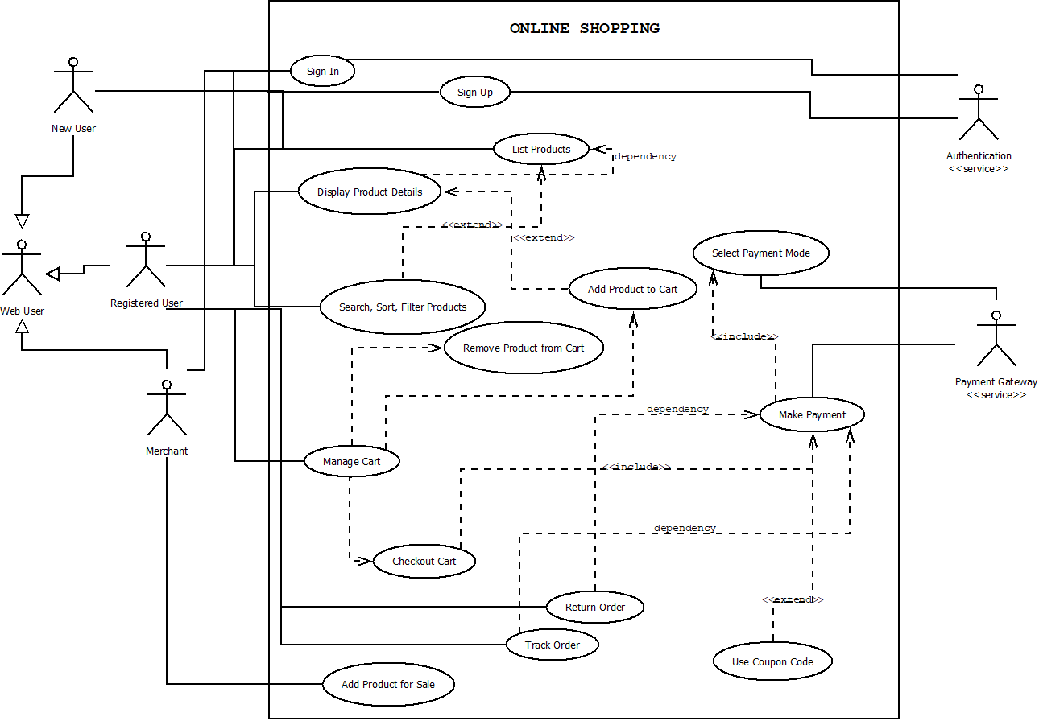

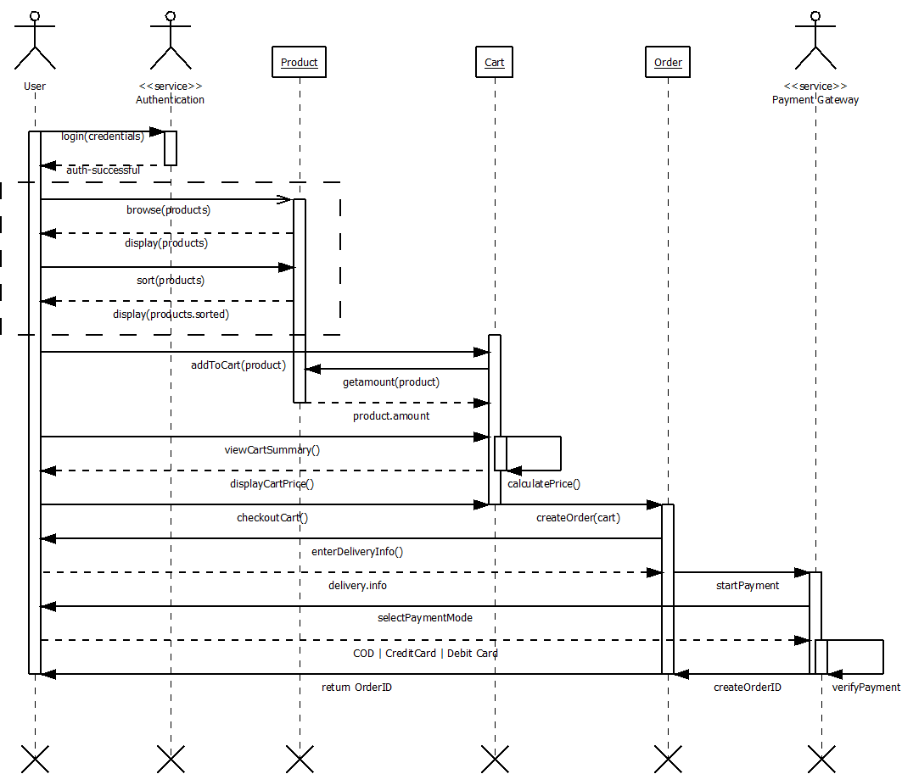

1. Analysis and Discussions

After elicitation and elaboration activities, the use case diagram is drawn. On further understanding and analysis of the system, the nature of interactions was understood and elucidated via the use case diagrams.

One of the most difficult and most basic requirements is understanding and agreeing upon what is to be built. Use case modelling is a way to describe what the system will do. Because use cases are written from an outside perspective, they're easier to understand by the stakeholders who define the problem to be solved. Requirement stated as in traditional SRS Documents can tend to be ambiguous, unclear or incomplete. Use case diagrams very effectively map the requirements of the software graphically. It focuses on the users of the system, and what they use. Use case modelling requires the identification of exceptional scenarios for the use cases. This helps in discovering subtle alternate requirements in the system. Once a use case model has been developed, it can be used for project planning (cost, complexity and timing estimates), object models, test case definitions, and user documentation.

A sequence diagram is a UML diagram that provides a graphical view of the chronology of the exchange of messages between objects and actors for a use case, the execution of an operation, or an interaction between classes, with an emphasis on their chronology. One or more sequence diagrams can be used to enact a use case or to identify all the possibilities of a complex behaviour.

A sequence diagrams shows actors, objects (instances of classes) and the messages sent between them. It conveys the same kind of information as a communication diagram, except that it concentrates on the chronology of messages passing between the objects in place of their structure. One or more sequence diagrams to enact a use case or to identify all the possibilities of a complex behaviour.

A sequence diagrams shows actors, objects (instances of classes) and the messages sent between them. It conveys the same kind of information as a communication diagram, except that it concentrates on the chronology of messages passing between the objects in place of their structure.

1. Conclusions

In this lab we performed the analysis part in Object Oriented Analysis and Design. The requirements of the system by the users is mapped by the use case diagram, and the messages passed for carrying out each use case, and the chronology, is captured in sequence diagrams.

1. Comments

1. Limitations of Experiments

Use case diagram cannot represent non-functional requirements like quality, reliability, user interface, security, etc.

2. Limitations of Results

If the elicitation and elaboration activities are not done correctly, the use case and sequence diagrams will be erroneous.

3. Learning happened

OOAD, UML, Use Case Diagram, Sequence Diagram

4. Recommendations

None

|  |  |  |
| --- | --- | --- |
| **Component** | **Max Marks** | **Marks Obtained** |
| **Viva** | **6** |  |
| **Results** | **7** |  |
| **Documentation** | **7** |  |
| **Total** | **20** |  |