# Laboratory 5

Title of the Laboratory Exercise: Class Diagrams

1. Introduction and Purpose of Experiment

Students will apply object oriented analysis and design for the given scenario for object decomposition

1. Aim and Objectives

Aim

* To construct a UML class diagram for a given system and identify the class members and determine their relationships

Objectives

At the end of this lab, the student will be able to

* + Identify the main members of the family
  + Identify how they are related to each other
  + Find the characteristics of each family member
  + Determine relations among family members
  + Decide the inheritance of personal traits and characters

1. Experimental Procedure

* Work in teams of 7 students
* Each team should read the problem statement and discuss the requirements as a group
* Each team will then create and confirm the design and document the design in an software design specifications document
* Each individual will then write their lab manual, documenting their observations

1. Calculations/Computations/Algorithms

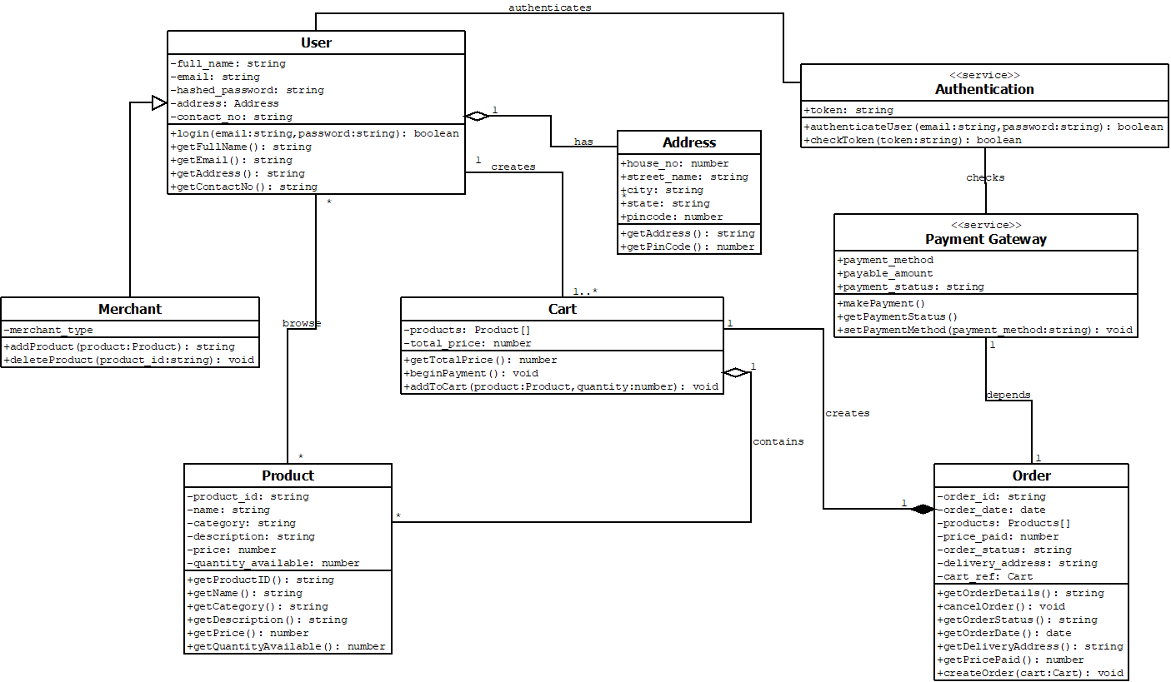

1. Analysis and Discussions

The class diagram is a static, structural diagram. Class diagram is not only used for visualizing, describing and documenting different aspects of a system but also for constructing executable code of the software application. The class diagram shows a collection of classes, interfaces, associations, collaborations and constraints.

Class diagrams are drawn by identifying the classes that constitute the project and the associations between them. The name of the class diagram should be meaningful to describe the aspect of the system. Each element and their relationships should be identified in advance. Responsibility (attributes and methods) of each class should be clearly identified. For each class, its attributes and methods should be specified.

Class diagrams are used for describing the static view of the system. It shows the collaboration among the elements of the static view. It also describes the functionalities performed by the system. Class diagrams are suited for construction of software applications using object oriented languages. Class diagrams are used for both general conceptual modelling of the systematics of the application, and for detailed modelling which can be translated into code. Class diagrams can also be used for data modelling. The classes in a class diagram represent both the main elements, interactions in the application, and the classes to be programmed.

1. Conclusions

In this lab, we created the class diagram for the Online Shopping Software, which is a structural, static diagram describing the main classes of the application and their relationships.

1. Comments

1. Limitations of Experiments

If the requirements of the system or the manner in which the system will be used is not clear or incorrect, the resulting class diagram will be erroneous and incomplete.

2. Limitations of Results

The class diagram is only structural. It cannot describe the uses of the system, or the sequence in which messages are passed. It also cannot describe non-functional requirements.

3. Learning happened

UML modelling of structural aspects through class diagrams.

4. Recommendations

None

|  |  |  |
| --- | --- | --- |
| **Component** | **Max Marks** | **Marks Obtained** |
| **Viva** | **6** |  |
| **Results** | **7** |  |
| **Documentation** | **7** |  |
| **Total** | **20** |  |