# Laboratory 6

Title of the Laboratory Exercise: State chart diagrams

1. Introduction and Purpose of Experiment

Students will apply object-oriented analysis and design for the given scenario for low level design of classes

1. Aim and Objectives

Aim

* To develop low level software design for a given class diagram using state chart diagrams

Objectives

At the end of this lab, the student will be able to

* + Identify states of each object
  + Identify triggers and messages for each object
  + Understand the behavior of a class, given its state chart diagram

1. Experimental Procedure

* Work in teams of 7 students
* Each team should read the class diagram and identify objects, interactions and states of objects
* Each team will then design state transitions and simulate the same. They will then document the design in an low level design specification document
* Each individual will then write their lab manual, documenting their observations

1. Calculations/Computations/Algorithms

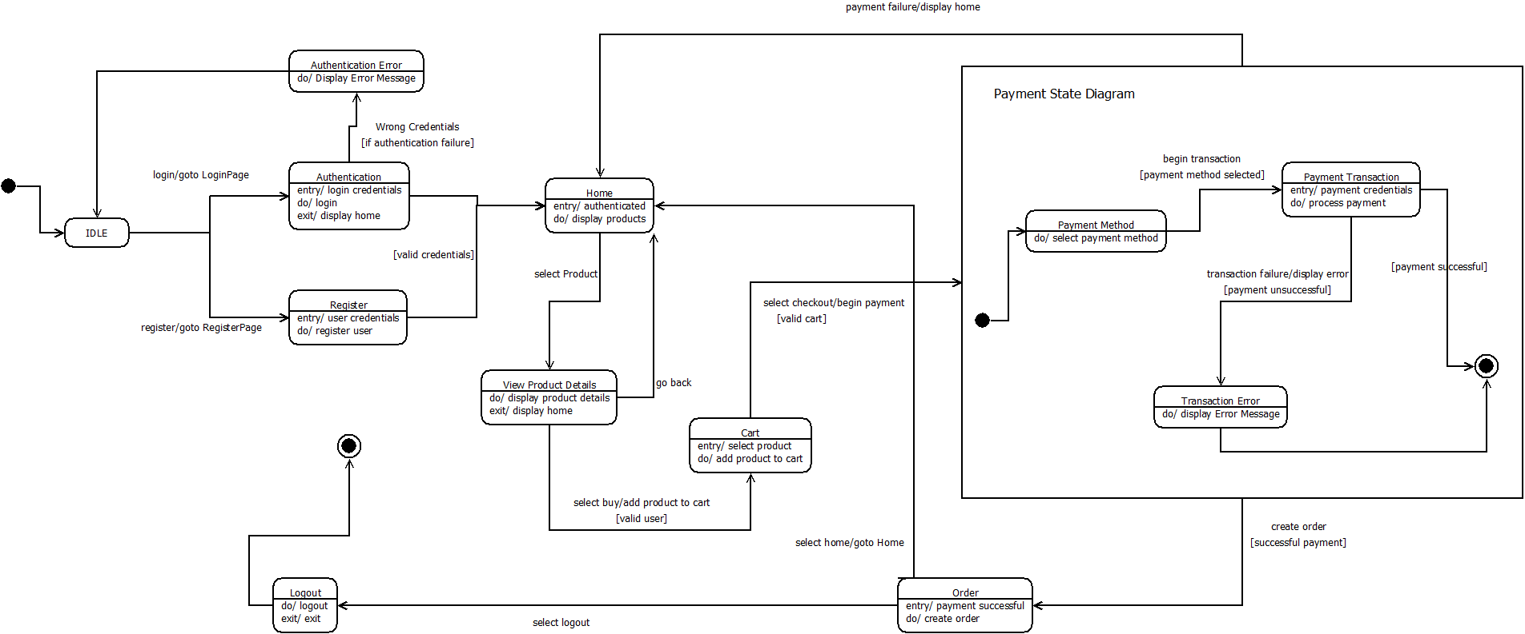

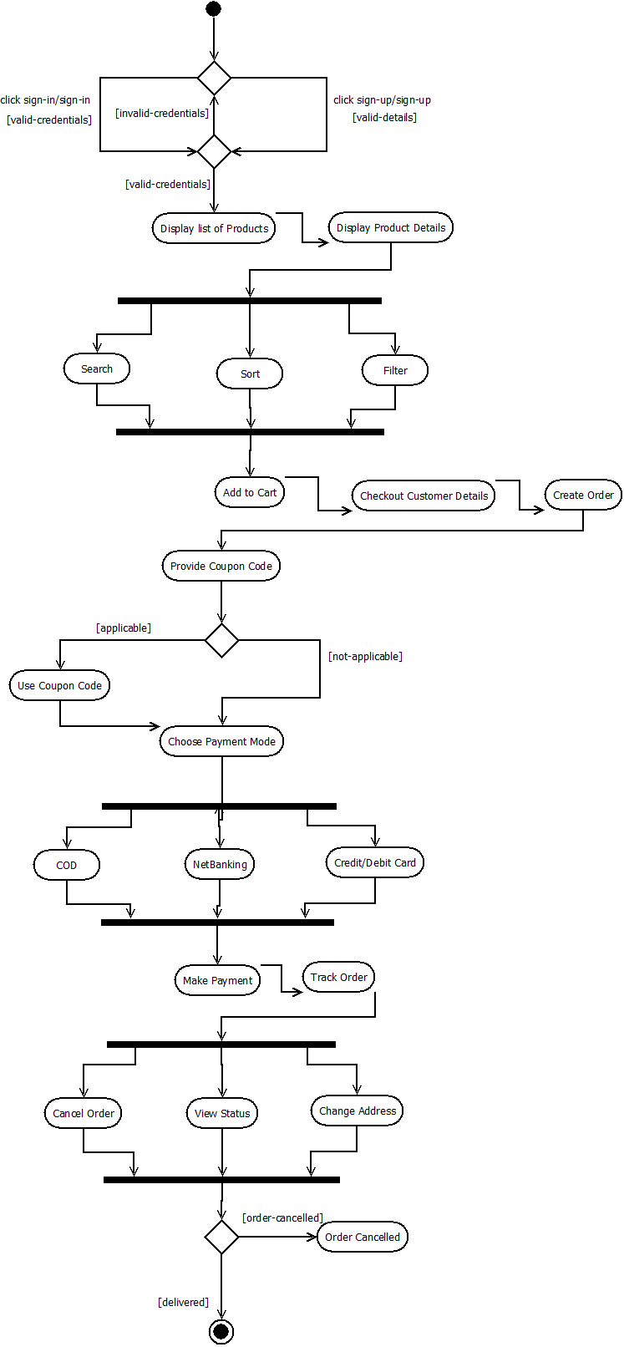

1. Analysis and Discussions

State chart diagrams address the dynamic view of a system. It shows a state machine, consisting of states, transitions, events and activities. They are used to model behaviour of a single instance of a class in object-oriented approaches.

State machine diagrams

– A state is rendered as a rectangle with rounded corners

– A transition is rendered as a solid directed line

– The final state implies deletion of the object

In this lab we draw the state machine diagram of the controller class. As a team, we discussed the lifeline activities of the controller class, the states that it is in, the transitions it makes and how it ends. Initially it asks for login credentials, and on successful login, it displays the menu. So the states identified in this understanding are “ask login credentials” and “display products”. There is a transition from the former to the latter on successful login. Identify all possible states and transitions and draw the state chart diagram accordingly.

The state machine diagram is a dynamic model describes the internal behaviour of a system by describing the states of an individual object and the possible transitions between states.

They can help identify important object attributes and refine the behaviour description of objects. State chart diagrams should focus on important attributes that affect the object’s behaviour.

State chart diagrams are also useful in modelling reactive systems.

1. Conclusions

The behaviour of the controller object is described through its states and transitions on events through a state machine diagram.

1. Comments

1. Limitations of Experiments

The behaviour of the controller class must be known to some degree. The transitions must take place on proper events and guards.

2. Limitations of Results

The behaviour of the controller class is not accurately captured. State diagrams can actually comprise of shapes from a collection of 35 shapes, all of which were not reviewed.

3. Learning happened

UML State Chart Diagram purpose, description and how to draw

4. Recommendations

None

|  |  |  |
| --- | --- | --- |
| **Component** | **Max Marks** | **Marks Obtained** |
| **Viva** | **6** |  |
| **Results** | **7** |  |
| **Documentation** | **7** |  |
| **Total** | **20** |  |