# Laboratory 8

Title of the Laboratory Exercise: Data flow modelling with CASE tools – Low Level Design

1. Introduction and Purpose of Experiment

Students will apply data flow modelling to develop the low level design for given scenario

1. Aim and Objectives

Aim

* To develop low level software design for a given requirements specification using Structured analysis and Design Technique

Objectives

At the end of this lab, the student will be able to

* + Identify functions in modules
  + Identify Inputs, Outputs and Data dependencies for functions
  + Create low level design document for a given SRS

1. Experimental Procedure

* Work in teams of 7 students
* Each team should read the problem statement and identify requirements as a group
* Each team will then confirm the requirements and document the requirements in an low level design document
* Each individual will then write their lab manual, documenting their observations

1. Calculations/Computations/Algorithms

Data Flow Diagram: This diagram provides an indication of how data objects are transformed by processes of the application. It thereby shows the different processing activities of the system, and the data interchange among these functions. It gives the ‘input-process-output’ view of the system. The users and external entities are represented by rectangles, processes by circles, data flows by labelled arrows, and data store by two parallel lines.

Level 0 or Context Diagram: It is the first data flow model representing the entire system as a whole. This diagram establishes the context of the system, depicting the users, input data given and received. Represent the entire software as single circle. Represent all data exchange from external entities and databases/data stores.

Data Flow Diagrams are refined until a bubble deals with just a single process. The information flow continuity is to be maintained from one level to another. Label the different bubbles accordingly. Bubbles in level 1 are labelled 1,2,3 and so on. In level 2, they are exploded as 1.1,1.2, 1.3…, 2.1, 2.2…, 3.1,3.2,3.3…. and so on.

1. Presentation of Results

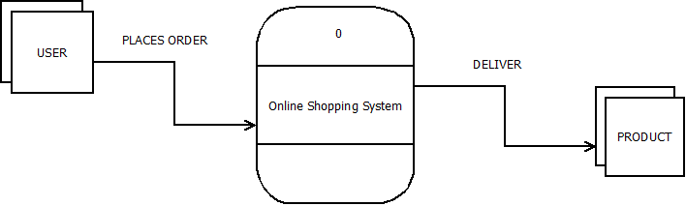

Figure 0‑1 Level 0 DFD

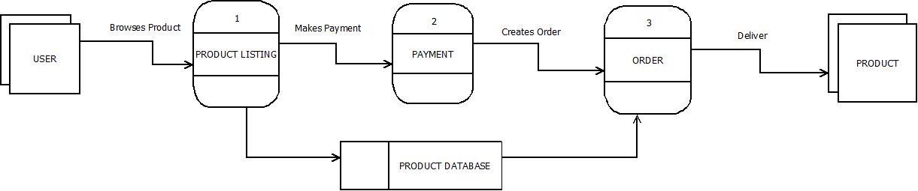

Figure 0‑2 Level 1 DFD

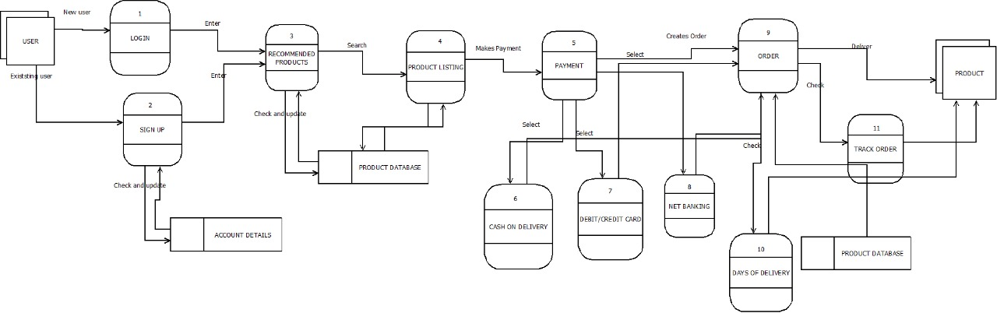 *Figure 0‑3 Level 2 DFD*

1. Analysis and Discussions

The Data Flow diagrams is a part of Structured Analysis and Design Technique. The benefit of doing Level 0 Context Diagram is that it defines the boundary between the system and the entities it interacts with, giving a high-level view of a system. It puts a special emphasis on the analysis of user needs. It isn’t difficult to draw, but requires careful attention to detail. The end result is a high-quality design, reducing the chances of error. Another benefit of DFD is that it visually portrays what would otherwise be difficult to explain in words. It works for both technical and non-technical audience. A drawback is that it takes time to create and perfect.

1. Conclusions

In this lab, we completed level 0, 1 and 2 data flow diagrams. Data flow diagrams give a clear picture of the software boundaries and the data flows between the external entities and the processes.

1. Comments

1. Limitations of Experiments

There must be continuity in data flows when refining processes of any level to the next level, taking care that new data flows are not created or if existing data flows are overlooked.

2. Limitations of Results

The diagrams are all modelled based on the functional requirements specified. If they are incorrect or incomplete, the diagrams can be flawed.

3. Learning happened

I learnt the need, benefit, methods and procedure for carrying out software design.

4. Recommendations

The analysis and design takes time to be done carefully.

|  |  |  |
| --- | --- | --- |
| **Component** | **Max Marks** | **Marks Obtained** |
| **Viva** | **6** |  |
| **Results** | **7** |  |
| **Documentation** | **7** |  |
| **Total** | **20** |  |