**B1.1 Introduction to the online reservation software**

The definition of [online booking software](https://online-booking.financesonline.com/) eliminates the need to facilitate online bookings. in [online booking system](https://www.bookinglive.com/) is software which allows a potential customer to book and pay for an activity or service directly through your website. That means from the moment a customer decides they want to book to choosing a date, picking a time and paying for the booking, everything is handled online, greatly reducing the workload on your staff and removing the opportunity for double-bookings.

Advanced systems like ours allow customers to book through a variety of methods online, including mobile, greatly expanding the potential for bookings for your business, and better leveraging an increasingly social internet.

**B1.2 Functional requirements specifications**

**FR1***:*The software should be able to allow the user to sign up if he/she is a new user else allow the user to log in with his/her email id or phone number along with a password.

Stakeholders owning the requirements: Administrator, New user

Dependent on requirements: --

**FR2:** The software should be to able verify password allow the user to reset the password if he/she forgets it, by sending an OTP to the registered phone number.

Stakeholders owning the requirements: Registered user

Dependent on Requirements: FR1

**FR3:** The software should allow the user to enter desired pickup and destination stops with date.

Stakeholders owning the requirements: Registered user

Dependent on Requirements: FR1

**FR4:** The software should be able to display the list of buses available at the desired route on the specified date with all the specifications of the buses like what amenities which bus provides.

Stakeholders owning the requirements: Admin, Registered user

Dependent on Requirements:FR1, FR2

**FR5**: The software should be able to allow the user to select a bus and book a seat in it.

Stakeholders owning the requirements: Registered user

Dependent on Requirements: FR3

**FR6:** The software should be able to allow the user to make payment.

Stakeholders owning the requirements: Registered user

Dependent on Requirements:FR1, FR5

**FR7:** The software should be able to allow the customer to apply promo codes.

Stakeholders owning the requirements: Registered user

Dependent on Requirements: FR1, FR6

**FR8:** The software should be able to display the confirmed tickets, containing the date, timing and seats details if the payment is successful.

Stakeholders owning the requirements: Admin, Registered user

Dependent on Requirements: FR1, FR6

**FR9:** The software should be able to allow the admin to update changes (if there are any) in bus schedules. And inform the customers by sending a message on their registered mobile number.

Stakeholders owning the requirements: Admin

Dependent on Requirements: --

**FR10:** The software should be able to allow the user to cancel the tickets following which a refund should be initiated.

Stakeholders owning the requirements: Registered user

Dependent on Requirements: FR1, FR6, FR8

**B1.3 Non- Functional requirements specifications**

**NFR1**: The software should be user friendly.

**NFR2:** The software should have a modern, precise and accurate.

**NFR3:** The software should have a safe and secure payment environment.

**NFR4:** The software should be efficient in terms of performance and response time.

**NFR5**: The software should be free from bugs and technical errors.

**B1.4 Conclusion**

The process to gather the software requirements from client, analyze and document them is known as requirement engineering. The goal of requirement engineering is to develop and maintain sophisticated and descriptive 'System Requirements Specification' document.

# 

# (10 Marks)

Develop the context level design for the online reservation software using Object-Oriented approach with User characterization and Use-case diagrams.

Your report should include the following:

**B2.1 Introduction to the behavioural design documentation**

**B2.2 User characterization**

FR1: The software should be able to allow the user to sign up if he/she is a new user else allow the user to log in with his/her email id or phone number along with a password.

|  |  |
| --- | --- |
| Use Case | Register |
| Actors | New user |
| Description | The user should be able to make a new account if he’s not having one already |

FR2: The software should be to able verify password allow the user to reset the password if he/she forgets it, by sending an OTP to the registered phone number.

|  |  |
| --- | --- |
| Use Case | Reset password |
| Actors | Registered user, New user |
| Description | If the password entered by the user is incorrect, display an alert to reset the password if he has forgotten it. |

FR3: The software should allow the user to enter desired pickup and destination stops with date.

|  |  |
| --- | --- |
| Use Case | Enter pickup and destination |
| Actors | Registered user |
| Description | A passenger must able to enter pickup and drop locations. |

FR4: The software should be able to display the list of buses available at the desired route on the specified date with all the specifications of the buses.

|  |  |
| --- | --- |
| Use Case | Display list of buses |
| Actors | Registered user |
| Description | The software should be able to display the list of buses available at the desired route on the specified date with all the specifications of the buses like what amenities which bus provides. |

FR5: The software should be able to allow the user to select a bus and book a seat in it.

|  |  |
| --- | --- |
| Use Case | Book seat |
| Actors | Registered user |
| Description | The user must be able to choose his desired number of seats. |

FR6: The software should be able to allow the user to make payment.

|  |  |
| --- | --- |
| Use Case | Make payment |
| Actors | Registered user |
| Description | The user must be able to pay for their tickets. |

FR7: The software should be able to allow the customer to apply promo codes.

|  |  |
| --- | --- |
| Use Case | Apply promo codes |
| Actors | Registered user |
| Description | The user must be able to apply promocodes to reduce the amount of ticket bill. |

FR8: The software should be able to display the confirmed tickets, containing the date, timing and seats details if the payment is successful.

|  |  |
| --- | --- |
| Use Case | Display confirmed tickets |
| Actors | Registered user, Admin |
| Description | The user should have a softcopy of his ticket. |

FR9: The software should be able to allow the admin to update changes (if there are any) in bus schedules.

|  |  |
| --- | --- |
| Use Case | Update changes |
| Actors | Admin |
| Description | The software should be able to allow the admin to update changes (if there are any) in bus schedules and inform the customers by sending a message on their registered mobile number. |

FR10: The software should be able to allow the user to cancel the tickets following which a refund should be initiated.

|  |  |
| --- | --- |
| Use Case | Cancellation and refund |
| Actors | Registered user, Admin |
| Description | The user should be able to cancel the ticket and save his money from getting wasted if there is some sudden change in his plan and he won’t be able to board the bus at that particular time. |

**B2.3 Use-case diagram with Use-case specification**

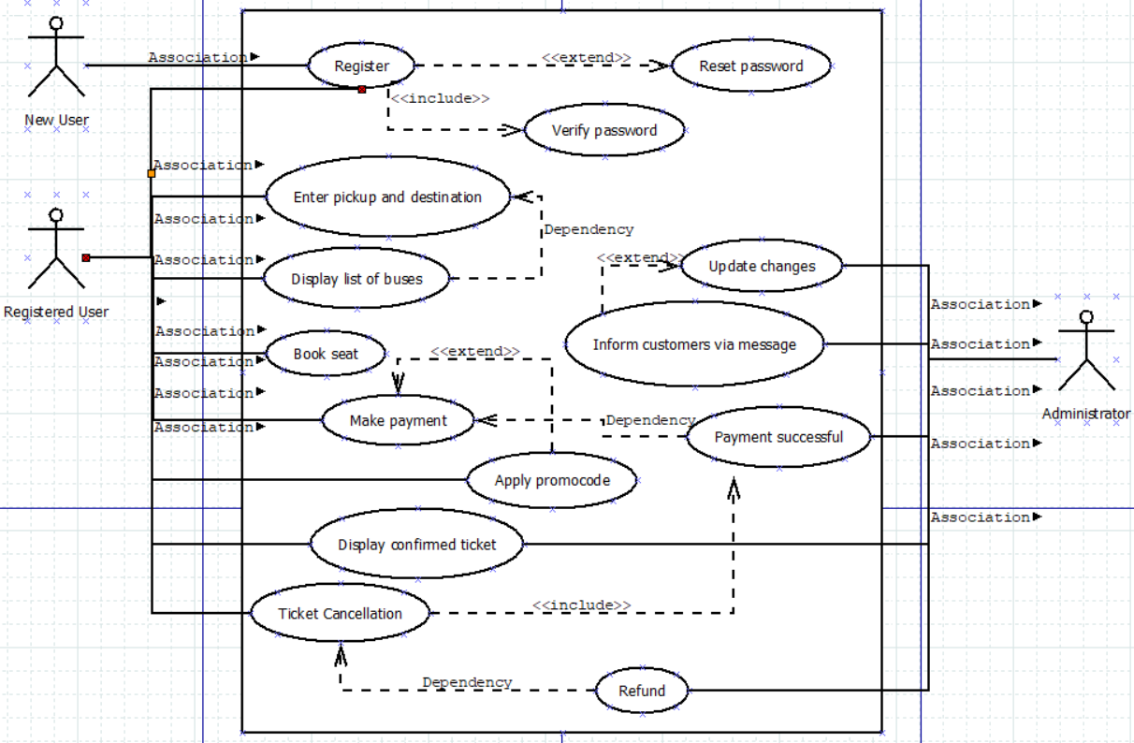

**B2.4 Conclusion**