

|  |  |
| --- | --- |
| **ASSIGNMENT** | |
| **Course Code** | CSC212A |
| **Course Name** | Data Communication |
| **Programme** | B. Tech. |
| **Department** | Computer Science and Engineering |
| **Faculty** | FET |

|  |  |
| --- | --- |
| **Name of the Student** | Prachi Poddar |
| **Reg. No** | 17ETCS002122 |
| **Semester/Year** | 4th /2nd |
| **Course Leader/s** | Prof. A. Prabhakara |

|  |  |  |  |  |  |  |  |  |
| --- | --- | --- | --- | --- | --- | --- | --- | --- |
| **Declaration Sheet** | | | | | | | | |
| Student Name | Prachi Poddar | | | | | | | |
| Reg. No | 17ETCS002122 | | | | | | | |
| Programme | B. Tech | | | | | Semester/Year | 4th /2nd | |
| Course Code | CSC212A | | | | | | | |
| Course Title | Data Communication | | | | | | | |
| Course Date |  | | to | |  | | | |
| Course Leader | Prof. A. Prabhakara | | | | | | | |
| **Declaration**  The assignment submitted herewith is a result of my own investigations and that I have conformed to the guidelines against plagiarism as laid out in the Student Handbook. All sections of the text and results, which have been obtained from other sources, are fully referenced. I understand that cheating and plagiarism constitute a breach of University regulations and will be dealt with accordingly. | | | | | | | | |
| Signature of the Student | |  | | | | | Date |  |
| Submission date stamp  (by Examination & Assessment Section) | |  | | | | | | |
| Signature of the Course Leader and date | | | | Signature of the Reviewer and date | | | | |
|  | | | |  | | | | |

|  |  |  |  |  |  |  |  |  |  |  |  |
| --- | --- | --- | --- | --- | --- | --- | --- | --- | --- | --- | --- |
| **Faculty of Engineering & Technology** | | | | | | | | | | |  |
| **Ramaiah University of Applied Sciences** | | | | | | | | | | |  |
| **Department** | | | | Computer Science and Engineering | | **Programme** | B. Tech. | | | |  |
| **Semester/Batch** | | | | 4th/2017 | | | | | | |  |
| **Course Code** | | | | CSC212A | | **Course Title** | Data Communication | | | |  |
| **Course Leader** | | | | Dr. Rinki Sharma, Prof. A. Prabhakara | | | | | | |  |
| **Assignment no 2** | | | | | | | | | | |  |
| Name of Student | | | **Prachi Poddar** | | Register No | | | **17ETCS002122** | | |  |
| Sections |  | Marking Scheme | | | | | | | Max Marks | First  Examiner  Marks | Second Examiner  M  arks |
| **Part**  **-**  **A** | A1.1 | Introduction to high rate modulation | | | | | | | 01 |  |  |
| A1.2 | Benefits and limitations of high order modulation techniques | | | | | | | 02 |  |  |
| A1.3 | Stance taken with justification | | | | | | | 02 |  |  |
|  | **Part-A Max Marks** | | | | | | | **05** |  |  |
| **Part B 1** | B1.1 | Algorithm/Flowchart for computation of Hamming distance with explanation | | | | | | | 03 |  |  |
| B1.2 | Implementation to compute Hamming distance between two binary strings of equal length, with explanation | | | | | | | 04 |  |  |
| B1.3 | Testing of implementation with explanation | | | | | | | 03 |  |  |
|  | **B.1 Max Marks** | | | | | | | 10 |  |  |
| **Part B 2** | B2.1 | Algorithm / flowchart for computation of Hamming (7, 4) code, with explanation | | | | | | | 03 |  |  |
| B2.2 | Implementation to compute Hamming (7, 4) code, with explanation | | | | | | | 04 |  |  |
| B2.3 | Testing of implementation with explanation | | | | | | | 03 |  |  |
|  | **B.2 Max Marks** | | | | | | | **10** |  |  |
|  | **Total Assignment Marks** | | | | | | | | **25** |  |  |

**Course Marks Tabulation**

|  |  |  |  |  |
| --- | --- | --- | --- | --- |
| **Component- CET B**  **Assignment** | **First**  **Examiner** | **Remarks** | **Second Examiner** | **Remarks** |
| A |  |  |  |  |
| B.1 |  |  |  |  |
| B.2 |  |  |  |  |
| **Marks (Max 50 )** |  |  |  |  |
| **Marks (out of 25 )** |  |  |  |  |
| Signature of First Examiner Signature of Second Examiner | | | | |

**Please note:**

1. Documental evidence for all the components/parts of the assessment such as the reports, photographs, laboratory exam / tool tests are required to be attached to the assignment report in a proper order.
2. The First Examiner is required to mark the comments in RED ink and the Second Examiner’s comments should be in GREEN ink.
3. The marks for all the questions of the assignment have to be written only in the **Component – CET B: Assignment** table.
4. If the variation between the marks awarded by the first examiner and the second examiner lies within +/- 3 marks, then the marks allotted by the first examiner is considered to be final. If the variation is more than +/- 3 marks then both the examiners should resolve the issue in consultation with the Chairman BoE.

**PART A 5 Marks**

**Preamble**

While High order modulation techniques achieve high data rates in digital communication systems, they also have certain drawbacks that affect the quality of signals at the receiver.

In this context, debate on the statement **“High order modulation techniques are the best option to achieve reliable and efficient digital communication systems”**

The documentation should comprise the following:

**A1.1**  **Introduction to high rate modulation:**

Modulation is a procedure of changing the characteristics of the wave to be transmitted by superimposing the message signal on the high frequency signal. In this procedure video, voice and other data signals adjust high frequency signals – otherwise called carrier wave. This carrier wave can be DC or AC or pulse chain contingent upon the application utilized. Generally high frequency sine wave is utilized as a carrier wave signal.These modulation techniques are arranged into two major sorts: analog and digital or pulse modulation.

**A1.2 Benefits and limitations of high order modulation techniques:**

Higher-order modulation is typically progressively used in the downlink compared to the uplink because of reasons, for example, larger downlink transmit power creating increasingly favorable SINR conditions and the non-orthogonality between uplink transmissions, which makes it all the more challenging to enable great coverage and high rates simultaneously, especially in multi user scenarios. Small cell organizations are examples of scenarios where SINRs facilitating higher-order modulation are relied upon to be seen all the more often. Also, the utilization of advanced collectors expands the applicability of higher-order modulation.

The introduction of higher-order modulation into the specifications is relatively straightforward and affects mainly some isolated parts of the physical-layer specifications. There are no updates to the RLC or MAC layers from a conceptual point of view. Larger data rates need, in any case, to be handled, and if the RLC PDU size is excessively small or the RLC window size is excessively small, the rate will be constrained by the ACK feedback rate.

The fundamental origin of the trouble in realizing higher order modulation is that it requires increasingly large SNR. This infers an a lot more tightly prerequisite for laser line width, bit goals, IQ modulator and demodulator imbalance, and fiber non linearity. For instance, the SNR penalty, Δγ, from the laser phase commotion can be depicted as

(8.10)Δγ(dB)=10log(10)11604πβTsγ=10βTsγ

The γ, or SNR required to achieve the BER of 10−3 for 4-QAM and 64-QAM, is 9.8 and 22.8 dB, individually. Assuming the fixed image time frame, the 64-QAM will require approximately multiple times narrower laser linewidth than 16-QAM, which is just the ratio between the corresponding required SNRs for the BER of 10−3. A similar analysis applied to different specifications, for example, the bit goals and modulator/demodulator imbalance, will be progressively stringent when using higher order modulation.

**A1.3** **Stance taken with justification:**

In communication networks, it was realized that the use of higher order modulation systems can increase data throughput over links with sufficiently good conditions. Increasing the order of qam modulation means to increase the number of bits n per qam symbol. The bandwidth efficiency of the communication link consequently increases with increasing the qam order. The bandwidth efficiency = n. Therefore, increasing the order of the qam from 64 to e.g. 265 or even higher will increase the bandwidth efficiency theoretically from 6 to 8 or higher. That is an increase of 33 percent.

**PART B 20 Marks**

**B1 10 Marks**

Hamming distance is effectively used for error detection and error correction, in data communication. Write a program to compute the Hamming distance between two binary strings of equal length and test its functionality.

The report should comprise the following with explanation:

**B1.1 Algorithm/Flowchart for computation of Hamming distance:**

1. Start
2. Take two binary numbers as input with string datatype.
3. Now figure the length of the two binary strings utilizing length function(length()).
4. Then check whether the two binary strings are of equivalent length or not.
5. If they are not of equivalent length at that point show a message to the user saying that the entered strings are not equivalent long which is an invalid input.
6. If the length of the two strings are equivalent at that point utilizing a charAt() function think about each character of the string inside the circle of length equivalent to the length of the string.
7. Count the occasions the individual characters are not coordinating utilizing a counter variable.
8. After tallying the quantity of unmatched characters, show tally which is only the hamming distance of the two binary numbers.
9. End.

**B1.2 Implementation to compute Hamming distance between two binary strings of equal length :**

Hamming distance between two strings of equivalent length is the quantity of positions at which the relating images are unique. To locate the quantity of various images, every single character of the string is contrasted and one another and inside the circle at whatever point the characters doesn't coordinate, tally esteem is increased. The estimation of tally will determine the hamming distance. To contrast singular character and one another, charAt() function is utilized to extract each character one by one and after that checked whether it is unequal or not. Circle should keep running from 0 to the length of the string which will be equivalent for both of the binary strings.

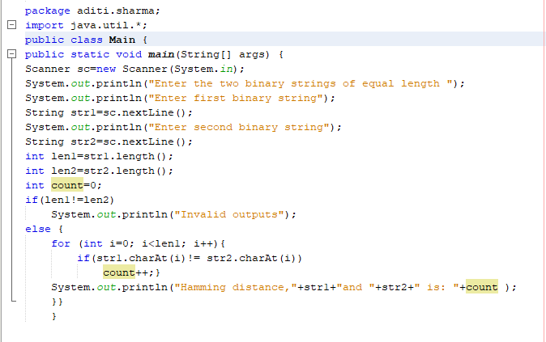

**B1.3 Testing of implementation :**

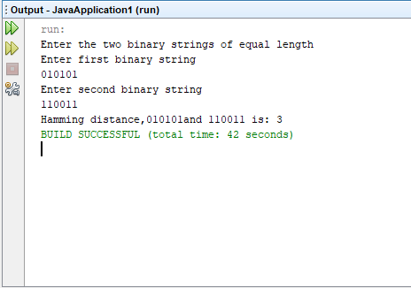

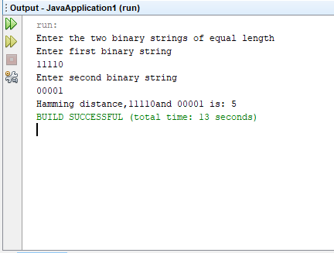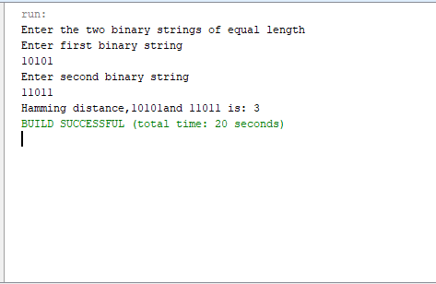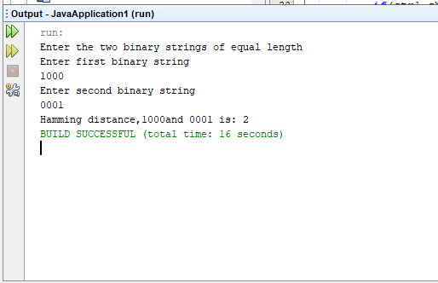

**Note: The developed program should be generic. Provide screenshots of the output in support of your answer. Demonstrate the implementation to the course leader.**

**B2** **10 Marks**

Hamming codes are used for error detection at the receiver. Students need to write a program to compute Hamming (7, 4) code for 4-bits of data.

The report should comprise of the following, with explanation:

**B2.1 Algorithm / flowchart for computation of Hamming (7, 4) code**

1. Start
2. Create an array to store 4 bits binary digit. Another array to store hamming code and third array to check the error.
3. Take 4 bit binary number as input and store it in an array. Take each piece input one by one.
4. Then compute the parity bits utilizing XOR function.
5. After computing the parity bits store the benefit of hamming code in array of size
6. Then showcase the processed hamming code.
7. Then accept the transmitted code as input and afterward check whether the transmitted and the got hamming code is same or not.
8. To check the error XOR is utilized to think about every individual bits.
9. If there is any error then the situation at which error found is shown and afterward the code after revision of the error is to be shown.
10. If there is no error discovered then the transmitted and the figured hamming codes are same and consequently the code will be shown.
11. End.

**B2.2 Implementation to compute Hamming (7, 4) code:**

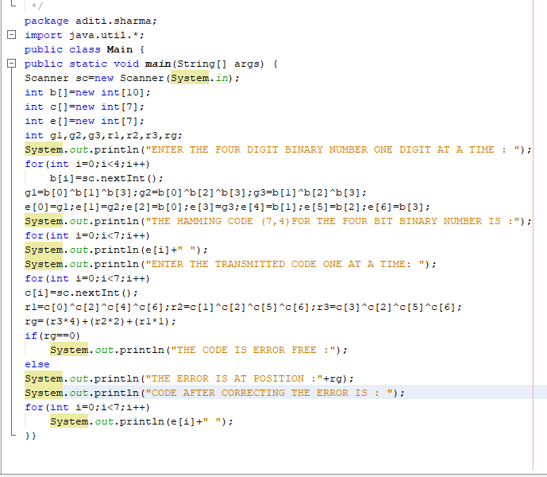

Hamming code (7,4) is a straight error-remedying code that encodes four bits of information into seven bits by including three parity bits. This code is utilized to encode the information and send through the signs. Receiver will at that point decipher the 7 bit information to 4 bit. In program first the 4 bit binary number is taken as input. At that point parity bit is determined as p1, p2 and p3. At that point hamming code is put away in an array of size 7 and after that the array is shown. Subsequent to figuring the code, user is approached to enter the transmitted flag and afterward it is checked with the processed code for any error. On the off chance that there is any error, at that point utilizing XOR error position is found and changed. After the error is amended, the transmitted code with error free is shown. In the event that there is no error, at that point the code is simply displayed. We are utilizing hamming code with the goal that the code can be recuperated effectively by a recipient notwithstanding when various errors are found in the transmitted code.

**B2.3 Validation of the implementation**

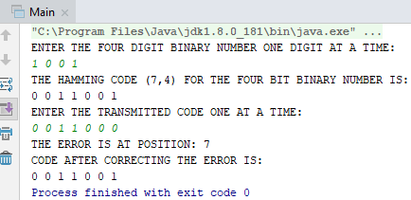

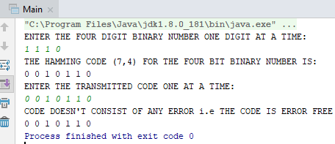





Bibliography

<https://www.elprocus.com/different-types-of-modulation-techniques-in-communication-systems/>

<https://fas.org/man/dod-101/navy/docs/es310/DigiComs/digicoms.htm>

<https://www.researchgate.net/publication/224734207_Combined_Digital_Phase_and_Amplitude_Modulation_Communication_Systems>

<https://www.analog.com/en/analog-dialogue/articles/mixed-signal-components-for-digital-communication-systems-ii.html>