

|  |  |
| --- | --- |
| **ASSIGNMENT** | |
| **Course Code** | HSC201A |
| **Course Name** | Law Assignment for Engineers |
| **Programme** | B.Tech |
| **Department** | CSE |
| **Faculty** | FET |

#### 

|  |  |
| --- | --- |
| **Name of the Student** | Prachi Poddar |
| **Reg. No** | 17ETCS002122 |
| **Semester/Year** | 4th/2nd |
| **Course Leader/s** | Adv. Reet Singh |

|  |  |  |  |  |  |  |  |  |
| --- | --- | --- | --- | --- | --- | --- | --- | --- |
| **Declaration Sheet** | | | | | | | | |
| Student Name | Prachi Poddar | | | | | | | |
| Reg. No | 17ETCS002122 | | | | | | | |
| Programme | B.Tech | | | | | Semester/Year | 4th/2nd | |
| Course Code | HSC201A | | | | | | | |
| Course Title | Law Assignment for Engineers | | | | | | | |
| Course Date |  | | to | |  | | | |
| Course Leader | Adv. Reet Singh | | | | | | | |
| **Declaration**  The assignment submitted herewith is a result of my own investigations and that I have conformed to the guidelines against plagiarism as laid out in the Student Handbook. All sections of the text and results, which have been obtained from other sources, are fully referenced. I understand that cheating and plagiarism constitute a breach of University regulations and will be dealt with accordingly. | | | | | | | | |
| Signature of the Student | |  | | | | | Date |  |
| Submission date stamp  (by Examination & Assessment Section) | |  | | | | | | |
| Signature of the Course Leader and date | | | | Signature of the Reviewer and date | | | | |
|  | | | |  | | | | |

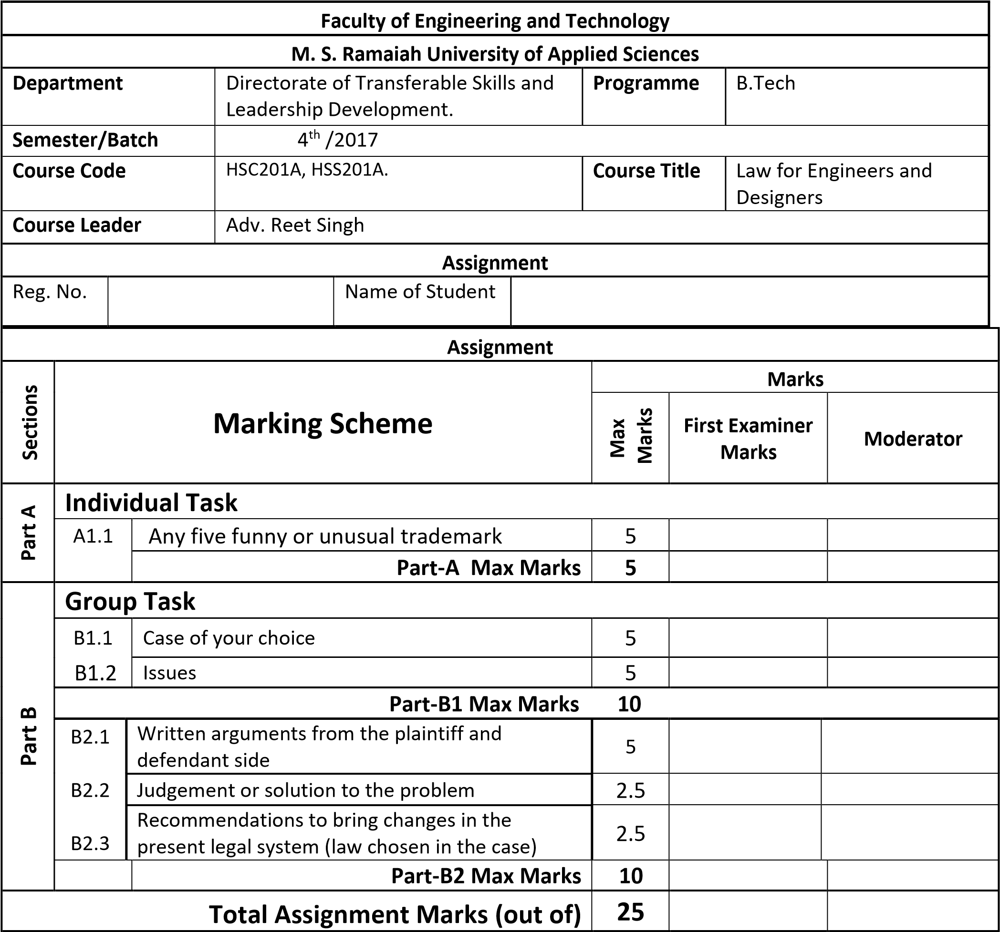

|  |  |  |  |  |
| --- | --- | --- | --- | --- |
| **Course Marks Tabulation** | | |  |  |
| **Component-1 (B) Assignment** | **First Examiner** | **Remarks** | **Moderator** | **Remarks** |
| A |  |  |  |  |
| B.1 |  |  |  |  |
| B.2 |  |  |  |  |
| **Marks (out of 25 )** |  |  |  |  |

**Signature of First Examiner Signature of Moderator**

**Solution to Question No. 1 Part A:**

**A 1.1 List and explain any five funny trademarks. (India, UK, US, Denmark and France):**

Introduction:

A trademark is a distinctive sign which identifies certain goods or services as those produced or provided by a specific person or enterprise. Thus from the definition, it is clear that a sign as an indicator of the required good or service must be distinctive so as to identify it as belonging to a specific person or enterprise. While generally, these signs are in the form of letters or symbols arranged in a specific pattern, a trademark can also be a non-conventional one in the quite, ‘non-visual’ sense that it could also include a shape, sound or smell as well.

1. **The Bitter Smell of Fresh Darts**

World’s leading manufacturer of darts, Unicorn Products, attempted to trademark “the smell of strong bitter beer” on their new range of darts in 1994. The olfactory trademark was successfully granted registration by the UK Trademark Registry under class 28.

Unicorn Products plan to inject the smell into a new range of flights which are designed, as they spin through the air, to give off the essential fragrance of British pubs. The flights would be impregnated with capsules of the smell which would burst open when the surface was touched,thereby creating the necessary public bar atmosphere.

Trademark owners seek to protect elements of their products or services in different ways and an

innovative way of doing so is by registering ‘aromas’ that identify them in the desired way. A trademark is understood as any sign or word or combination of these elements or any other medium that, due to its characteristics, is capable of individualizing or identifying a product or service.

Law 61 of 2012 that reformed the aforementioned Law 35 of 1996 added to the then current

regulations aromas, flavors and sounds as constituent elements of a trademark.

1. **Taylor Swift trademarks 1989 phrases including “This Sick Beat”**

Taylor Swift has trademarked a series of phrases that are featured on her chart-topping album 1989.

The musician has applied for a legal trademark with the US government for phrases like 'This Sick Beat' and 'Party Like It's 1989'.

Other phrases that Swift has sought to trademark include 'Could Show You Incredible Things', 'Nice to Meet You, Where You Been?' and 'Cause We Never Go Out of Style', according to legal database Justia. The trademarks will prevent others from marketing those phrases on items like Christmas stockings, guitar straps, whalebone and removal tattoos, as well as typewriters, pot holders, whips, saddlery and nonmedicated toiletries

1. **ICICI Bank gets its corporate jingle trademarked**

The largest private sector lender of the country, ICICI Bank has its corporate jingle trademark registered. The jingle "Dhin Chik Dhin Chik" is trademarked as that of the bank under the Intellectual Property Rights (IPR) of India.

The sound mark was published in the trademark journal as a graphical representation which not many people would understand and the registration certificate also consisted of the sound mark as a graphical representation.

The test for determining whether a sound mark qualifies for registration once it has passed the

graphical representation requirement is to consider whether the mark is distinctive per se or can distinguish the goods or services of the owner from those of others. Generally speaking, a successful registration of a non-traditional mark must be supported by robust evidence of factual distinctiveness.

1. **Parce que vous le valez bien, “Just Do it”**

The famous l’Oréal slogan “Because you’re worth it,” registered at the USPTO in 1976, has evolved with the company’s customers over the years. “Parce que je le vaux bien” and its English translation “Because I’m worth it” became popular in the late 1990s. In 2004, l’Oréal advertising started targeting the ever-growing cosmetics market for men with “Because you’re worth it too.” Then in 2009, their advertising started using “Because we’re worth it” and for kids “Because we’re worth it too.” The shift to “we” followed a psychologybased study of l’Oréal’s consumer base. "We" apparently creates stronger consumer involvement in l'Oréal’s philosophy and lifestyle and provides more perceived consumer satisfaction with l'Oréal products.

A slogan is a separate category of sign, and is different from the standard trademark. Slogans can, in

principle, be protected under trademark law, although they are not explicitly listed among the signs likely to constitute a trademark. However, Article L. 711-1 of the French Intellectual Property Code provides for “combinations of words,” and Article 4 of Regulation No. 207/2009 on the Community trademark refers to “words” in a broader sense. Slogans must conform to the same requirements as any other trademark and, in particular, should not be generic in nature or describe the goods or services themselves, and must have their own distinctive character.

1. **Bozo – The Clown Unhappy**

For one: a little rib joint in Tennessee called Bozo’s Fire Pit Bar-B-Q, founded in 1923 by Thomas Jefferson “Bozo” Williams. The restaurant, which registered for a trademark in 1982, found a rival in a franchising Bozo (i.e. the clown), i.e. Larry Harmon.

Harmon, who assumed the role of a sort of clown-Jesus, decided one day he wanted to foray into the restaurant business, and to do so without the risk of brand confusion.

Harmon’s lawyer told the New York Times in 1991, “We’ve never objected to their using the name Bozo’s in their restaurant and wish them only well. But the idea of little mom-and-pop businesses whom nobody has ever heard of being able to register their trademarks for the whole country is a prescription for paralysis.”

Harmon cited rude waitstaff, food poisoning, and health code violations as risk possibilities. While he may be infamous for doing so elsewhere—when it comes to business liabilities, Bozo does not clown around.

**Part B:**  **(Group Task)**

Group Members:

|  |  |
| --- | --- |
| PRACHI PODDAR | 17ETCS002122 |
| PRADEEP R. | 17ETCS002123 |
| PODILI ARUN | 17ETCS002120 |

**B1**

**B1.1** Identify a case of your choice for any one of the following:

* Constitution of India
* Law of Contracts
* Law of Torts
* Company Law
* Labour Laws
* Intellectual Property Laws

**Solution:**

**LAW OF CONTRACT:**

**CASE: Lalman Shukla v Gauri Dutt**

**FACTS:**

* Defendant’s, i.e. Gauri Dutt’s nephew absconded from home and the plaintiff, i.e. Lalman Shukla, the munim, amongst all the other servants was directed to pursue the boy. Accordingly, with the required amount for railway ticket and other expenses, the plaintiff left for finding the boy in Haridwar. Later, the defendant issued hand-bills offering a reward of Rs. 501 to anyone who found out his nephew. Meanwhile, the plaintiff traced the boy at Rishikesh and wired the defendant about the boy’s safety who travelled to Haridwar and brought the boy back to Cawnpore. The plaintiff was duly rewarded with 2 sovereigns at Haridwar and Rs. 20 on coming back home. For the next 6 months, the plaintiff worked for the defendant and after dismissal from his services, he brought a suit, claiming the remaining amount, i.e. Rs. 499 of the reward for finding the nephew.
* The Learned Counsel for the defendant urged that the plaintiff’s claim could only be maintained on the basis of contract and since there was no acceptance to the said offer, there was no contract between the parties. Moreover, the plaintiff was obliged to find the nephew and therefore, was not entitled to recover any amount.
* Accordingly, the Lower Court dismissed the claim and aggrieved, the plaintiff (Hereafter referred to as the Appellant) filed an appeal in front of the Honourable High Court of Allahabad. Thus, the needy knocked the doors of this Honourable Court, and its legal expertise quite meticulously, presented its Judgment and granted justice.

**B1.2** State any two issues from the chosen case.

Issues:

1. Whether there was a valid acceptance to the offer made?
2. Was Lalman Shukla entitled to the reward?

**Conclusion and Judgement:**

The Court observed, that a suit like the present one could “only be founded on a contract. In order to constitute a contract, there must be an acceptance of the offer and there can be no acceptance unless there is a knowledge of the offer. Motive is not essential but knowledge and intention are.” It was observed that in the case of a public advertisement offering a reward, the performance of the act raises an inference of acceptance in terms of section 8 of the Indian Contract Act, 1872, which provides that, “performance of the conditions of a proposal… is an acceptance of the proposal”.

Therefore, in the present case it was observed that the right to a reward could only be founded upon a contract.

Lastly, no relief could be granted to the Plaintiff since he was in the service of the Defendant and as such he was sent to trace the missing boy.

The application was, therefore, dismissed.

*******