

|  |  |
| --- | --- |
| **ASSIGNMENT** | |
| **Course Code** | BSC208A |
| **Course Name** | Engineering Mathematics – 4 |
| **Programme** | B.tech |
| **Department** | CSE |
| **Faculty** | FET |

#### 

|  |  |
| --- | --- |
| **Name of the Student** | PRACHI PODDAR |
| **Reg. No** | 17ETCS002122 |
| **Semester/Year** | 4TH/2ND |
| **Course Leader/s** | Sumanth Bharadwaj |

|  |  |  |  |  |  |  |  |  |
| --- | --- | --- | --- | --- | --- | --- | --- | --- |
| **Declaration Sheet** | | | | | | | | |
| Student Name | PRACHI PODDAR | | | | | | | |
| Reg. No | 17ETCS002122 | | | | | | | |
| Programme | B.Tech | | | | | Semester/Year | 4TH/2ND | |
| Course Code | BSC208A | | | | | | | |
| Course Title | Engineering Mathematics – 4 | | | | | | | |
| Course Date |  | | to | |  | | | |
| Course Leader | Sumanth Bharadwaj | | | | | | | |
| **Declaration**  The assignment submitted herewith is a result of my own investigations and that I have conformed to the guidelines against plagiarism as laid out in the Student Handbook. All sections of the text and results, which have been obtained from other sources, are fully referenced. I understand that cheating and plagiarism constitute a breach of University regulations and will be dealt with accordingly. | | | | | | | | |
| Signature of the Student | |  | | | | | Date | 18/03/2019 |
| Submission date stamp  (by Examination & Assessment Section) | |  | | | | | | |
| Signature of the Course Leader and date | | | | Signature of the Reviewer and date | | | | |
|  | | | |  | | | | |

|  |  |  |  |  |  |  |  |  |
| --- | --- | --- | --- | --- | --- | --- | --- | --- |
| **Faculty of Engineering and Technology** | | | | | | | | |
| **Ramaiah University of Applied Sciences** | | | | | | | | |
| Department / Faculty | | | Mathematics / FMPS | Programme | | B. Tech. | | |
| Semester/Batch | | | 4th / 2017 | | | | | |
| Course Code | | | BSC208A | Course Title | | Engineering Mathematics – 4 | | |
| Course Leader(s) | | | Mahesha Narayana, Somashekhara G., Hemanthkumar B., Sumanth Bharadwaj, Shivashankar C., T. N. Sakshath and Siddabasappa C. | | | | | |
| **Assignment – 2** | | | | | | | | |
| **Reg. No.** | | **17ETCS002122** | | **Name of Student** | **PRACHI PODDAR** | | | |
| **Questions** | | **Marking Scheme** | | | **Max**    **Marks** | | **First**  **Examiner Marks** | **Moderator** |
| **Q1** | **1.1** | Mathematical form of given problem. | | | 2 | |  |  |
| **1.2** | MATLAB function to solve the boundary value problem using finite difference method with ℎ = 1 and 𝑘 . | | | 6 | |  |  |
| **1.3** | Plot of the solution 𝑢(𝑥, 𝑡) in the region 0 ≤ 𝑥 ≤ 8 and 0 ≤ 𝑡 ≤ 2 | | | 2 | |  |  |
|  | | **Max Marks** | | | 10 | |  |  |
| **Q2** | **2.1** | Calculation of mean, median and mode | | | 2 | |  |  |
| **2.2** | Calculation of quartiles and standard deviation | | | 2 | |  |  |
| **2.3** | Scatter plot | | | 2 | |  |  |
| **2.4** | Correlation coefficient | | | 2 | |  |  |
| **2.5** | Regression Line | | | 1 | |  |  |
| **2.6** | Identification of variability and justification | | | 1 | |  |  |
|  | | **Max Marks** | | | 10 | |  |  |
| **Q3** | **3.1** | Determination of probability that the first four marbles are yellow | | | 1 | |  |  |
| **3.2** | Determination of probability that none of final four marbles is brown | | | 1 | |  |  |
| **3.3** | Determination of probability that the first three marbles are of different colours | | | 1 | |  |  |
| **3.4** | Determination of probability that all same colour marbles are together | | | 2 | |  |  |
|  | | **Max Marks** | | | 05 | |  |  |
| **Total Assignment Marks** | | | | | 25 | |  |  |

|  |  |  |  |  |
| --- | --- | --- | --- | --- |
| **Course Marks Tabulation** | | | | |
| **Component-1 (B) Assignment** | **First Examiner** | **Remarks** | **Moderator** | **Remarks** |
| Question No. 1 |  |  |  |  |
| Question No. 2 |  |  |  |  |
| Question No. 3 |  |  |  |  |
| **Marks (out of 25)** |  |  |  |  |
| **Signature of First Examiner Signature of Moderator** | | | | |

**Please note:**

1. Documental evidence for all the components/parts of the assessment such as the reports, photographs, laboratory exam / tool tests are required to be attached to the assignment report in a proper order.
2. The First Examiner is required to mark the comments in RED ink and the Second Examiner’s comments should be in GREEN ink.
3. The marks for all the questions of the assignment have to be written only in the **Component – CET B: Assignment** table.
4. If the variation between the marks awarded by the first examiner and the second examiner lies within +/- 3 marks, then the marks allotted by the first examiner is considered to be final. If the variation is more than +/- 3 marks then both the examiners should resolve the issue in consultation with the Chairman BoE.

# Assignment – 2 Term-2

**Instructions to students:**

1. The assignment consists of **3** questions.
2. Maximum marks is **25**.
3. The assignment has to be neatly word processed as per the prescribed format.
4. The maximum number of pages should be restricted to **10**.
5. The printed assignment must be submitted to the course leader.
6. **Submission Date: 18/03/2019**
7. **Submission after the due date is not permitted.**
8. **IMPORTANT**: It is essential that all the sources used in preparation of the assignment must be suitably referenced in the text.
9. Marks will be awarded only to the sections and subsections clearly indicated as per the problem statement/exercise/question.

**Preamble**

This course deals with essentials probability, random process, statistics and numerical solutions to differential equations. Students are taught the probability theory and statistical distributions needed to quantify uncertainty and accuracy of information. The significance and utility of numerical methods for solution of differential and partial differential equations are emphasized in this course. Key considerations in the choice and adaptation of optimization methods for the solution of a problem are discussed in this course. The students will be able to suggest and apply probabilistic /numerical technique to solve a diverse range of mathematical problems.

# **Question No. 1**

**Solution to Question No. 1:**

## 1.1 Write the one dimensional heat equation with initial and boundary conditions:

The General form of the one-dimensional heat equation is:

$$c^{2}\frac{∂^{2}u}{∂x^{2}}=\frac{∂u}{∂t}$$

$$c=1$$

Given the rod extends from $x=0$ to $x=8$

$$0≤x≤8$$

$$l=8$$

Taking the boundary conditions:

$$u\left(0, t\right)=0 \\ u\left(8, t\right)=0$$

Taking the initial conditions:

$$u\left(x, 0\right)=f\left(x\right) \\ u\left(x, 0\right)=4x-\frac{1}{2}x^{2}$$

The given time interval is $0≤t≤2$

$$u\left(x,t\right)=\sum_{n=1}^{∞}{A_{n} Sin\left(\frac{nπx}{8}\right)×\exp\left[-{\left(\frac{nπc}{8}\right)}^{2}t\right]}$$

$$A_{n}=\frac{2}{8}\left[\int_{0}^{8}{\left(4x-\frac{1}{2}x^{2}\right)} Sin\left(\frac{nπx}{8}\right) dx\right]$$

Therefore, An

## 1.2 Write the MATLAB code to solve the boundary value problem using finite difference

## method with ℎ = 1 and 𝑘 =1/4

MATLAB function

function [ ] = HeatEquation(x0,xn,t0,tn,h,k,c)

x=x0:h:xn; %prachi

t=t0:k:tn;

m=length(x);

n=length(t);

u=zeros(m,n);

a=(c*k)/(h^2);

f=@(x)((4*x) - (0.5.*x.^2));

if a > 0.5

fprintf("method fails for a>0.5");

return;

end

u(:,1) = f(x);

for j=1:n-1

for i=2:m-1

u(i,j+1)= a*u(i+1, j) + (1-2*a)*u(i, j) + a*u(i-1,j);

end

end

disp(u)

surf(t,x,u)

legend('Temperature','location','best')

xlabel('t')

ylabel('x')

zlabel('u')

end

**command window:**

>> HeatEquation(0,8,0,2,1,1/4,1)

0 0 0 0 0 0 0 0 0

3.5000 3.2500 3.0625 2.9063 2.7695 2.6465 2.5337 2.4290 2.3308

6.0000 5.7500 5.5000 5.2656 5.0469 4.8418 4.6484 4.4652 4.2909

7.5000 7.2500 7.0000 6.7500 6.5039 6.2637 6.0303 5.8042 5.5857

8.0000 7.7500 7.5000 7.2500 7.0000 6.7520 6.5078 6.2690 6.0366

7.5000 7.2500 7.0000 6.7500 6.5039 6.2637 6.0303 5.8042 5.5857

6.0000 5.7500 5.5000 5.2656 5.0469 4.8418 4.6484 4.4652 4.2909

3.5000 3.2500 3.0625 2.9063 2.7695 2.6465 2.5337 2.4290 2.3308

0 0 0 0 0 0 0 0 0

## 1.3 Plot the solution of the partial differential equation 𝑢(𝑥,𝑡) for 0 ≤ 𝑥 ≤ 8 and 0 ≤ 𝑡 ≤ 2:



Figure 1.1: Heat equation graph

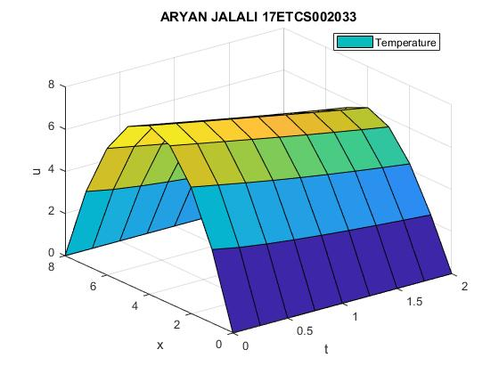

# **Question No. 2**

**Solution to Question No. 2:**

## 2.1 Calculate the mean, median and mode for the column corresponding to smoking, bladder cancer, lung cancer and kidney cancer:

Given data:

Table data Taken

|  |  |  |  |  |  |
| --- | --- | --- | --- | --- | --- |
| STATE | CIG | BLAD | LUNG | KID | LEUK |
| AL | 18.20 | 2.90 | 17.05 | 1.59 | 6.15 |
| AZ | 25.82 | 3.52 | 19.80 | 2.75 | 6.61 |
| AR | 18.24 | 2.99 | 15.98 | 2.02 | 6.94 |
| CA | 28.60 | 4.46 | 22.07 | 2.66 | 7.06 |
| CT | 31.10 | 5.11 | 22.83 | 3.35 | 7.20 |
| DE | 33.60 | 4.78 | 24.55 | 3.36 | 6.45 |
| DC | 40.46 | 5.60 | 27.27 | 3.13 | 7.08 |
| FL | 28.27 | 4.46 | 23.57 | 2.41 | 6.07 |
| ID | 20.10 | 3.08 | 13.58 | 2.46 | 6.62 |
| IL | 27.91 | 4.75 | 22.80 | 2.95 | 7.27 |
| IN | 26.18 | 4.09 | 20.30 | 2.81 | 7.00 |
| IO | 22.12 | 4.23 | 16.59 | 2.90 | 7.69 |
| KS | 21.84 | 2.91 | 16.84 | 2.88 | 7.42 |
| KY | 23.44 | 2.86 | 17.71 | 2.13 | 6.41 |
| LA | 21.58 | 4.65 | 25.45 | 2.30 | 6.71 |
| ME | 28.92 | 4.79 | 20.94 | 3.22 | 6.24 |
| MD | 25.91 | 5.21 | 26.48 | 2.85 | 6.81 |
| MA | 26.92 | 4.69 | 22.04 | 3.03 | 6.89 |
| MI | 24.96 | 5.27 | 22.72 | 2.97 | 6.91 |
| MN | 22.06 | 3.72 | 14.20 | 3.54 | 8.28 |
| MS | 16.08 | 3.06 | 15.60 | 1.77 | 6.08 |
| MO | 27.56 | 4.04 | 20.98 | 2.55 | 6.82 |
| MT | 23.75 | 3.95 | 19.50 | 3.43 | 6.90 |
| NB | 23.32 | 3.72 | 16.70 | 2.92 | 7.80 |
| NE | 42.40 | 6.54 | 23.03 | 2.85 | 6.67 |
| NJ | 28.64 | 5.98 | 25.95 | 3.12 | 7.12 |
| NM | 21.16 | 2.90 | 14.59 | 2.52 | 5.95 |
| NY | 29.14 | 5.30 | 25.02 | 3.10 | 7.23 |
| ND | 19.96 | 2.89 | 12.12 | 3.62 | 6.99 |
| OH | 26.38 | 4.47 | 21.89 | 2.95 | 7.38 |
| OK | 23.44 | 2.93 | 19.45 | 2.45 | 7.46 |
| PE | 23.78 | 4.89 | 12.11 | 2.75 | 6.83 |
| RI | 29.18 | 4.99 | 23.68 | 2.84 | 6.35 |
| SC | 18.06 | 3.25 | 17.45 | 2.05 | 5.82 |
| SD | 20.94 | 3.64 | 14.11 | 3.11 | 8.15 |
| TE | 20.08 | 2.94 | 17.60 | 2.18 | 6.59 |
| TX | 22.57 | 3.21 | 20.74 | 2.69 | 7.02 |
| UT | 14.00 | 3.31 | 12.01 | 2.20 | 6.71 |
| VT | 25.89 | 4.63 | 21.22 | 3.17 | 6.56 |
| WA | 21.17 | 4.04 | 20.34 | 2.78 | 7.48 |
| WI | 21.25 | 5.14 | 20.55 | 2.34 | 6.73 |
| WV | 22.86 | 4.78 | 15.53 | 3.28 | 7.38 |
| WY | 28.04 | 3.20 | 15.92 | 2.66 | 5.78 |
| AK | 30.34 | 3.46 | 25.88 | 4.32 | 4.90 |

Table Mean, Median, Mode

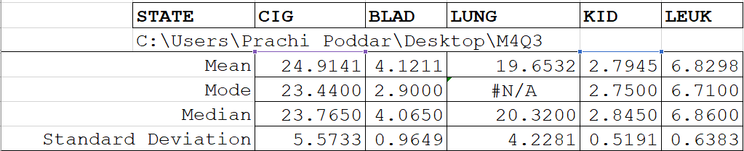

## 2.2 Calculate the quartiles and standard deviation for the column corresponding to smoking, bladder cancer, lung cancer and kidney cancer:

Table Quartiles and Standard deviation

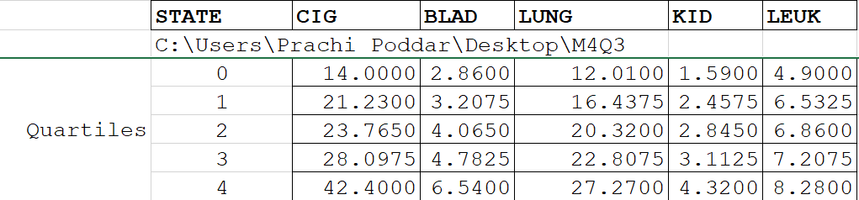

## 2.3 Draw the scatter plot for the following:

1. **Smoking vs bladder cancer**

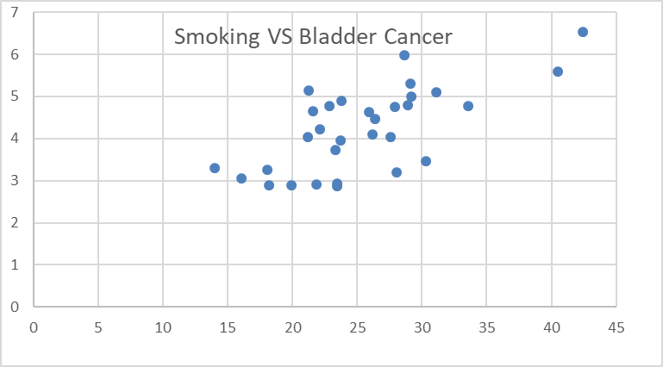

Fig 1.2: Scatter plot of Smoking vs bladder cancer

1. **Smoking vs lung cancer**

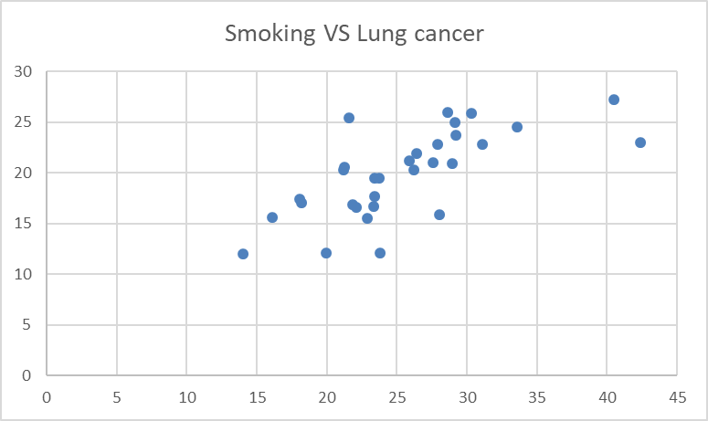

Fig 1.3: Scatter plot of Smoking vs lung cancer

1. **Smoking vs kidney cancer**

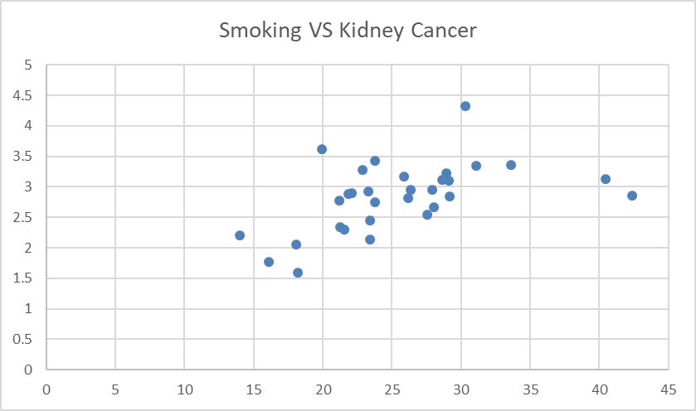

Fig 1.4: Scatter plot of Smoking vs Kidney cancer

1. **Smoking leukemia**

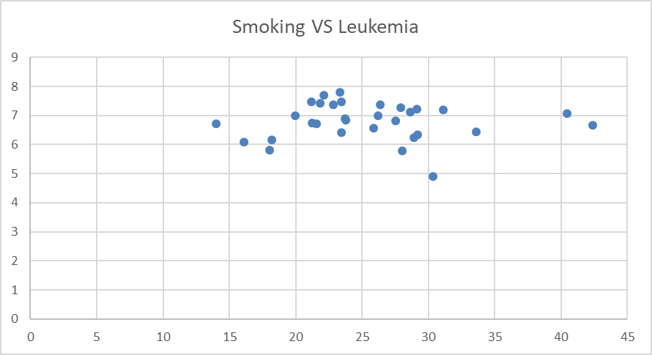

Fig 1.5: Scatter plot of Smoking vs leukemia

## 2.4 Determine the correlation coefficient between:



## 2.5 Draw the regression line in scatter plot obtained in Q2.3:

## 2.6 Identify the minimum variability (greatest consistency) and maximum variability in scatter plot obtained in Q2.3. Justify your choices:

Table coefficients of determination

|  |  |
| --- | --- |
| Smoking vs Bladder | 0.485058 |
| Smoking vs lungs | 0.489109 |
| Smoking vs kidney | 0.268099 |
| Smoking vs leukemia | 2.58 * 10-5 |

Data with coefficient of determination closer to 0 has maximum variability and data with coefficient of determination closer to 1 has minimum variability. Therefore, we can say that the maximum coefficient of determination, i.e, Smoking vs lung cancer has great consistency as it has minimum variability and Smoking vs leukemia has least consistency as it has maximum variability.

# **Question No. 3**

**Solution to Question No. 3:**

Let 9 yellow, 4 magenta and 7 brown marbles are arranged randomly in a line. Assume all marbles are distinct, even if with the same color.

Therefore: $$probability of any event E is given by:$$

$$p\left(E\right)=\frac{number of favourable events}{Total number of possible events}$$

## 3.1 The probability that the first 4 marbles are yellow:

out of 9 yellow marbles 4 are chosen and arranged, hence p(E1) is given as,

$$p\left(E_{1}\right)=\frac{\left(selection of yellow marbles\right)×\left(mutual arrangement\right)×\left(remaining arrangments\right)}{total events}$$

Using permutation and combinations,

$$⇒p\left(E_{1}\right)=\frac{{(9}_{C_{2}}×4!×16!)}{20!}$$

$$⇒p\left(E_{1}\right)=\frac{126×24×16!}{20×19×18×17×16!}$$

$$⇒p\left(E_{1}\right)=\frac{42}{1615}$$

## 3.2 The probability that none of final 4 marbles is brown:

Consider that last final 4 marble are either yellow or magenta or combination of both.

$$p\left(E_{2}\right)=\frac{\left(selection of non-brown marbles\right)×\left(mutual arrangement\right)×\left(remaining arrangments\right)}{total events}$$

Using permutation and combinations,

$$⇒p\left(E_{2}\right)=\frac{{(13}_{C_{4}}×4!×16!)}{20!}$$

$$⇒p\left(E_{2}\right)=\frac{715×24×16!}{20×19×18×17×16!}$$

$$⇒p\left(E_{2}\right)=\frac{143}{969}$$

## 3.3 The probability that the first 3 marbles are of different colors:

Choose distinct marbles with different color and arrange them , then arrange remaining marbles

$$p\left(E_{3}\right)$$

$$=\frac{(\left(select brown marbles\right)× \left(select yellow marbles\right)×\left(select magenta marbles\right)×\left(mutual arrangement\right))×\left(remaining arrangments\right)}{total events}$$

Using permutation and combinations,

$$⇒p\left(E_{3}\right)=\frac{{((7}_{C_{1}}{×9}_{C_{1}}×4_{C_{1}})×3!×17!)}{20!}$$

$$⇒p\left(E_{3}\right)=\frac{(7×9×4)×6×17!}{20×19×18×17!}$$

$$⇒p\left(E_{3}\right)=\frac{1512}{6840}=\frac{21}{95}$$

## 3.4 The probability that all same color marbles are together:

To keep all the same colour marbles together, arrange 1st colour marble then arrange 2nd colour marble then arrange 3rd colour marble and then arrange them mutually, this is equivalent to favorable events

Since the selection is always 1, hence the permutation needs to be done,

$$p\left(E_{4}\right)=\frac{\left(arrangement of yellow marble\right)×\left(arrangement of brown marble\right)×\left(arrangement of magenta marble\right)×3!}{total possible events}$$

$$⇒p\left(E_{4}\right)=\frac{\left((9_{C_{9}}×9!)×(7_{C_{7}}×7! )×(4_{C_{4}}×4!\right)×3!}{20!}$$

$$⇒p\left(E_{4}\right)=\frac{9!×7!×4!×3!}{20! }$$

$$⇒p\left(E_{4}\right)=\frac{1}{9237800}$$

**\*\*\*\*\*\*\***