

|  |  |
| --- | --- |
| **ASSIGNMENT** | |
| **Course Code** | HSC301A |
| **Course Name** | Economics for Engineers |
| **Programme** | B.Tech |
| **Department** | CSE |
| **Faculty** | FET |

#### 

|  |  |
| --- | --- |
| **Name of the Student** | Satyajit Ghana |
| **Reg. No** | 17ETCS002159 |
| **Semester/Year** | 05/2019 |
| **Course Leader/s** | Sunita Chakraborty |

|  |  |  |  |  |  |  |  |  |
| --- | --- | --- | --- | --- | --- | --- | --- | --- |
| **Declaration Sheet** | | | | | | | | |
| Student Name | Satyajit Ghana | | | | | | | |
| Reg. No | 17ETCS002159 | | | | | | | |
| Programme | B.Tech | | | | | Semester/Year | 05/2019 | |
| Course Code | HSC301A | | | | | | | |
| Course Title | Economics for Engineers | | | | | | | |
| Course Date |  | | to | |  | | | |
| Course Leader | Sunita Chakraborty | | | | | | | |
| **Declaration**  The assignment submitted herewith is a result of my own investigations and that I have conformed to the guidelines against plagiarism as laid out in the Student Handbook. All sections of the text and results, which have been obtained from other sources, are fully referenced. I understand that cheating and plagiarism constitute a breach of University regulations and will be dealt with accordingly. | | | | | | | | |
| Signature of the Student | |  | | | | | Date |  |
| Submission date stamp  (by Examination & Assessment Section) | |  | | | | | | |
| Signature of the Course Leader and date | | | | Signature of the Reviewer and date | | | | |
|  | | | |  | | | | |

# **Contents**

____________________________________________________________________________

**Declaration Sheet** ii

**Contents** iii

**List of Tables** iv

**List of Figures** v

**Question No. 1** 6

A 1.1 Introduction to all the sectors that exists: 6

A 1.2 Advantages of these service sectors: 8

A 1.3 Explain about the service sectors which brings the growth for our country: 8

**Question No. 2** 10

B 1.1 Explain the main determinants of equilibrium of demand and supply curve: 10

B 1.2 Discuss the reasons for the shift in the demand and supply curve: 12

**Question No. 3** 14

B 2.1 Differentiate between Total Utility and Marginal Utility: 14

B 2.2 Explain the law of Diminishing Marginal Utility with graphical representation: 15

**Question No. 4** 17

B 3.1 Explain the measures that is required for the growth of the company: 17

B 3.2 Mention the challenges that the company faces for the growth: 19

**Question No. 5** 21

B 4.1 Conclusion of the study: 21

B 4.2 Recommend the appropriate methods to overcome the problems: 22

# **List of Tables**

**____________________________________________________________________________**

Table 1 MU vs TU 14

Table 2 Data 15

# **List of Figures**

____________________________________________________________________________

Figure 0‑1 Demand and Supply Curve 11

Figure 0‑1 MU and TU 16

# 

# **Question No. 1**

**Solution to Question No. 1 Part A:**

## A 1.1 Introduction to all the sectors that exists:

The services sector is not only the dominant sector in India’s GDP, but has also attracted significant foreign investment flows, contributed significantly to exports as well as provided large-scale employment. India’s services sector covers a wide variety of activities such as trade, hotel and restaurants, transport, storage and communication, financing, insurance, real estate, business services, community, social and personal services, and services associated with construction.

Service Sector in India # 1. Trade:

Trade is an important segment in India’s GDP. The GDP from trade (inclusive of whole­sale and retail in the organized and unorganized sectors) at constant prices increased from Rs.4,33,967 crore in 2004-05 to Rs.6,71,396 crore in 2009-10, at a CAGR of 9.1 per cent. The share of trade in the GDP, however, remained fairly stable at around 15 per cent in the last four years.

Service Sector in India # 2. Tourism, Including Hotels and Restaurants:

Tourism is one of the major engines of economic growth in most parts of the world including India. Since tourism does not fall under a single heading in the National Accounts Statistics, its contribution has to be estimated.

Service Sector in India # 3. Shipping:

Shipping plays an important role in the economic development of the country, especially in India’s international trade. The Indian shipping industry also plays an important role in the energy security of the country, as energy resources, such as coal, crude oil, and natural gas are mainly transported by ship. Further, during crisis situations, Indian ship­ping contributes to the uninterrupted supply of essentials, and can serve as second line of defense. Approximately, 95 per cent of the country’s trade by volume, and 68 per cent in terms of value, is being transported by sea.

Service Sector in India # 4. Port Services:

Being the gateways of international trade, ports play a vital role in the overall economic development of the country. India is blessed with a long coastline with 13 major ports and around 200 non-major ports. While around 72 per cent of the total cargo handled by volume was through India’s major ports and the rest through non-major ports till 2008- 09, with the development of private ports the share of major ports fell to 67 per cent during 2009-10.

Service Sector in India # 5. Storage Services:

The warehousing services sector plays an important role in the economy of the country. Warehousing services are an important cog both in bound logistics, as raw materials, parts, and stores have to be stocked, inventory control maintained, and materials which do not meet specifications returned to suppliers, as well as outbound logistics as the goods produced have to be stored in different geographical locations before shipping/ dispatch as per demand/order inflows.

Service Sector in India # 6. Telecom and Related Services:

The opening of the telecom sector in India has not only led to rapid growth but also helped a great deal towards maximization of consumer benefits as tariffs have been falling across the board as a result of increasing competition, with the telecom service price index falling from 100 in 2004-05 to 85.08 in 2007-08.

Service Sector in India # 7. Real Estate Services:

The real estate sector includes development of commercial and residential real estates, with participation and involvement of both Government agencies and private develop­ers. The GDP from the real estate sector (including ownership of dwellings) along with business services witnessed a growth of 7.5 per cent (at constant prices) in the year 2009- 10.

Service Sector in India # 8. IT Services:

India has gained a brand identity as a knowledge economy due to its IT sector. The IT industry has four major components: IT services, business process outsourcing (BPO), engineering services and R&D, and software products. The growth in the services sector in India has been led by the IT sector which has become a growth engine for the economy, contributing substantially to increases in the GDP, employment, and exports.

Service Sector in India # 9. Accounting and Auditing Services:

Accounting, auditing, and book-keeping services are part of ‘business services’. The accounting profession in India is highly developed with the potential to become interna­tionally more competitive.

Service Sector in India # 10. Research & Development Services (R&D):

Service Sector in India # 11. Legal Services:

Service Sector in India # 12. Consultancy:

Consultancy is essentially a knowledge-based profession with an underlying develop­mental role spanning a wide range of sectors. Not only do consultancy services play an important role in the development of the economy, but such consultancy exports enhance the visibility of Indian technical expertise abroad and boost the external sector in multiple ways, including foreign exchange revenues, promotion of export of technol­ogy and merchandise (especially capital goods and raw materials), and training of per­sonnel, while contributing significantly to national development in the host country.

Service Sector in India # 13. Construction:

The construction industry in India is an important indicator of development as it creates investment opportunities across various related sectors. The construction industry has contributed an estimated Rs.3,84,282 crore (at constant prices) to national GDP in 2010-11 (a share of around 8 per cent).

## A 1.2 Advantages of these service sectors:

Service sector also recognized as tertiary or residual sector is indispensable for economic development in any economy including India. It has developed as the main and fastest-growing sector in the global economy in the last three decades. The rising part of the services sector in the gross domestic product (GDP) of India indicates the importance of the sector to the economy (GOI 2012). The services sector accounted for about 30 per cent of total GDP of India in 1950s; its share in GDP increased to 38 per cent in the 1980s, then to 43 per cent in the 1990s and finally to about 56.5 per cent in 2012‐13 (GOI 2013). Thus, the services sector currently accounts for more than half of India’s GDP. While the share of the services in GDP increased from 34 per cent in 1970s to 54 per cent in 2010‐11, the corresponding share of services sector employment in total employment changed from 15 per cent in 1972‐73 to only about 26.67 per cent per cent in 2009‐10. As a consequence, a large proportion of workers remain in rural agriculture. Among others, this has led to a situation of a large gap in productivity between agricultural workers and workers in the services sector **(Papola and Sahu 2012)**. Service sector employment is associated with informal sector not only due to the relatively large proportion on unprotected jobs, but also due to the fact that a large proportion domestic worker is accounted for as services sector workers **(Jonakin 2006)**. Unlike the output of agriculture, mining or manufacturing which are material and tangible, the output of the services sector such as teaching, cleaning, selling, curing and entertaining have no physical form and therefore are immaterial or intangible **(Noon 2003)**. The present study makes an analysis of service sector in Indian economy. The paper also makes an analysis of Indian services sector through examining its growth and contributions in the economy.

The contribution of the services sector has increased very rapidly in the India GDP for many foreign consumers have shown interest in the country's service exports. This is due to the fact that India has a large pool of highly skilled, low cost, and educated workers in the country. This has made sure that the services that are available in the country are of the best quality. The foreign companies seeing this have started outsourcing their work to India especially in the area of business services which includes business process outsourcing and information technology services. This has given a major boost to the Services Sector in India, which in its turn has made the sector contribute more to the India GDP

## A 1.3 Explain about the service sectors which brings the growth for our country:

Agriculture Sector of Indian Economy is the most important sectors of the Indian economy remains Agriculture and one of the most significant part of India. Agriculture is the only means of living for almost two-thirds of the employed class in India. As being stated by the economic data of financial year 2006-07, agriculture has acquired 18 percent of India's GDP.

The agriculture sector of India has occupied almost 43 percent of India's geographical area. Agriculture is still the only largest contributor to India's GDP even after a decline in the same in the agriculture share of India. Agriculture also plays a significant role in the growth of socio-economic sector in India.

In the earlier times, India was largely dependent upon food imports but the successive stories of the agriculture sector of Indian economy has made it self-sufficing in grain production. The country also has substantial reserves for the same. India depends heavily on the agriculture sector, especially on the food production unit after the 1960 crisis in food sector. Since then, India has put a lot of effort to be self-sufficient in the food production and this endeavor of India has led to the Green Revolution. The Green Revolution came into existence with the aim to improve the agriculture in India.

The services enhanced by the Green Revolution in the agriculture sector of Indian economy are as follows:

* Acquiring more area for cultivation purposes
* Expanding irrigation facilities
* Use of improved and advanced high-yielding variety of seeds
* Implementing better techniques that emerged from agriculture research
* Water management
* Plan protection activities through prudent use of fertilizers, pesticides, and cropping applications

All these measures taken by the Green Revolution led to an alarming rise in the wheat and rice production of India's agriculture. Considering the quantum leap witnessed by the wheat and rice production unit of India's agriculture, a National Pulse Development Programme that covered almost 13 states, was set up in 1986 with the aim to introduce the improved technologies to the farmers. A Technology Mission was introduced in 1986 right after the success of National Pulse Development Programme to boost the oilseeds sector in Indian economy. Pulses too came under this programme. A new seed policy was planned to provide entree to superior quality seeds and plant material for fruits, vegetables, oilseeds, pulses, and flowers.

# **Question No. 2**

**Solution to Question No. 1 Part B:**

## B 1.1 Explain the main determinants of equilibrium of demand and supply curve:

One of the most fundamental economic models is the law of supply and demand for a certain product (milk, bread, fuel etc.) or service (transportation, health care, education etc.) in a free-market environment. In this model the quantity of a certain item produced and sold is described by two curves, called the supply and demand curves of the item.

The supply function or supply curve gives the quantity of an item that producers will supply at any given price. The demand function or demand curve gives the quantity that consumers will demand at any given price.

We will denote the price per unit by p and the quantity supplied or demanded at that price by q. As is the convention in economics, we will always write p as a function of q. Thus, the supply curve will be denoted by the formula

$$p = S(q)$$

and represented by a graph where the x and y axes correspond to q and p values respectively. Similarly, we will use

$$p = D(q)$$

to denote the demand curve. As you might expect, the supply function S is increasing – the higher the price, the more the producers will supply. The demand function D is decreasing – the higher the price, the less the consumers will buy.

The point of intersection $(q_{e}, p_{e})$ of the supply and demand curves is called the market equilibrium point. The numbers $q_{e}$ and $p_{e}$ are termed equilibrium quantity and equilibrium price respectively

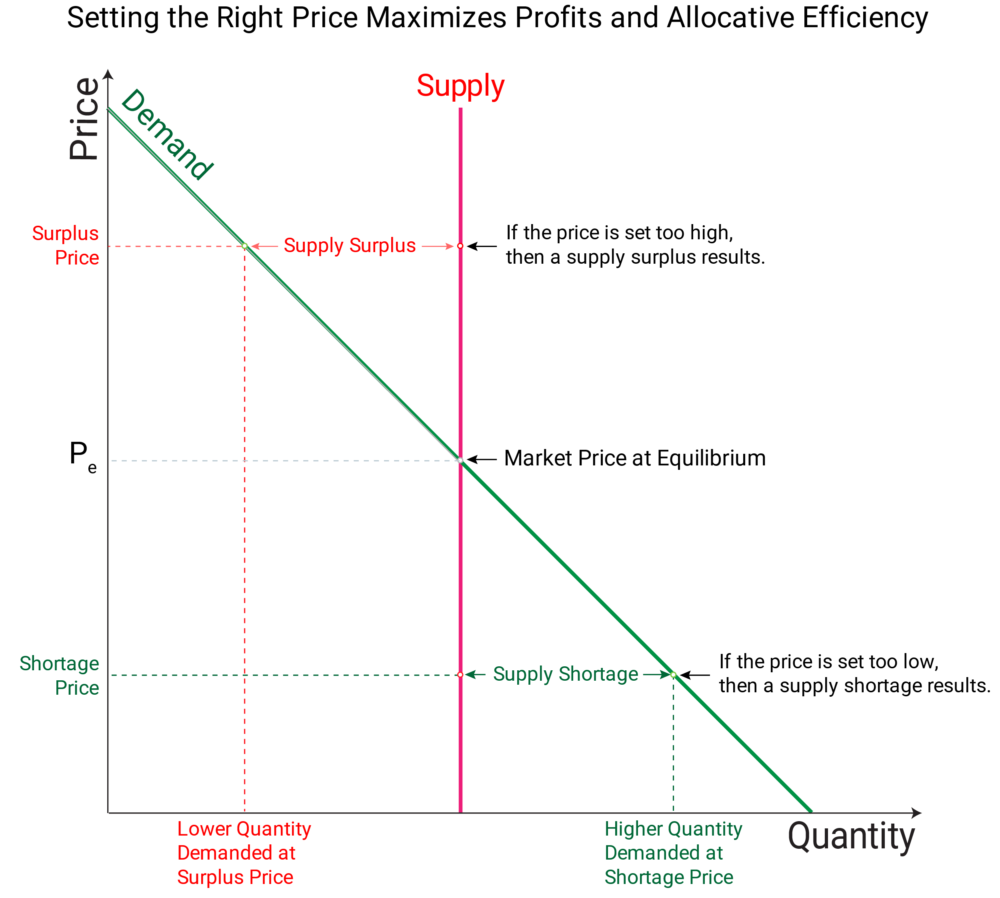

Figure ‑ Demand and Supply Curve

If sellers’ price their product too low, then they may not be able to provide the quantity demanded by the buyers, since buyers demand more at lower prices, resulting in a supply shortage. If sellers’ price their product too high, then they will not be able to sell all that they have, since buyers demand less at higher prices, resulting in a supply surplus. In either case, sellers will have to adjust their price toward the market equilibrium price to maximize profits. The market equilibrium price is the highest price that sellers can charge and still be able to sell all that they have, with no surplus or shortage.

Supply determinants other than prices include the prices of the factors of production used to create the product, technology, taxes and subsidies, number of sellers, price expectations, and the prices of other related goods. If supply determinants increase supplies, while the demand remains constant, then the equilibrium price will decline, because it must adjust to the new, higher equilibrium quantity, which can only be sold at lower prices. Supply determinants that decrease supplies will cause the equilibrium price to rise, since it will take fewer buyers to buy the product at the higher price and only those who are willing to pay the higher price will buy it.

Demand determinants other than price include consumer preferences, income, prices of substitutes and complements, and the number of buyers. If the supply remains constant, but non-price demand determinants increase demand, then the equilibrium price will rise, since the equilibrium quantity will also increase, and the suppliers will only supply more product at a higher price. Likewise, if demand decreases because of factors other than price, then the equilibrium price will decline, since suppliers will only be able to sell the new, lower equilibrium quantity of their product.

## B 1.2 Discuss the reasons for the shift in the demand and supply curve:

What affects demand?

We defined demand as the amount of some product a consumer is willing and able to purchase at each price. That suggests at least two factors in addition to price that affect demand. Willingness to purchase suggests a desire, based on what economists call tastes and preferences. If you neither need nor want something, you will not buy it. Ability to purchase suggests that income is important. Professors are usually able to afford better housing and transportation than students, because they have more income. Prices of related goods can affect demand also. If you need a new car, the price of a Honda may affect your demand for a Ford. Finally, the size or composition of the population can affect demand. The more children a family has, the greater their demand for clothing. The more driving-age children a family has, the greater their demand for car insurance, and the less for diapers and baby formula.

These factors matter for both individual and market demand as a whole. Exactly how do these various factors affect demand, and how do we show the effects graphically? To answer those questions, we need the ceteris paribus assumption.

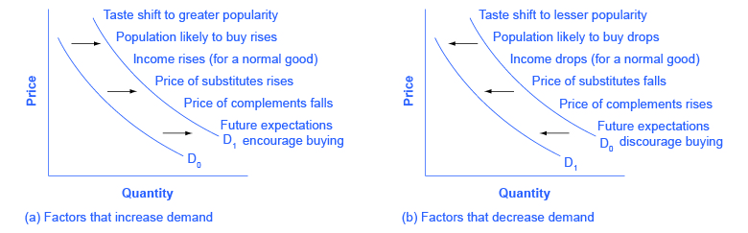

How production costs affects supply?

A supply curve shows how quantity supplied will change as the price rises and falls, assuming ceteris paribus so that no other economically relevant factors are changing. If other factors relevant to supply do change, then the entire supply curve will shift. Just as we described a shift in demand as a change in the quantity demanded at every price, a shift in supply means a change in the quantity supplied at every price.

In thinking about the factors that affect supply, remember what motivates firms: profits, which are the difference between revenues and costs. A firm produces goods and services using combinations of labor, materials, and machinery, or what we call inputs or factors of production. If a firm faces lower costs of production, while the prices for the good or service the firm produces remain unchanged, a firm’s profits go up. When a firm’s profits increase, it is more motivated to produce output, since the more it produces the more profit it will earn. When costs of production fall, a firm will tend to supply a larger quantity at any given price for its output. We can show this by the supply curve shifting to the right.

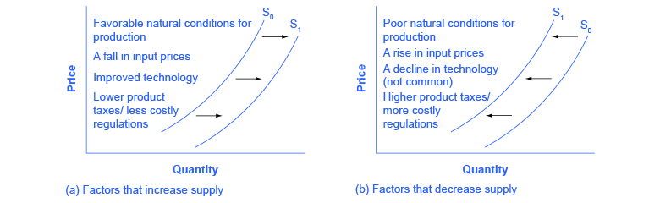

Because demand and supply curves appear on a two-dimensional diagram with only price and quantity on the axes, an unwary visitor to the land of economics might be fooled into believing that economics is about only four topics: demand, supply, price, and quantity. However, demand and supply are really “umbrella” concepts: demand covers all the factors that affect demand, and supply covers all the factors that affect supply. We include factors other than price that affect demand and supply are included by using shifts in the demand or the supply curve. In this way, the two-dimensional demand and supply model becomes a powerful tool for analyzing a wide range of economic circumstances.

# **Question No. 3**

**Solution to Question No. 2 Part B:**

## B 2.1 Differentiate between Total Utility and Marginal Utility:

Table MU vs TU

|  |  |
| --- | --- |
| **Marginal Utility** | **Total Utility** |
| Marginal utility is the satisfaction gained from consuming an additional quantity of a particular good or service.  Marginal Utility means the amount of utility a person gains from the consumption of each successive unit of a commodity. | Total utility is the total satisfaction received from consuming a given total quantity of a good or service.  Total utility is the aggregate utility that a person derives from consuming a particular product. |
| For example, when a person increases the consumption of eggs from one egg to two eggs, the total utility increases from 30 utils to 45 utils. The marginal utility here would be the15 utils of the 2nd egg consumed.  Marginal utility, thus, can also be described as difference between total utility derived from one level of consumption and total utility derived from another level of consumption. | For example, a person consumes eggs and gains 50 utils of total utility. This total utility is the sum of utilities from the successive units (30 utils from the first egg, 15 utils from the second and 5 utils from the third egg).  Summing up total utility is the amount of satisfaction (utility) obtained from consuming a particular quantity of a good or service within a given time period. It is the sum of marginal utilities of each successive unit of consumption. |
| $$MU=\frac{ΔTU_{x}}{ΔQ_{x}} \\ where, MU=Marginal Utility \\ ΔTU_{x}=Change in Total Utility \\ ΔQ_{x}=Change in quantity consumed \\ by 1 unit$$ | $$TU_{n}=U_{x}+U_{y}+U_{z} \\ =∑MU \\ where, n=No. of commodities \\ U=utilities of consumption of goods \\ MU=Marginal Utility$$ |
| Marginal utility decreases with each additional unit of a commodity consumed. | Total utility increases as more of a commodity is consume |

## B 2.2 Explain the law of Diminishing Marginal Utility with graphical representation:

**Total Utility**: Total utility of a fixed quantity of a commodity (TU) is the total satisfaction derived from consuming the given amount of some commodity $x$. More of commodity x provides more satisfaction to the consumer. TU depends on the quantity of the commodity consumed. Therefore, $TU_{n}$ refers to total utility

derived from consuming n units of a commodity $x$.

**Marginal Utility**: Marginal utility (MU) is the change in total utility due to consumption of one additional unit of a commodity. For example, suppose 4 bananas give us 28 units of total utility and 5 bananas give us 30 units of total utility. Clearly, consumption of the 5th banana has caused total utility to increase by 2 units (30 units minus 28 units). Therefore, marginal utility of the 5th banana is 2 units.

$$MU_{5} = TU_{5} – TU_{4} = 30 – 28 = 2$$

In general, $MU_{n} = TU_{n} – TU_{n-1}$, where subscript n refers to the $n^{th}$ unit of the

commodity

Total utility and marginal utility can also be related in the following way.

$$TU_{n} = MU_{1} + MU_{2} + … + MU_{n-1} + MU_{n}$$

This simply means that TU derived from consuming n units of bananas is the sum total of marginal utility of first banana ($MU_{1}$), marginal utility of second banana ($MU_{2}$), and so on, till the marginal utility of the nth unit. Table and Figure below show an imaginary example of the values of marginal and total utility derived from consumption of various amounts of a commodity. Usually, it is seen that the marginal utility diminishes with increase in consumption of the commodity. This happens because having obtained some amount of the commodity, the desire of the consumer to have still more of it becomes weaker. The same is also shown in the table and graph. Values of marginal and total utility derived from consumption of various amounts of a commodity

Table Data

|  |  |  |
| --- | --- | --- |
| Units | Total Utility | Marginal Utility |
| 1 | 12 | 12 |
| 2 | 18 | 6 |
| 3 | 22 | 4 |
| 4 | 24 | 2 |
| 5 | 24 | 0 |
| 6 | 22 | -2 |



Figure ‑ MU and TU

Notice that $MU_{3}$ is less than $MU_{2}$. You may also notice that total utility increases but at a diminishing rate: The rate of change in total utility due to change in quantity of commodity consumed is a measure of marginal utility. This marginal utility diminishes with increase in consumption of the commodity from 12 to 6, 6 to 4

and so on. This follows from the law of diminishing marginal utility.

Law of Diminishing Marginal Utility states that marginal utility from consuming each additional unit of a commodity declines as its consumption increases, while keeping consumption of other commodities constant.

MU becomes zero at a level when TU remains constant. In the example, TU does not change at 5th unit of consumption and therefore $MU_{5} = 0$. Thereafter, TU starts falling and MU becomes negative. **(NCERT, Theory of Consumer Behaviour)**

# **Question No. 4**

**Solution to Question No. 3 Part B:**

## B 3.1 Explain the measures that is required for the growth of the company:

1. Build a sales funnel.

The first way to quickly grow your business is by building a sales funnel. If you don't have a sales funnel, you're making a monumental mistake. Sales funnels can help to automate your business. It helps you to scale and grow quickly and easily. Sure, there's some front-end work involved. Obviously. But, once those processes are in place, it's smooth sailing from there.

2. Utilize a customer management system.

Manually tracking transactions is hard. No one wants to do that. It gets too cumbersome as the business grows. If you want to scale quickly, use a customer management system. There are plenty to choose from. But it really depends on your line of work. Of course, cloud-based software like Salesforce is always a viable option.

3. Research the competition.

When going to market, and you're really looking to get your offer to the masses, you need to research the competition. This allows you to uncover any advertiser's online strategy. Find the ads that have been running for the longest and emulate those. That's the quickest way you scale any business. If it's proven and it's working for your competitors, it's likely it'll work for you.

4. Create a customer loyalty program.

Loyalty programs are great ways to increase sales. It costs up to three times more money to acquire new customers than it does to sell something to an existing customer. Other resources pin this number anywhere from four to 10 times more. However, any way that you slice it, acquiring new customers is expensive.

5. Identify new opportunities.

Analyze new opportunities in your business by understanding your demographic better. Understand everything from distribution channels to your direct competitors, and even an analysis of foreign markets and other potential industries. There are likely dozens of new opportunities you could pursue immediately with the proper amount of analysis.

6. Calculate the price/earnings (PE) ratio

For a publicly-traded company, the PE ratio represents the premium paid for the company's stock. That is, it is the current stock price divided by the average earnings per share over the last twelve months. A high result from this calculation means that investors expect that the company will increase in value in the future. Conversely, a low value may represent lower or negative growth expectations

7. Form strategic partnerships.

Strategic partnerships with the right companies can truly make a world of difference. It could allow you to reach a wide swath of customers quickly. Identifying those partnerships might be easier said than done. But, look out for companies that are complementary to your own. Contact them and propose opportunities for working together.

8. Licensing deals

Doing licensing deals is a great way to grow your business without too much added effort. If you have a product that you can license to others and share a revenue of, that's an ideal way to grow quickly. Taking a popular or successful product and bringing it to a company with a large footprint can help you achieve market saturation quicker.

9. Find profit growth

Net profit, also called net income or simply profit, is the "bottom line" of the company. It measures the company's earnings after all expenses and taxes have been subtracted from revenue. Profits are then used to either pay dividends or are reinvested in the company. Profits, like revenues, are often measured using the compounded annual growth rate (CAGR). This allows companies to show their averaged profit growth over time, rather than focusing on individual years

10. Measure market capitalization

For publicly traded companies (companies who sell stock to the public), market capitalization (market cap) is a measurement of the total value of the company's outstanding stock. It is calculated by multiplying the current stock price by the total number of outstanding shares. Market cap is often used to measure a company's growth over time and is the most common indicator of a company's size used by financial professionals

11. Build passive income streams.

Growing a business takes significant effort. If you're dealing with razor-thin margins, consider building passive income streams. This way, you don't have to worry so much about keeping the lights on, so to speak. Passive income will afford you the opportunity to make mistakes and not have to lose your shirt. It'll keep you in business and provide a basis to grow and market and scale quickly by giving you ample resources.

12. Acquire other businesses.

Sometimes, acquiring other businesses is a very quick way to grow your own business. If you can find competitors or businesses in other industries that would complement your own, you could use them as platforms to scale fast. Take a look within your industry and even outside of it to find potential for potential opportunities.

## B 3.2 Mention the challenges that the company faces for the growth:

1. Balancing Quality and Growth

Growing consultancies often report reduced quality while scaling, especially the fast-growth ones.

During the first year or two, a small handful of people is in charge of all operations. Skilled professionals start a business, deliver outstanding quality, work day and night on execution, and build a client base.

Throughout the growth period, new roles are created — support, business development, marketing, management. As recruitment and onboarding processes are still in their infancy, this creates a separation between the level of quality across different team members.

2. Time Management

Effectively allocating time on the right initiatives is a craft and this is a valid problem for virtually every industry. Regardless of whether you run a cab company, a software agency, an event management consultancy or a law firm.

Productive time management maximizes the potential of every single employee. Within a team, the power law kicks in: two slow parties will exponentially drag an assignment further and incur communication overhead. This entails the time of the founders, senior management, supervisors, and every end unit of the business.

3. Communication

A communication study reported by the Society for HR Management includes 400 companies with 100,000 employees each. Inadequate communication incurs an average of $62.4M in loss caused by overhead, misaligned work, incorrect deliverables, and more. Communication problems easily make it to the top 10 critical business challenges across all organizations.

And there are so many contributing factors: lack of enough experience, vague requirements, fear of disappointing management (or losing one’s job), ego, poor processes. Establishing a streamlined communication protocol and straightforward processes is what management consulting and operational management are all about.

4. Landing New Business

Every business struggle with closing new customers. Startups haven’t proven themselves yet, lack a fully trained sales team on-site, and need to compete with large, well-known organizations. Especially true if the founder has no sales expertise.

Enterprises are expensive. Their operational costs are high which affects their price point. Also, most enterprises can’t innovate fast enough, allowing for competitors to chime in or startups to launch, acquiring some of their existing users. Even when an established sales process is in place, the landscape of the market evolves with a fast pace. Consumers get access to new opportunities (or competitors). Some profitable channels get oversaturated. Retaining top salespeople is expensive and eats up the business margins.

# **Question No. 5**

**Solution to Question No. 4 Part B:**

## B 4.1 Conclusion of the study:

Growing a business is complicated. According to SBE Council, 89% of all businesses employ fewer than 20 employees. And scaling a company further is contingent on solving a number of challenges — most of those being common across all organizations out there. Scaling your business is hard. It takes considerable effort. In the beginning, it means wearing different hats. It means dealing with sales and marketing. It means understanding taxes and corporate compliance. It involves having to interact with customers on a daily basis. And so much more.

The study is oriented upon identifying the key points which hinder a company from growing, we looked and elaborated upon

* Balancing Quality and Growth
* Time Management
* Communication
* Landing New Business
* Lack of Direction/Vision

We’ve concentrated more on startups and entrepreneurships since India is a hub for growing startups, especially Bangalore, with various govt. schemes funding and promoting startups. In a later section B4.2, we’ll see how to overcomes some of the problems mentioned before. One of the common problems we found during the study of growing a company is to start fast, but starting fast doesn’t mean that you should force scaling. Scaling is something that happens carefully, in a measured cadence. Starting fast means that you leverage all possible resources to focus on one thing -- getting started. Getting started is the main thing. Once your business is up and running, anything else is possible. A startup is a race. The faster you are, the more likely you are to win big. If there will be people buying or using your product, you need to learn all you can about these people, from these people and for these people. Your business will live or die based on their receptivity to the product or service.

There are some entrepreneurs who know exactly what they want to sell. There are other entrepreneurs who have no idea what they’re going to sell. They just want to sell something. Here’s my advice: Sell anything.

Many of the world’s greatest entrepreneurs aren’t selling anything new. They are selling it different or better:

## B 4.2 Recommend the appropriate methods to overcome the problems:

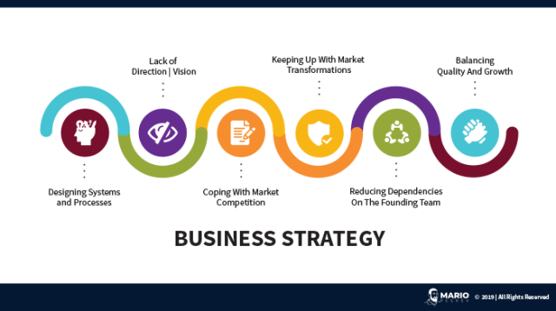

* Create a Roadmap

Developing a roadmap will not only assist you in going beyond your plans into goals which you want to act on, but it will also help you in avoiding any unnecessary distractions and diversions. So, if you want to scale up your business, you need to create a roadmap. Roadmaps will help you in ensuring the ongoing day-to-day tasks align with and contribute to your higher-level business strategy and track your progress toward goals.

* Marketing

No matter how good your product is, you will fail if you are not seen. Marketing is the core activity that makes money for your brand. It’s not the product — it’s how you raise awareness and engage with your audience. People should strive to find their genius zone; the core part that sets them apart from everyone else, and find the audience that not only needs what you do but also engages with you and encourages you on your path. Becoming a thought leader in your niche gives you game-changing leverage to stand out from the competition

Marketing on social media is also generally considered more cost-effective than traditional types of outbound marketing like TV and billboard ads. It also enables you to target your audience more effectively.

* Focus on Customer Service/Experience

Customers' perceptions of your business can really make or break a business. Deliver quality experiences and products, and they'll quickly sing your praises on social media; mess it up, and they'll tell the world even faster. Fast growth depends on making your current and potential customers happy with their experience. You can grow your business as quickly and as much as you want but if you don’t look after your customers, it simply will not last. Make sure that customer service is an absolute priority in all your operations. If you look after your customers, they will stay loyal, and a loyal customer base is a key to any kind of business growth.

**Bibliography**

________________________________________________________________________________

1. Landsburg, Steven E. The Armchair Economist: Economics and Everyday Life. New York: The Free Press. 2012. specifically Section IV: How Markets Work.
2. National Chicken Council. 2015. “Per Capita Consumption of Poultry and Livestock, 1965 to Estimated 2015, in Pounds.” Accessed April 13, 2015. http://www.nationalchickencouncil.org/about-the-industry/statistics/per-capita-consumption-of-poultry-and-livestock-1965-to-estimated-2012-in-pounds/.
3. Wessel, David. “Saudi Arabia Fears $40-a-Barrel Oil, Too.” The Wall Street Journal. May 27, 2004, p. 42. http://online.wsj.com/news/articles/SB108561000087822300.
4. <https://www.math.ubc.ca/~malabika/teaching/ubc/spring11/math105/surplus.pdf>
5. <https://thismatter.com/economics/market-equilibrium.htm>
6. <http://ncert.nic.in/textbook/pdf/leec202.pdf>
7. <https://www.businessmanagementideas.com/india/service-sectors/13-types-of-service-sectors-in-india/18726>
8. <https://mariopeshev.com/business/the-biggest-business-challenges-growing-companies/>
9. <https://www.business2community.com/strategy/the-31-biggest-business-challenges-growing-companies-face-02223572>
10. <https://blog.markgrowth.com/10-business-growth-tips-for-smes-8723e95238fc>