# Experiment 2: Error Detection using CRC-CCITT

**Aim:** To apply CRC (CCITT Polynomial) for error detection

**Objective:** After carrying out this experiment, students will be able to:

* Apply CRC CCITT to develop codes for error detection
* Analyse how this CRC is able to detect bit errors irrespective of their length and position in the data

**Problem statement:** You are required to write a program that uses CRC to detect burst errors in transmitted data. Initially, write the program using the CRC example you studied in class. Your final program should ask the user to input data and choose a generator polynomial from the list given in the figure below. Your program is required to calculate the checksum and the transmitted data. Subsequently, the user enters the received data. Applying the same generator polynomial on the received data should result in a remainder of 0.

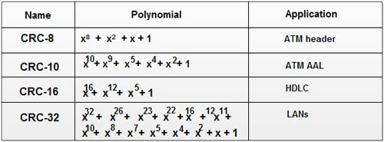

**Analysis:** While analyzing your program, you are required to address the following points:

* How is this method different from 2D parity scheme that you have implemented previously?
* What are the limitations of this method of error detection?

**MARKS DISTRIBUTION**

|  |  |  |
| --- | --- | --- |
| **Component** | **Maximum Marks** | **Marks Obtained** |
| Preparation of Document | 7 |  |
| Results | 7 |  |
| Viva | 6 |  |
| **Total** | **20** |  |

Submitted by:

Register No:

1. Algorithm/Flowchart
2. Program
3. Results
4. Analysis and Discussions
5. Conclusions
6. Comments
   1. Limitations of the experiment
   2. Limitations of the results obtained
   3. Learning
   4. Recommendations