**Computer Simulation Laboratory**

**B.Tech. 5th Semester**



**Department: Computer Science and Engineering**

**Faculty of Engineering & Technology**

**M. S. Ramaiah University of Applied Sciences**



**M. S. Ramaiah University of Applied Sciences**

Private University Established in Karnataka State by Act No. 15 of 2013

|  |  |
| --- | --- |
| Faculty | Engineering & Technology |
| Programme | B. Tech. in Computer Science and Engineering |
| Year/Semester | 5th Semester |
| Name of the Laboratory | Computer Simulation Laboratory |
| Laboratory Code | CSC308A |

List of Experiments

1. Introduction to Java simulation and Implementing a Java program for random numbers generation for given scenario
2. Simulation of a single server queue (Grocery centre problem)
3. Simulation of a Two server Queue (Able Baker Problem)
4. Discrete Distributions AND Continuous Distributions
5. Random Number generator using LCG
6. Random Variate Generator using lnverse-Transfonn Technique

Exponential Distribution

Uniform Distribution

1. Test for random numbers

KS test

Chi square Test

1. Simulation of a single server Single queue(M/M/1)

# Laboratory 1: Introduction to java simulation and Random Number Generation

1. Introduction and Purpose of Experiment

Computer simulation provides students to design and implement computer simulation models, conduct simulation experiments and evaluate system performance. This laboratory exercise will help the students to get familiar with using object‐oriented simulation in Java.

Java (Structured Parallel Discrete Event Simulation in Java) system is designed to incorporate the parallel programming technology into discrete event simulations. The java system adopts the approach of augmenting a general-purpose language with essential constructs to support simulation modeling based on the process-oriented modeling technology.

Random numbers are widely used ingredient in the simulation of almost all discrete systems. Simulation languages generate random numbers that are used to generate event times and other random variables. Random number generators have applications in gambling, statistical sampling, computer simulation, cryptography, completely randomized design and other areas where producing an unpredictable result is desirable. The generation of pseudo random numbers is an important and common task in computer programming.

1. Aim and Objectives

Aim

* To use Netbeans and understand using object‐oriented simulation in Java
* To develop programs generating random numbers and Understand its significance in various applications

Objectives

At the end of this lab, the student will be able to

* Explain the features and use of Netbeans IDE to develop java programs for simulation
* Edit, compile and execute java programs successfully using Netbeans IDE

Use different random generation methods for generating random numbers

Create java programs for generating random numbers

1. Experimental Procedure

Students are given a set of programs for generating random numbers using built-in methods. Programs should be edited, compiled and executed using Netbeans IDE.

Random number generation using inbuilt methods/manually

Ex: coin toss, die, and cards

1. Calculations/Computations/Algorithms

Generate a random numbers for coin flip, die and cards

1. Presentation of Results

/*

 * To change this license header, choose License Headers in Project Properties.

 * To change this template file, choose Tools | Templates

 * and open the template in the editor.

 */

package rnumgen;

import java.util.Random;

import java.util.Scanner;

/**

 *

 * @author Student

 */

public class RNUMGEN {

    /**

     * @param args the command line arguments

     */

    public static void main(String[] args) {

        // TODO code application logic here

        Random rgen = new Random();

        Scanner input = new Scanner(System.in);

        System.out.println("RANDOMGEN");

        System.out.println("Enter your choice : ");

        System.out.println("1.Coin\t2.Dice\t3.Card");

        int choice = input.nextInt();

        switch(choice) {

            case 1: {

                System.out.println("How many times do you want to flip a coin ? : ");

                int N = input.nextInt();

                System.out.print("[ ");

                int count = 0;

                for (int i = 0 ; i < N ; i++) {

                    int val = rgen.nextInt(2);

                    if (val == 0)

                        count++;

                    System.out.print( val + ", ");

                }

                System.out.print("\b]");

                System.out.println("\nCOUNT 0 : " + count + " , 1 : " + (N-count) );

                break;

            }

            case 2: {

                int []count = new int[7];

                System.out.println("How many times do you want to roll a dice ? : ");

                int N = input.nextInt();

                System.out.print("[ ");

                for (int i = 0 ; i < N ; i++) {

                    int val = (rgen.nextInt(6)+1);

                    count[val]++;

                    System.out.print( val + ", ");

                }

                System.out.print("\b]\nCOUNTS: \n");

                System.out.print("[ ");

                int j = 0;

                for (int e : count) {

                    System.out.print(j + " : " + e + ", ");

                    j++;

                }

                System.out.print("\b]\nCOUNTS: \n");

                break;

            }

            case 3: {

                int []count = new int[53];

                System.out.println("How many card do you want ? : ");

                int N = input.nextInt();

                System.out.print("[ ");

                for (int i = 0 ; i < N ; i++) {

                    int val = (rgen.nextInt(52)+1);

                    count[val]++;

                    System.out.print( val + ", ");

                }

                System.out.print("\b]\nCOUNTS: \n");

                System.out.print("[ ");

                int j = 0;

                for (int e : count) {

                    System.out.print(j + " : " + e + ", ");

                    j++;

                }

                System.out.print("\b]\nCOUNTS: \n");

                break;

            }

        }

    }

}

1. 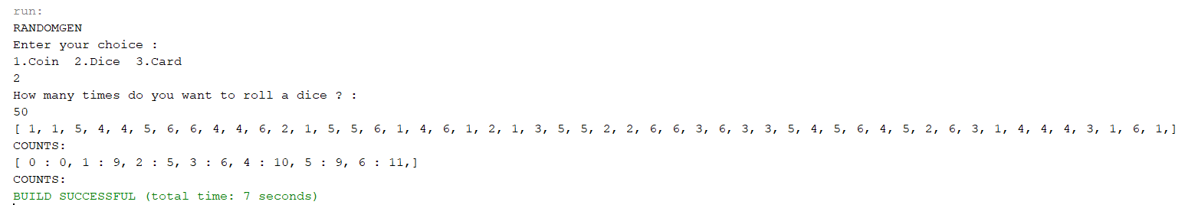Analysis and Discussions
2. Conclusions

Random class is used to generate pseudo-random numbers in java. An instance of this class is thread-safe. The instance of this class is however cryptographically insecure. This class provides various method calls to generate different random data types such as float, double, int.

Constructors:

Random(): Creates a new random number generator

Random(long seed): Creates a new random number generator using a single long seed

The random() method returns a double value with a positive sign, greater than or equal to 0.0 and less than 1.0. When you call Math.random(), under the hood, a java.util.Random pseudorandom-number generator object is created and used.

The java.util.Random class implements what is generally called a linear congruential generator (LCG). It is designed to be fast but does not meet requirements for real-time use, such as use in unique session ID generation on a web server, scientific experiments, cryptography, or lotteries and sweepstakes where a monetary stake is involved.

# Laboratory 2: Simulation of a single server queue (Grocery centre problem)

1. Introduction and Purpose of Experiment
2. Aim and Objectives
3. Experimental Procedure

An ATM booth has a single machine to withdraw cash. Customers arrive at the ATM at random times that are from 1 to 8 minutes apart. Each Inter-arrival time has the same probability of occurrence and service times vary from 1 to 6 minutes with the respective probabilities of time taken for service shown in Table 3 below:

|  |  |  |  |  |  |  |
| --- | --- | --- | --- | --- | --- | --- |
| Service(in minutes) | 1 | 2 | 3 | 4 | 5 | 6 |
| Probability | 0.10 | 0.20 | 0.30 | 0.25 | 0.10 | 0.05 |

1. Table 3

Simulate the system for arrival of 1000 customers starting with an empty ATM queue to determine the following:

i. Average waiting time of a customer

ii. Idle time of the ATM machine

iii. Average service time

iv. Average time between arrivals

Use random numbers between 1 to 1000 to determine inter arrival time, and random numbers between 1 to 100 to determine service time.

1. Algorithms

single_server_queue_model():

1. for each request in queue:

2. AT[i] = AT[i-1] + IAT[i]

3. if (AT[i] >= SE[i-1])

4. SS[i] = AT[i-1]

5. else SS[i] = SE[i-1]

6. SE[i] = SS[i] + ST[i]

7. WAIT[i] = SS[i]-AT[i]

8. IDLE[i] = AT[i] – SE[i-1] >= 0 ? AT[i] – SE[i1] : 0

1. Presentation of Results

/*

 * To change this license header, choose License Headers in Project Properties.

 * To change this template file, choose Tools | Templates

 * and open the template in the editor.

 */

package lab02;

import java.util.ArrayList;

import java.util.Collections;

import java.util.HashMap;

import java.util.List;

import java.util.Map;

import java.util.OptionalDouble;

import java.util.Random;

import java.util.Scanner;

import java.util.stream.Collectors;

import java.util.stream.IntStream;

/**

 *

 * @author shadowleaf

 */

public class Lab02 {

    /**

     * @param args the command line arguments

     */

    public static void main(String[] args) {

        Scanner input = new Scanner(System.in);

        System.out.print("Enter the Number of Requests : ");

        Integer N = input.nextInt();

        Random rand = new Random();

        // Taking it as input

//        List<Integer> IAT = new ArrayList<>();

//        List<Integer> ST = new ArrayList<>();

//        IAT.add(0);

//        ST.add(0);

//

//        System.out.print("Enter IAT's : ");

//        for (int i = 0 ; i < N ; i++) {

//            IAT.add(input.nextInt());

//        }

//

//        System.out.print("Enter ST's : ");

//        for (int i = 0 ; i < N ; i++) {

//            ST.add(input.nextInt());

//        }

        // Inter Arrival Times range from 1 - 8 mins

        List<Integer> IAT = IntStream.range(0, N + 1).mapToObj(i -> rand.nextInt(8) + 1).collect(Collectors.toList());

        // Service Time ranges from 1 - 6 mins

        List<Integer> ST = IntStream.range(0, N + 1).mapToObj(i -> rand.nextInt(6) + 1).collect(Collectors.toList());

        Map<String, List<Integer>> SIM_TAB = new HashMap<>();

        SIM_TAB.put("IAT", IAT);

        SIM_TAB.put("ST", ST);

        SIM_TAB.put("SS", new ArrayList<>(Collections.nCopies(N + 1, 0)));

        SIM_TAB.put("AT", new ArrayList<>(Collections.nCopies(N + 1, 0)));

        SIM_TAB.put("SE", new ArrayList<>(Collections.nCopies(N + 1, 0)));

        SIM_TAB.put("WAIT", new ArrayList<>(Collections.nCopies(N + 1, 0)));

        SIM_TAB.put("IDLE", new ArrayList<>(Collections.nCopies(N + 1, 0)));

        SIM_TAB.get("AT").set(0, 0);

        for (int i = 1; i <= N; i++) {

            SIM_TAB.get("AT").set(i, SIM_TAB.get("AT").get(i - 1) + SIM_TAB.get("IAT").get(i));

            if (SIM_TAB.get("AT").get(i) >= SIM_TAB.get("SE").get(i - 1)) {

                SIM_TAB.get("SS").set(i, SIM_TAB.get("AT").get(i));

            } else {

                SIM_TAB.get("SS").set(i, SIM_TAB.get("SE").get(i - 1));

            }

            SIM_TAB.get("SE").set(i, SIM_TAB.get("SS").get(i) + SIM_TAB.get("ST").get(i));

            SIM_TAB.get("WAIT").set(i, SIM_TAB.get("SS").get(i) - SIM_TAB.get("AT").get(i));

            SIM_TAB.get("IDLE").set(i, SIM_TAB.get("AT").get(i) - SIM_TAB.get("SE").get(i-1) >= 0 ? SIM_TAB.get("AT").get(i) - SIM_TAB.get("SE").get(i-1) : 0);

        }

        System.out.println("REQNO\tIAT\tAT\tSS\tSE\tST\tWAIT\tIDLE");

        for (int i = 1; i <= N; i++) {

            String out = i + "\t"

                    + SIM_TAB.get("IAT").get(i) + "\t"

                    + SIM_TAB.get("AT").get(i) + "\t"

                    + SIM_TAB.get("SS").get(i) + "\t"

                    + SIM_TAB.get("SE").get(i) + "\t"

                    + SIM_TAB.get("ST").get(i) + "\t"

                    + SIM_TAB.get("WAIT").get(i) + "\t"

                    + SIM_TAB.get("IDLE").get(i);

            System.out.println(out);

        }

        // Avg WAIT, Avg. Ser, Avg. IAT

        OptionalDouble avgWAIT = SIM_TAB.get("WAIT").stream().mapToDouble(a -> a).average();

        OptionalDouble avgService = SIM_TAB.get("ST").stream().mapToDouble(a -> a).average();

        OptionalDouble avgIAT = SIM_TAB.get("IAT").stream().mapToDouble(e -> e).average();

        System.out.println("Average WAIT : " + avgWAIT.getAsDouble());

        System.out.println("Averate Service Time : " + avgService.getAsDouble());

        System.out.println("Averate IAT : " + avgIAT.getAsDouble());

    }

}

1. Analysis and Discussions

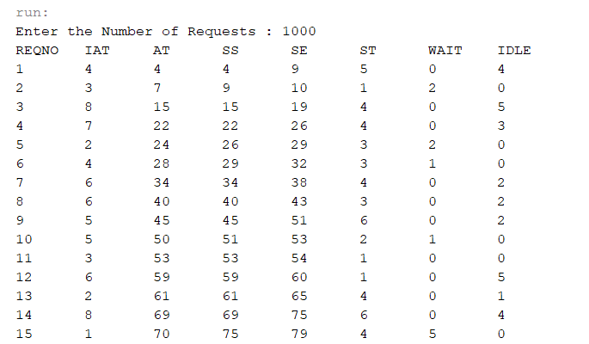

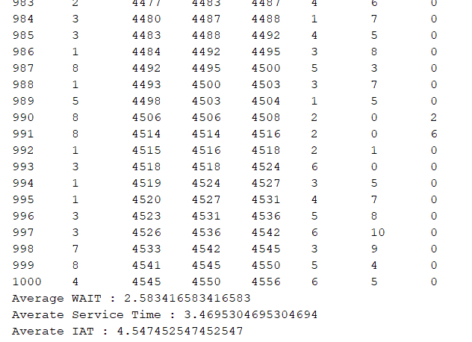

1. Conclusions

Single Server Queue

This is the simplest queuing system as represented in the following figure. The central element of the system is a server, which provides service to the connected devices or items. Items request to the system to be served, if the server is idle. Then, it is served immediately, else it joins a waiting queue. After the task is completed by the server, the item departs.

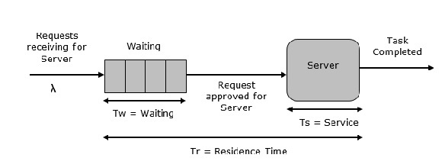

# Laboratory 3: Simulation of a two server Queue (Able Baker Problem)

1. Introduction and Purpose of Experiment
2. Aim and Objectives
3. Experimental Procedure

An ATM booth has a two machine to withdraw cash. Customers arrive at the ATM at random times that are from 1 to 4 minutes apart with the respective probabilities of time taken for arrival shown in Table below. Service times of machine **A**ble vary from 2 to 5 minutes and service times of machine **Baker** vary from 3 to 6 minutes with the respective probabilities of time taken for service shown in Table below:

Simulate the system for arrival of 1000 customers starting with an empty ATM queue to determine the following:

i. Average waiting time of a customer

ii. Total time in the system

**IAT Able Baker**

  

Use random numbers between 1 to 1000 to determine inter arrival time, and random numbers between 1 to 100 to determine service time

1. Algorithms
2. Presentation of Results

/*

 * To change this license header, choose License Headers in Project Properties.

 * To change this template file, choose Tools | Templates

 * and open the template in the editor.

 */

package lab03;

import java.util.Arrays;

import java.util.Random;

import java.util.Scanner;

/**

 *

 * @author shadowleaf

 */

public class Lab03 {

    /**

     * @param arr

     * @param e

     * @param sta

     * @param end

     */

    public static void fillArray(int arr[], int e, int sta, int end) {

        for (int i = sta ; i <= end ; i++) {

            arr[i] = e;

        }

    }

    public static int[] prepareProbDist(double prob[], int ass_prob[]) {

        int[] cumulativeProb = new int[ass_prob.length];

        int[] prob_lookup = new int[101];

        cumulativeProb[0] = (int)(prob[0] * 100);

        for (int i = 1 ; i < cumulativeProb.length ; i++) {

            cumulativeProb[i] = (int)(cumulativeProb[i-1] + prob[i] * 100);

        }

        int start = 0;

        for (int i = 0 ; i < cumulativeProb.length ; i++) {

            int end = cumulativeProb[i];

            fillArray(prob_lookup, ass_prob[i], start, end);

            start = end;

        }

        return prob_lookup;

    }

    /**

     *

     * @param args

     */

    public static void main(String[] args) {

        Scanner input = new Scanner(System.in);

        System.out.print("Enter the Number of Requests : ");

        Integer N = input.nextInt();

        Random rand = new Random();

        double[] IATPROB = {0.25, 0.40, 0.20, 0.15};

        int[] IAT_ASS = {1, 2, 3, 4}; // IAT Associated

        int[] IAT_LOOKUP = prepareProbDist(IATPROB, IAT_ASS);

        double[] APROB = {0.30, 0.28, 0.25, 0.17};

        int[] AST_ASS = {2, 3, 4, 5};

        int[] AST_LOOKUP = prepareProbDist(APROB, AST_ASS);

        double[] BPROB = {0.35, 0.25, 0.20, 0.20};

        int[] BST_ASS = {3, 4, 5, 6};

        int[] BST_LOOKUP = prepareProbDist(BPROB, BST_ASS);

        // generate IAT, AST, BST

        int[] IAT = new int[N+1];

        int[] AST = new int[N+1];

        int[] BST = new int[N+1];

//        int[] IAT = new int[N+1];

        int[] ST = new int[N+1];

        int[] AT = new int[N+1];

        int[] ASS = new int[N+1];

        int[] ASE = new int[N+1];

        int[] BSS = new int[N+1];

        int[] BSE = new int[N+1];

        int[] TIS = new int[N+1];

        int[] WAIT = new int[N+1];

// Randomly directly generate the IAT and ST

//        for (int i = 1 ; i <= N ; i++) {

//            IAT[i] = rand.nextInt(8) + 1;

//            ST[i] = rand.nextInt(6) + 1;

//        }

// Testing :

//        int[] ST = {0, 6, 1, 5, 5, 5};

//        int[] IAT = {0, 3, 2, 3, 1, 5};

        int idxAbleLastBusy = 0;

        int idxBakerLastBusy = 0;

        for (int i = 1 ; i <= N ; i++) {

            // generate random number from 0 to 100

            int randNum = rand.nextInt(101);

            // get a random IAT from the lookup table

            IAT[i] = IAT_LOOKUP[randNum];

            AT[i] = AT[i-1] + IAT[i];

            boolean ableIsFree = ASE[idxAbleLastBusy] <= AT[i];

            boolean bakerIsFree = BSE[idxBakerLastBusy] <= AT[i];

            if (ableIsFree) {

                // get a random service time for Able

                ST[i] = AST_LOOKUP[randNum];

                ASS[i] = AT[i]; ASE[i] = AT[i] + ST[i];

                TIS[i] = AT[i] - ASE[i]; WAIT[i] = ASS[i] - AT[i];

                idxAbleLastBusy = i;

            } else if (bakerIsFree) {

                // get a random serivce time for Baker

                ST[i] = BST_LOOKUP[randNum];

                BSS[i] = AT[i]; BSE[i] = AT[i] + ST[i];

                TIS[i] = AT[i] - BSE[i]; WAIT[i] = BSS[i] - AT[i];

                idxBakerLastBusy = i;

            } else { // neither of them is free

                // check who gets free first

                boolean isAbleFreeFirst = ASE[idxAbleLastBusy] <= BSE[idxBakerLastBusy];

                if (isAbleFreeFirst) { // able is free first

                    ST[i] = AST_LOOKUP[randNum];

                    ASS[i] = ASE[idxAbleLastBusy]; ASE[i] = ASE[idxAbleLastBusy] + ST[i];

                    TIS[i] = AT[i] - ASE[i]; WAIT[i] = ASS[i] - AT[i];

                    idxAbleLastBusy = i;

                } else { // baker is free first

                    ST[i] = BST_LOOKUP[randNum];

                    BSS[i] = BSE[idxBakerLastBusy]; BSE[i] = BSE[idxBakerLastBusy] + ST[i];

                    TIS[i] = AT[i] - BSE[i]; WAIT[i] = BSS[i] - AT[i];

                    idxBakerLastBusy = i;

                }

            }

            // mat pucho ye bakwaas kahe kiye hum

            TIS[i] *= -1;

        }

        System.out.printf("|%s\t|%s\t|%s\t|%s\t|%s\t|%s\t|%s\t|%s\t|%s\t|%s\t\n", "REQNO", "IAT", "ST", "AT", "ASS", "ASE", "BSS", "BSE", "TIS", "WAIT");

        for (int i = 1 ; i <= N ; i++) {

            System.out.printf("|%d\t|%d\t|%d\t|%d\t|%d\t|%d\t|%d\t|%d\t|%s\t|%s\t\n", i, IAT[i], ST[i], AT[i], ASS[i], ASE[i], BSS[i], BSE[i], TIS[i], WAIT[i]);

        }

        System.out.printf("Aberage Waiting Time : %.5f\nTotal Time in System : %d\n", Arrays.stream(WAIT).mapToDouble(a -> a).average().getAsDouble(), Arrays.stream(TIS).sum());

    }

}

1. Analysis and Discussions

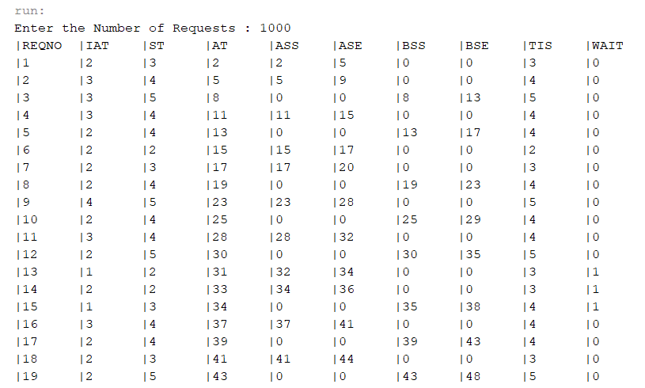

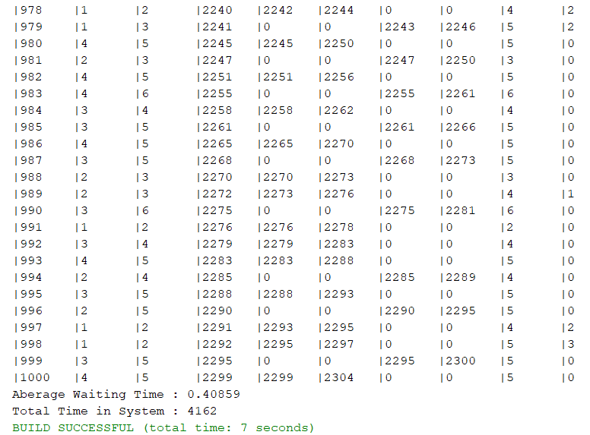

1. Conclusions

# Laboratory 4: Discrete Distributions AND Continuous Distributions

1. Introduction and Purpose of Experiment
2. Aim and Objectives
3. Experimental Procedure

Design and Implement a Java program for the following **Discrete Probability Distribution**

* 1. Binomial distribution
     1. To find the number of successes in **n** independent Bernoulli trials, given that **X** has a binomial distribution
     2. Calculate the
        1. Mean, E(X)
        2. Variance, V(X)
  2. Geometric distribution
     1. To identify the number of Bernoulli trials, *X*, to achieve the 1st success
     2. Calculate the
        1. Mean, *E(X)*
        2. Variance *V(X)*
  3. Negative binomial distribution

1. To identify the number of Bernoulli trials, X, until the kth success
2. Calculate the Mean, E(X) and Variance V(X)
   1. Develop and implement a Java program by selecting suitable distribution function for given scenario:If 40% of the assembled ink-jet printers are rejected at the inspection station. Your program should identify:
3. Probability that the first acceptable ink-jet printer is the third one inspected. Considering each inspection as a Bernoulli trial with q=0.4 and p=0.6.
4. Probability that the third printer inspected is the second acceptable printer
5. Design and Implement a Java program for the following **Continuous Distribution**

A computer repair person is “beeped” each time there is a call for service. If the number of beeps per hour is Poisson distributed (α = 2 beeps per hour). Then design and implement a Java program to determine the following.

* + 1. The probability of exactly three beeps in the next hour:
    2. The probability of two or more beeps in a 1-hour period:

1. Algorithms
2. Presentation of Results

/*

 * To change this license header, choose License Headers in Project Properties.

 * To change this template file, choose Tools | Templates

 * and open the template in the editor.

 */

package lab04;

import java.util.Scanner;

/**

 *

 * @author shadowleaf

 */

public class Lab04 {

    /**

     * @param args the command line arguments

     */

    public static void main(String[] args) {

        Scanner input = new Scanner(System.in);

        Distribution.DISTR_TYPE currDistr;

        Integer choice;

        System.out.print("Enter the Distrubution you want\n1.\tBinomial\n2.\tGeometrical\n3.\tNegative Binomial\n4.\tPoisson\nYour Choice : ");

        choice = input.nextInt();

        Distribution distr = null;

        switch (choice) {

            case 1: {

                // Binomial

                currDistr = Distribution.DISTR_TYPE.BINOM;

                System.out.print("Enter N : ");

                Long N = input.nextLong();

                System.out.print("Enter X : ");

                Long K = input.nextLong();

                System.out.print("Enter P (success) : ");

                Double P = input.nextDouble();

                distr = new BinomialDistribution(currDistr, N, P, K);

            }

            break;

            case 2: {

                // Geometrical

                currDistr = Distribution.DISTR_TYPE.GEOMT;

                System.out.print("Enter P (success) : ");

                Double P = input.nextDouble();

                System.out.print("Enter K : ");

                Long K = input.nextLong();

                distr = new GeometricDistribution(currDistr, P, K);

            }

            break;

            case 3: {

                // Negative Binomial

                currDistr = Distribution.DISTR_TYPE.NBINOM;

                System.out.print("Enter P (success) : ");

                Double P = input.nextDouble();

                System.out.print("Enter N : ");

                Long N = input.nextLong();

                System.out.print("Enter R : ");

                Long R = input.nextLong();

                distr = new NegativeBinomialDistribution(currDistr, P, N, R);

            }

            break;

            case 4: {

                // Poisson

                currDistr = Distribution.DISTR_TYPE.POISSON;

                System.out.print("Enter lambda : ");

                Double lambda = input.nextDouble();

                System.out.print("Enter K : ");

                Long K = input.nextLong();

                distr = new PoissonDistribution(currDistr, lambda, K);

            }

            break;

            default:

                main(args);

                return;

        }

        if (distr != null) {

            System.out.printf("P( X = %d ) = %.10f\nE[X] = %.10f\nVar[X] = %.10f\n",

                    distr.getParam(), distr.getDistribution(), distr.getExpectance(), distr.getVariance());

        } else {

            System.out.println("DISTR IS NULL");

        }

    }

}

/*

 * To change this license header, choose License Headers in Project Properties.

 * To change this template file, choose Tools | Templates

 * and open the template in the editor.

 */

package lab04;

/**

 *

 * @author shadowleaf

 */

public abstract class Distribution {

    public static enum DISTR_TYPE {

        BINOM, GEOMT, NBINOM, POISSON

    };

    public Distribution(DISTR_TYPE currentDistr) {

        this.currentDistr = currentDistr;

    }

    public DISTR_TYPE currentDistr;

    public static Long choose(Long n, Long r) {

        if (r > n/2)

            r = n - r;

        Long ans = 1l;

        for (int i = 1 ; i <= r ; i++) {

            ans *= (n - r + i);

            ans /= i;

        }

        return ans;

    }

    public abstract Long getParam();

    /**

     *

     * Calculates P(X = K) generally speaking

     *

     * @return

     */

    public abstract Double getDistribution();

    public abstract Double getExpectance();

    public abstract Double getVariance();

}

/*

 * To change this license header, choose License Headers in Project Properties.

 * To change this template file, choose Tools | Templates

 * and open the template in the editor.

 */

package lab04;

/**

 *

 * @author shadowleaf

 */

public class BinomialDistribution extends Distribution {

    Long N, K;

    Double P;

    public BinomialDistribution(DISTR_TYPE currentDistr, Long N, Double P, Long K) {

        super(currentDistr);

        this.N = N;

        this.P = P;

        this.K = K;

    }

    public Double binomialDistribution() {

        return choose(N, K) * (double)Math.pow(P, K) * (double)Math.pow( 1 - P, N - K);

    }

    @Override

    public Double getDistribution() {

        return binomialDistribution();

    }

    @Override

    public Double getExpectance() {

        return (double)N * P;

    }

    @Override

    public Double getVariance() {

        return N * P * (1.0 - P);

    }

    @Override

    public Long getParam() {

        return K;

    }

}

/*

 * To change this license header, choose License Headers in Project Properties.

 * To change this template file, choose Tools | Templates

 * and open the template in the editor.

 */

package lab04;

/**

 *

 * @author shadowleaf

 */

public class GeometricDistribution extends Distribution {

    Double P;

    Long K;

    public GeometricDistribution(DISTR_TYPE currentDistr, Double P, Long K) {

        super(currentDistr);

        this.P = P;

        this.K = K;

    }

    public Double geometricDistribution() {

        return (double)Math.pow(1 - P, K - 1) * P;

    }

    @Override

    public Double getDistribution() {

        return geometricDistribution();

    }

    @Override

    public Double getExpectance() {

        return (1.0) / P;

    }

    @Override

    public Double getVariance() {

        return (1 - P) / (P * P);

    }

    @Override

    public Long getParam() {

        return K;

    }

}

/*

 * To change this license header, choose License Headers in Project Properties.

 * To change this template file, choose Tools | Templates

 * and open the template in the editor.

 */

package lab04;

/**

 *

 * @author shadowleaf

 */

public class NegativeBinomialDistribution extends Distribution {

    Double P;

    Long R;

    Long N;

    public NegativeBinomialDistribution(DISTR_TYPE currentDistr, Double P, Long N, Long R) {

        super(currentDistr);

        this.P = P;

        this.R = R;

        this.N = N;

    }

    @Override

    public Double getDistribution() {

        return choose(N-1, R-1) * Math.pow(P, N-R) * (double)Math.pow(1-P, R);

    }

    @Override

    public Double getExpectance() {

        return R / P;

    }

    @Override

    public Double getVariance() {

        return (R * (1.0 - P)) / (P * P);

    }

    @Override

    public Long getParam() {

        return R;

    }

}

/*

 * To change this license header, choose License Headers in Project Properties.

 * To change this template file, choose Tools | Templates

 * and open the template in the editor.

 */

package lab04;

/**

 *

 * @author shadowleaf

 */

public class PoissonDistribution extends Distribution {

    Double lambda;

    Long K;

    public PoissonDistribution(DISTR_TYPE currentDistr, Double lambda, Long K) {

        super(currentDistr);

        this.lambda = lambda;

        this.K = K;

    }

    @Override

    public Double getDistribution() {

        Double ans = Math.pow(lambda, K) * Math.exp(-lambda);

        for (Long i = 1l; i <= K; i++) {

            ans /= i;

        }

        return ans;

    }

    @Override

    public Double getExpectance() {

        return lambda;

    }

    @Override

    public Double getVariance() {

        return getExpectance();

    }

    @Override

    public Long getParam() {

        return K;

    }

}

1. Analysis and Discussions

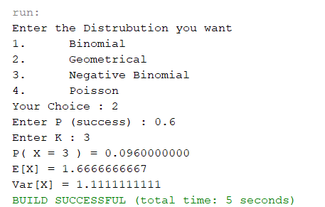

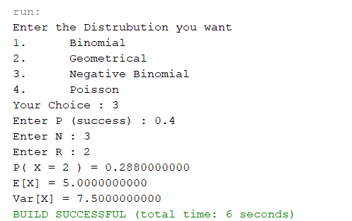

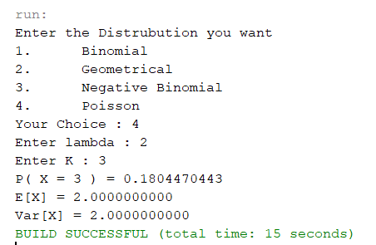

1. Conclusions
   1. Bernoulli Distribution
 $$P\left(X=x\right)=p^{x}{\left(1-p\right)}^{1-x}$$

 $$μ=p \\ σ^{2}=p(1-p)$$

 2. Binomial Distribution
 $$P\left(X=x\right)=nC_{x}p^{x}q^{n-x}$$

 $$μ=np \\ σ^{2}=np(1-p)$$

 3. Geometric Distribution
 $$P\left(X=x\right)=p{\left(1-p\right)}^{x-1}$$

 $$μ=\frac{1}{p} \\ σ^{2}=\frac{q}{p^{2}}$$

 4. Negative Binomial Distribution
 $$P\left(X=x\right)=x-1C_{r-1}p^{r}{\left(1-p\right)}^{x-r}$$

 $$μ=\frac{r}{p} \\ σ^{2}=\frac{rq}{p^{2}}$$

 5. Poisson Distribution

$$P\left(X=x\right)=\frac{λ^{x}e^{-λ}}{x!}$$

$$μ=λ \\ σ^{2}=λ$$

# Laboratory 5: Random Number generator using LCG and MCG

1. Introduction and Purpose of Experiment
2. Aim and Objectives
3. Experimental Procedure
4. Develop and implement a Java program to generate pseudorandom numbers based on the linear congruential random number generator to produce a sequence of 20 integers, $X$ 1 $, X$ 2 $, …$ between 0 and $m-1 b$ y following a recursive relationship: Use 0, and.
5. Modify the above program for multiplicative congruential method to determine the period of the generator for, and0,.

Satisfy the following property of max period $(P):$

1. Generate random numbers with longest possible period is $P = m = 2^{b}$
2. Generate random numbers with longest possible period is $P = m / 4 = 2^{b-2 }$
3. Algorithms
4. Presentation of Results

/*

 * To change this license header, choose License Headers in Project Properties.

 * To change this template file, choose Tools | Templates

 * and open the template in the editor.

 */

package lab05;

import java.util.ArrayList;

import java.util.Arrays;

/**

 *

 * @author shadowleaf

 */

public class Lab05 {

    /**

     * @param args the command line arguments

     */

    public static void main(String[] args) {

        {

            // X_n+1 = (aX_n + c) mod m

            // X_0 = 27

            // a = 17

            // c = 43

            // m = 100

            // n = 20

            System.out.println("LCG ----------\n");

            Integer a = 17, c = 43, m = 100, n = 20;

            ArrayList<Integer> X = new ArrayList<>();

            X.add(27);

            System.out.printf("X0 = %d, a = %d, c = %d, m = %d, n = %d\n", X.get(0), a, c, m, n);

            for (int i = 0; i < n; i++) {

                X.add((a * X.get(i) + c) % m);

            }

            Integer i = 0;

            for (Integer e : X) {

                System.out.printf("X%d = %d, ", i++, e);

            }

            System.out.println("\n");

        }

        {

            System.out.println("MCG ----------\n");

            // a = 13

            // m = 2^6

            // X_0 = 1, 2, 3, 4

            Integer a = 13;

            Integer m = 1 << 6;

            // important

            ArrayList<Integer> C = new ArrayList(Arrays.asList(17, 0));

            for (Integer c : C) {

            ArrayList<ArrayList<Integer>> X = new ArrayList<>();

            X.add(new ArrayList(Arrays.asList(1))); // X0 = 1

            X.add(new ArrayList(Arrays.asList(2))); // X0 = 2

            X.add(new ArrayList(Arrays.asList(3))); // X0 = 3

            X.add(new ArrayList(Arrays.asList(4))); // X0 = 4

                for (int i = 0; i < X.size(); i++) {

                    Integer X0 = X.get(i).get(0);

                    // if X0 is even c should not be zero

                    if ( (X0 % 2 == 0) && (c == 0) ) {

                        continue;

                    }

                    System.out.printf("X0 = %d, a = %d, c = %d, m = %d\n", X0, a, c, m);

                    Integer j = 0;

                    while (true) {

                        Integer Xnew = (a * X.get(i).get(j++) + c) % m;

                        X.get(i).add(Xnew);

                        if (Xnew.equals(X0)) {

                            System.out.printf("P = %d\n", j);

                            Integer k = 0;

                            for (Integer e : X.get(i)) {

                                System.out.printf("X%d = %d, ", k++, e);

                            }

                            System.out.println("\n");

                            break;

                        }

                    }

                }

            }

        }

    }

}

1. Analysis and Discussions

run:

LCG ----------

X0 = 27, a = 17, c = 43, m = 100, n = 20

X0 = 27, X1 = 2, X2 = 77, X3 = 52, X4 = 27, X5 = 2, X6 = 77, X7 = 52, X8 = 27, X9 = 2, X10 = 77, X11 = 52, X12 = 27, X13 = 2, X14 = 77, X15 = 52, X16 = 27, X17 = 2, X18 = 77, X19 = 52, X20 = 27,

MCG ----------

X0 = 1, a = 13, c = 17, m = 64

P = 64

X0 = 1, X1 = 30, X2 = 23, X3 = 60, X4 = 29, X5 = 10, X6 = 19, X7 = 8, X8 = 57, X9 = 54, X10 = 15, X11 = 20, X12 = 21, X13 = 34, X14 = 11, X15 = 32, X16 = 49, X17 = 14, X18 = 7, X19 = 44, X20 = 13, X21 = 58, X22 = 3, X23 = 56, X24 = 41, X25 = 38, X26 = 63, X27 = 4, X28 = 5, X29 = 18, X30 = 59, X31 = 16, X32 = 33, X33 = 62, X34 = 55, X35 = 28, X36 = 61, X37 = 42, X38 = 51, X39 = 40, X40 = 25, X41 = 22, X42 = 47, X43 = 52, X44 = 53, X45 = 2, X46 = 43, X47 = 0, X48 = 17, X49 = 46, X50 = 39, X51 = 12, X52 = 45, X53 = 26, X54 = 35, X55 = 24, X56 = 9, X57 = 6, X58 = 31, X59 = 36, X60 = 37, X61 = 50, X62 = 27, X63 = 48, X64 = 1,

X0 = 2, a = 13, c = 17, m = 64

P = 64

X0 = 2, X1 = 43, X2 = 0, X3 = 17, X4 = 46, X5 = 39, X6 = 12, X7 = 45, X8 = 26, X9 = 35, X10 = 24, X11 = 9, X12 = 6, X13 = 31, X14 = 36, X15 = 37, X16 = 50, X17 = 27, X18 = 48, X19 = 1, X20 = 30, X21 = 23, X22 = 60, X23 = 29, X24 = 10, X25 = 19, X26 = 8, X27 = 57, X28 = 54, X29 = 15, X30 = 20, X31 = 21, X32 = 34, X33 = 11, X34 = 32, X35 = 49, X36 = 14, X37 = 7, X38 = 44, X39 = 13, X40 = 58, X41 = 3, X42 = 56, X43 = 41, X44 = 38, X45 = 63, X46 = 4, X47 = 5, X48 = 18, X49 = 59, X50 = 16, X51 = 33, X52 = 62, X53 = 55, X54 = 28, X55 = 61, X56 = 42, X57 = 51, X58 = 40, X59 = 25, X60 = 22, X61 = 47, X62 = 52, X63 = 53, X64 = 2,

X0 = 3, a = 13, c = 17, m = 64

P = 64

X0 = 3, X1 = 56, X2 = 41, X3 = 38, X4 = 63, X5 = 4, X6 = 5, X7 = 18, X8 = 59, X9 = 16, X10 = 33, X11 = 62, X12 = 55, X13 = 28, X14 = 61, X15 = 42, X16 = 51, X17 = 40, X18 = 25, X19 = 22, X20 = 47, X21 = 52, X22 = 53, X23 = 2, X24 = 43, X25 = 0, X26 = 17, X27 = 46, X28 = 39, X29 = 12, X30 = 45, X31 = 26, X32 = 35, X33 = 24, X34 = 9, X35 = 6, X36 = 31, X37 = 36, X38 = 37, X39 = 50, X40 = 27, X41 = 48, X42 = 1, X43 = 30, X44 = 23, X45 = 60, X46 = 29, X47 = 10, X48 = 19, X49 = 8, X50 = 57, X51 = 54, X52 = 15, X53 = 20, X54 = 21, X55 = 34, X56 = 11, X57 = 32, X58 = 49, X59 = 14, X60 = 7, X61 = 44, X62 = 13, X63 = 58, X64 = 3,

X0 = 4, a = 13, c = 17, m = 64

P = 64

X0 = 4, X1 = 5, X2 = 18, X3 = 59, X4 = 16, X5 = 33, X6 = 62, X7 = 55, X8 = 28, X9 = 61, X10 = 42, X11 = 51, X12 = 40, X13 = 25, X14 = 22, X15 = 47, X16 = 52, X17 = 53, X18 = 2, X19 = 43, X20 = 0, X21 = 17, X22 = 46, X23 = 39, X24 = 12, X25 = 45, X26 = 26, X27 = 35, X28 = 24, X29 = 9, X30 = 6, X31 = 31, X32 = 36, X33 = 37, X34 = 50, X35 = 27, X36 = 48, X37 = 1, X38 = 30, X39 = 23, X40 = 60, X41 = 29, X42 = 10, X43 = 19, X44 = 8, X45 = 57, X46 = 54, X47 = 15, X48 = 20, X49 = 21, X50 = 34, X51 = 11, X52 = 32, X53 = 49, X54 = 14, X55 = 7, X56 = 44, X57 = 13, X58 = 58, X59 = 3, X60 = 56, X61 = 41, X62 = 38, X63 = 63, X64 = 4,

X0 = 1, a = 13, c = 0, m = 64

P = 16

X0 = 1, X1 = 13, X2 = 41, X3 = 21, X4 = 17, X5 = 29, X6 = 57, X7 = 37, X8 = 33, X9 = 45, X10 = 9, X11 = 53, X12 = 49, X13 = 61, X14 = 25, X15 = 5, X16 = 1,

X0 = 3, a = 13, c = 0, m = 64

P = 16

X0 = 3, X1 = 39, X2 = 59, X3 = 63, X4 = 51, X5 = 23, X6 = 43, X7 = 47, X8 = 35, X9 = 7, X10 = 27, X11 = 31, X12 = 19, X13 = 55, X14 = 11, X15 = 15, X16 = 3,

1. Conclusions

**The max period(P) is:**

* + For m a power of 2, say m = 2b, and c ≠0, the longest possible period is P = m = 2b , which is achieved provided that c is relatively prime to m (that is, the greatest common factor of c and m is 1), and a = 1 + 4k, where k is an integer.

1. For m a power of 2, say m = 2b, and c = 0, the longest possible period is P = m / 4 = 2b-2 , which is achieved provided that the seed X0 is odd and the multiplier, a, is given by a = 3 + 8k or a = 5 + 8k, for some k = 0, 1,...
2. For m a prime number and c = 0, the longest possible period is P = m - 1, which is achieved provided that the multiplier, a, has the property that the smallest integer k such that ak - 1 is divisible by m is k = m - 1,

# Laboratory 6: Random Variate Generator using lnverse-Transfonn Technique

1. Introduction and Purpose of Experiment
2. Aim and Objectives
3. Experimental Procedure

Design and implement a Java program to determine a sequence of 10 random variates $X$ by generating a sequence of random numbers $R$ using the flowing distributions:

* + 1. Uniform distribution in the interval [10, 20]
    2. Exponential distribution with mean value 5
    3. Normal distribution with mean 3.1 and sigma 0.6

1. Algorithms
2. Presentation of Results

/*

 * To change this license header, choose License Headers in Project Properties.

 * To change this template file, choose Tools | Templates

 * and open the template in the editor.

 */

package lab06;

import java.util.Random;

import java.util.Scanner;

/**

 *

 * @author shadowleaf

 */

public class Lab06 {

    /**

     * @param args the command line arguments

     */

    public static void main(String[] args) {

        Scanner input = new Scanner(System.in);

        Random random = new Random();

        int N = 10;

        double []R = new double[N];

        double []X = new double[N];

        for (int i = 0 ; i < R.length ; i++) {

            R[i] = random.nextDouble();

        }

        boolean done = false;

        System.out.print("Random Variate Generator\n"

                + "1.\tUniform Distribution\n"

                + "2.\tExponential Distribution\n"

                + "3.\tNormal Distribution\n"

                + "Your Choice : ");

        switch(input.nextInt()) {

            case 1: {

                int a, b;

                System.out.print("Enter value of a : ");

                a = input.nextInt();

                System.out.print("Enter value of b : ");

                b = input.nextInt();

                for (int i = 0 ; i < X.length ; i++) {

                    X[i] = a + (b-a) * R[i];

                }

                done = true;

            }

                break;

            case 2: {

                double lambda;

                System.out.print("Enter the value of lambda : ");

                lambda = input.nextDouble();

                for (int i = 0 ; i < X.length ; i++) {

                    X[i] = Math.log(R[i]) / (-lambda);

                }

                done = true;

            }

                break;

            case 3: {

                double meu, sigma;

                System.out.print("Enter the value of meu : ");

                meu = input.nextDouble();

                System.out.print("Enter the value of sigma : ");

                sigma = input.nextDouble();

                for (int i = 0 ; i < X.length ; i++) {

                    X[i] = (Math.pow(R[i], 0.135) - Math.pow(1-R[i], 0.135) ) / 0.1975;

                    X[i] = X[i] * sigma + meu;

                }

                done = true;

            }

                break;

        }

        if (done) {

            System.out.println("\nThe Random Variates are  : ");

            for (int i = 0 ; i < X.length ; i++) {

                System.out.print(X[i]+"\n");

            }

            System.out.println();

        }

    }

}

1. Analysis and Discussions

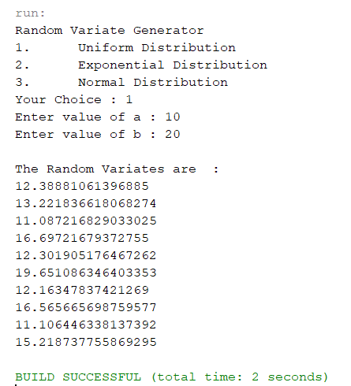

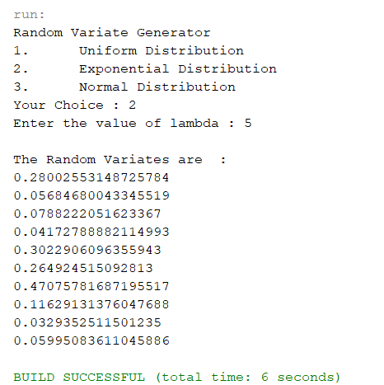

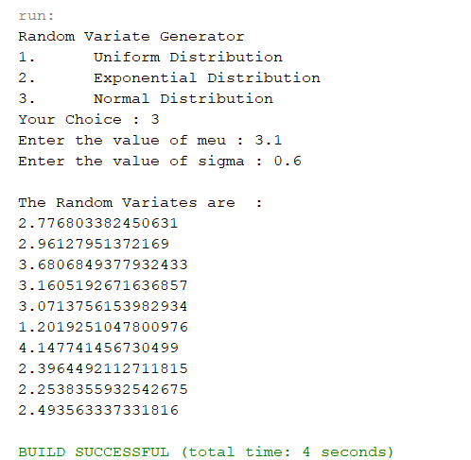

1. Conclusions

Standard Normal Distribution

The inverse CDF of the standard normal distribution is approximated as:

$$X=F^{-1}\left(R\right)=\frac{R^{0.135}-{\left(1-R\right)}^{0.135}}{0.1975}$$

Example usage for $X\sim Nor(μ, σ^{2})$, $Z\sim Nor(0, 1)$

Then take $X←μ+σZ$

Taking example of $X\sim Nor(3, 16)$ and $R=0.59$

Then

$$X=μ+σZ=3+4Φ^{-1}\left(0.59\right)=3+4\left(0.2275\right)=3.91$$

Exponential Distribution

$$X=-\frac{\ln{(1-R)}}{λ}$$

Or

$$X=-\frac{\ln{(R)}}{λ}$$

Uniform Distribution

$$X=a+(b-a)R$$

# Laboratory 7: Tests for Random Numbers using Frequency Tests

1. Introduction and Purpose of Experiment
2. Aim and Objectives
3. Experimental Procedure

**K-S Test**

Design and implement a Java program to test the generated random numbers 0.44, 0.81, 0.14, 0.05, 0.93 for uniformity by using the Kolmogorov-Smirnov test with the level of significance α= 0.10

**Chi-Square test**

A public opinion poll surveyed a random sample of 1000 voters. Respondents were classified by gender (male or female) and by voting preference (BJP, Congress and AAP). Results are shown below:

|  |  |  |  |  |
| --- | --- | --- | --- | --- |
|  | Programing language Preferences | | | Row total |
| BJP | Congress | AAP |
| Male | 200 | 150 | 50 | 400 |
| Female | 250 | 300 | 50 | 600 |
| Column total | 450 | 450 | 100 | 1000 |

Design and implement a Java program to conduct chi-square test with $α = 0.05$ level of significance and determine if there is a gender gap. Identify whether the men’s preferences differ significantly from the women's preferences.

1. Algorithms

**KS-Test**

-> Rank the N random numbers in ascending order.

-> Calculate D+ as max(i/N-Ri) for all i in(1, N)

-> Calculate D- as max(Ri-((i-1)/N)) for all i in(1, N)

-> Calculate D as max(D+, D-)

-> If D>D(alpha)

Rejects Uniformity

else

It fails to reject the Null Hypothesis.

**Chi-Square Test**

First calculate the expected frequencies for the groups, then determining whether the division of the groups, called the observed frequencies, matches the expected frequencies.

The result of the test is a test statistic that has a chi-squared distribution and can be interpreted to reject or fail to reject the assumption or null hypothesis that the observed and expected frequencies are the same.

1. Presentation of Results

/*

 * To change this license header, choose License Headers in Project Properties.

 * To change this template file, choose Tools | Templates

 * and open the template in the editor.

 */

package lab07;

import java.util.Arrays;

/**

 *

 * @author shadowleaf

 */

public class Lab07 {

    /**

     * @param args the command line arguments

     */

    public static void main(String[] args) {

        {

            System.out.println("KS Test");

            Double[] rn = {0.44, 0.81, 0.14, 0.05, 0.93};

            Arrays.sort(rn);

            Integer N = rn.length;

            Double Dplus = Double.MIN_VALUE;

            Double Dminus = Double.MIN_VALUE;

            Double i = 1.0;

            for (int idx = 0; idx < N; idx++) {

                Double newDplus = ((i / N) - rn[idx]);

                Double newDminus = rn[idx] - ((i - 1) / N);

                Dplus = Math.max(Dplus, newDplus);

                Dminus = Math.max(Dminus, newDminus);

//            System.out.printf("newDplus = %.10f, newDminus = %.10f\n", newDplus, newDminus);

                System.out.printf("Dplus_%d = %.10f, Dminus_%d = %.10f\n", idx + 1, newDplus, idx + 1, newDminus);

                i += 1.0;

            }

            Double D = Math.max(Dplus, Dminus);

            System.out.printf("Dplus : %.10f\nDminus : %.10f\nD : %.10f\n", Dplus, Dminus, D);

            Double alpha = 0.05;

        }

        {

            System.out.println("\nChi-Square Test");

            Integer[][] data_obs = {{200, 150, 50}, {250, 300, 50}};

            Integer nrows = data_obs.length;

            Integer ncols = data_obs[0].length;

            Integer[] col_total = new Integer[ncols];

            Integer[] row_total = new Integer[nrows];

            Integer total = 0;

            int row, col;

            // calculate col totals

            for (col = 0; col < col_total.length; col++) {

                col_total[col] = 0;

                for (row = 0; row < nrows; row++) {

                    col_total[col] += data_obs[row][col];

                }

                total += col_total[col];

            }

            // calculate row totals

            for (row = 0; row < row_total.length; row++) {

                row_total[row] = 0;

                for (col = 0; col < ncols; col++) {

                    row_total[row] += data_obs[row][col];

                }

            }

//            System.out.println(Arrays.toString(row_total));

//            System.out.println(Arrays.toString(col_total));

//            System.out.println(total);

            Double[][] data_exp = new Double[nrows][ncols];

            // calculate expected values

            for (row = 0; row < nrows; row++) {

                for (col = 0; col < ncols; col++) {

                    data_exp[row][col] = col_total[col] * row_total[row] / (double) total;

//                    System.out.printf("%.5f ", data_exp[row][col]);

                }

//                System.out.println();

            }

            Double chi_sqr = 0.0;

            // calculate chi square

            for (row = 0; row < nrows; row++) {

                for (col = 0; col < ncols; col++) {

                    Double Oi = (double) data_obs[row][col];

                    Double Ei = data_exp[row][col];

                    chi_sqr += (Oi - Ei) * (Oi - Ei) / Ei;

                }

            }

            System.out.printf("Chi-Square = %.10f\n", chi_sqr);

            Integer dfree = (nrows - 1) * (ncols - 1);

            Double alpha = 0.05;

        }

    }

}

1. Analysis and Discussions

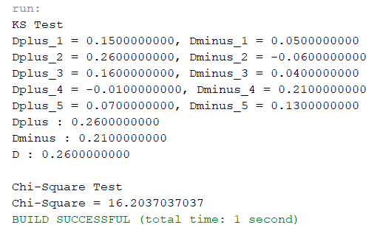

1. Conclusions

**KS-Test**

Kolmogorov–Smirnov test a very efficient way to determine if two samples are significantly different from each other. It is usually used to check the uniformity of random numbers. Uniformity is one of the most important properties of any random number generator and Kolmogorov–Smirnov test can be used to test it.

The Kolmogorov–Smirnov test may also be used to test whether two underlying one-dimensional probability distributions differ. It is a very efficient way to determine if two samples are significantly different from each other.

The Kolmogorov–Smirnov statistic quantifies a distance between the empirical distribution function of the sample and the cumulative distribution function of the reference distribution, or between the empirical distribution functions of two samples.

H0(Null Hypothesis): Null hypothesis assumes that the numbers are uniformly distributed between 0-1. If we are able to reject the Null Hypothesis, this means that the numbers are not uniformly distributed between 0-1. Failure to reject the Null Hypothesis although does not necessarily mean that the numbers follow the uniform distribution.

**Chi-square Test**

Chi-square Test for Feature Extraction:

Chi-square test is used for categorical features in a dataset. We calculate Chi-square between each feature and the target and select the desired number of features with best Chi-square scores. It determines if the association between two categorical variables of the sample would reflect their real association in the population.

