|  |  |
| --- | --- |
| **Assignment** | |
| **Course Code** | CSC309A |
| **Course Name** | Computer Graphics |
| **Programme** | B.Tech |
| **Department** | CSE |
| **Faculty** | FET |

|  |  |
| --- | --- |
| **Name of the Student** | Satyajit Ghana |
| **Reg. No.** | 17ETCS002159 |
| **Semester/Year** | 06/2020 |
| **Course Leader(s)** | Dr. Subarna Chatterjee |



|  |  |  |  |  |  |  |  |  |
| --- | --- | --- | --- | --- | --- | --- | --- | --- |
| Declaration Sheet | | | | | | | | |
| Student Name | Satyajit Ghana | | | | | | | |
| Reg. No | 17ETCS002159 | | | | | | | |
| Programme | B.Tech | | | | | Semester/Year | 06/2020 | |
| Course Code | CSC309A | | | | | | | |
| Course Title | Computer Graphics | | | | | | | |
| Course Date |  | | to |  | | | | |
| Course Leader | Dr. Subarna Chatterjee | | | | | | | |
| **Declaration**  The assignment submitted herewith is a result of my own investigations and that I have conformed to the guidelines against plagiarism as laid out in the Student Handbook. All sections of the text and results, which have been obtained from other sources, are fully referenced. I understand that cheating and plagiarism constitute a breach of University regulations and will be dealt with accordingly. | | | | | | | | |
| Signature of the Student | |  | | | | | Date |  |
| Submission date stamp  (by Examination & Assessment Section) | |  | | | | | | |
| Signature of the Course Leader and date | | | | | Signature of the Reviewer and date | | | |
|  | | | | |  | | | |

# Contents

Declaration Sheet ii

Contents iii

List of Figures iv

1 Question 1 5

1.1 Introduction 5

1.2 Implementation of Transformation 5

1.3 Results with Screenshot and Discussion 9

Bibliography 16

# List of Figures

Figure 1 Original Polygon 10

Figure 2 Rotated Polygon 11

Figure 3 Translated Polygon 12

Figure 4 Scaled Polygon 13

Figure 5 Final Transformed Polygon 14

# Question 1

Solution to Question No. 1

## Introduction

## Implementation of Transformation

**main.cpp**

#include <iostream>

#include <string>

#include <GL/freeglut.h>

#define WIN_WIDTH 1000

#define WIN_HEIGHT 1000

#define GRID_X_MIN -8

#define GRID_X_MAX 60

#define GRID_Y_MIN -8

#define GRID_Y_MAX 60

#define WIN_TITLE "Graphics Assignement"

int state = 0;

const unsigned char state_title[][20] = { "ORIGINAL", "ROTATED", "TRANSLATED", "SCALED", "FINAL TRANSFORMED" };

int total_states = 5;

void render();

void reshape(int, int);

void keyboard(unsigned char, int, int);

void special_keys(int key, int x, int y);

void init();

int main(int argc, char* argv[]) {

    glutInit(&argc, argv);

    // initialize the display mode

    glutInitDisplayMode(GLUT_DEPTH | GLUT_DOUBLE | GLUT_RGBA | GLUT_MULTISAMPLE);

    // for anti-aliasing

    glEnable(GLUT_MULTISAMPLE);

    // set the window position

    glutInitWindowPosition(100, 100);

    // set the window size

    glutInitWindowSize(WIN_WIDTH, WIN_HEIGHT);

    // now create the window

    glutCreateWindow(WIN_TITLE);

    // register the core functions

    glutDisplayFunc(render);

    glutReshapeFunc(reshape);

    glutKeyboardFunc(keyboard);

    glutSpecialFunc(special_keys);

    init();

    glutMainLoop();

    return 0;

}

void init() {

    glClearColor(164 / 255.0, 176 / 255.0, 190 / 255.0, 0.8);

    glFlush();

}

void reshape(int w, int h) {

    glMatrixMode(GL_MODELVIEW);

    glLoadIdentity();

    gluOrtho2D(GRID_X_MIN, GRID_X_MAX, GRID_Y_MIN, GRID_Y_MAX);

}

void show_grid() {

    glBegin(GL_LINES);

    const GLubyte prestigeBlue[] = { 47.0, 53.0, 66.0, 1.0 };

    const GLubyte pureRed[] = { 255.0, 0.0, 0.0, 1.0 };

    for (float i = GRID_X_MIN; i <= GRID_X_MAX; i += 1.0) {

        glColor4ubv(prestigeBlue);

        if (i == 0)

            glColor4ubv(pureRed);

        glVertex2f(i, GRID_Y_MIN);

        glVertex2f(i, GRID_Y_MAX);

    }

    for (float i = GRID_Y_MIN; i <= GRID_Y_MAX; i += 1.0) {

        glColor4ubv(prestigeBlue);

        if (i == 0)

            glColor4ubv(pureRed);

        glVertex2f(GRID_X_MIN, i);

        glVertex2f(GRID_X_MAX, i);

    }

    glEnd();

}

void polygon() {

    glBegin(GL_POLYGON);

    const GLubyte jalapenoRed[] = { 183.0, 21.0, 64.0, 1.0 };

    const GLubyte darkSapphire[] = { 12.0, 36.0, 97.0, 1.0 };

    const GLubyte forestBlues[] = { 10.0, 61.0, 98.0, 1.0 };

    const GLubyte reefEncounter[] = { 7.0, 153.0, 146.0, 1.0 };

    glColor4ubv(jalapenoRed);

    glVertex2f(-1.0, 1.0);

    glColor4ubv(darkSapphire);

    glVertex2f(-1.0, -1.0);

    glColor4ubv(forestBlues);

    glVertex2f(1.0, -1.0);

    glColor4ubv(reefEncounter);

    glVertex2f(1.0, 1.0);

    glEnd();

}

void show_original() {

    glPushMatrix();

    polygon();

    glPopMatrix();

}

void show_transformed() {

    glPushMatrix();

    glScalef(5.0, 6.0, 1.0);

    glTranslatef(4.0, 8.0, 0.0);

    glRotatef(90, 0.0, 0.0, 1.0);

    polygon();

    glPopMatrix();

}

void show_text() {

    glPushMatrix();

    glColor3f(0.0, 0.0, 0.0);

    glTranslatef(30.0, 30.0, 1.0);

    glRasterPos2f(0.0, 0.0);

    const unsigned char *string = state_title[state];

    glutBitmapString(GLUT_BITMAP_HELVETICA_18, string);

    glPopMatrix();

}

void render() {

    glClear(GL_COLOR_BUFFER_BIT | GL_DEPTH_BUFFER_BIT);

    show_text();

    show_grid();

    switch (state) {

        //ORIGINAL

    case 0:

        glPushMatrix();

        polygon();

        glPopMatrix();

        break;

        // ROTATED

    case 1:

        glPushMatrix();

        glRotatef(90, 0.0, 0.0, 1.0);

        polygon();

        glPopMatrix();

        break;

        // TRANSLATED

    case 2:

        glPushMatrix();

        glTranslatef(4.0, 8.0, 0.0);

        polygon();

        glPopMatrix();

        break;

        // SCALED

    case 3:

        glPushMatrix();

        glScalef(5.0, 6.0, 1.0);

        polygon();

        glPopMatrix();

        break;

        // FINAL TRANSFORMED

    case 4:

        show_grid();

        show_original();

        show_transformed();

        break;

    }

    glFlush();

    glutSwapBuffers();

}

void keyboard(unsigned char c, int x, int y) {

    switch (c) {

    case 13:

    case 'q':

    case 'Q':

        exit(EXIT_SUCCESS);

        break;

    }

}

void special_keys(int key, int x, int y) {

    switch (key) {

    case GLUT_KEY_RIGHT:

        state = ((state + 1) % total_states + total_states) % total_states;

        glutPostRedisplay();

        break;

    case GLUT_KEY_LEFT:

        state = ((state - 1) % total_states + total_states) % total_states;

        glutPostRedisplay();

        break;

    }

}

## Results with Screenshot and Discussion

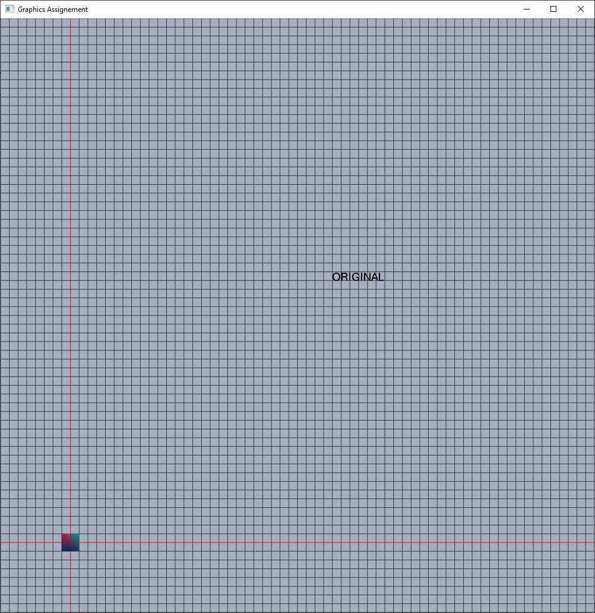

Figure Original Polygon

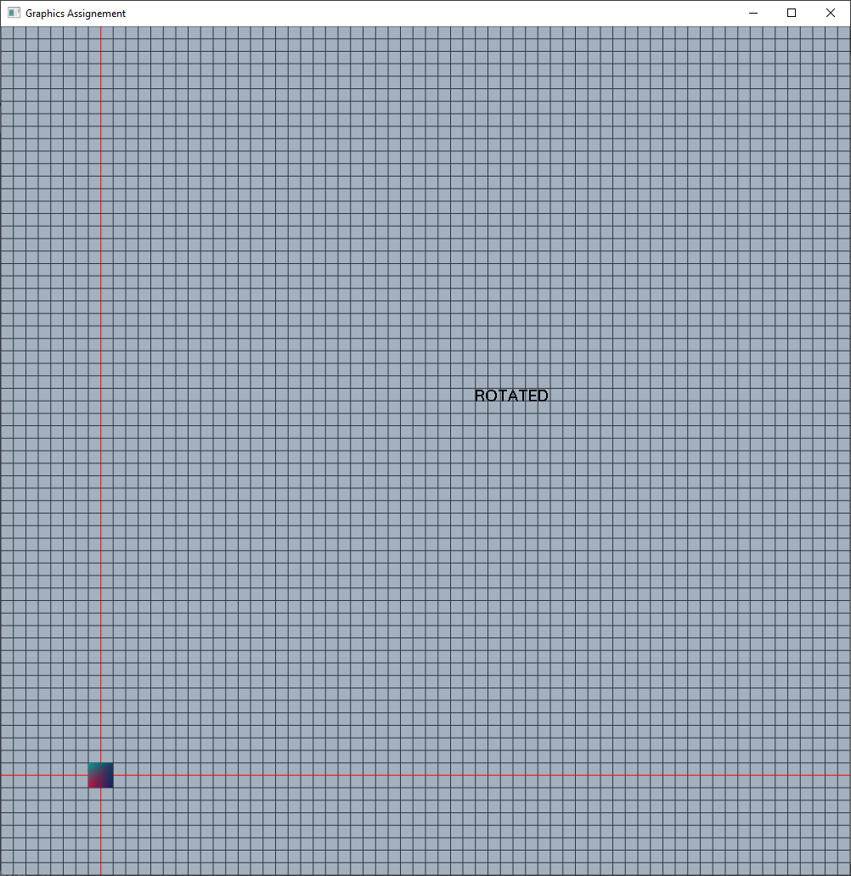

**(-1, 1)**

**(1, -1)**

**(-1, 1)**

**(1, 1)**

Figure Rotated Polygon

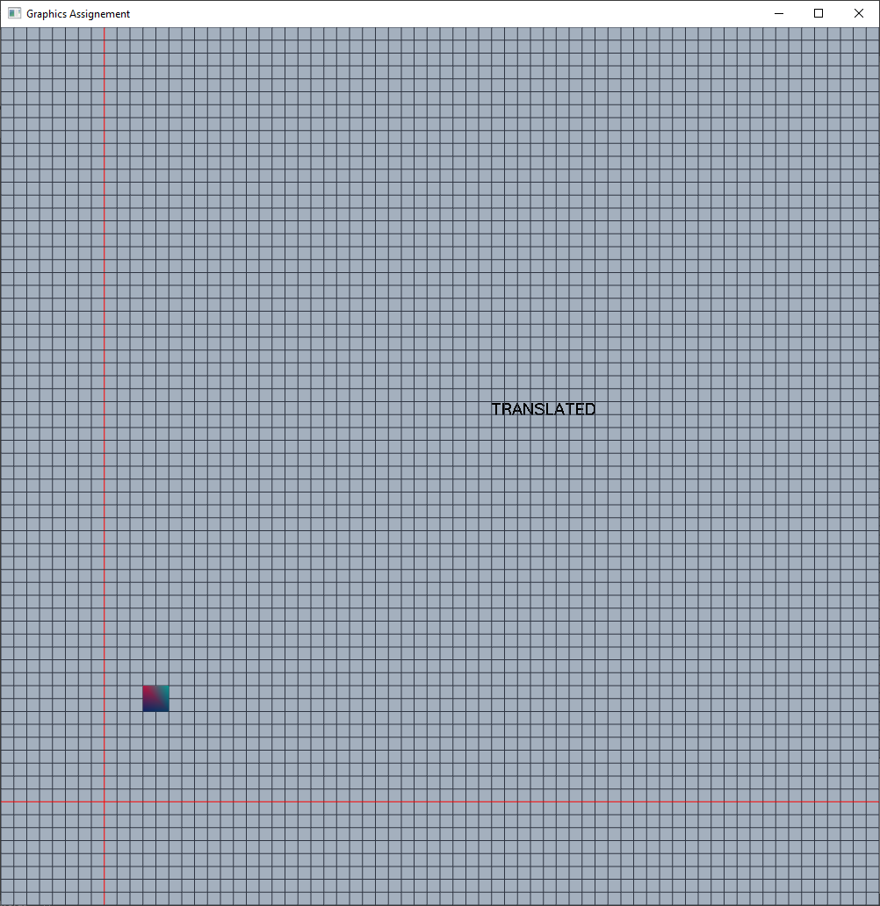

**(3, 9)**

**(5, 9)**

**(5, 7)**

**(3, 7)**

Figure Translated Polygon

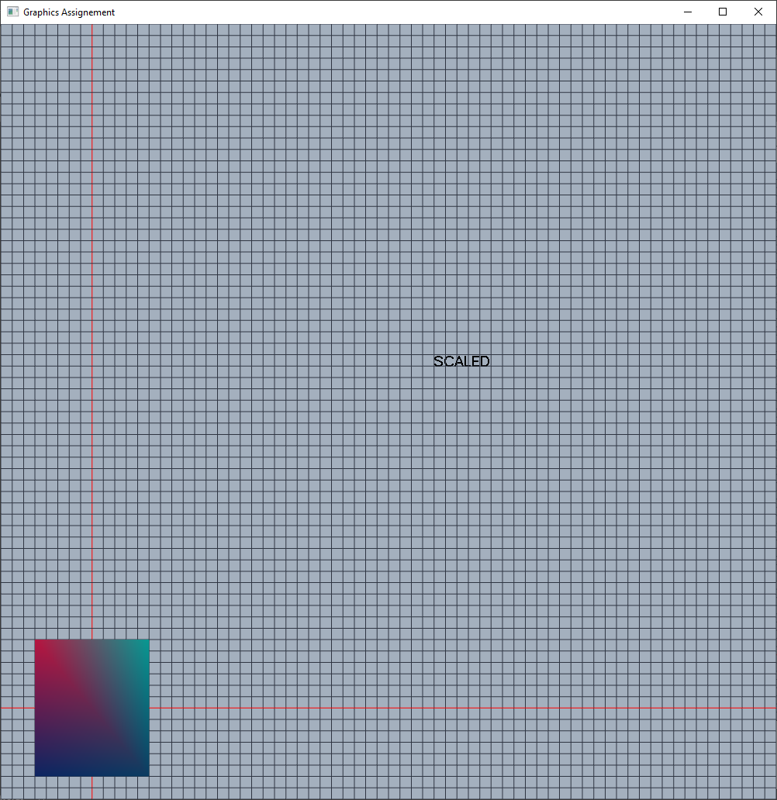

**(5, -6)**

**(-5, -6)**

**(5, 6)**

**(-5, 6)**

Figure Scaled Polygon

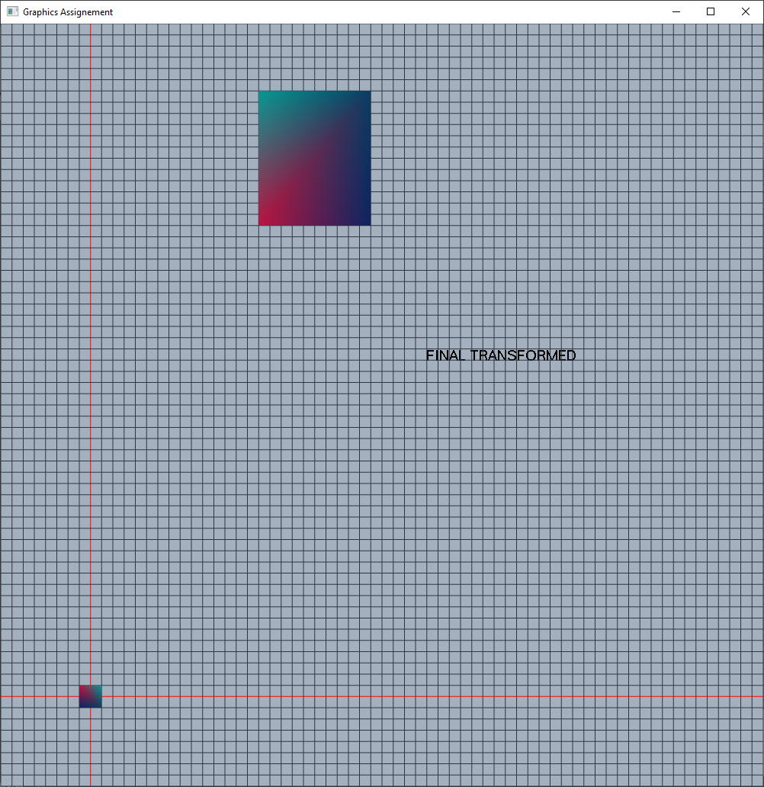

**(25, 42)**

**(25, 54)**

**(15, 42)**

**(15, 54)**

Figure Final Transformed Polygon

All the transformed applied sequentially,

Rotate:

Translate:

Scale:

Final Polygon:

# Bibliography