# Laboratory 2

Title of the Laboratory Exercise: Requirement analysis and data modelling

1. Introduction and Purpose of Experiment

The requirements analysis phase produce both data requirements and functional requirements. The data requirements are used as a source of database design and should be specified as detailed and complete form as possible. In data modelling, the designers first create a conceptual model of how data items relate to each other. By doing this lab, students will be able to perform data modelling of the application.

1. Aim and Objectives

Aim

* To analyse the given application and create a data model

Objectives

At the end of this lab, the student will be able to

* Identify functional and data requirements from problem statement
* Create a data model from the data requirements

1. Experimental Procedure
   * Read the problem statement and identify requirements
   * Perform data modelling
   * Document the requirements and ER diagram
2. Question

Students have to choose one of the following problem statements and develop the software solution. The Course leader is the customer. Contact the Course leader for any clarificatpoions.

1. Library management system
2. Hospital management system
3. Employee management system

Perform the following based on the problem statement you have chosen

1. Analyse the given application and list the functional and data requirements
2. Perform data modelling based on the identified data requirements
3. Calculations/Computations/Algorithms

**Functional Requirements**

1. The system should allow the manager and the employee to login
2. The system should allow the manager to add employees and details to the database
3. The system should allow the manager to modify employee details
4. The system should allow the manager to assign projects to the employees
5. The system should allow the manager to add and manage departments
6. The system should allow the manager to manage employee logistics

|  |  |
| --- | --- |
| **Requirement Tag** | **FR1** |
| **Requirement Description** | The system should allow the manager and the employee to login |
| **Dependent on Requirements** | None |
| **User/System interacting with the requirement** | Manager |

|  |  |
| --- | --- |
| **Requirement Tag** | **FR2** |
| **Requirement Description** | The system should allow the manager to add employees and details to the database |
| **Dependent on Requirements** | FR1 |
| **User/System interacting with the requirement** | Manager |

|  |  |
| --- | --- |
| **Requirement Tag** | **FR3** |
| **Requirement Description** | The system should allow the manager to modify employee details |
| **Dependent on Requirements** | FR1, FR2 |
| **User/System interacting with the requirement** | Manager |

|  |  |
| --- | --- |
| **Requirement Tag** | **FR4** |
| **Requirement Description** | The system should allow the manager to assign projects to the employees |
| **Dependent on Requirements** | FR1, FR3 |
| **User/System interacting with the requirement** | Manager |

|  |  |
| --- | --- |
| **Requirement Tag** | **FR5** |
| **Requirement Description** | The system should allow the manager to add and manage departments. |
| **Dependent on Requirements** | FR1 |
| **User/System interacting with the requirement** | Manager |

|  |  |
| --- | --- |
| **Requirement Tag** | **FR6** |
| **Requirement Description** | The system should allow the manager to manage employee logistics |
| **Dependent on Requirements** | FR1, FR2 |
| **User/System interacting with the requirement** | Manager |

**Data Requirements**

|  |  |
| --- | --- |
| Requirement Tag | DR1 |
| Item Name | Manager Details |
| Item Description | Maintains the manager details  ID, Username, Password |
| Item Type | Integer, String, String |
| User/System interacting with the requirement | Manager |

|  |  |
| --- | --- |
| Requirement Tag | DR2 |
| Item Name | Employee Details |
| Item Description | Maintains the employee details  ID, Name, Type, Contact Number, Address, Last Paid On |
| Item Type | Integer, String, Enum<String>, Array<Integer>, Array<String>, Date |
| User/System interacting with the requirement | User |

|  |  |
| --- | --- |
| Requirement Tag | DR3 |
| Item Name | Project Details |
| Item Description | Maintains the project details  ID, Name, Type, Status |
| Item Type | Integer, String, Enum<String>, Enum<String> |
| User/System interacting with the requirement | User |

|  |  |
| --- | --- |
| Requirement Tag | DR4 |
| Item Name | Salary Details |
| Item Description | Maintains the Salary details  Type, Base Salary, Gross Salary, Allowance |
| Item Type | Enum<String>, Integer, Integer, Integer |
| User/System interacting with the requirement | User |

|  |  |
| --- | --- |
| Requirement Tag | DR5 |
| Item Name | Department Details |
| Item Description | Maintains the Department details  ID, Name, Budget |
| Item Type | Integer, String, Integer |
| User/System interacting with the requirement | User |

1. Presentation of Results

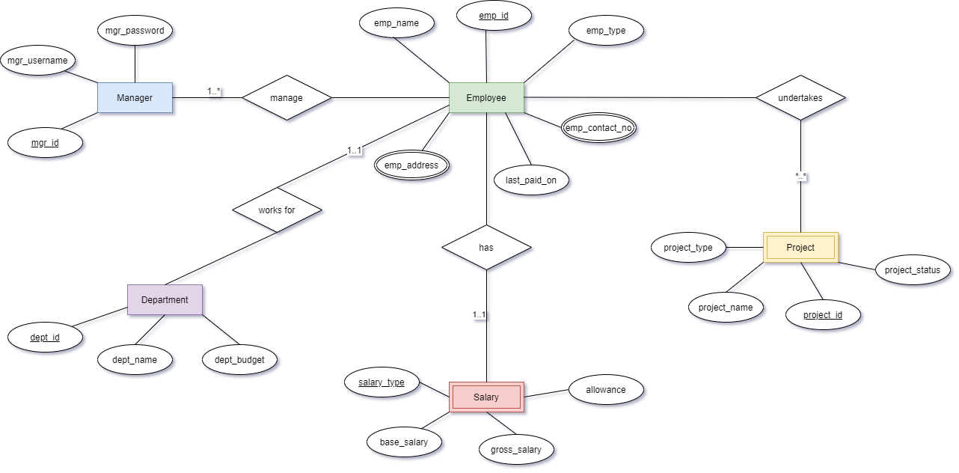

1. Conclusions

An Entity Relationship Diagram (ERD) is a visual representation of different data using conventions that describe how these data are related to each other.

ER diagrams constitute a very useful framework for creating and manipulating databases. First, ER diagrams are easy to understand and do not require a person to undergo extensive training to be able to work with it efficiently and accurately. This means that designers can use ER diagrams to easily communicate with developers, customers, and end users, regardless of their IT proficiency. Second, ER diagrams are readily translatable into relational tables which can be used to quickly build databases. In addition, ER diagrams can directly be used by database developers as the blueprint for implementing data in specific software applications. Lastly, ER diagrams may be applied in other contexts such as describing the different relationships and operations within an organization.

1. Comments

1. Limitations of Experiments

* Limited expressiveness
* Not concise
* Can be ambiguous
* Mostly for relational database only.

1. Limitations of Results

* Loss of information content: Some information be lost or hidden in ER model
* Limited relationship representation: ER model represents limited relationship as compared to another data models like relational model etc.
* No representation of data manipulation: It is difficult to show data manipulation in ER model.
* Popular for high level design: ER model is very popular for designing high level design
* No industry standard for notation

3. Learning happened

* Conceptually it is very simple: ER model is very simple because if we know relationship between entities and attributes, then we can easily draw an ER diagram.
* Better visual representation: ER model is a diagrammatic representation of any logical structure of database. By seeing ER diagram, we can easily understand relationship among entities and relationship.
* Effective communication tool: It is an effective communication tool for database designer.
* Highly integrated with relational model: ER model can be easily converted into relational model by simply converting ER model into tables
* Easy conversion to any data model: ER model can be easily converted into another data model like hierarchical data model, network data model and so on.

1. Recommendations

* Try to make unambiguous ER diagrams
* Make it more concise
* Try to be more expressive in the diagram