# Laboratory 5

Title of the Laboratory Exercise: Java database programming

1. Introduction and Purpose of Experiment

The SQL includes commands to define view on the data. A view contains rows and columns, just like a real table. Java uses JDBC (Java Database Connectivity) to connect to databases. JDBC allows to connect to a wide-range of databases such as Oracle, MySQL, etc. By doing this lab, students will be able to implement views in SQL and connect the developed database with the application.

1. Aim and Objectives

Aim

* To design and implement views on the data using SQL commands
* To connect to the relational database in Java

Objectives

At the end of this lab, the student will be able to

* Design and execute views using SQL commands
* Perform database programming in Java

1. Experimental Procedure
   * 1. Analyse the problem statement
     2. Execute the built-in functions in SQL
     3. Design and execute the view statements in SQL
     4. Test the executed commands
     5. Document the Results
     6. Analyse and discuss the outcomes of your experiment
2. Questions
   1. Create a table MANGER with attributes such as Name, Id, Department, Address, and Salary. Write SQL statements for the following expressions.
3. Create a view ‘MANAGER_VIEW’ to display the details such as name and department of each manager
4. Display the name of the manager from MANAGER_VIEW whose department is ‘CSE’
5. Drop the views generated
   1. Write a Java program to do the following operations
6. Insert the details of the Managers into the table
7. Display all the details of the Managers in the ascending order of their names
8. Count the number of Managers staying in each location and display the address and the total number
9. Display the number of Managers in each location. Only include locations with more than or equal to 2 Managers
10. Presentation of Results

USE students;

*-- Drop the table if it exists*

DROP TABLE IF EXISTS MANAGER;

*-- Create the table*

CREATE TABLE MANAGER (Name VARCHAR(50), Id INT PRIMARY KEY, Department CHAR(20), Address VARCHAR(255), Salary FLOAT);

*-- Insert Values*

INSERT INTO MANAGER VALUES

('SATYAJIT GHANA', 0, 'CSE', 'BEL', 12500),

('ANUSHA', 1, 'CSE', 'JP NAGAR', 12000),

('SHIKHAR', 2, 'ASE', 'J.CROSS', 15000);

*-- Show the table*

SELECT **\*** FROM MANAGER;

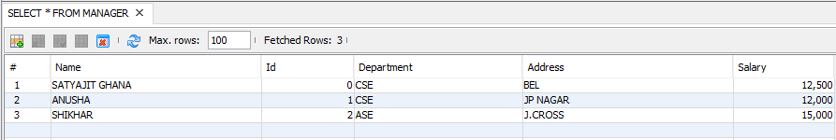

Figure 0‑1 Created Table MANAGER

USE students;

DROP VIEW IF EXISTS MANAGER_VIEW;

*-- Create the View*

CREATE VIEW MANAGER_VIEW AS SELECT Name, Department FROM MANAGER;

*-- Show the View*

SELECT **\*** FROM MANAGER_VIEW;

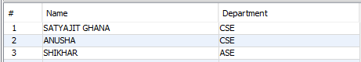

Figure 0‑2 Created View MANAGER_VIEW

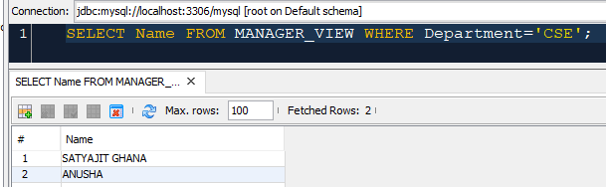

Figure 0‑3 SELECT from MANAGER_VIEW

*/\**

*\* To change this license header, choose License Headers in Project Properties.*

*\* To change this template file, choose Tools | Templates*

*\* and open the template in the editor.*

*\*/*

**package** lab05;

*import* java.sql.*\**;

*/\*\**

*\**

*\* @author shadowleaf*

*\**

*\* Table Details : MANAGER (Name VARCHAR(50), Id INT PRIMARY KEY, Department CHAR(20), Address VARCHAR(255), Salary FLOAT);*

*\*/*

*public* class Lab05 {

*public* *static* *void* addData(Statement **stmt**) *throws* SQLException {

            stmt.executeUpdate("INSERT INTO MANAGER VALUE ('SAMHITHA', 3, 'ISE', 'MALLESHWARAM', 15000)");

            stmt.executeUpdate("INSERT INTO MANAGER VALUE ('SHOBHAN', 4, 'ECE', 'RAJAJINAGAR', 20000)");

            stmt.executeUpdate("INSERT INTO MANAGER VALUE ('SOUMYADIP', 5, 'EEE', 'BEL', 12000)");

    }

*public* *static* *void* viewAllData(Statement **stmt**) *throws* SQLException {

        ResultSet rs **=** stmt.executeQuery("SELECT * FROM MANAGER");

        System.*out*.printf("%20s | %3s | %5s | %10s | %9s\n", "Name", "Id", "Dept", "Address", "Salary\n");

*// iterate through the result*

**while** (rs.next()) {

            String name **=** rs.getString("Name");

            Integer id **=** rs.getInt("Id");

            String dept **=** rs.getString("Department");

            String address **=** rs.getString("Address");

            Double salary **=** rs.getDouble("Salary");

            System.*out*.printf("%20s | %3d | %5s | %10s | %8.2f\n", name, id, dept, address, salary);

        }

    }

*public* *static* *void* viewDeptCount(Statement **stmt**) *throws* SQLException {

        ResultSet rs **=** stmt.executeQuery("SELECT Department, COUNT(Department) FROM MANAGER GROUP BY Department");

        System.*out*.printf("%10s | %10s", "Dept", "Count\n\n");

**while** (rs.next()) {

            String dept **=** rs.getString("Department");

            Integer count **=** rs.getObject(2, Integer.*class*);

            System.*out*.printf("%10s | %10d\n", dept, count);

        }

    }

*public* *static* *void* findManagers(Statement **stmt**) *throws* SQLException {

        ResultSet rs **=** stmt.executeQuery("SELECT Address, COUNT(Address) FROM MANAGER GROUP BY Address HAVING COUNT(Address) >= 2");

        System.*out*.printf("%20s | %10s", "Address", "Count\n\n");

**while** (rs.next()) {

            String address **=** rs.getString("Address");

            Integer count **=** rs.getObject(2, Integer.*class*);

            System.*out*.printf("%20s | %10d\n", address, count);

        }

    }

*/\*\**

*\* @param args the command line arguments*

*\*/*

*public* *static* *void* main(String[] **args**) {

**try** {

*// load the registered driver*

            Class.forName("com.mysql.jdbc.Driver");

*// create a connection object*

            Connection conn **=** DriverManager.getConnection("jdbc:mysql://localhost/students", "shadowleaf", "redosmiumtetroxide");

*// create a statement object*

            Statement st **=** conn.createStatement();

*// add data to the table*

            addData(st);

            System.*out*.println("ALL DETAILS");

*// display all the details of the managers*

            viewAllData(st);

            System.*out*.println();

            System.*out*.println("DEPARTMENT COUNT");

*// view the department count*

            viewDeptCount(st);

            System.*out*.println();

            System.*out*.println("LOCATION MANAGER COUNT >= 2");

*// view the locations with managers count >=2*

            findManagers(st);

        } **catch** (ClassNotFoundException | SQLException **e**) {

            System.*out*.println("Exception Occured : " **+** e.getMessage());

        }

    }

}

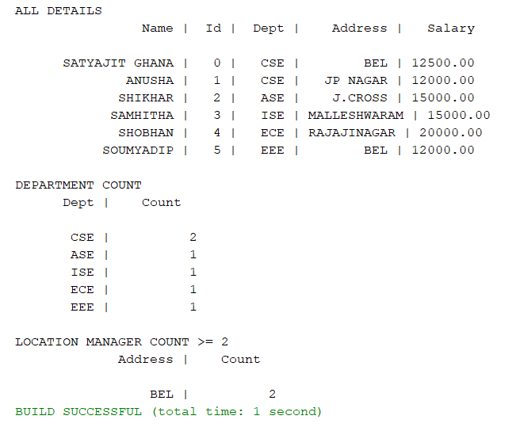

Figure 0‑4 Perform SQL Operations using JAVA

1. Analysis and Discussions

Views in SQL are kind of virtual tables. A view also has rows and columns as they are in a real table in the database. We can create a view by selecting fields from one or more tables present in the database. A View can either have all the rows of a table or specific rows based on certain condition.

Java Database Connectivity (JDBC) is an application programming interface (API) for the programming language Java, which defines how a client may access any kind of tabular data, especially relational database.

1. Conclusions

Java code was executed successfully and appropriate results were obtained.

Database views are created using the CREATE VIEW statement. Views can be created from a single table, multiple tables or another view.

1. Comments

1. Limitations of Experiments

Views cannot be created on Temporary Tables

You cannot associate rules and defaults with views

You cannot pass parameters to SQL Server views

2. Limitations of Results

Correct drivers need to be deployed for each type of database.

Cannot update or insert multiple tables with sequence. (Sequence is always random)

3. Learning happened

Learnt how to create and drop a view.

Learnt how to write SQL commands in java application and execute them.