# Laboratory 4

Title of the Laboratory Exercise: implement constraints and built in functions

1. Introduction and Purpose of Experiment

Constraints are the rules which are enforced on the data being stored in a table. There are constraints that can be applied to a table such as NOT NULL, UNIQUE, PRIMARY KEY and FOREIGN KEY. SQL has many built-in functions for performing calculations on data. In SQL, a built-in function is a piece for programming that takes zero or more inputs and returns a value. By doing this lab, students will be able to implement constraints and built in functions on the database.

1. Aim and Objectives

Aim

* To design and implement constraints on the data using SQL commands
* To implement built in functions in SQL

Objectives

At the end of this lab, the student will be able to

* Identify different types of constraints on the data
* Apply constraints on the data in different ways
* Implement built-in functions in SQL

1. Experimental Procedure
   * 1. Analyse the problem statement
     2. Design SQL commands using appropriate constraints
     3. Execute the SQL commands
     4. Test the executed commands
     5. Document the Results
     6. Analyse and discuss the outcomes of your experiment
2. Questions

Consider the relational schema given below.

PLAYER_DETAILS (PCode, PName, DOB, City, Score)

MATCH_DETAILS (MatchID, MatchName, PCode)

1. Apply the following constraints on the given database schema. Enter appropriate tuples to show the purpose of each constraint.
2. Not NULL
3. Default
4. Unique
5. Primary key
6. Foreign key
7. Execute the following built-in functions in SQL using Netbeans IDE
8. String functions
9. Date functions
10. Numeric functions
11. Presentation of Results

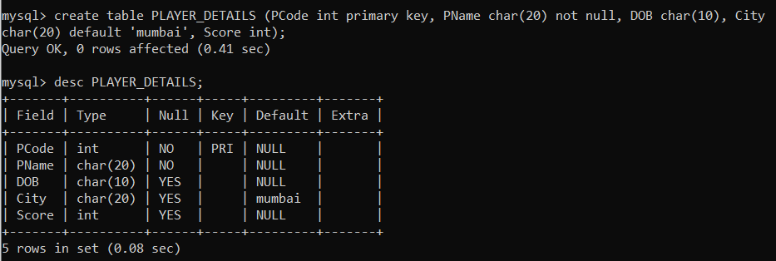

Fig: Created table PLAYER_DETAILS (*PCode* as primary key, *PName* as NOT NULL and *city* as default)

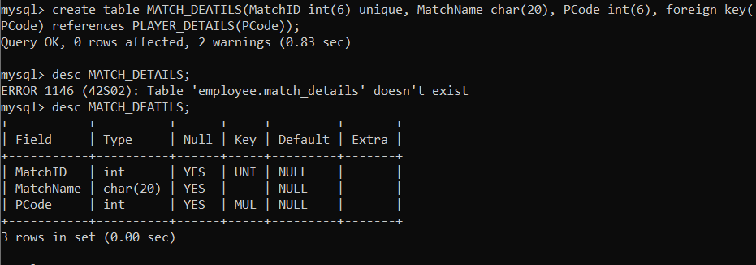

Fig: Created table MATCH_DEATILS (*MatchID* as unique and *PCode* as foreign key)

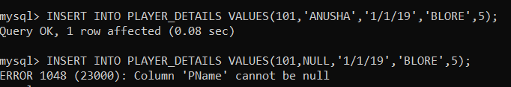

Fig: NOT NULL constraint.

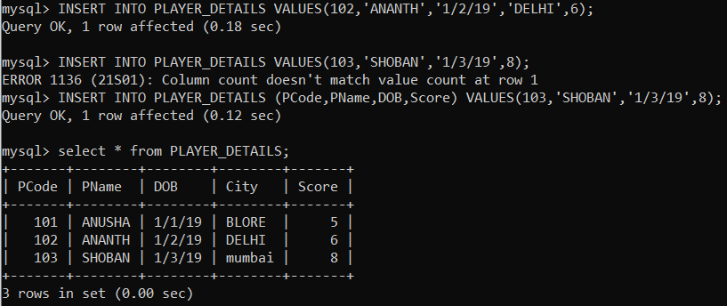

Fig: Default constraint.

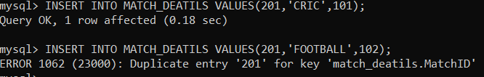

Fig: Unique constraint.

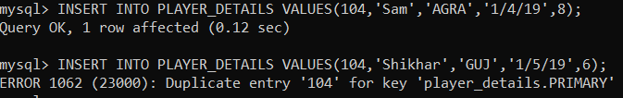

Fig: Primary constraint.

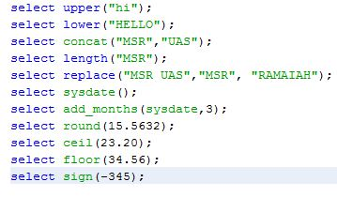

Fig: source code to execute the SQL commands in Netbeans IDE.



Fig: upper () function.

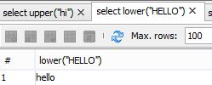

Fig: lower () function.

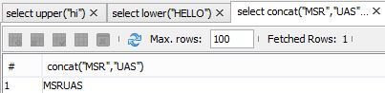

Fig: concat () function



Fig: length () function



Fig: replace () function.

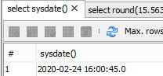

Fig: sysdate () function.



Fig: round () function



Fig: ceil () function



Fig: floor () function

 Fig: sign () function

1. Analysis and Discussions

Relational Integrity constraints is referred to conditions which must be present for a valid relation. These integrity constraints are derived from the rules in the mini-world that the database represents.

Constraints are restrictions on the actual values in a database state

There are various restrictions on data that can be specified on a relational database in the form of constraints.

Constraints that can be directly expressed in schemas of the data model, typically by specifying them in the DDL are called schema-based constraints.

1. Conclusions

* While creating tables, by default the rows can have null value. The enforcement of not null constraint in a table ensures that the table contains values.
* The DEFAULT constraint inserts a default value into a column of a table. When you insert a new row into the table, no need to specify the value for the column.
* UNIQUE is used to ensure that information in the column for each record is unique, as with telephone or driver’s license numbers. It prevents the duplication of value with rows of a specified column in a set of columns. A column defined with the constraint can allow null value.
* A primary key avoids duplication of rows and does not allow null values. It can be defined on one or more columns in a table and is used to uniquely identify each row in a table. These values should never be null. Better to use only one primary key at the table level.
* Referential integrity constraint enforces relationship between tables. Foreign key is a column or combination of column included in the definition of referential integrity, which would refer to a referenced key. They create a parent child relationship between two tables. Referenced key is a unique or primary key upon which is defined on a column belonging to the parent table.

1. Comments

1. Limitations of Experiments

We cannot use the User defined functions, shortly called as UDF in SQL Server to modify the database state.

SQL UDF can not return multiple result sets.

2. Limitations of Results

The SQL UDF does not support error handling, such as TRY..CATCH, RAISEERROR, or @ERROR.

We cannot call a stored Procedure from SQL UDF, but we can call extended Stored Procedure.

3. Learning happened

Learnt the different types of schema-based constraints.

Learnt how to work with SQL in Netbeans IDE.

Learnt the syntax and purpose of basic inbuilt functions in SQL.

4. Recommendations