# Laboratory 5

Title of the Laboratory Exercise: Java database programming

1. Introduction and Purpose of Experiment

The SQL includes commands to define view on the data. A view contains rows and columns, just like a real table. Java uses JDBC (Java Database Connectivity) to connect to databases. JDBC allows to connect to a wide-range of databases such as Oracle, MySQL, etc. By doing this lab, students will be able to implement views in SQL and connect the developed database with the application.

1. Aim and Objectives

Aim

* To design and implement views on the data using SQL commands
* To connect to the relational database in Java

Objectives

At the end of this lab, the student will be able to

* Design and execute views using SQL commands
* Perform database programming in Java

1. Experimental Procedure
   * 1. Analyse the problem statement
     2. Execute the built-in functions in SQL
     3. Design and execute the view statements in SQL
     4. Test the executed commands
     5. Document the Results
     6. Analyse and discuss the outcomes of your experiment
2. Questions
   1. Create a table MANGER with attributes such as Name, Id, Department, Address, and Salary. Write SQL statements for the following expressions.
3. Create a view ‘MANAGER_VIEW’ to display the details such as name and department of each manager
4. Display the name of the manager from MANAGER_VIEW whose department is ‘Information Technology’
5. Drop the views generated
   1. Write a Java program to do the following operations
6. Insert the details of the Managers into the table
7. Display all the details of the Managers in the ascending order of their names
8. Count the number of Managers staying in each location and display the address and the total number
9. Display the number of Managers in each location. Only include locations with more than 3 Managers
10. Presentation of Results

a) 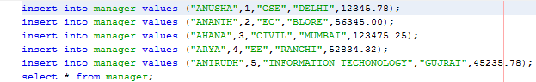

Fig: Inserting values into table

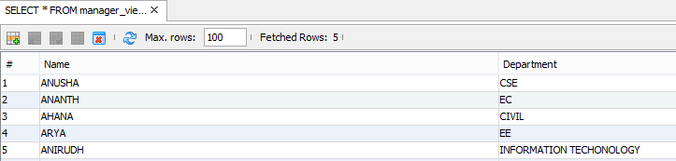

Fig: Created manager view and displayed it

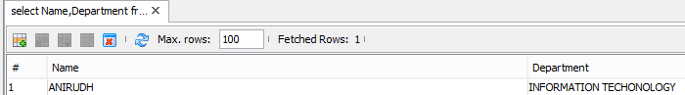

Fig: Employee from InfoTech Department



Fig: Drop the created view

b)

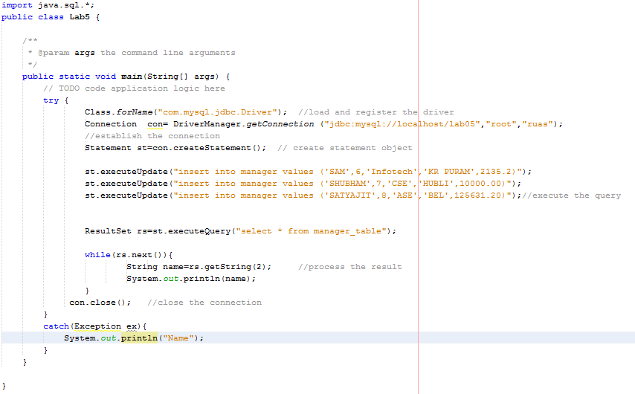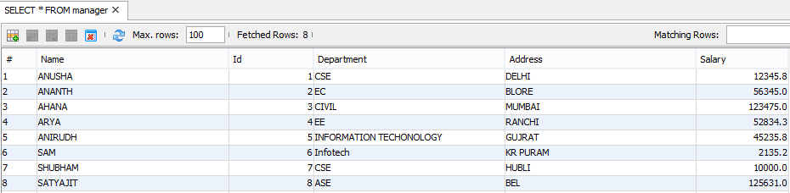

Fig: Java code to insert details of manager in table

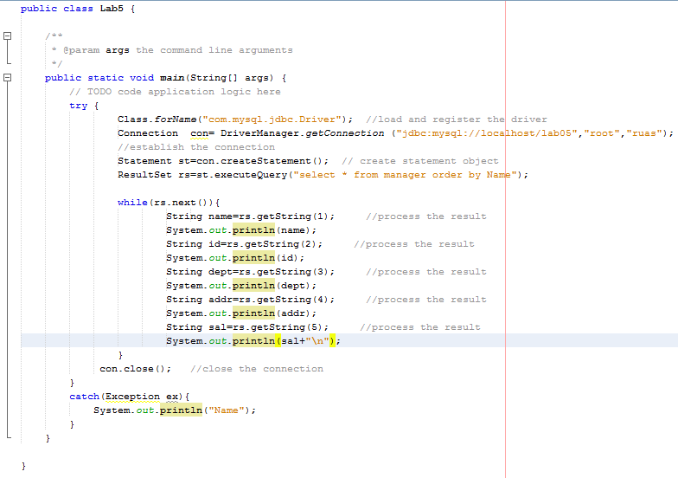

Fig: Java code to print managers in ascending order of name

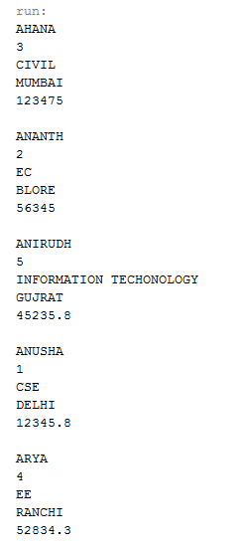

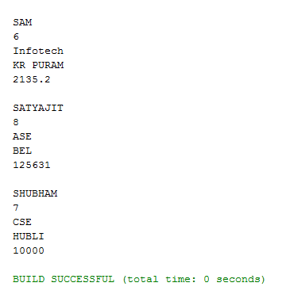

1. Analysis and Discussions

Views in SQL are kind of virtual tables. A view also has rows and columns as they are in a real table in the database. We can create a view by selecting fields from one or more tables present in the database. A View can either have all the rows of a table or specific rows based on certain condition.

Java Database Connectivity (JDBC) is an application programming interface (API) for the programming language Java, which defines how a client may access any kind of tabular data, especially relational database.

1. Conclusions

Java code was executed successfully and appropriate results were obtained.

Database views are created using the CREATE VIEW statement. Views can be created from a single table, multiple tables or another view.

1. Comments

1. Limitations of Experiments

Views cannot be created on Temporary Tables

You cannot associate rules and defaults with views

You cannot pass parameters to SQL Server views

2. Limitations of Results

Correct drivers need to be deployed for each type of database.

Cannot update or insert multiple tables with sequence. (Sequence is always random)

3. Learning happened

Learnt how to create and drop a view.

Learnt how to write SQL commands in java application and execute them.