|  |  |
| --- | --- |
| **Assignment** | |
| **Course Code** | CSC402A |
| **Course Name** | Data Mining |
| **Programme** | B.Tech |
| **Department** | CSE |
| **Faculty** | FET |

|  |  |
| --- | --- |
| **Name of the Student** | Satyajit Ghana |
| **Reg. No.** | 17ETCS002159 |
| **Semester/Year** | 07/2020 |
| **Course Leader(s)** | Prof. Mohan Kumar |



|  |  |  |  |  |  |  |  |  |
| --- | --- | --- | --- | --- | --- | --- | --- | --- |
| Declaration Sheet | | | | | | | | |
| Student Name | Satyajit Ghana | | | | | | | |
| Reg. No | 17ETCS002159 | | | | | | | |
| Programme | B.Tech | | | | | Semester/Year | 07/2020 | |
| Course Code | CSC402A | | | | | | | |
| Course Title | Data Mining | | | | | | | |
| Course Date |  | | to |  | | | | |
| Course Leader | Prof. Mohan Kumar | | | | | | | |
| **Declaration**  The assignment submitted herewith is a result of my own investigations and that I have conformed to the guidelines against plagiarism as laid out in the Student Handbook. All sections of the text and results, which have been obtained from other sources, are fully referenced. I understand that cheating and plagiarism constitute a breach of University regulations and will be dealt with accordingly. | | | | | | | | |
| Signature of the Student | |  | | | | | Date |  |
| Submission date stamp  (by Examination & Assessment Section) | |  | | | | | | |
| Signature of the Course Leader and date | | | | | Signature of the Reviewer and date | | | |
|  | | | | |  | | | |

# Contents

Declaration Sheet ii

Contents iii

List of Figures iv

1 Question 1 5

1.1 Data Cleaning: Redundant and Inconsistent Data 5

1.1.1 Inconsistent Data 5

1.1.2 Univariate Analysis 6

1.2 Data Cleaning: Missing Values and Outliers 6

1.2.1 Outlier Analysis 7

1.3 Data Normalization 11

1.3.1 Min-Max Scaling 11

1.3.2 Z-Score Standardization 12

1.3.3 Decimal Scaling 13

1.4 Data Transformation 14

1.4.1 Natural Log Transform 14

1.4.2 Square Root Transform 15

NOTE: age has a skewness of 0 using Square Root Transform ! 15

1.4.3 Inverse Square Root Transform 16

1.5 EDA and Interpretation of Results 17

Bibliography 20

# List of Figures

Figure 1‑1 Book Ratings, before and after removing 0 ratings 5

Figure 1‑2 Book Rating Univariate Analysis 6

Figure 1‑3 Age univariate analysis 6

Figure 1‑4 Isolation Forest of Original Data 7

Figure 1‑5 Dropping book_rating using IQR 8

Figure 1‑6 Dropping Age using IQR 8

Figure 1‑7 Isolation forest after dropping outliers with IQR 8

Figure 1‑8 Dropping book_rating with BoxCox 9

Figure 1‑9 Dropping age with BoxCox 9

Figure 1‑10 Isolation Forest after BoxCox 9

Figure 1‑11 Dropping book_rating with imputation 10

Figure 1‑12 Dropping age with imputation 10

Figure 1‑13 Isolation Forest after imputation 10

# Question 1

Solution to Question No. 1 Part A

This contains a brief summary of the data, and its preprocessing, refer to the Jupyter Notebook output at the end of this for a complete study of data.

## Data Cleaning: Redundant and Inconsistent Data

|  |  |  |  |  |  |  |
| --- | --- | --- | --- | --- | --- | --- |
| Column | Mean | Std | Min | Max | Skewness | Kurtosis |
| age | 36.23 | 10.41 | 5 | 100 | 0.83 | 1.34 |
| book_rating | 2.83 | 3.85 | 0 | 10 | 0.75 | -1.21 |

### Inconsistent Data

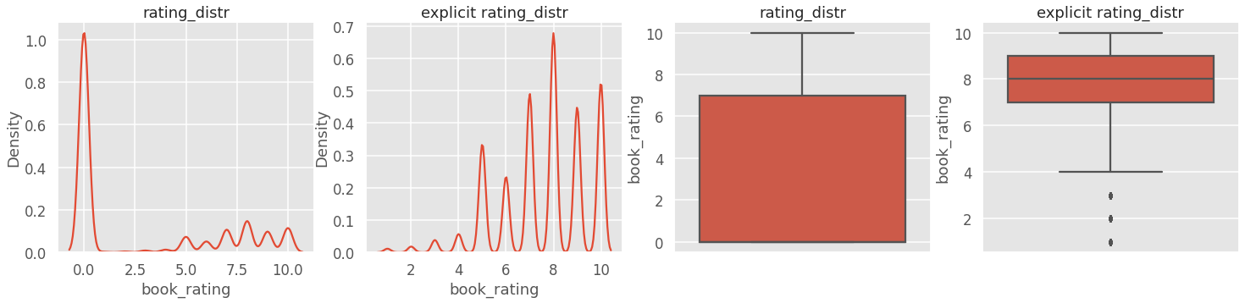

Figure 1‑1 Book Ratings, before and after removing 0 ratings

Since 0 rated books done make sense they were removed, after removing our skewness and kurtosis values have changed a lot.

|  |  |  |  |  |  |  |
| --- | --- | --- | --- | --- | --- | --- |
| Column | Mean | Std | Min | Max | Skewness | Kurtosis |
| age | 36.23 | 10.36 | 5 | 100 | 0.85 | 1.64 |
| book_rating | 2.83 | 3.85 | 1 | 10 | -0.66 | -0.12 |

### Univariate Analysis

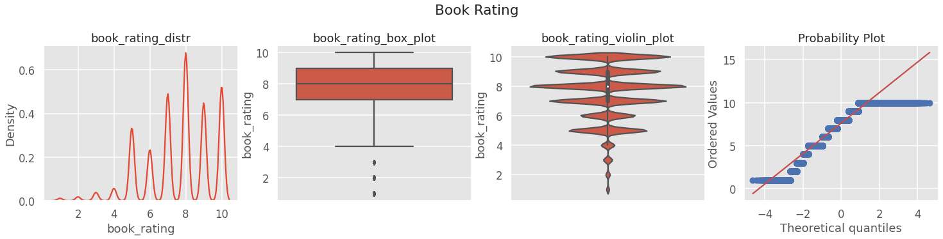

Figure 1‑2 Book Rating Univariate Analysis

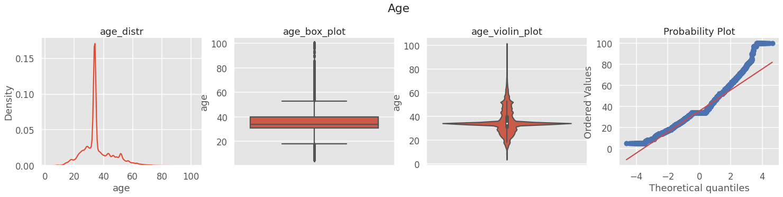

Figure 1‑3 Age univariate analysis

## Data Cleaning: Missing Values and Outliers

Refer Jupyter Notebook for Cleaning up Missing Values

### Outlier Analysis

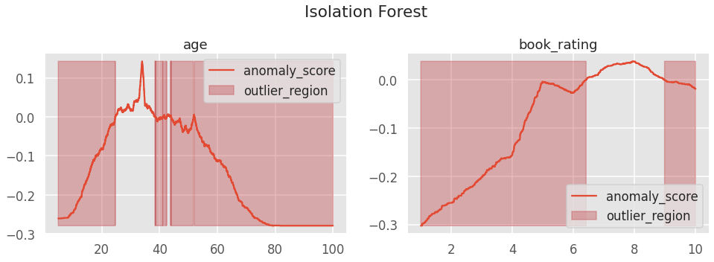

Figure 1‑4 Isolation Forest of Original Data

#### After Dropping Outliers using IQR

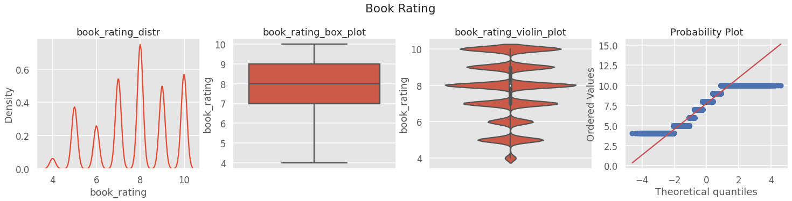

Figure 1‑5 Dropping book_rating using IQR

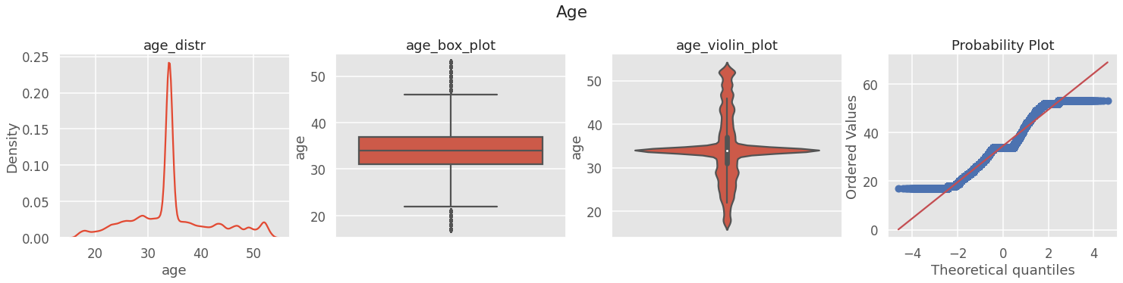

Figure 1‑6 Dropping Age using IQR

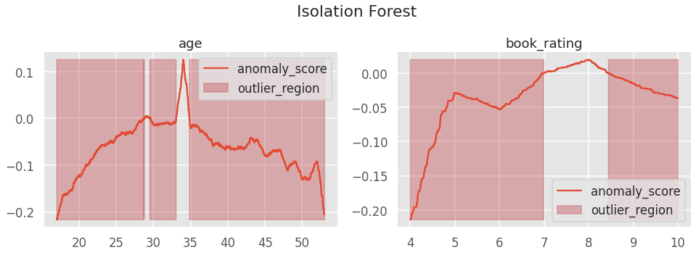

Figure 1‑7 Isolation forest after dropping outliers with IQR

|  |  |  |  |  |  |  |
| --- | --- | --- | --- | --- | --- | --- |
| Column | Mean | Std | Min | Max | Skewness | Kurtosis |
| age | 36.53 | 7.69 | 17 | 53 | 0.35 | 0.16 |
| book_rating | 7.74 | 1.66 | 4 | 10 | -0.34 | -0.80 |

#### Removing Outliers with BoxCox

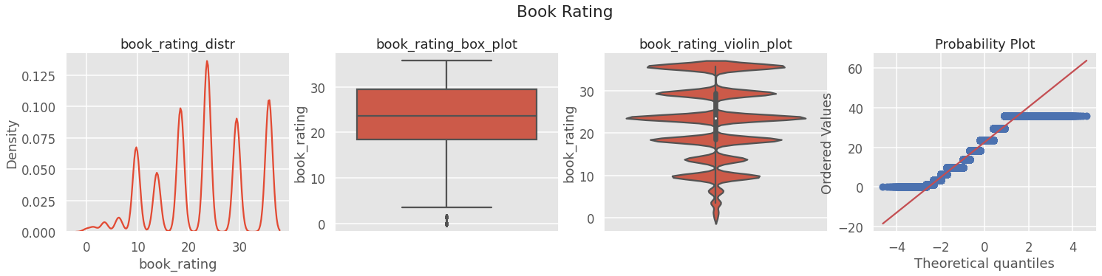

Figure 1‑8 Dropping book_rating with BoxCox

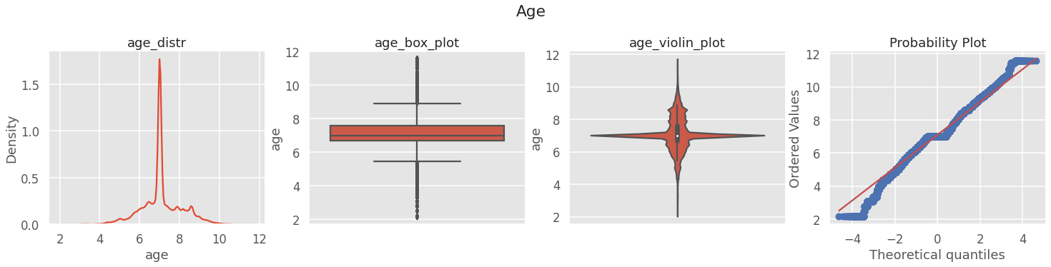

Figure 1‑9 Dropping age with BoxCox

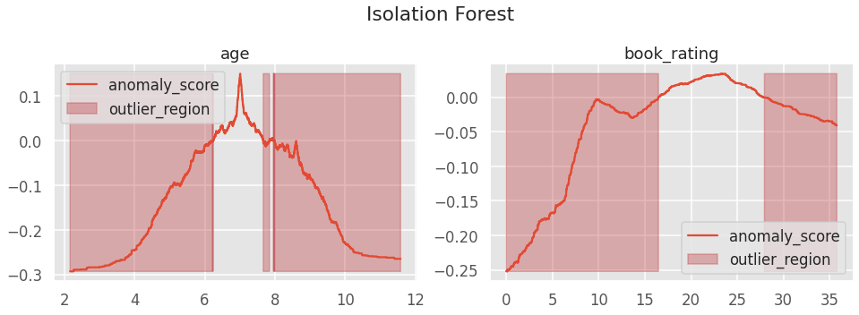

Figure 1‑10 Isolation Forest after BoxCox

|  |  |  |  |  |  |  |
| --- | --- | --- | --- | --- | --- | --- |
| Column | Mean | Std | Min | Max | Skewness | Kurtosis |
| age | 7.09 | 1.01 | 2.16 | 11.57 | 0.04 | 1.14 |
| book_rating | 22.62 | 9.14 | 0 | 35 | -0.17 | -0.83 |

#### Removing Outliers with Imputation



Figure 1‑11 Dropping book_rating with imputation



Figure 1‑12 Dropping age with imputation

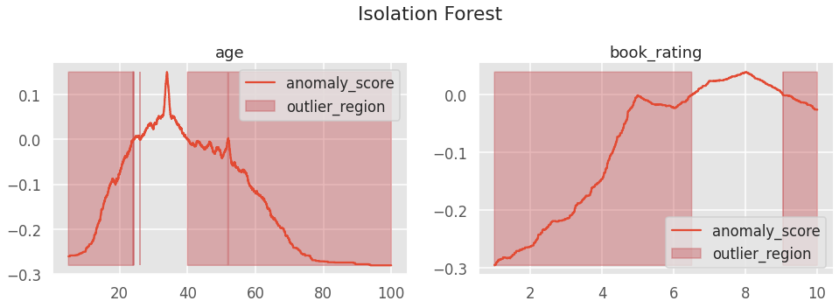

Figure 1‑13 Isolation Forest after imputation

|  |  |  |  |  |  |  |
| --- | --- | --- | --- | --- | --- | --- |
| Column | Mean | Std | Min | Max | Skewness | Kurtosis |
| age | 35.85 | 10.36 | 5 | 100 | 0.86 | 1.64 |
| book_rating | 7.62 | 1.83 | 1 | 10 | -0.66 | -0.12 |

## Data Normalization

### Min-Max Scaling

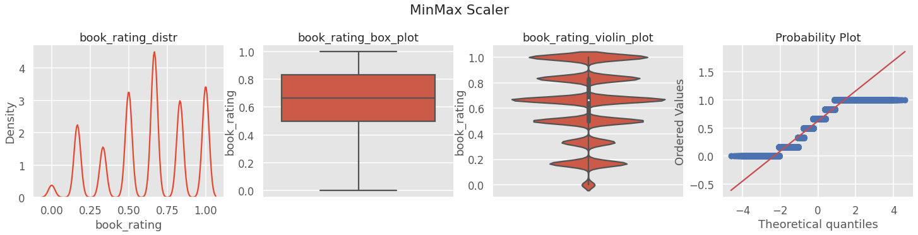

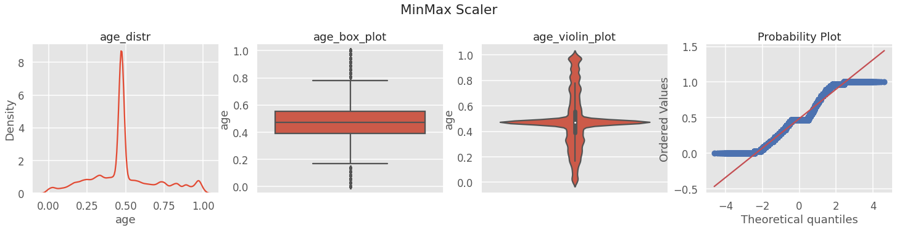

|  |  |  |  |  |  |  |
| --- | --- | --- | --- | --- | --- | --- |
|  | Mean | Std | Min | Max | Skewness | Kurtosis |
| book_rating | 0.62 | 0.27 | 0 | 1 | -0.34 | -0.80 |
| age | 0.48 | 0.21 | 0 | 1 | 0.35 | 0.17 |

### 

### Z-Score Standardization

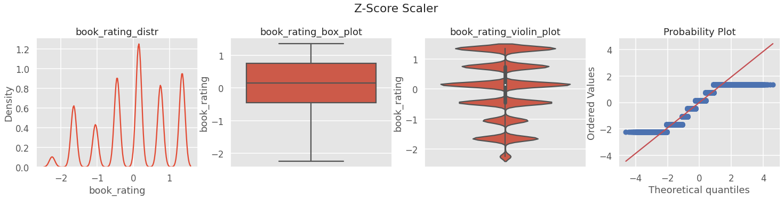

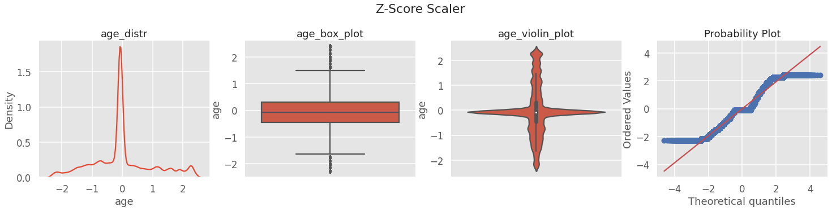

|  |  |  |  |  |  |  |
| --- | --- | --- | --- | --- | --- | --- |
|  | Mean | Std | Min | Max | Skewness | Kurtosis |
| book_rating | ~0 | ~1 | -2.24 | 1.35 | -0.34 | -0.80 |
| age | ~0 | ~1 | -2.27 | 2.39 | 0.35 | 0.17 |

### 

### Decimal Scaling

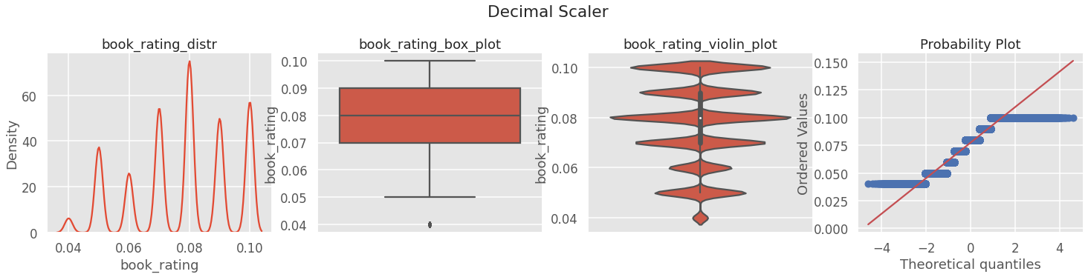

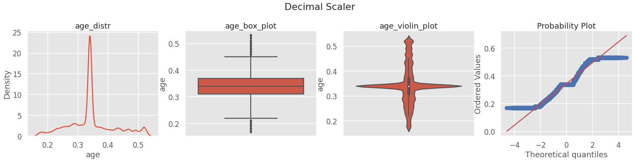

|  |  |  |  |  |  |  |
| --- | --- | --- | --- | --- | --- | --- |
|  | Mean | Std | Min | Max | Skewness | Kurtosis |
| book_rating | 0.077 | 0.01 | 0.04 | 0.1 | -0.34 | -0.80 |
| age | 0.34 | 0.07 | 0.17 | 0.53 | 0.35 | 0.17 |

## Data Transformation

### Natural Log Transform

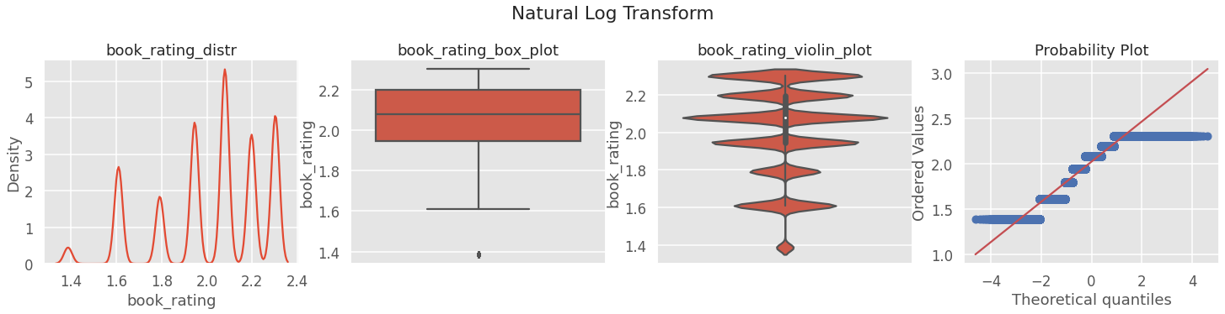

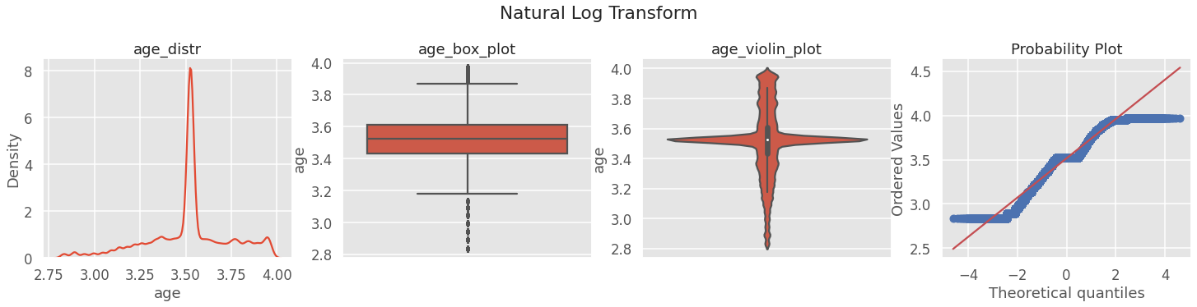

|  |  |  |  |  |  |  |
| --- | --- | --- | --- | --- | --- | --- |
|  | Mean | Std | Min | Max | Skewness | Kurtosis |
| book_rating | 2.02 | 0.23 | 1.38 | 2.3 | -0.74 | -0.23 |
| age | 3.511 | 0.229 | 2.83 | 3.97 | -0.405 | 0.544 |

### 

### Square Root Transform

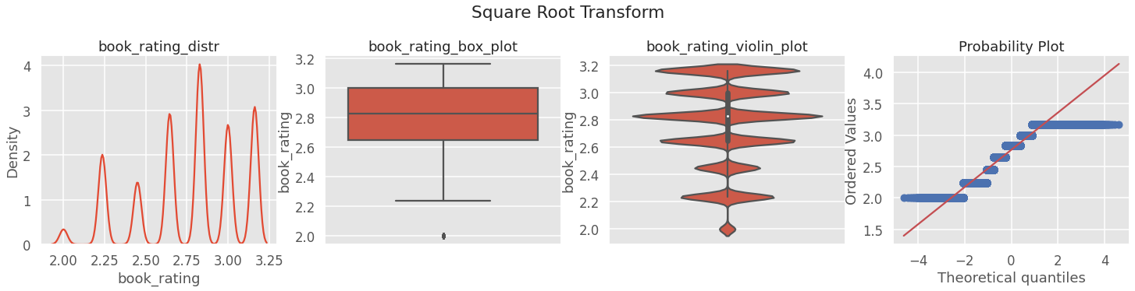

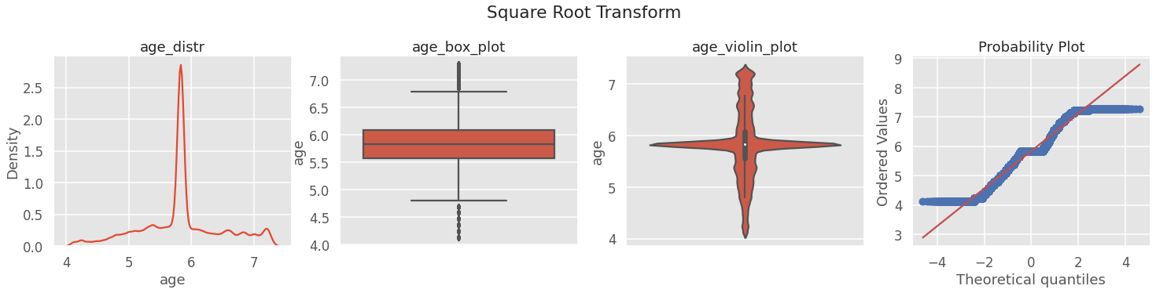

|  |  |  |  |  |  |  |
| --- | --- | --- | --- | --- | --- | --- |
|  | Mean | Std | Min | Max | Skewness | Kurtosis |
| book_rating | 2.76 | 0.31 | 2 | 3.16 | -0.54 | -0.57 |
| age | 5.84 | 0.65 | 4.123 | 7.28 | **-0.0089** | -0.57 |

### NOTE: age has a skewness of 0 using Square Root Transform !

### Inverse Square Root Transform

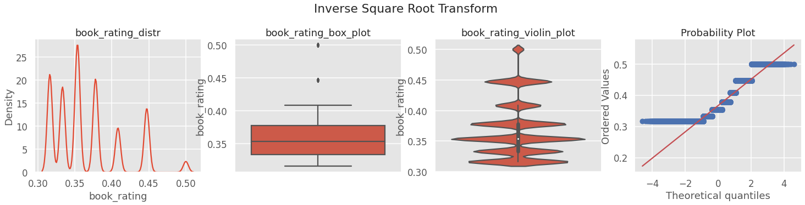

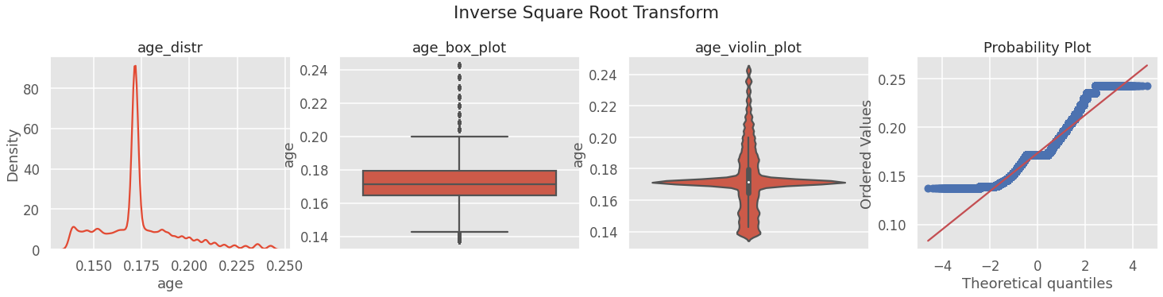

|  |  |  |  |  |  |  |
| --- | --- | --- | --- | --- | --- | --- |
|  | Mean | Std | Min | Max | Skewness | Kurtosis |
| book_rating | 0.366 | 0.044 | 0.31 | 0.5 | 0.96 | 0.24 |
| age | 0.17 | 0.02 | 0.13 | 0.24 | 0.82 | 1.21 |

## EDA and Interpretation of Results

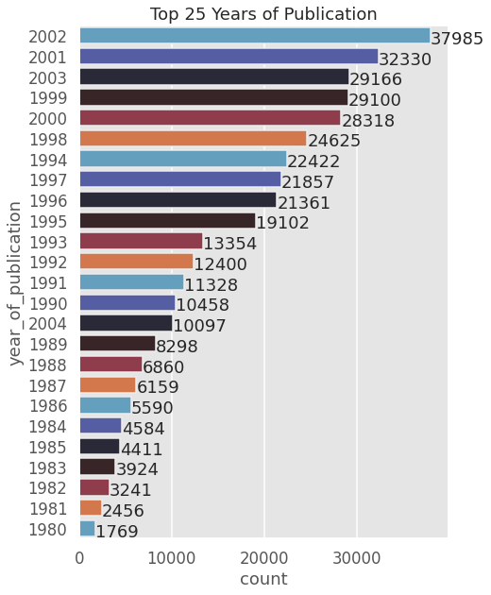

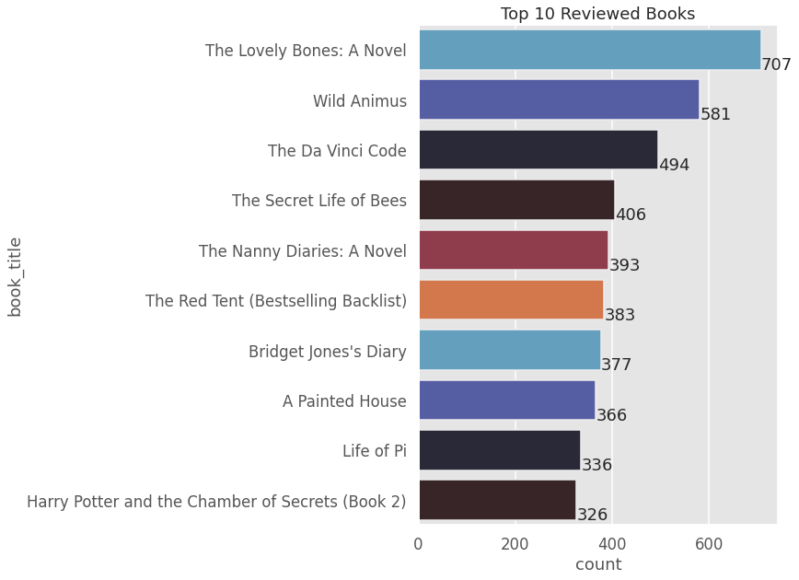

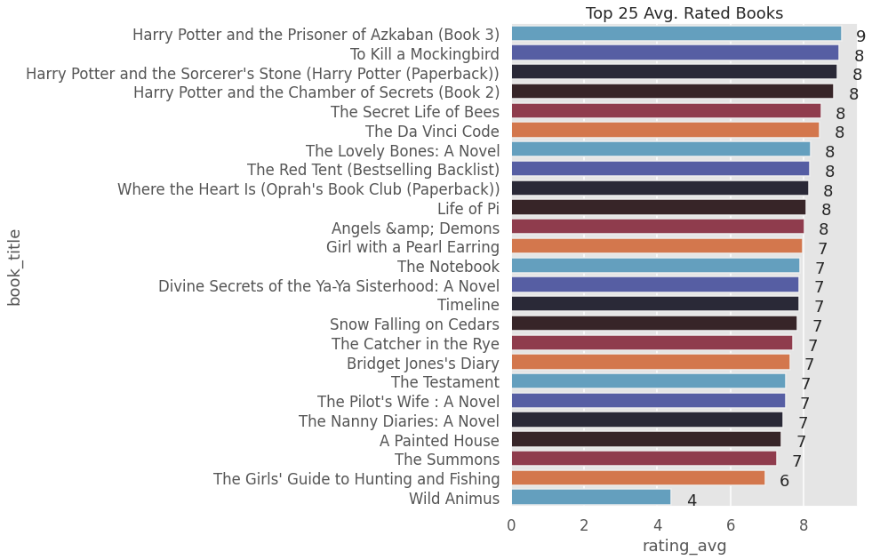

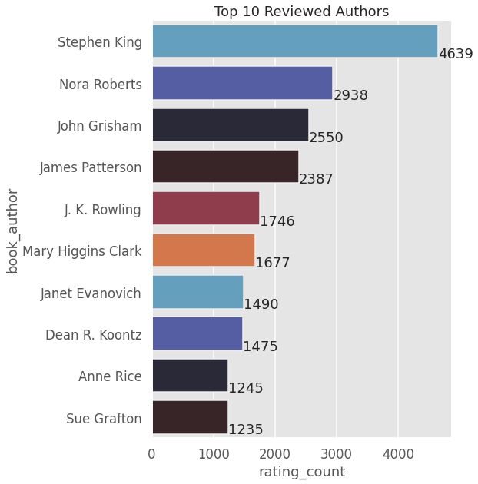

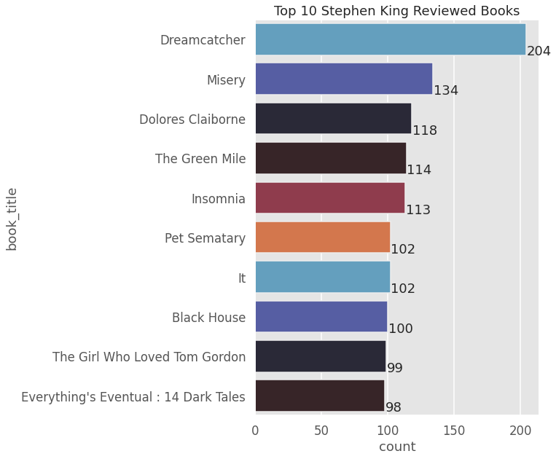

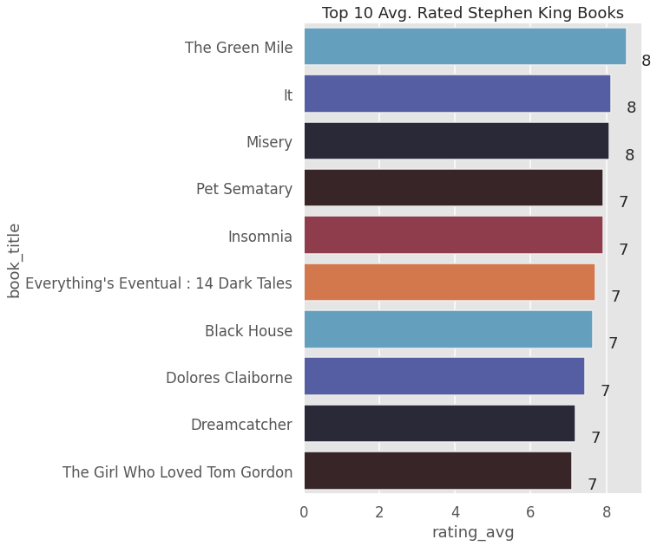

# Bibliography