|  |  |
| --- | --- |
| **Assignment** | |
| **Course Code** | CSE308A |
| **Course Name** | Computer Vision |
| **Programme** | B.Tech |
| **Department** | CSE |
| **Faculty** | FET |

|  |  |
| --- | --- |
| **Name of the Student** | Satyajit Ghana |
| **Reg. No.** | 17ETCS002159 |
| **Semester/Year** | 07/2021 |
| **Course Leader(s)** | Dr. Aruna Kumar S V |



|  |  |  |  |  |  |  |  |  |
| --- | --- | --- | --- | --- | --- | --- | --- | --- |
| Declaration Sheet | | | | | | | | |
| Student Name | Satyajit Ghana | | | | | | | |
| Reg. No | 17ETCS002159 | | | | | | | |
| Programme | B.Tech | | | | | Semester/Year | 07/2021 | |
| Course Code | CSE308A | | | | | | | |
| Course Title | Computer Vision | | | | | | | |
| Course Date |  | | to |  | | | | |
| Course Leader | Dr. Aruna Kumar S V | | | | | | | |
| **Declaration**  The assignment submitted herewith is a result of my own investigations and that I have conformed to the guidelines against plagiarism as laid out in the Student Handbook. All sections of the text and results, which have been obtained from other sources, are fully referenced. I understand that cheating and plagiarism constitute a breach of University regulations and will be dealt with accordingly. | | | | | | | | |
| Signature of the Student | |  | | | | | Date |  |
| Submission date stamp  (by Examination & Assessment Section) | |  | | | | | | |
| Signature of the Course Leader and date | | | | | Signature of the Reviewer and date | | | |
|  | | | | |  | | | |

# Contents

Declaration Sheet ii

Contents iii

List Of Figures iv

1 Question 1 5

1.1 Introduction 5

1.2 Summary 5

1.3 Conclusion 5

2 Question 2 6

2.1 Introduction 6

2.2 Summary 6

2.3 More Stuff 6

2.4 Conclusion 6

3 Question 3 7

3.1 Introduction 7

3.2 Summary 7

3.3 More Stuff 7

3.4 Conclusion 7

Bibliography 8

# Question 1

Solution to Question No. 1

## Introduction to Segmentation Techniques

## Importance of Segmentation Techniques in Computer Vision

## Summary of State-of-the-Art techniques for Segmentation

# Question 2

Solution to Question 2

## Write the flow chart or Algorithm

## Create an Image Dataset. Explain pre-processing methods relevant to the created dataset

COCO categories:

cat dog

COCO supercategories:

animal

### Image Samples Visualized using COCO Tools

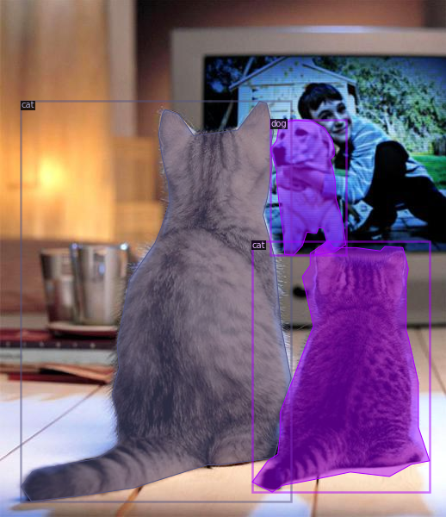

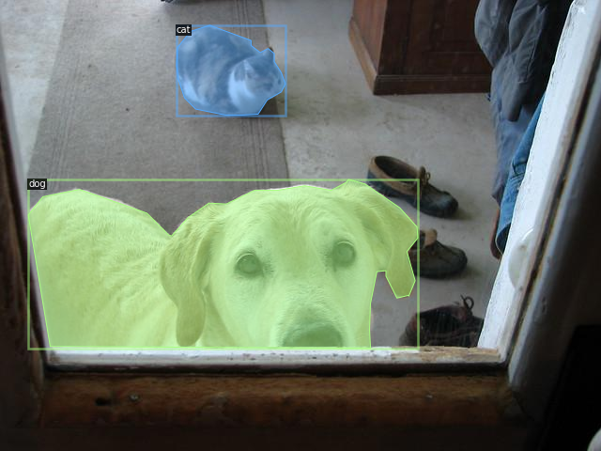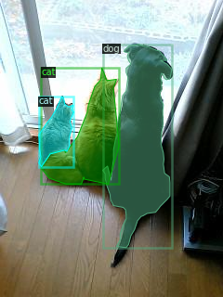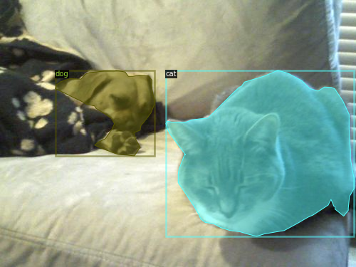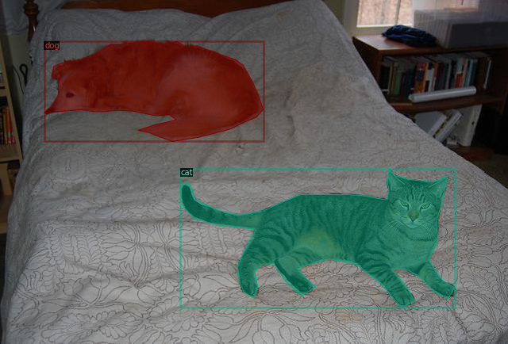

## Results and Discussions

### Test Images Prediction

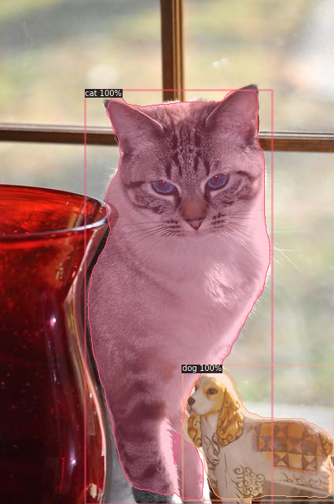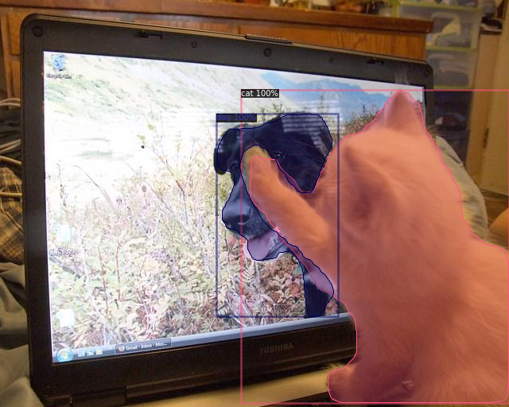

# Bibliography

# Appendix

Training Logs

[01/17 10:11:52 d2.data.datasets.coco]: Loaded 32 images in COCO format from /content/cat_dog_coco/annotations/annotations.json

[01/17 10:11:52 d2.data.dataset_mapper]: [DatasetMapper] Augmentations used in training: [ResizeShortestEdge(short_edge_length=(640, 672, 704, 736, 768, 800), max_size=1333, sample_style='choice'), RandomFlip()]

[01/17 10:11:52 d2.engine.train_loop]: Starting training from iteration 0

[01/17 10:12:02 d2.utils.events]: eta: 0:40:41 iter: 19 total_loss: 2.53 loss_cls: 0.8805 loss_box_reg: 0.9396 loss_mask: 0.6926 loss_rpn_cls: 0.006285 loss_rpn_loc: 0.006694 time: 0.4791 data_time: 0.0163 lr: 4.9953e-06 max_mem: 3255M

[01/17 10:12:12 d2.utils.events]: eta: 0:40:31 iter: 39 total_loss: 2.502 loss_cls: 0.8392 loss_box_reg: 0.9773 loss_mask: 0.6875 loss_rpn_cls: 0.008476 loss_rpn_loc: 0.007306 time: 0.4786 data_time: 0.0067 lr: 9.9902e-06 max_mem: 3255M

. . . . . . . .

[01/17 10:51:50 d2.utils.events]: eta: 0:00:19 iter: 4959 total_loss: 0.1519 loss_cls: 0.01956 loss_box_reg: 0.0574 loss_mask: 0.07078 loss_rpn_cls: 9.858e-06 loss_rpn_loc: 0.002456 time: 0.4828 data_time: 0.0082 lr: 0.00025 max_mem: 3394M

[01/17 10:52:00 d2.utils.events]: eta: 0:00:09 iter: 4979 total_loss: 0.1468 loss_cls: 0.01878 loss_box_reg: 0.05593 loss_mask: 0.06667 loss_rpn_cls: 1.776e-05 loss_rpn_loc: 0.002517 time: 0.4828 data_time: 0.0080 lr: 0.00025 max_mem: 3394M

[01/17 10:52:13 d2.utils.events]: eta: 0:00:00 iter: 4999 total_loss: 0.1479 loss_cls: 0.01777 loss_box_reg: 0.05872 loss_mask: 0.06731 loss_rpn_cls: 2.385e-05 loss_rpn_loc: 0.003065 time: 0.4829 data_time: 0.0067 lr: 0.00025 max_mem: 3394M

[01/17 10:52:13 d2.engine.hooks]: Overall training speed: 4998 iterations in 0:40:13 (0.4829 s / it)

[01/17 10:52:13 d2.engine.hooks]: Total training time: 0:40:19 (0:00:06 on hooks)