# Laboratory 2

Title of the Laboratory Exercise: Stacks and queues

Introduction and Purpose of Experiment

Stacks and queues are very important data structures used in many real time applications. This experiment introduces the development of stack and queue ADT and applying them together.

1. Aim and Objectives

Aim

* To develop stack and queue ADT and to use them for string applications

Objectives

At the end of this lab, the student will be able to

* Design and develop and use stack and demonstrate its operations
* Design and develop and use queue and demonstrate its operations

1. Pseudo Codes

|  |  |
| --- | --- |
| * + - 1. Stack – Push   If top > MAX  Print Stack Overflow  End  Else  Set top = top + 1  Set stack[top] = value  End   * + - 1. Stack – Pop   If top < 0  Print Stack Underflow  End  Else  Set top = top - 1  Return stack[top + 1]  End   * + - 1. Stack – Display   Set i = 0  While i < top  Print stack[i]  Set i = i +1;  End | * + - 1. Queue – Enqueue   If tail > MAX  Print Queue Overflow  End  Else  Set tail = tail + 1  Set queue[tail] = value  End   * + - 1. Queue – Dequeue   If head > tail or tail == -1  Print Queue Underflow  End  Else  Set head = head + 1  Return queue[head - 1]  End   * + - 1. Queue – Display   Set i = head  While i < tail  Print queue[i]  Set i = i +1;  End |

1. Implementation in C

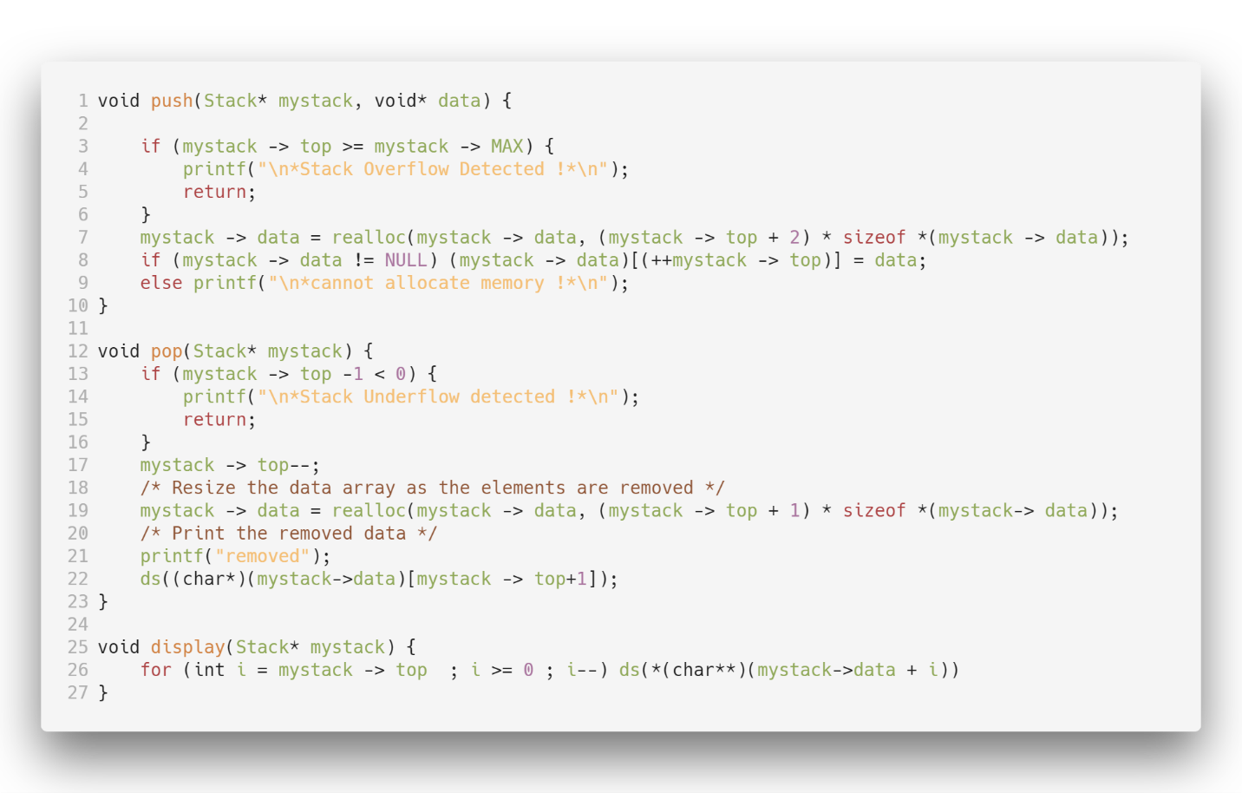

Figure 1 Stack

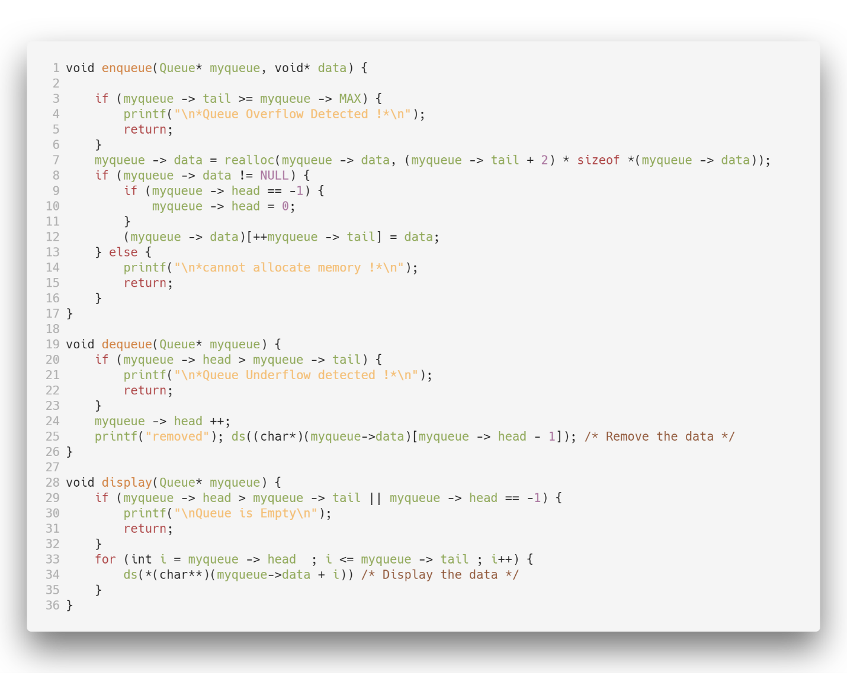

Figure 2 Queue

1. Presentation of Results

|  |  |
| --- | --- |
| --- STACKS USING DYNAMIC ALLOCATIONS ---  1.Push 2.Pop 3.Display 4.Exit  Enter your choice : 1  Enter your data : Satyajit Ghana  --- STACKS USING DYNAMIC ALLOCATIONS ---  1.Push 2.Pop 3.Display 4.Exit  Enter your choice : 3  DEBUG--**(char**)(mystack->data + i) : Satyajit Ghana*  --- STACKS USING DYNAMIC ALLOCATIONS ---  1.Push 2.Pop 3.Display 4.Exit  Enter your choice : 2  removed  DEBUG--*(char*)(mystack->data)[(mystack -> top)+1] : Satyajit Ghana* | --- QUEUES USING DYNAMIC ALLOCATIONS ---  1.Enqueue 2.Dequeue 3.Display 4.Exit  Enter your choice : 1  Enter your data : Satyajit Ghana  --- QUEUES USING DYNAMIC ALLOCATIONS ---  1.Enqueue 2.Dequeue 3.Display 4.Exit  Enter your choice : 3  DEBUG--**(char**)(myqueue->data + i) : Satyajit Ghana*  --- QUEUES USING DYNAMIC ALLOCATIONS ---  1.Enqueue 2.Dequeue 3.Display 4.Exit  Enter your choice : 2  removed  DEBUG--*(char*)(myqueue->data)[myqueue -> head - 1] : Satyajit Ghana* |

1. Conclusions

Backtracking is used in algorithms in which there are steps along some path (state) from some starting point to some goal. In all of these cases, there are choices to be made among a number of options. We need some way to remember these decision points in case we want/need to come back and try the alternative Again, stacks can be used as part of the solution. Recursion is another, typically more favored, solution, which is actually implemented by a stack.

The simplest two search techniques are known as Depth-First Search (DFS) and Breadth-First Search (BFS). These two searches are described by looking at how the search tree (representing all the possible paths from the start) will be traversed.

Breadth-First Search with a Queue, in breadth-first search we explore all the nearest possibilities by finding all possible successors and enqueue them to a queue.