# Laboratory 1

**Introduction to Logisim and Circuit Development**

1. Introduction and Purpose of Experiment

Students will learn to use Logisim simulator to simulate logic circuits and implement them using appropriate ICs

1. Aim and Objectives

**Aim:** To use Logisim to simulate logic circuits and implement them

**Objectives:** At the end of this lab, the student will be able to

* Use Logisim to simulate logic circuits
* Choose appropriate ICs to implement the logic circuits
* Implement the logic circuits using the ICs and hardware kit

1. Experimental Procedure
   1. Draw the truth tables and circuit diagrams for the following expressions.
 $Y=A\sim B+\sim AB$

 $W=BC+\sim BC$

 $O=\sim ABC+A\sim BC+ABC$

$X=\sim AB+\sim AB\sim C+\sim ABCD+\sim AB\sim C\sim D$

$F=\sim WXYZ+\sim WXY\sim Z+WXYZ+WXY\sim Z$

2. Use Logisim to generate the truth tables and circuit diagrams for the above expressions.
   3. Implement the first three expressions in the non-minimized form and verify the truth tables. Show the output to the course leader.
   4. Do you see any limitations in the simulator and/or the hardware kit? Discuss how these can be overcome.

Your document should include:

* Handwritten truth tables and circuit diagrams for the expressions
* Logisim screenshots
* Answer to 3(d)

3.a.1. $Y=A\sim B+\sim AB$

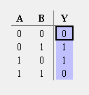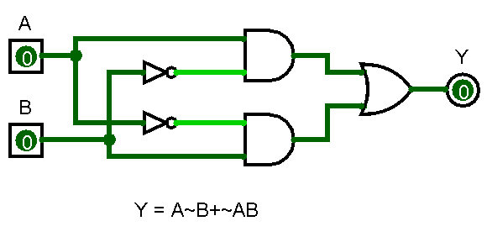

3.a.2. $W=BC+\sim BC$

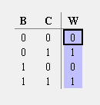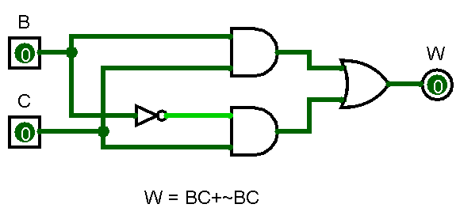

3.a.3. $O=\sim ABC+A\sim BC+ABC$

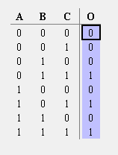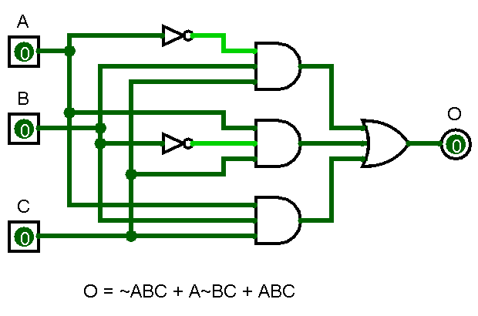

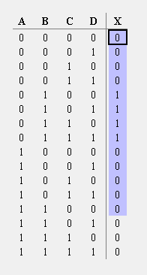3.a.4. $X=\sim AB+\sim AB\sim C+\sim ABCD+\sim AB\sim C\sim D$

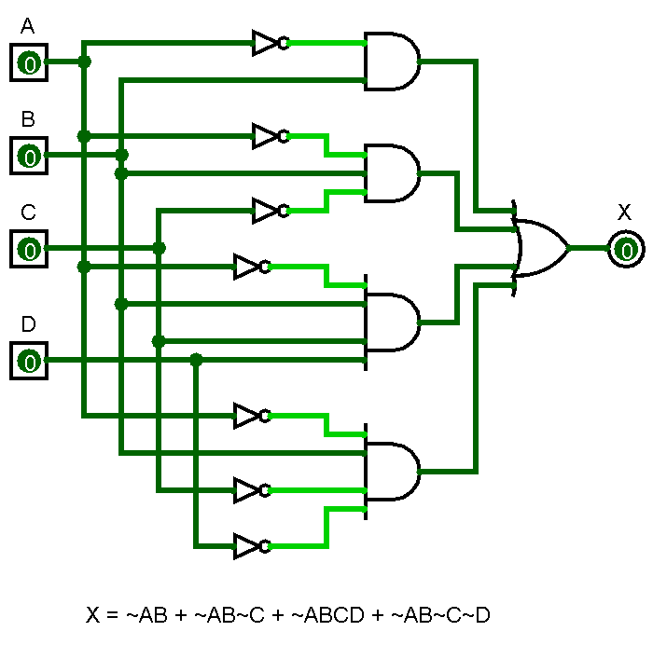

3.a.5. $F=\sim WXYZ+\sim WXY\sim Z+WXYZ+WXY\sim Z$

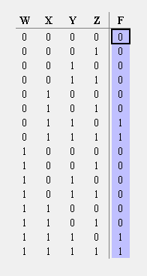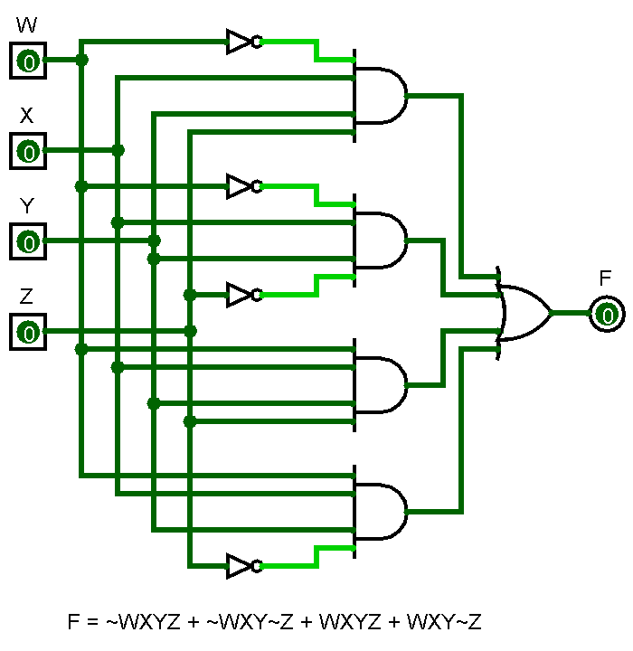

3.d The Complexity of the circuit increases exponentially as the number of variables increases, consequently the number of gates also increases and it makes it difficult to manage the circuit, both at the simulator level and at the implementation level, to overcome this issue, the circuit can be first reduced using K-Maps or Quine-McClusky method, to obtain a reduced expression. To overcome the complexity arising due to the more number of variables can be solved by making small mudules for parts of the expression, and these modules can then be wired together, this would reduce the complexity and make the circuit more simpler. Also the number of gates that can be simultaneously used in the hardware kit is limited, and even so the number of wires used for it becomes too much to keep track of.