# Laboratory 5

**Combinational Circuits-I**

**Adders and Subtractors**

1. Introduction and Purpose of Experiment

Students will learn to design, simulate and implement adders and subtractors.

1. Aim and Objectives

**Aim:** To use adders and subtractors and perform mathematical operations on binary numbers

**Objectives:** At the end of this lab, the student will be able to

* Add and subtract 4-bit binary numbers
* Use adder circuits to perform subtraction

1. Experimental Procedure
   1. Write truth tables, Boolean expressions and circuit diagrams for the following combinational circuits:
      1. Half and full adder
      2. Half and full subtractor
   2. Using 2 full adders and other additional circuitry, design a circuit capable of adding and subtracting two 2-bit numbers.
   3. Use Logisim to simulate the circuits designed above.
   4. Implement the circuit and show the output to the course leader.
   5. Show in detail how a full adder can be implemented using two half adders.

Your document should include:

* Handwritten truth tables, expressions and circuit diagrams for the combinational circuits in 3(a).
* Design of the circuit
* Logisim screenshots of the designed circuit
* Answer to 3(e)

3.a.i

Half and Full Adder

|  |  |
| --- | --- |
|  |  |

|  |
| --- |
|  |
|  |

3.a.ii

Half and Full Subtractor

|  |  |
| --- | --- |
|  |  |

|  |
| --- |
|  |
|  |

3.b

Adder and Subtractor

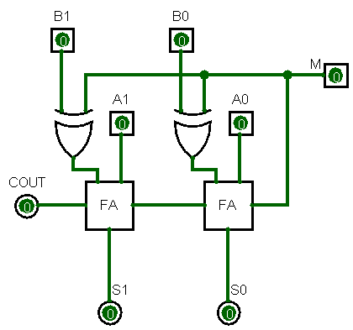

Where M is the Addition/Subtraction toggle switch, when M = 0 it is simple addition, and when M = 1 its subtraction, basically when M = 1 it compliments the input B and send carry-in = 1 to the first Full Adder.

3.e

We can implement a full adder circuit with the help of two half adder circuits. At first, half adder will be used to add A and B to produce a partial Sum and a second half adder logic can be used to add C-IN to the Sum produced by the first half adder to get the final S output.

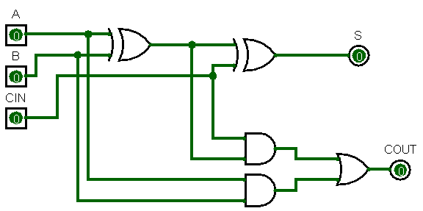

If any of the half adder logic produces a carry, there will be an output carry. So, COUT will be an OR function of the half-adder Carry outputs. Take a look at the implementation of the full adder circuit shown below.

