# Laboratory 7

**Combinational Circuits-III**

**Decimal to BCD Encoder and Decoders**

1. Introduction and Purpose of Experiment

Students will learn to design and implement a circuit for Decimal to BCD Encoder.

1. Aim and Objectives

**Aim:** Design and implement a circuit for Decimal to BCD Encoder

**Objectives:** At the end of this lab, the student will be able to

* Develop a circuit for Decimal to BCD Encoder
* Understand the basics of Decoders

1. Experimental Procedure
   1. Write truth table and block diagram for Decimal to BCD Encoder
   2. Construct the circuits for Decimal to BCD Encoder using appropriate ICs. Verify the functionality and show the output to the course leader
   3. Using an example, describe how a decoder can be implemented using a Demultiplexer.

Your document should include:

* Handwritten truth table and block diagrams for the circuit in 3(a).
* Answer to 3(c)

3.b

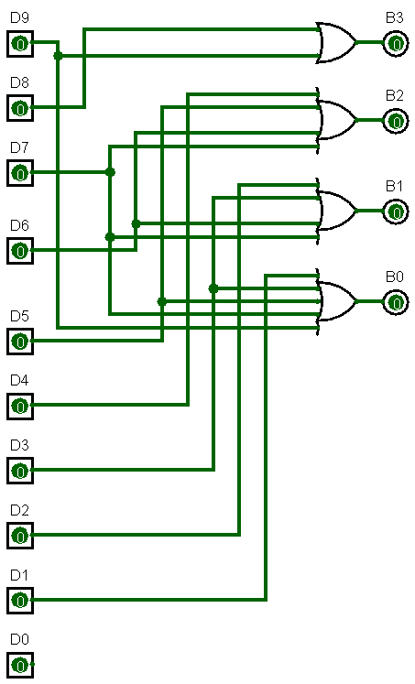

3.c

To see how a demultiplexer can be made into a decoder let’s first see the function tables of a demultiplexer and a decoder, and the example we will be taking here will be of a 1:4 DEMUX and a 2:4 DECODER:

|  |  |  |  |  |  |  |  |  |  |  |  |  |  |  |  |  |  |  |  |  |  |  |  |  |  |  |  |  |  |  |  |  |  |  |  |  |  |  |  |  |  |  |  |  |  |  |  |  |  |  |  |  |  |  |  |  |  |  |  |  |  |
| --- | --- | --- | --- | --- | --- | --- | --- | --- | --- | --- | --- | --- | --- | --- | --- | --- | --- | --- | --- | --- | --- | --- | --- | --- | --- | --- | --- | --- | --- | --- | --- | --- | --- | --- | --- | --- | --- | --- | --- | --- | --- | --- | --- | --- | --- | --- | --- | --- | --- | --- | --- | --- | --- | --- | --- | --- | --- | --- | --- | --- | --- |
| |  |  |  |  | | --- | --- | --- | --- | | 1:4 DEMUX | | | | | I | S1 | S0 | Y | | I0 | 0 | 0 | I0 | | I1 | 0 | 1 | I1 | | I2 | 1 | 0 | I2 | | I3 | 1 | 1 | I3 | | |  |  |  |  |  |  | | --- | --- | --- | --- | --- | --- | | 2:4 DECODER | | | | | | | I1 | I0 | Y0 | Y1 | Y2 | Y3 | | 0 | 0 | 1 | 0 | 0 | 0 | | 0 | 1 | 0 | 1 | 0 | 0 | | 1 | 0 | 0 | 0 | 1 | 0 | | 1 | 1 | 0 | 0 |  | 1 | |

From this we can observe that in a DEMUX the input is directly sent to the corresponding output line given the right select bits, and in a decoder its essentially the same thing, just that the output is 1 for the line number corresponding to the select bit. So if we make the input line of a demux as 1, it becomes a decoder, the select lines of the demux become the input for the decoder.

