Hotel Route Planner Modifications
Report 2 | Source selection, complete route display, and road distance updates
Each modification extends the same six-vertex undirected road graph. The programs use C++98-compatible syntax for Dev-C++ 5.11.

Modification A Select a Different Source

Objective
Modification A lets the user choose any place as the source vertex and recalculates shortest distances from that place. The selected source is excluded from the attraction list.

Algorithm
- Display the numbered vertices and read a valid source index.
- Initialize Dijkstra’s algorithm with distance zero at the selected source and infinity elsewhere.
- Repeatedly choose the nearest unvisited vertex and relax its roads.
- Display the resulting distances, then sort and display reachable attractions by increasing distance..

Flowchart
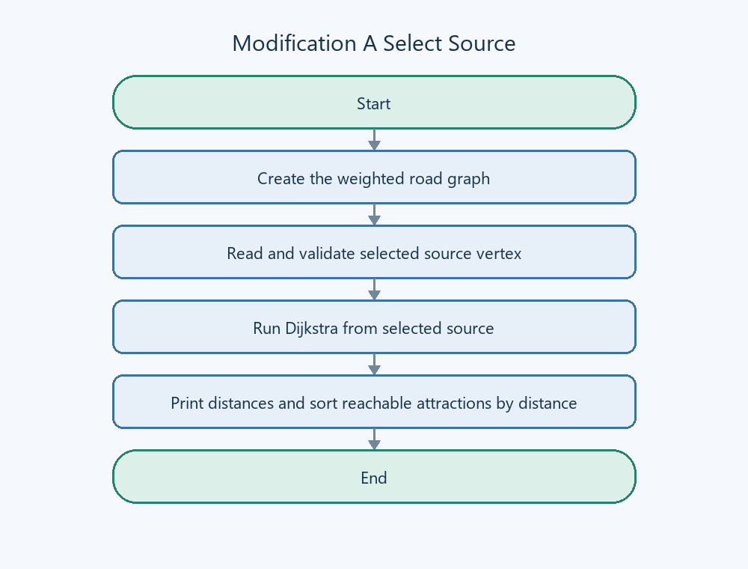
Figure 1. Modification A Select a Different Source

Modification B Display the Complete Shortest Path

Objective
Modification B displays the full shortest route to a destination, together with its total distance. It also displays the shortest distances and the nearest-first reachable list from the hotel.

Algorithm
- Run Dijkstra from the hotel and save a parent vertex whenever a shorter route is found.
- Read and validate the destination.
- If it is unreachable, report that no route exists.
- Otherwise, follow parent links from the destination to the hotel, reverse the collected sequence, and display the path and distance..

Flowchart
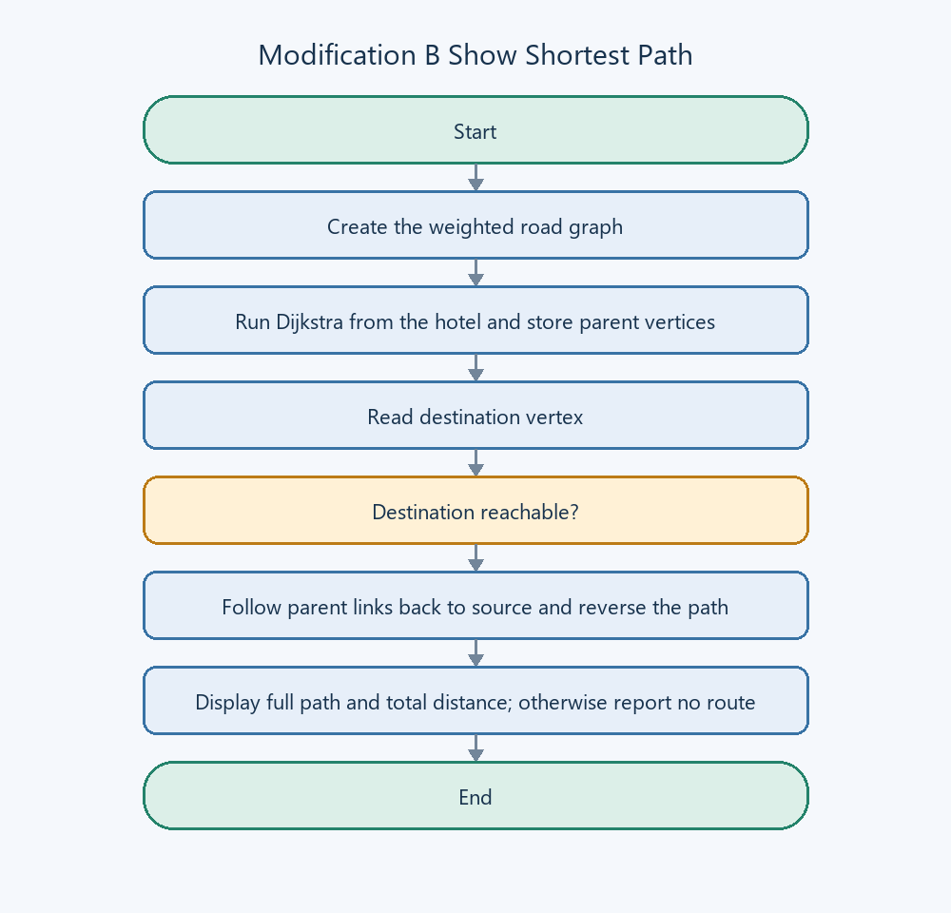
Figure 2. Modification B Display the Complete Shortest Path

Modification C Update a Road Distance

Objective
Modification C changes the weight of an existing road and recalculates shortest distances from the hotel. The new road distance must be a non-negative whole number.

Algorithm
- Display the vertices and read two different endpoints that already have a road between them.
- Read and validate the new non-negative distance.
- Update the road in both directions.
- Run Dijkstra again from the hotel, then display all updated distances and the reachable attractions in increasing distance order..

Flowchart
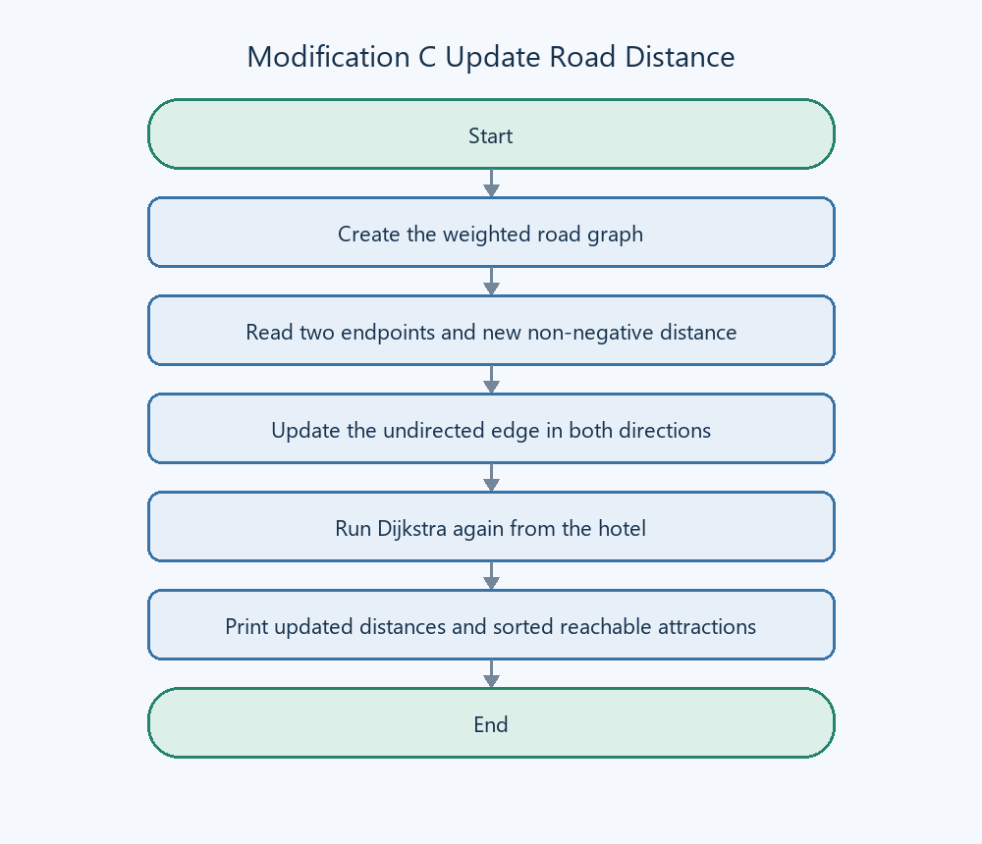
Figure 3. Modification C Update a Road Distance

