Hotel and Tourist Attraction Route Planner
Report 1 | Original problem, algorithm, flowchart, and C++ program

Original Problem Statement
Develop a C++ program that represents a hotel and tourist attractions as vertices in a graph. Roads are edges with non-negative distances. Apply Dijkstra’s algorithm from the hotel, display the shortest distance to every attraction, and list reachable attractions in increasing order of distance.

Algorithm
- Create the weighted undirected graph and set every diagonal distance to zero.
- Set the hotel’s distance to zero and all other distances to infinity. Mark every vertex unvisited.
- Choose the unvisited vertex with the smallest tentative distance. If no finite distance remains, stop.
- Mark the chosen vertex visited. For each neighboring vertex, calculate the route through the chosen vertex.
- If this route is shorter, replace the neighbor’s distance with the new distance.
- Repeat the selection and distance update until no reachable unvisited vertex remains.
- Display the distance to every other vertex. Sort reachable attractions by distance and display the ordered list.

Flowchart
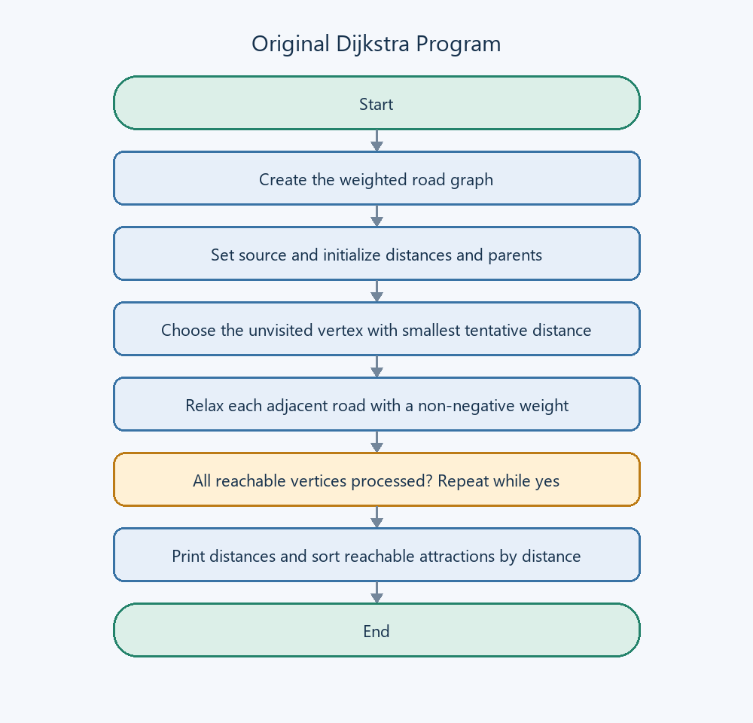
Figure 1. Original shortest-distance process

