**NAME – Satyajit Panda**

**DATE - 27/06/2022 (MON)**

1. Arduino basics

Programmed to blink the port 13 LED

Program



1. Bread board connections

Programmed to connect an LED to the breadboard.

**DATE – 28/06/2022 (TUE)**

1. Parallel connection on LEDS on bread board and blinking them

Program



Both the LEDs are connected to pin 5, and we use the pin to control at what time interval it should set it high and low.

1. Checking BPM using a heart rate sensor

The heart rate sensor is connected with the Arduino with its power input (red wire) to 3.3/5v supply, blue wire to GND and the ac signal output (purple wire) to A0 AC input of Arduino.

Program for observing the heart rate in serial plotter



Serial Plotter output

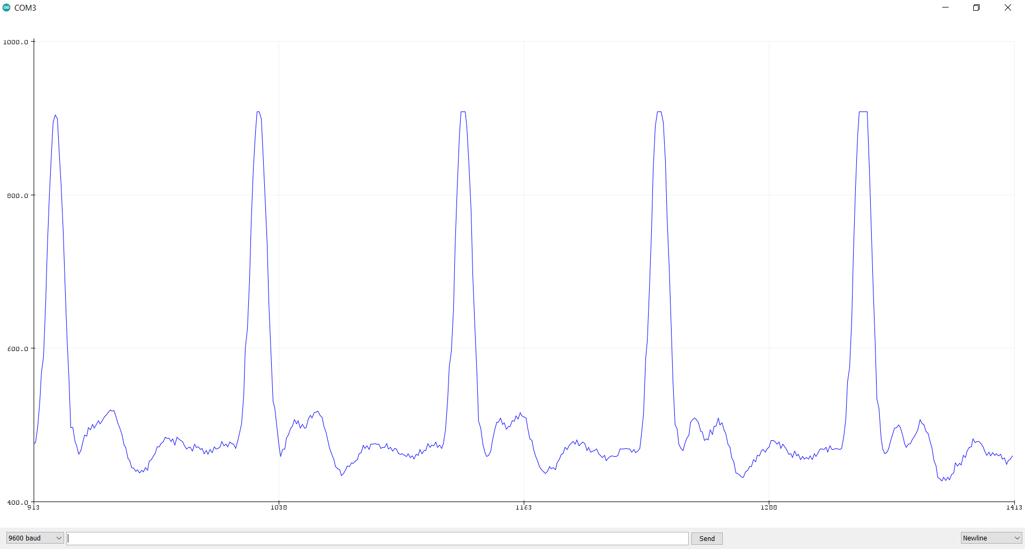

Program to display the BPM in the serial monitor



Serial Monitor output

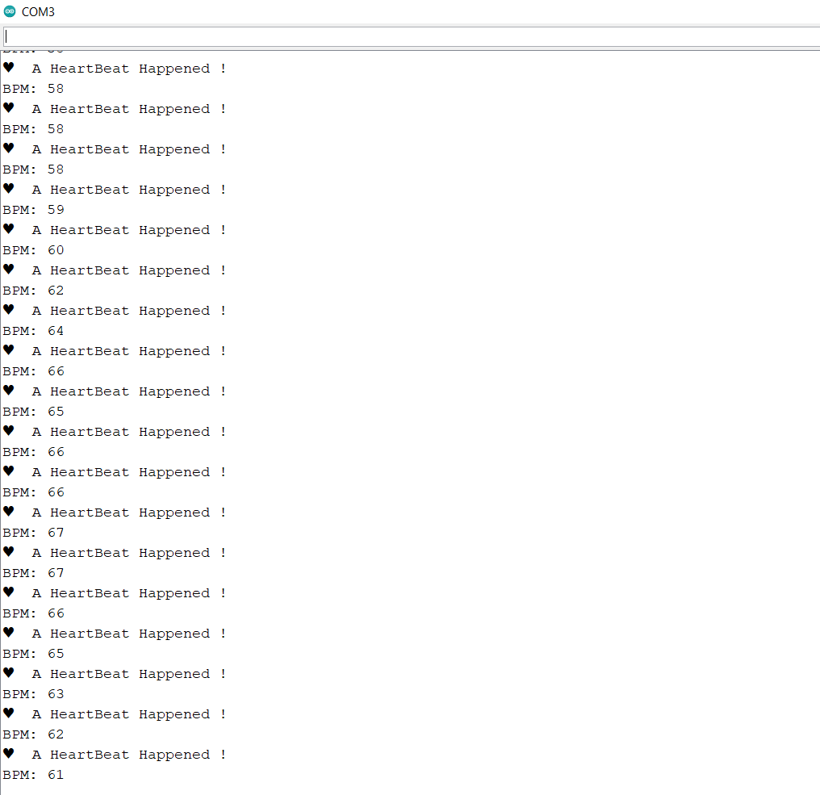

**DATE – 29/06/2022 (WED)**

1. Converting the serial monitor data into a csv file and storing it

Coolterm software is used to export the serial monitor data and to store it in a txt file, then we convert this txt into a csv(comma separated values) file.

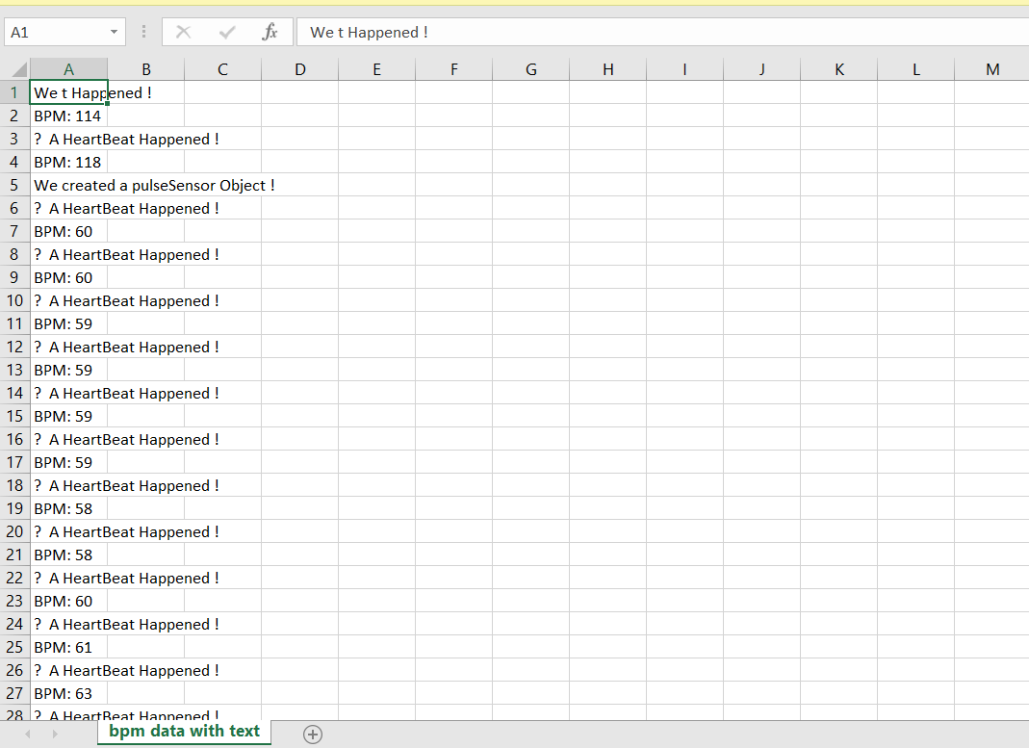

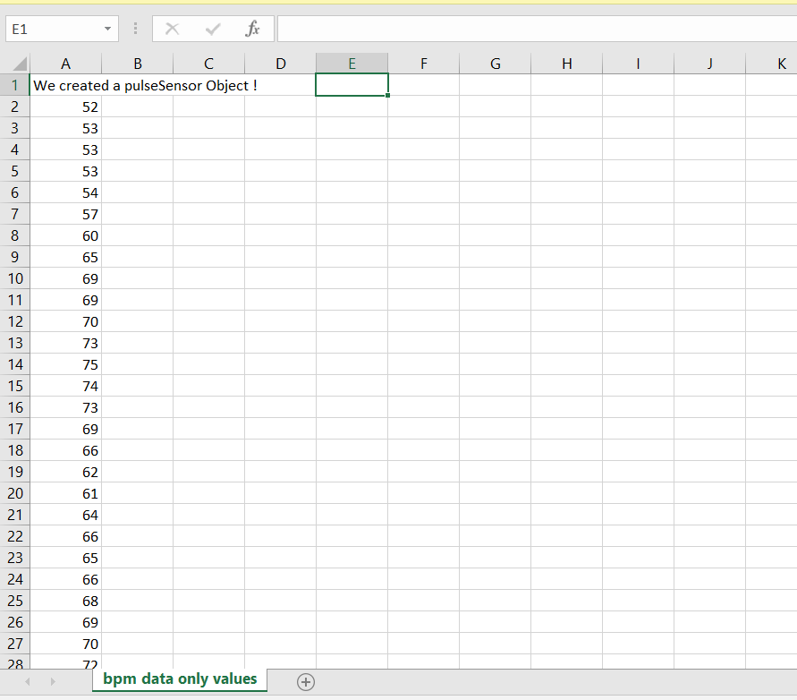

1. Read about basics of python

**DATE – 30/06/2022 (THU)**

Basic python programs done.

1. Program to calculate BMI

mass=int(input("enter your weight : "))

height=int(input("enter your height in centimetre : "))

bmi=mass/pow(height/100,2)

print("your BMI is ",'%.2f'%bmi)

1. Program to know a year is leap year or not

year = int(input("enter the year to check : "))

if year%4==0 :

    if year%100==0 and year%400==0:

        print("it is a leap year")

    elif year%100==0:

        print("it is not")

    else:

        print("it is a leap year")

else:

    print("it is not")

1. Program for tip caluculator

sum=int(input("enter the original amount : "))

pct=int(input("enter the tip % : "))

tip=int(sum*(1+(pct/100)))

print("the tip amount is : ",tip)

**DATE – 04/07/2022 (MON)**

1. The maze problem

print("you are at the starting position")

print("the available moves are left, right, up and down")

current = input("enter your move : ")

current = current.lower()

if current == "left": ## starting position

    print("You can't go left from starting, you are dead")

elif current == "right": ## position 1

    print("you are on the right track, move ahead")

    print("from here you can move up,down and right")

    current = input("enter your move : ")

    current = current.lower()

    if current=="up": ## position 2

        print("you got a right move but there is wall ahead, so start again")

    elif current=="right": ## position 4

        print("you are on the right track, go ahead")

        current = input("choose left or right : ")

        current = current.lower()

        if current == "up" or current=="left" or current == "right":

            print("no up or down or right moves are available from here, start again")

        elif current=="down": ## position 5

            print("you are on the right track, move ahead")

            current = input("enter your move : ")

            current = current.lower()

            if current=="left" or current=="up" or current=="down":

                print("no up, down or left moves available here, start again")

            elif current=="right": ## position 6

                print("hurray, you reached at the end 😊😊 !!!")

            else:

                print("invlaid input, start again")

        else:

            print("invalid input, start again")

    elif current=="down": ## position 3

        print("you are on the right track, move ahead")

        current = input("enter your move : ")

        current = current.lower()

        if current=="up" or current=="left" or current=="down":

            print("no left or up or down moves are availabe here, start again")

        elif current=="right": ##position 5

            print("you are on the right track, move ahead")

            current = input("enter your move : ")

            current = current.lower()

            if current=="left" or current=="up" or current=="down":

                print("no up, down or left moves available here, start again")

            elif current=="right": ## position 6

                print("hurray, you reached at the end 😊😊 !!!")

            else:

                print("invlaid input, start again")

        else:

            print("invalid move, start again")

    elif current=="left":

         print("no left moves are available from here, start again")

    else:

        print("invalid move, start again")

elif current=="up" or current=="down":

    print("no up or down moves are available from here, start again")

else:

    print("invalid input")

1. True-love calculator program

p_name = input("enter the 1st person name : ")

q_name = input("enter the 2nd person name : ")

p_name = p_name.lower()

q_name = q_name.lower()

count1 = 0

count2 = 0

for character in p_name:

    if "true".find(character)!=-1:

        count1+=1

    if "love".find(character)!=-1:

        count1+=1

for character in q_name:

    if "true".find(character)!=-1:

        count2+=1

    if "love".find(character)!=-1:

        count2+=1

ans = count1*10 + count2

if ans<=10 or ans>=90:

    print("Your score is ",ans,", you go together like coke and mentos")

elif ans>=40 and ans<=50:

    print("Your score is ",ans,", you are alright together")

else:

    print("Your score is ",ans)

1. Dice game problem

import random

decision = input("You want to roll the dice Y/N")

if  decision=='y'or decision=='Y':

    print(random.randint(1,6))

1. Password generator problem

import random

arr = ["A", "B", "C", "D", "E", "F", "G", "H", "I", "J", "K", "L", "M", "N", "O", "P", "Q", "R", "S", "T", "U", "V", "W", "X", "Y", "Z", "a", "b", "c", "d", "e", "f", "g", "h", "i", "j", "k", "l", "m", "n", "o", "p", "q", "r", "s", "t", "u", "v", "w", "x", "y", "z",'1','2','3','4','5','6','7','8','9','!','@','#','$','%','^','&','*','(',')','[',']','{','}']

l=len(arr)

inp = input("enter y to generate a new password : ")

if inp=='y':

    res=""

    for i in range(8):

        num=random.randint(0,l)

        res+=arr[num]

    print("the password is : ",res)

else:

    print("invalid input")

Connecting Arduino with things speak to view the sensor data online

**DATE – 05/07/2022 (TUE)**

Exploring how we can send Arduino sensor data online

**DATE – 06/07/2022 (WED)**

1. How to use IR sensor data with Arduino

Components used – Arduino, jumper wires, IR sensor, LED light, cable

Infrared Sensor is an electronic instrument that is used to detect any type of obstacle/object

We are using an Arduino diecimila here.

The sender and receiver end of the IR sensor is as below.

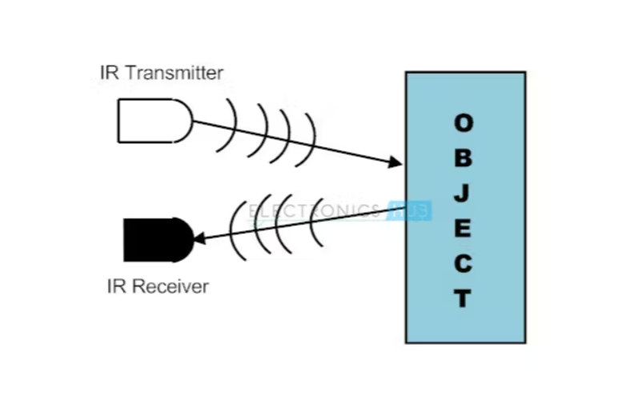

The circuit connection is like

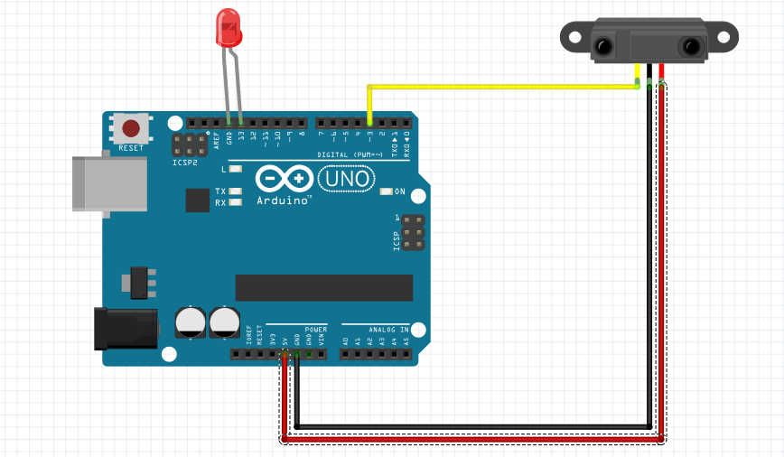

Code



[reference](https://create.arduino.cc/projecthub/biharilifehacker/how-to-use-ir-sensor-with-arduino-with-full-code-bihar-3f29c3)

**Output pictures**

**DATE – 07/07/**

1. **Stepper motor connection with Arduino**

Components used – Arduino diecimila, 28BYJ-48 stepper motor, driver

The driver is connected with the Arduino with 5v power supply and ground.

The IN1, IN2, IN3, IN4 are connected to the 12, 11, 10 and 9 digital pins of the Arduino diecimila.

The step motor 28BYJ-48 (5V DC) is connected with the driver in the provided port.

The Arduino is connected to the system and the code is uploaded.

**Circuit photo**

**Code**

#define STEPPER_PIN_1 9

#define STEPPER_PIN_2 10

#define STEPPER_PIN_3 11

#define STEPPER_PIN_4 12

int step_number = 0;

void setup() {

pinMode(STEPPER_PIN_1, OUTPUT);

pinMode(STEPPER_PIN_2, OUTPUT);

pinMode(STEPPER_PIN_3, OUTPUT);

pinMode(STEPPER_PIN_4, OUTPUT);

}

void loop() {

OneStep(false);

delay(2);

}

void OneStep(bool dir){

if(dir){

switch(step_number){

case 0:

digitalWrite(STEPPER_PIN_1, HIGH);

digitalWrite(STEPPER_PIN_2, LOW);

digitalWrite(STEPPER_PIN_3, LOW);

digitalWrite(STEPPER_PIN_4, LOW);

break;

case 1:

digitalWrite(STEPPER_PIN_1, LOW);

digitalWrite(STEPPER_PIN_2, HIGH);

digitalWrite(STEPPER_PIN_3, LOW);

digitalWrite(STEPPER_PIN_4, LOW);

break;

case 2:

digitalWrite(STEPPER_PIN_1, LOW);

digitalWrite(STEPPER_PIN_2, LOW);

digitalWrite(STEPPER_PIN_3, HIGH);

digitalWrite(STEPPER_PIN_4, LOW);

break;

case 3:

digitalWrite(STEPPER_PIN_1, LOW);

digitalWrite(STEPPER_PIN_2, LOW);

digitalWrite(STEPPER_PIN_3, LOW);

digitalWrite(STEPPER_PIN_4, HIGH);

break;

}

}else{

switch(step_number){

case 0:

digitalWrite(STEPPER_PIN_1, LOW);

digitalWrite(STEPPER_PIN_2, LOW);

digitalWrite(STEPPER_PIN_3, LOW);

digitalWrite(STEPPER_PIN_4, HIGH);

break;

case 1:

digitalWrite(STEPPER_PIN_1, LOW);

digitalWrite(STEPPER_PIN_2, LOW);

digitalWrite(STEPPER_PIN_3, HIGH);

digitalWrite(STEPPER_PIN_4, LOW);

break;

case 2:

digitalWrite(STEPPER_PIN_1, LOW);

digitalWrite(STEPPER_PIN_2, HIGH);

digitalWrite(STEPPER_PIN_3, LOW);

digitalWrite(STEPPER_PIN_4, LOW);

break;

case 3:

digitalWrite(STEPPER_PIN_1, HIGH);

digitalWrite(STEPPER_PIN_2, LOW);

digitalWrite(STEPPER_PIN_3, LOW);

digitalWrite(STEPPER_PIN_4, LOW);

}

}

step_number++;

if(step_number > 3){

step_number = 0;

}

}