# Create database

Run SQL script

X_DB/ MultiStater

# Theme used

# Code flow

makemovie.php

|

Makemovie2.php

|

makemovieAjax.php

readyforshoot.php

|

shooting.php shootingAjax.php

|

shootout.php?rid=2&uid=93

readyforrelease.php

|

release.php?rid=865

|

released.php?news=<a href=\'running.php?rid=865\'>Okay! Staring with Arjanrajesh and Anushka directed by A. karunakaran is Releasing in 243 Centers&rid=865

readyforrun.php?rid=865

|

running.php?rid=865

# Poster Genrator

**Fatal error**: Uncaught Error: Call to undefined function imagecreatefromjpeg() in C:\xampp\htdocs\hit\poster\poster1.php:61 Stack trace: #0 {main} thrown in **C:\xampp\htdocs\hit\poster\poster1.php** on line **61**

<https://www.youtube.com/watch?v=Jmzkdc2fjgc>

You can get this Error in LocalHost only… On Domain Host you wont get.

Testing Poster Generation: Use this URL

[http://javabo.ml/poster/poster1.php?rid=858&b=sadsad&p=satya&d=A. kodanda rami reddy&a= Arjanrajesh&ac= Anushka &c=Anumolu Srikar&e=Bindra&m=Kedra&w=Lola&tit=Okay&fif=0&hun=0&fiv=0&t5=1&sev=0&onf=0&a2=&a3=&ac2=&ac3=&d2=&d3=&w2=&w3=&m2=Thaman&m3= Achu](http://javabo.ml/poster/poster1.php?rid=858&b=sadsad&p=satya&d=A.%20kodanda%20rami%20reddy&a=%20Arjanrajesh&ac=%20Anushka%20&c=Anumolu%20Srikar&e=Bindra&m=Kedra&w=Lola&tit=Okay&fif=0&hun=0&fiv=0&t5=1&sev=0&onf=0&a2=&a3=&ac2=&ac3=&d2=&d3=&w2=&w3=&m2=Thaman&m3=%09Achu)

URL will form from here. **Running.php**

Line 597:

var plink = 'poster/poster1.php?rid='+rid+'&b='+b+'&p='+p+'&d='+d+'&a='+a+'&ac='+ac+'&c='+c+'&e='+e+'&m='+m+'&w='+w+'&tit='+tit+'&fif='+fif+'&hun='+hun+'&fiv='+fiv+'&t5='+t5+'&sev='+sev+'&onf='+onf

+'&a2='+a2+'&a3='+a3+'&ac2='+ac2+'&ac3='+ac3+'&d2='+d2+'&d3='+d3+'&w2='+w2+'&w3='+w3+'&m2='+m2+'&m3='+m3;

# Poster Editing

<https://youtu.be/SV38L4c4JKY>

1. Open Image in Photoshop
2. Select Face area CTRL+C for Copy and paste in untitled new doc of size 400x400 pixels

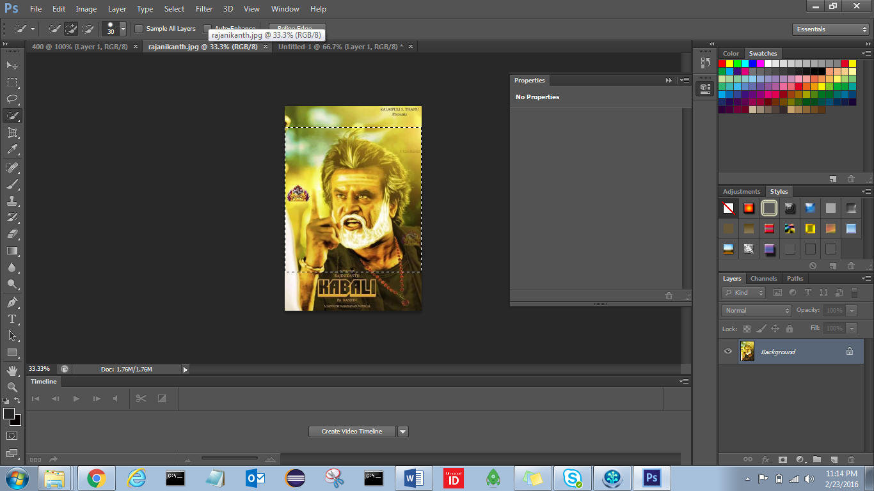

1. Right click on Background 🡪 select Layer from Background

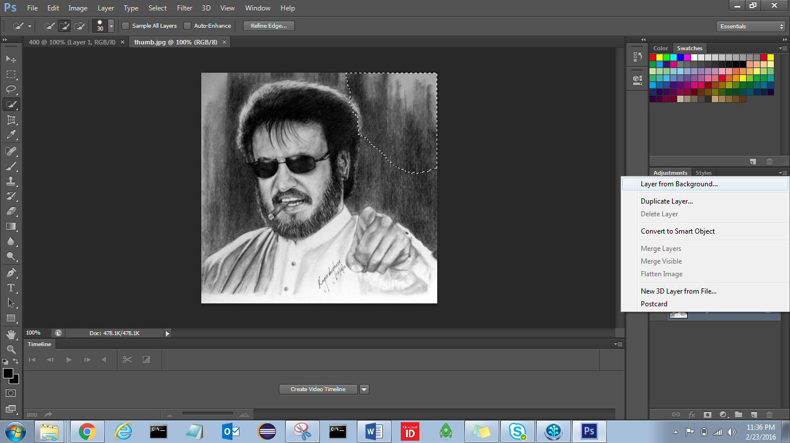

1. Click on Transparency , it will Lock

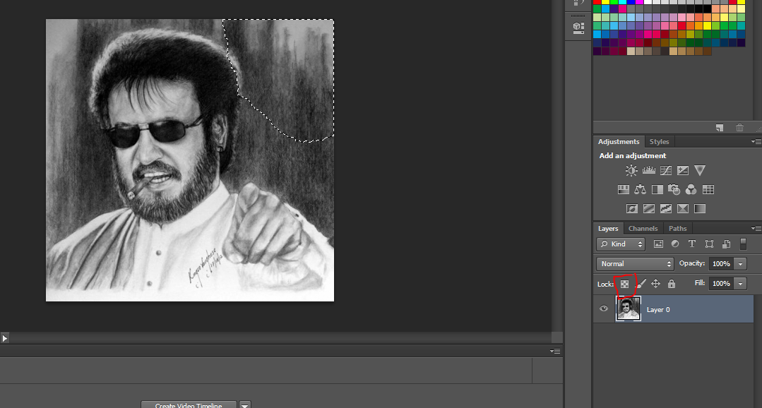

1. Click on Magic tool

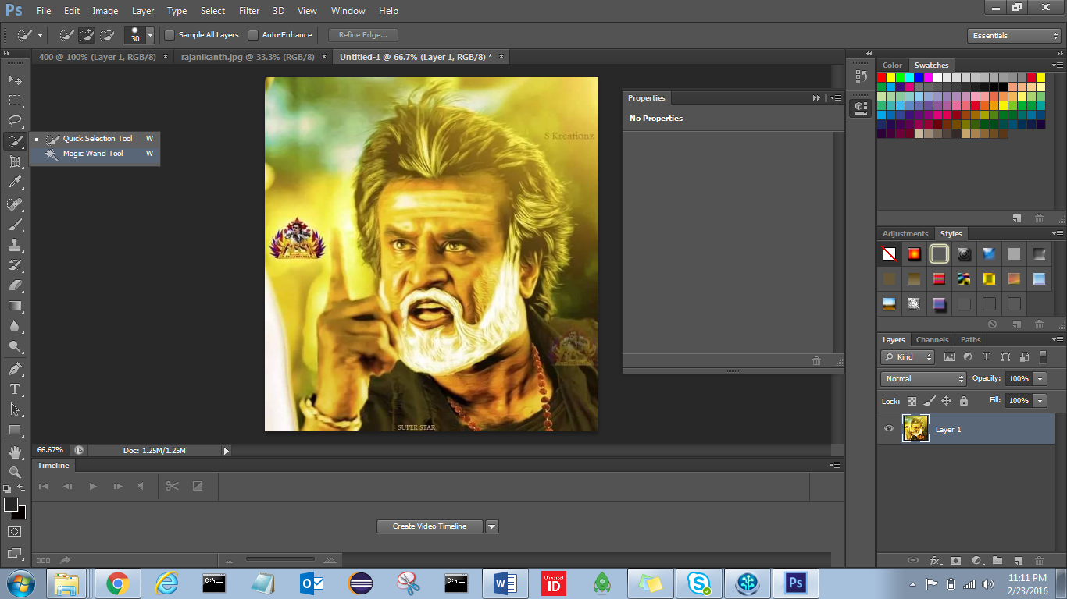

1. Select outside of image and DELETE

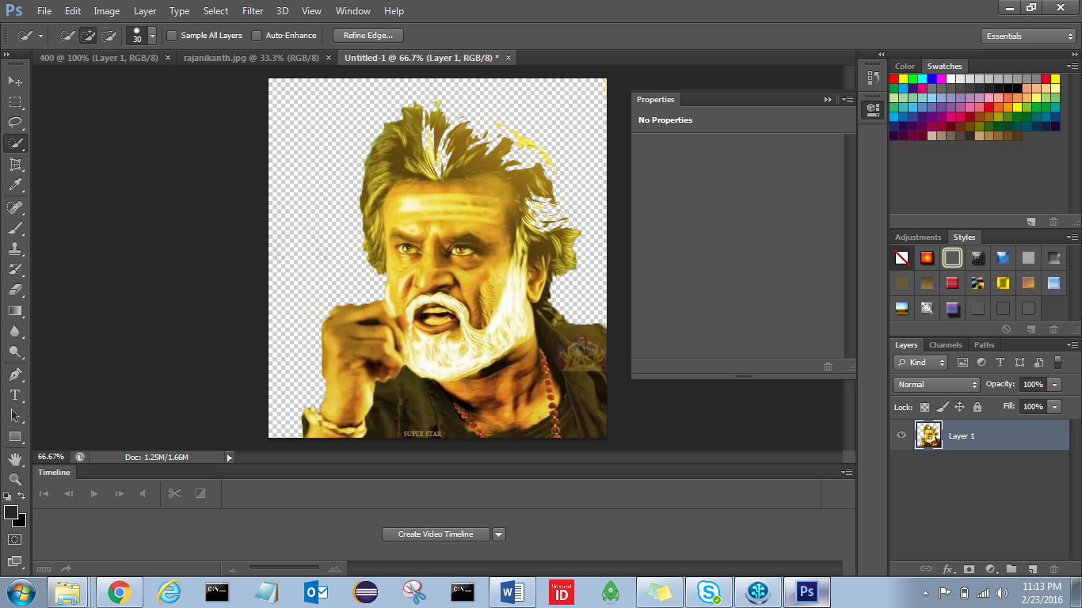

1. Top menu 🡪 Image 🡪 adjustments 🡪 Threshold

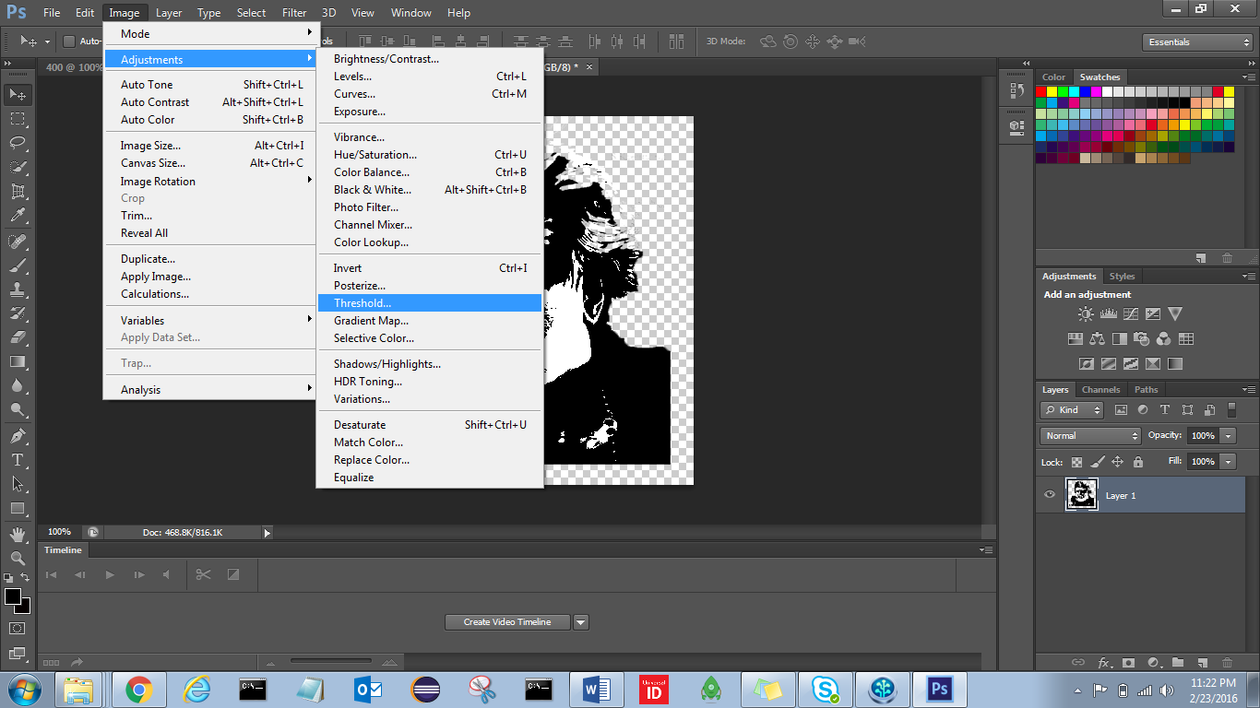

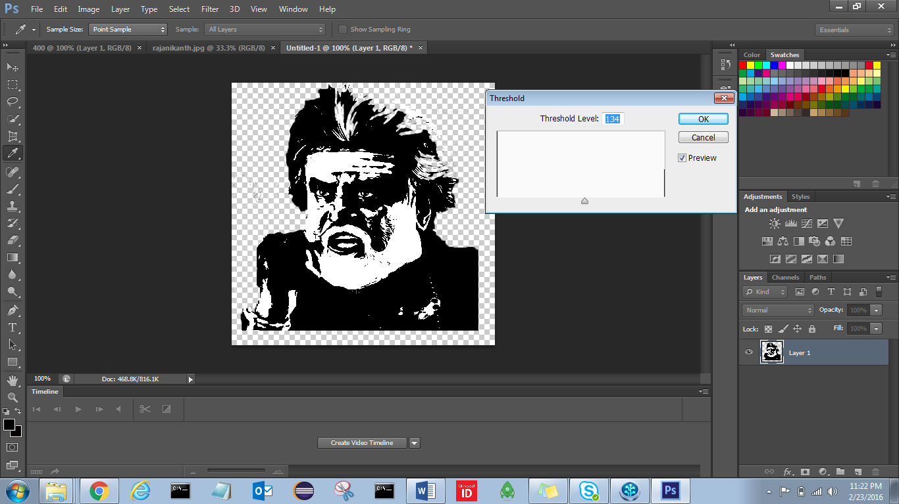

1. Expand image to Complete image area by clicking 
2. If it is not showing check Show transformations 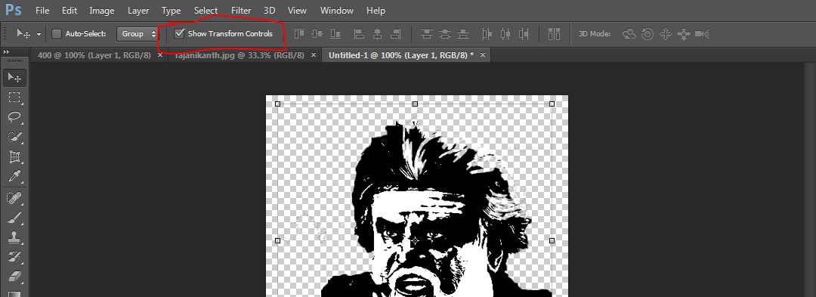
3. Click Save CNTL+S

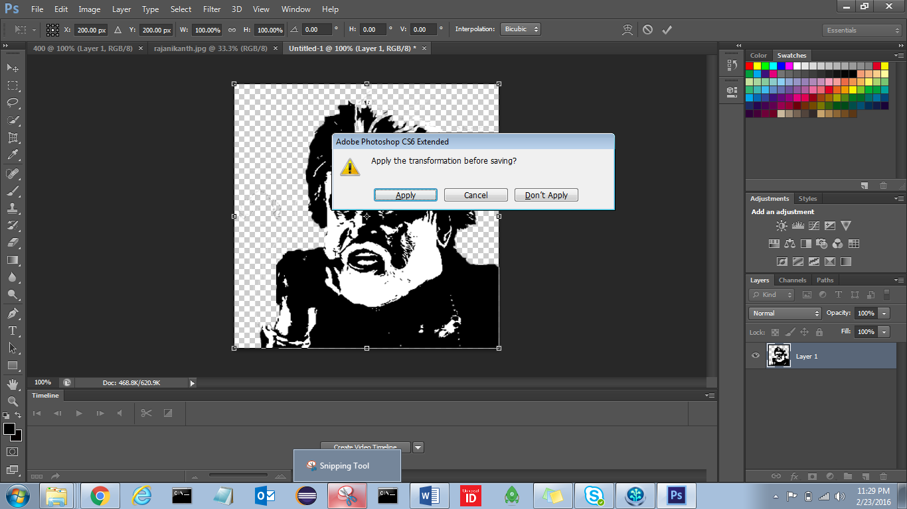

1. Apply, save as PNG

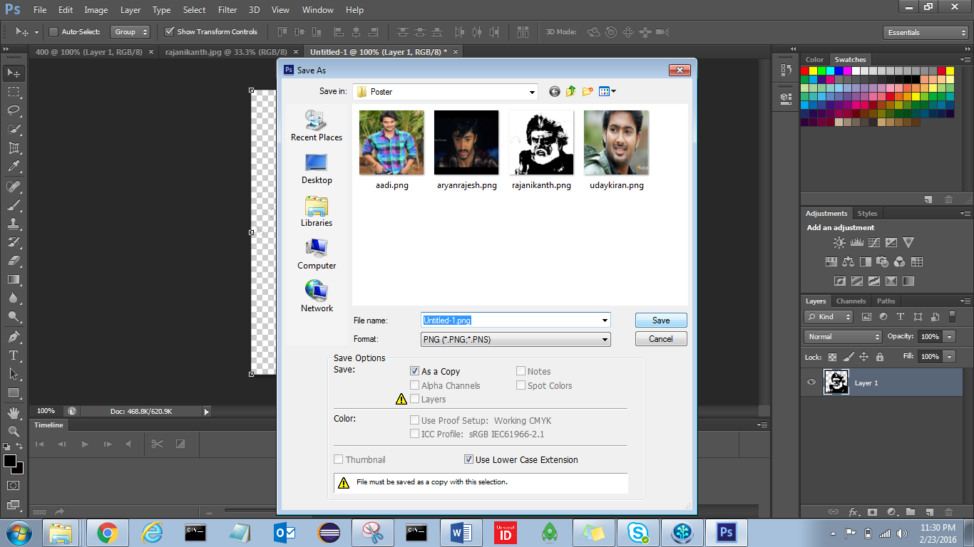

# Errors

## Login.php :

Uncaught SyntaxError: Unexpected token < in JSON at position 0