Create database
Run SQL script
X_DB/ MultiStater

Theme used

Code flow
makemovie.php
|
Makemovie2.php
|
makemovieAjax.php

readyforshoot.php
|
shooting.php shootingAjax.php
|
shootout.php?rid=2&uid=93 : All calculations done here (addcenters.php – for updated centers)

readyforrelease.php
|
release.php?rid=865
|
released.php?news=<a href=\'running.php?rid=865\'>Okay! Staring with Arjanrajesh and Anushka directed by A. karunakaran is Releasing in 243 Centers&rid=865

readyforrun.php?rid=865
|
running.php?rid=865

Poster Genrator
Fatal error: Uncaught Error: Call to undefined function imagecreatefromjpeg() in C:\xampp\htdocs\hit\poster\poster1.php:61 Stack trace: #0 {main} thrown in C:\xampp\htdocs\hit\poster\poster1.php on line 61
https://www.youtube.com/watch?v=Jmzkdc2fjgc
You can get this Error in LocalHost only… On Domain Host you wont get.

Testing Poster Generation: Use this URL
http://javabo.ml/poster/poster1.php?rid=858&b=sadsad&p=satya&d=A. kodanda rami reddy&a= Arjanrajesh&ac= Anushka &c=Anumolu Srikar&e=Bindra&m=Kedra&w=Lola&tit=Okay&fif=0&hun=0&fiv=0&t5=1&sev=0&onf=0&a2=&a3=&ac2=&ac3=&d2=&d3=&w2=&w3=&m2=Thaman&m3= Achu

URL will form from here. Running.php

Line 597:

var plink = 'poster/poster1.php?rid='+rid+'&b='+b+'&p='+p+'&d='+d+'&a='+a+'&ac='+ac+'&c='+c+'&e='+e+'&m='+m+'&w='+w+'&tit='+tit+'&fif='+fif+'&hun='+hun+'&fiv='+fiv+'&t5='+t5+'&sev='+sev+'&onf='+onf
+'&a2='+a2+'&a3='+a3+'&ac2='+ac2+'&ac3='+ac3+'&d2='+d2+'&d3='+d3+'&w2='+w2+'&w3='+w3+'&m2='+m2+'&m3='+m3;

Poster Editing
https://youtu.be/SV38L4c4JKY

- Open Image in Photoshop
- Select Face area CTRL+C for Copy and paste in untitled new doc of size 400x400 pixels
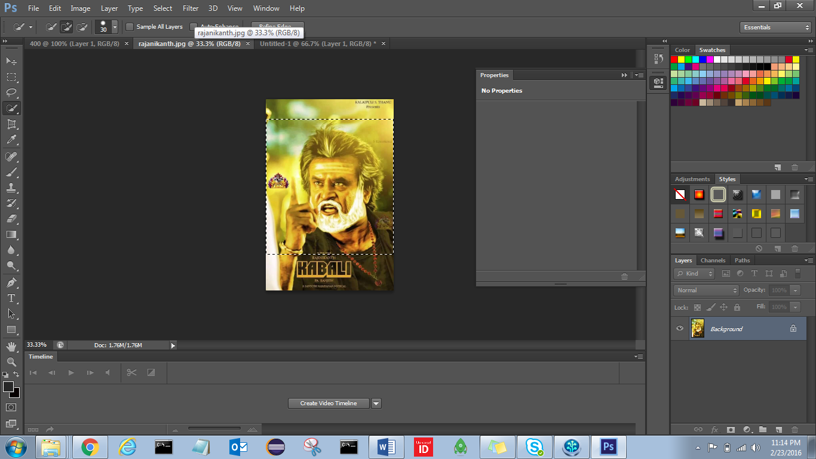
- Right click on Background select Layer from Background
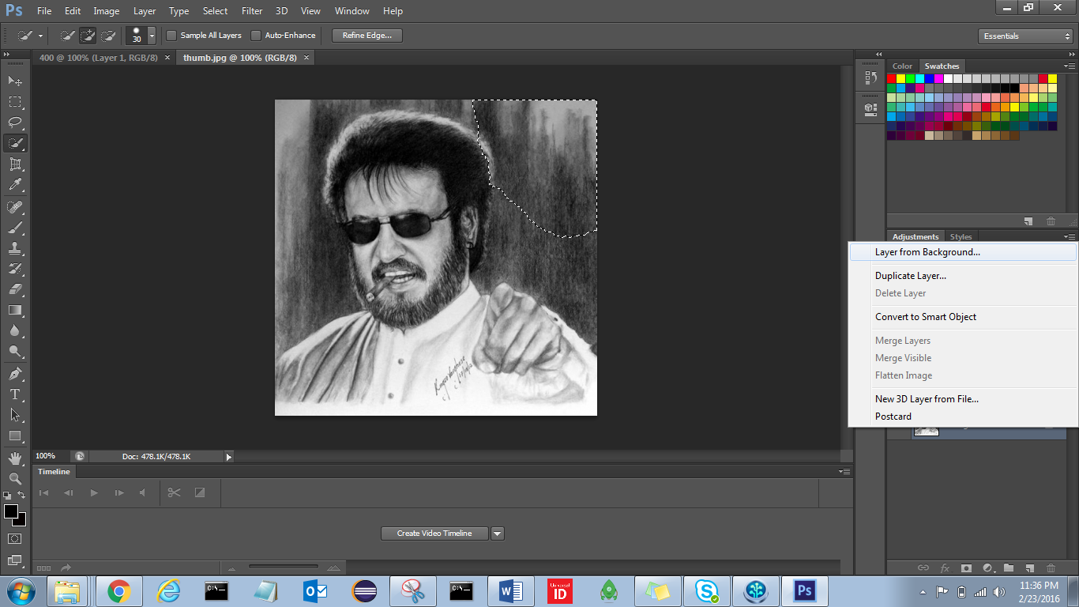

- Click on Transparency, it will Lock
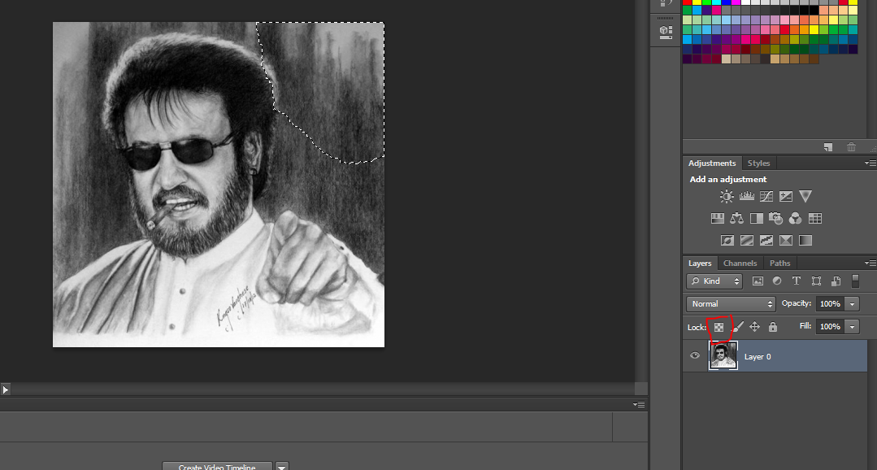
- Click on Magic tool

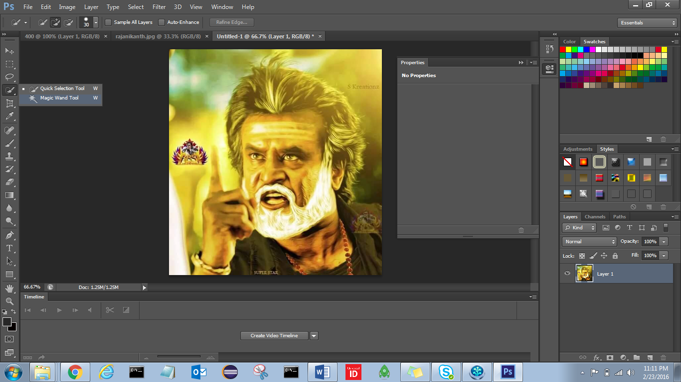

- Select outside of image and DELETE
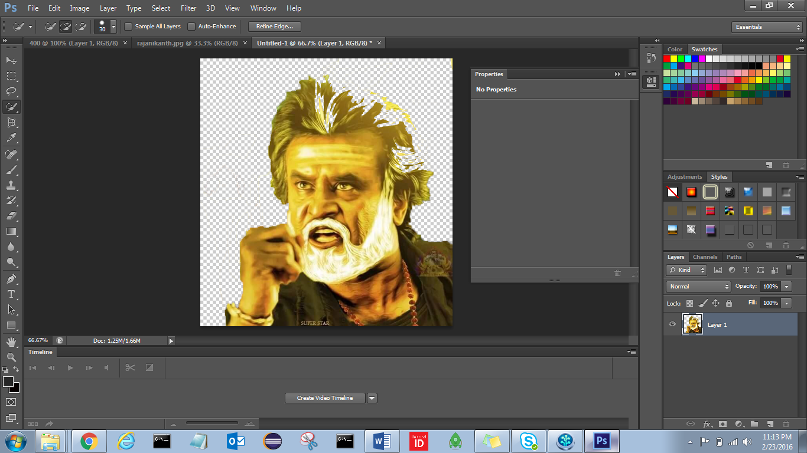

- Top menu Image adjustments Threshold
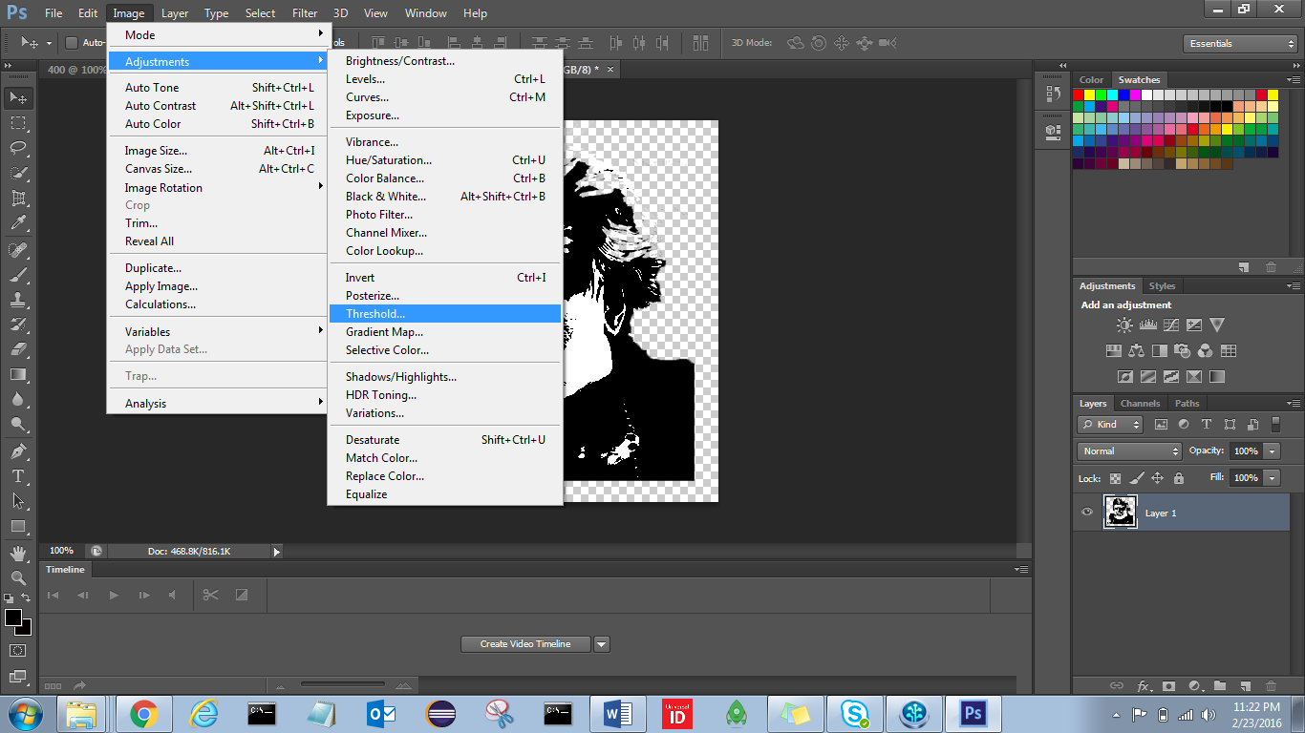

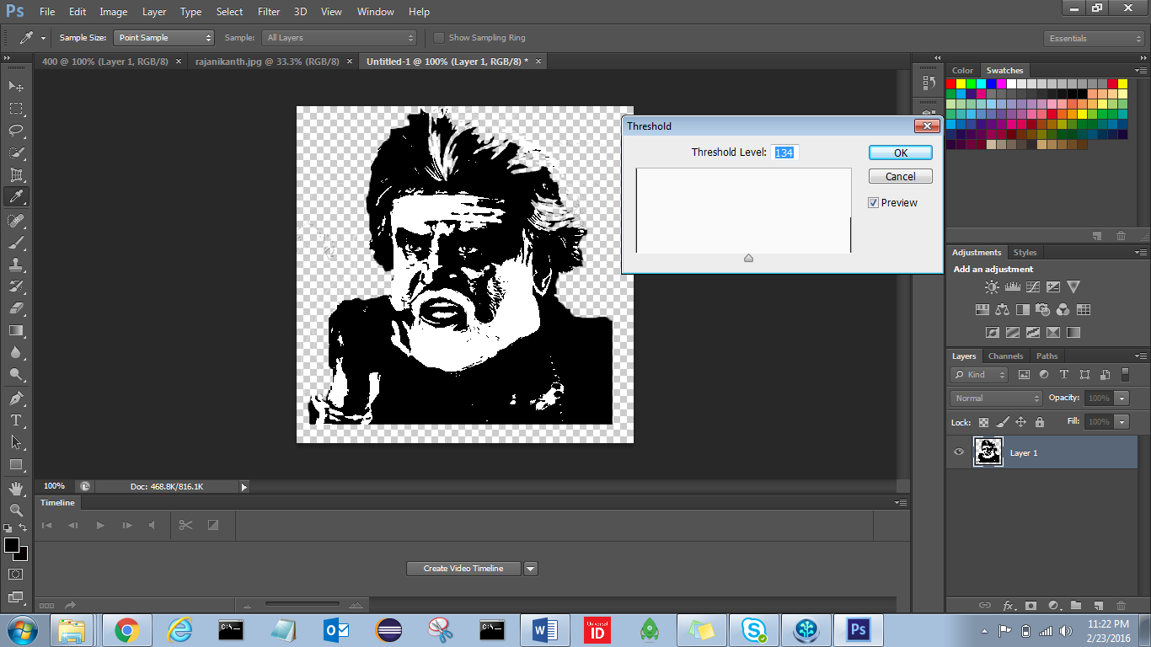

- Expand image to Complete image area by clicking 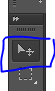
- If it is not showing check Show transformations 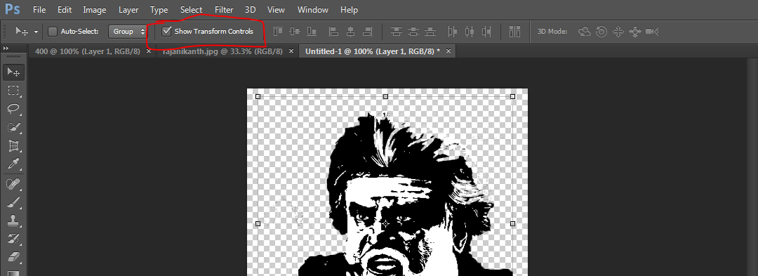
- Click Save CNTL+S
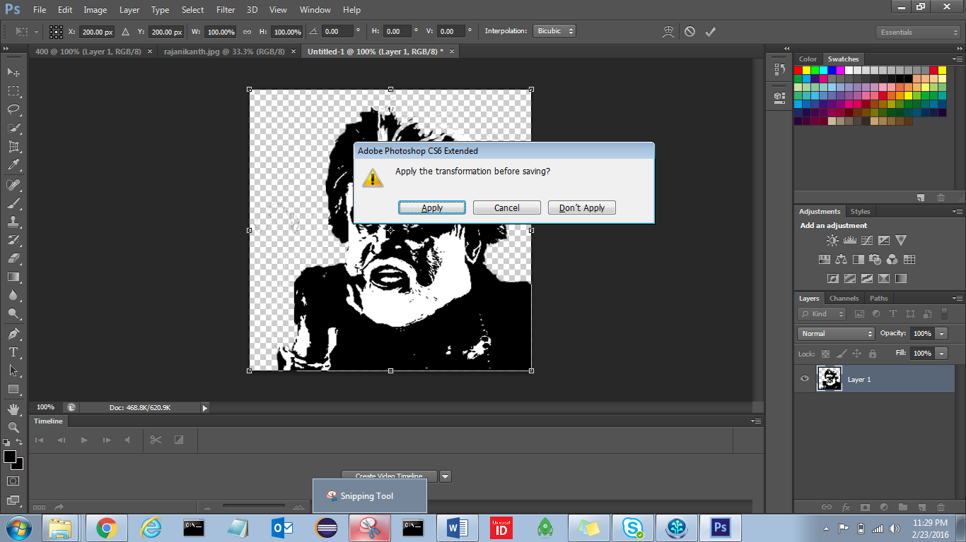

- Apply, save as PNG
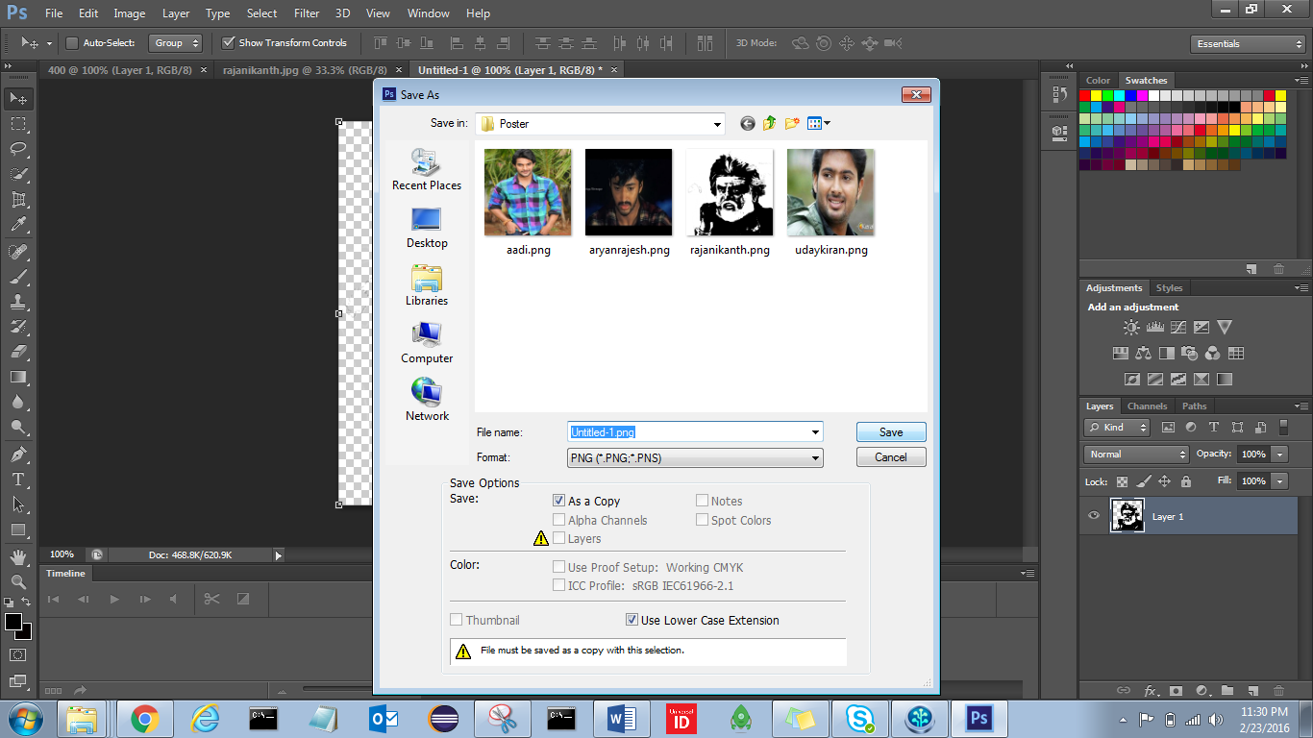

Errors

Login.php:
Uncaught SyntaxError: Unexpected token < in JSON at position 0

Poster generation
https://www.codexworld.com/how-to/install-php-gd-library-windows-server/
Download php_gd2.dll online
extension=php_gd2.dll
extension=gd

