WEEK-2 2520030368
K. SATYA CHARAN
Step 1 — Create Database
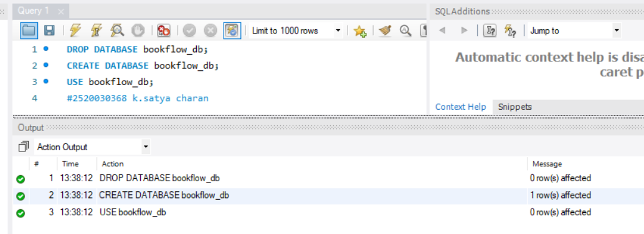
Step 2 — Create Books Table (DDL + Constraints)

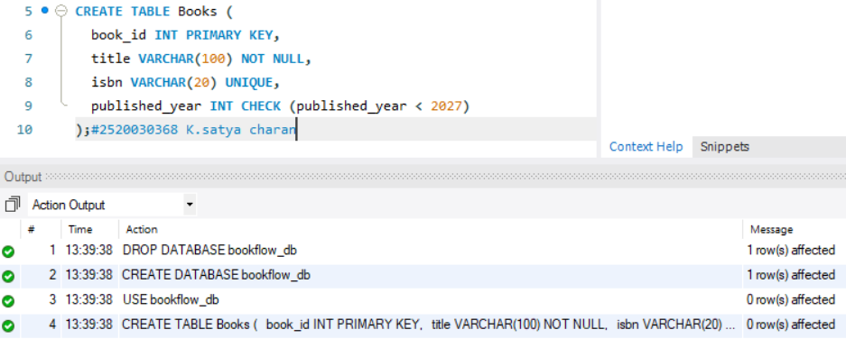

Step 3 & 4 — Insert Books and Display

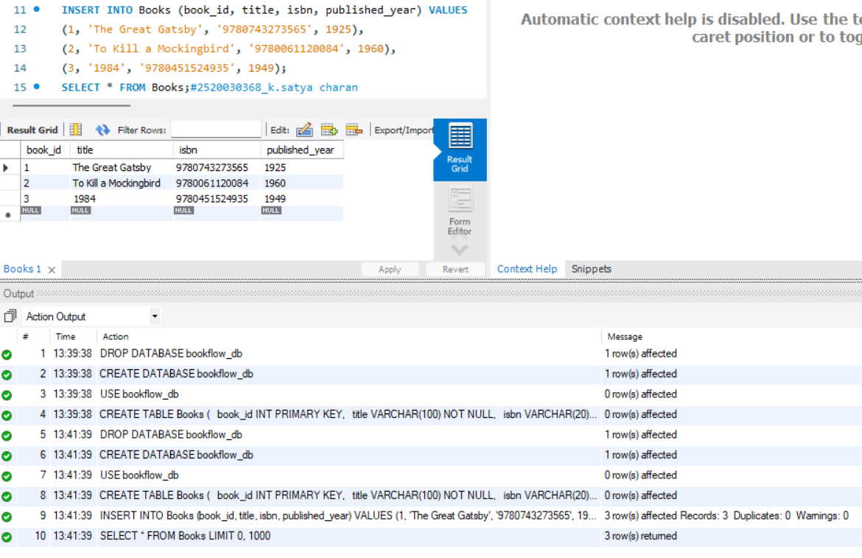

Step 5, 6 & 7 — Members Table: Create, Insert, Display

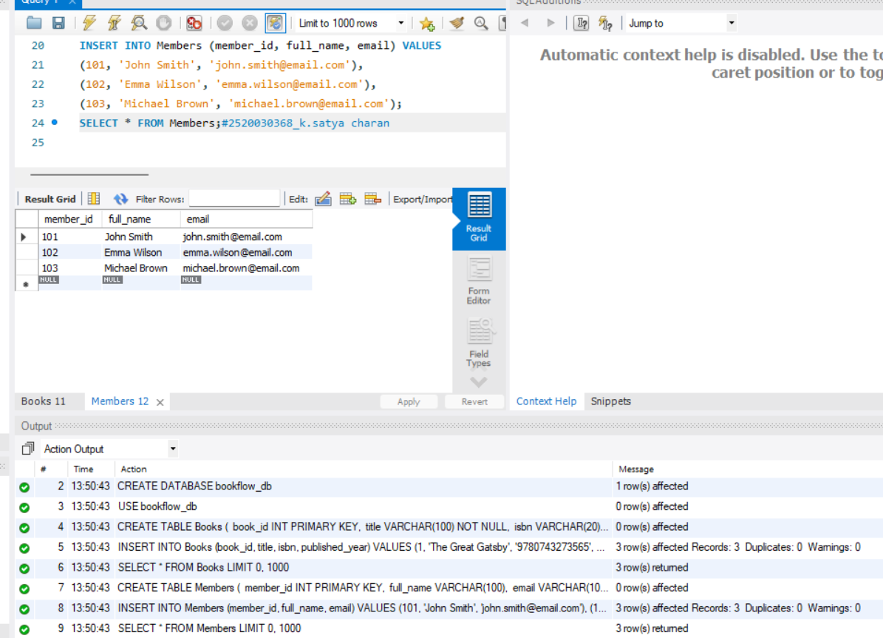

Step 8 — Create Loans Table (FOREIGN KEYS)
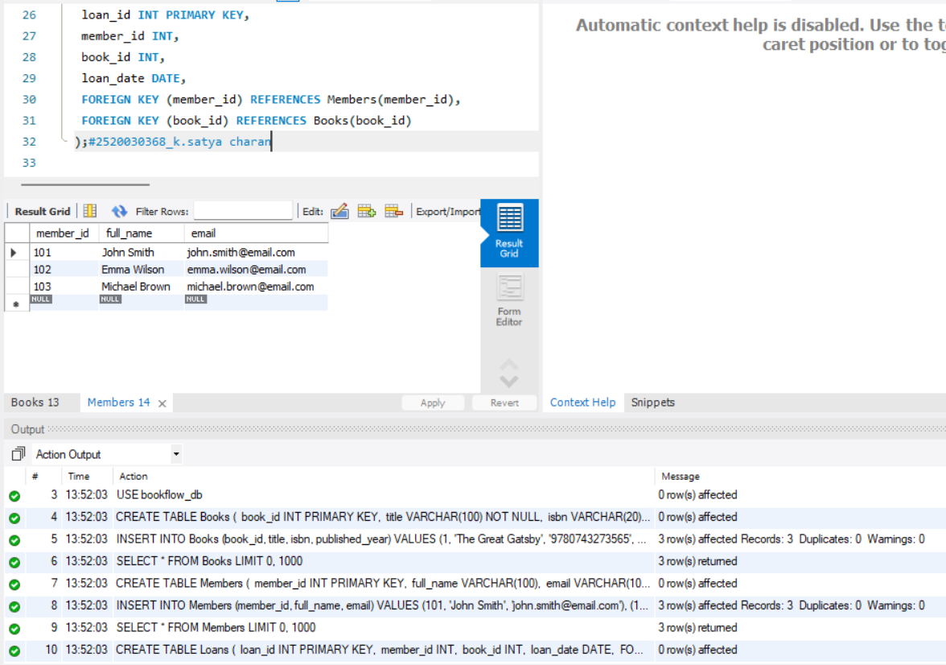

Step 9 & 10 — Insert 10 Loans and Display
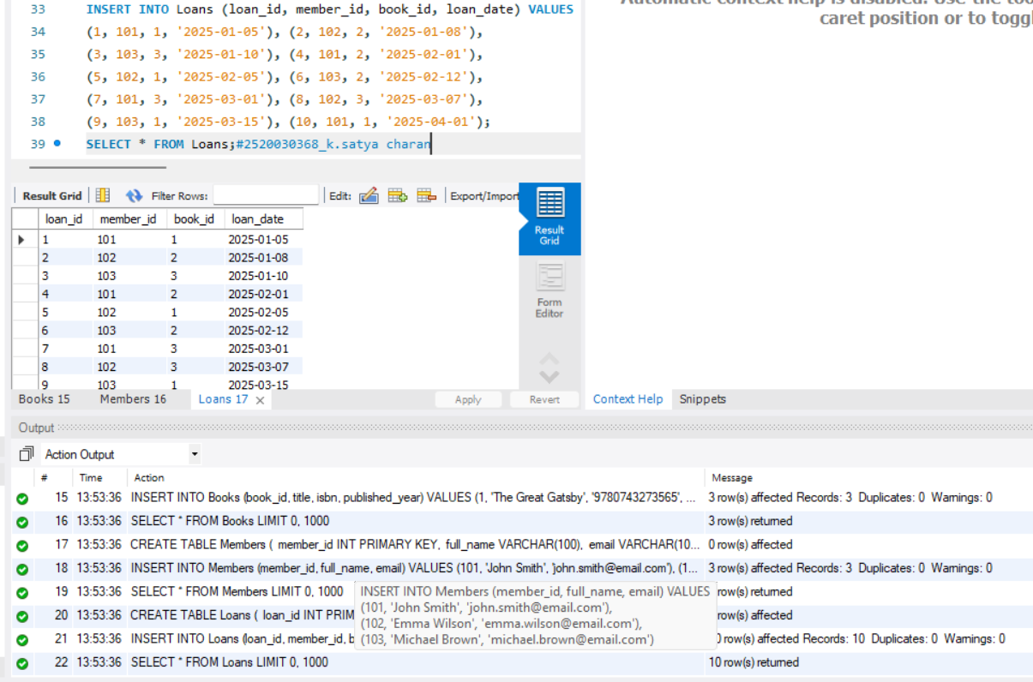

Step 11 — JOIN Query (Who Borrowed What)

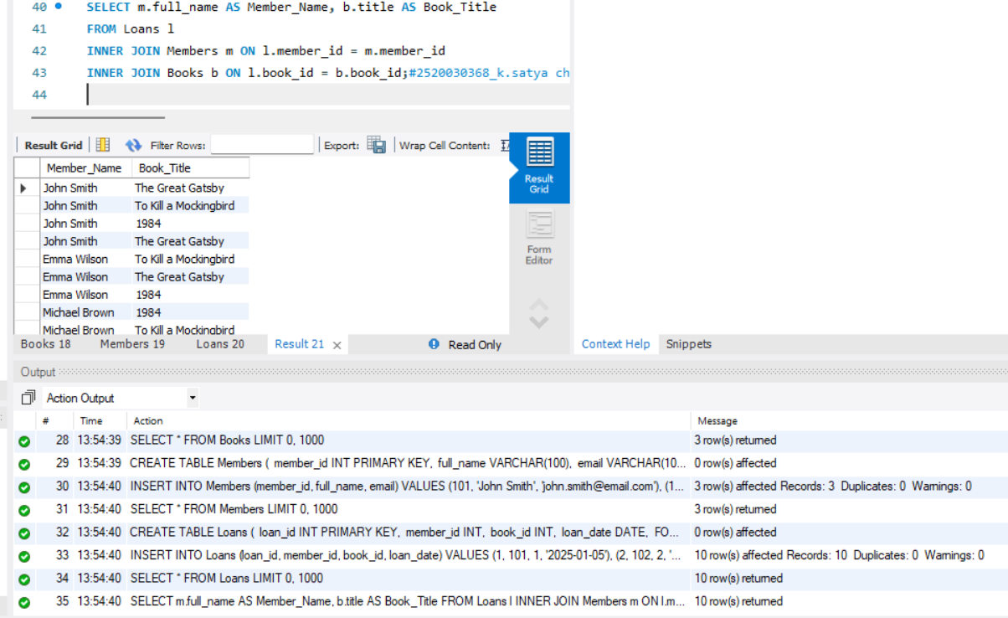

Step 12 — GROUP BY Query (Books per Year)

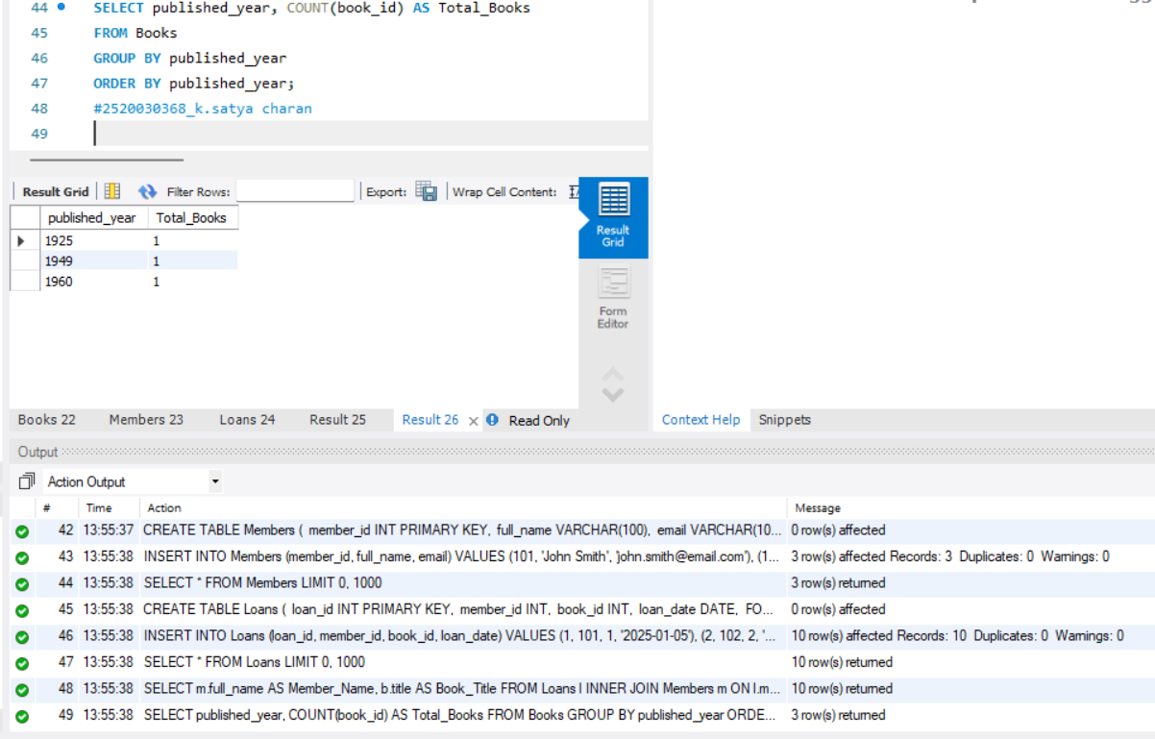

Step 13–16 — Donation via TRANSACTION (Atomicity

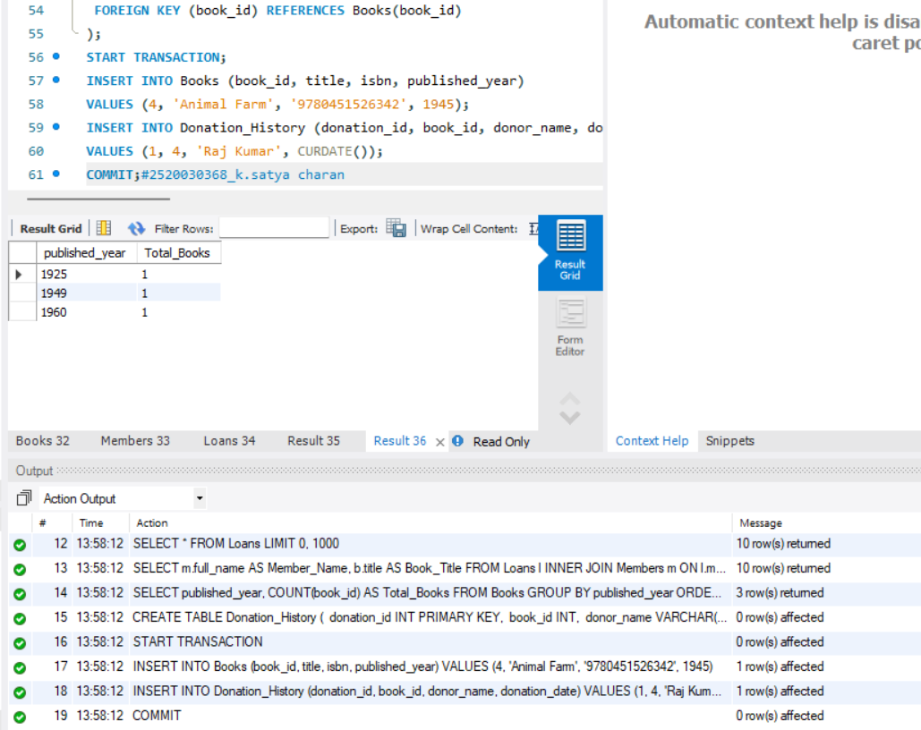

Step 17 & 18 — Index on ISBN + Fast Search

