Database System Engineering and Distributed Backend Development(25CS1302E)
Practical Week-1

Name : Kammili Satya Charan
Roll No. : 2520030368
SEC : 7
Step 1 : Database Setup
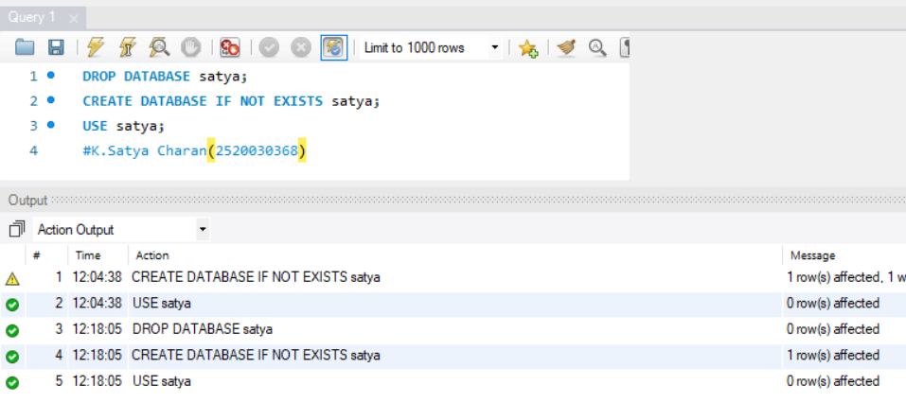Step 2 : Table Creation
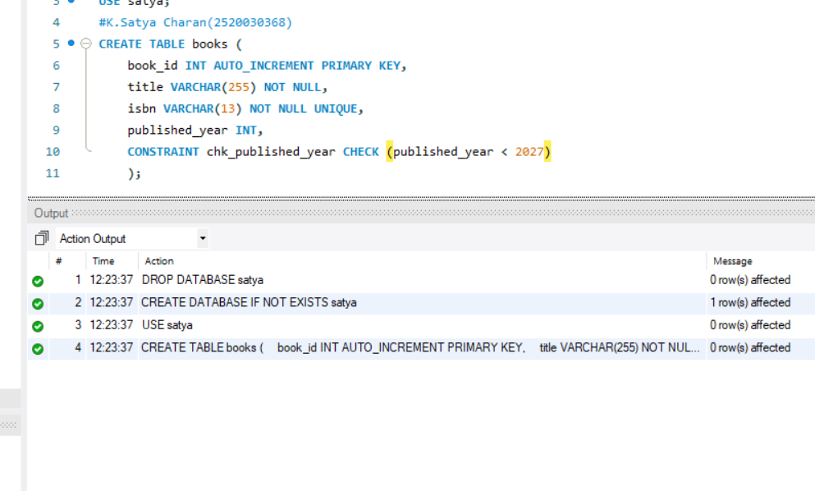
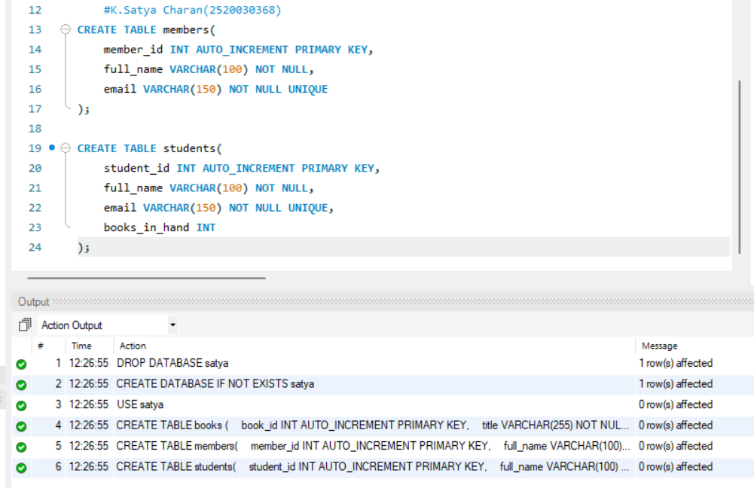
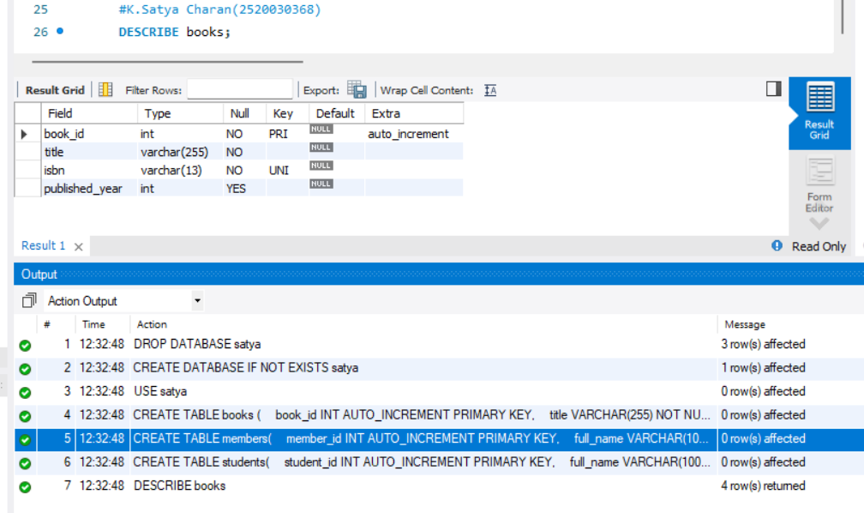
Step 3 : Initial Seeding
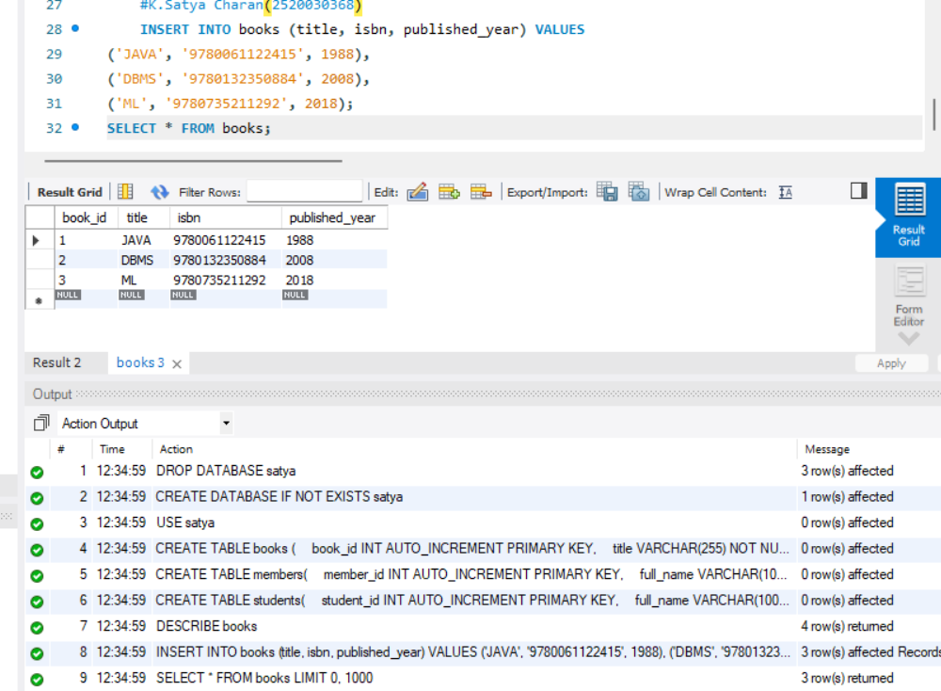
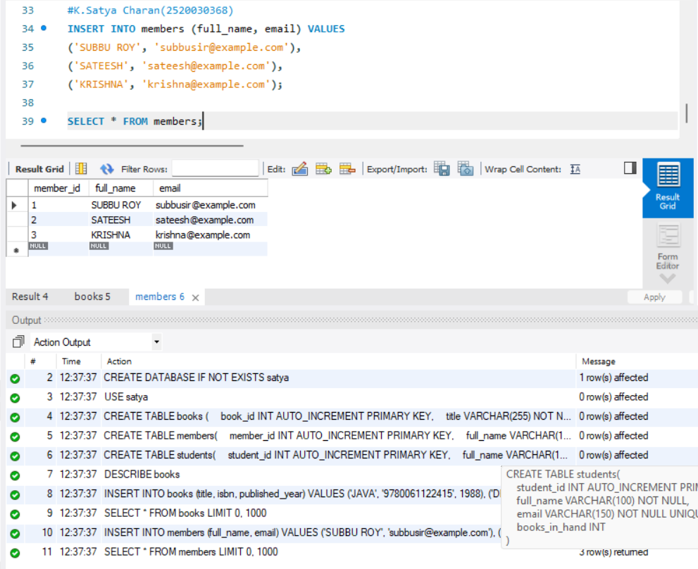

Step 4 : Constraint Tests
