Retail Data Platform
on Azure + Databricks
Project Design Document
v1.1 — adds ReSA canonical model
Author: Satyaki Guha
Status: Living document — open for edits
Last updated: April 2026

One-Line Pitch
End-to-end retail data platform on Azure + Databricks: streaming POS ingestion, ReSA-style sales audit, medallion lakehouse, and LLM-powered insights over 2+ years of multi-channel retail data.

Table of Contents

1. Project Vision & Goals

1.1 Why this project
The goal is a portfolio-grade retail data platform that showcases the skills relevant to modern data engineering roles — particularly in retail-adjacent companies — while leveraging the author's 7+ years of Oracle Retail QA experience as a differentiator.

1.2 Primary goals
- Demonstrate end-to-end data engineering across batch + streaming
- Showcase medallion lakehouse design with Delta Lake on Databricks
- Build a ReSA-style Sales Audit layer — the signature differentiator
- Integrate LLMs into a production-grade pipeline (not just a notebook demo)
- Flex Azure (DP-700) + Databricks (Associate + Professional) certifications
- Practice modern DevOps — Git, CI/CD, Infrastructure as Code

1.3 Non-goals
- Training custom ML/LLM models from scratch
- Building a production-grade UI or customer-facing app
- Handling truly massive datasets (we aim for ~100s of millions of rows, not billions)

2. Architecture Overview

2.1 High-level architecture
The diagram below shows the end-to-end flow. Three source channels (in-store POS, e-commerce, marketplace) feed through Azure Data Factory and Auto Loader into a governed Databricks lakehouse. Silver conforms all three channels into the Oracle ReSA canonical data model (SA_TRAN_HEAD / SA_TRAN_ITEM / SA_TRAN_DISC / SA_TRAN_TENDER / SA_TRAN_TAX / SA_TRAN_IGTAX / SA_STORE_DAY / SA_MISSING_TRAN), which then feeds both a Kimball analytics star schema and a ReSA-style audit engine. The LLM layer overlays the Gold and Audit layers; Synapse Serverless + Power BI provide the serving tier.
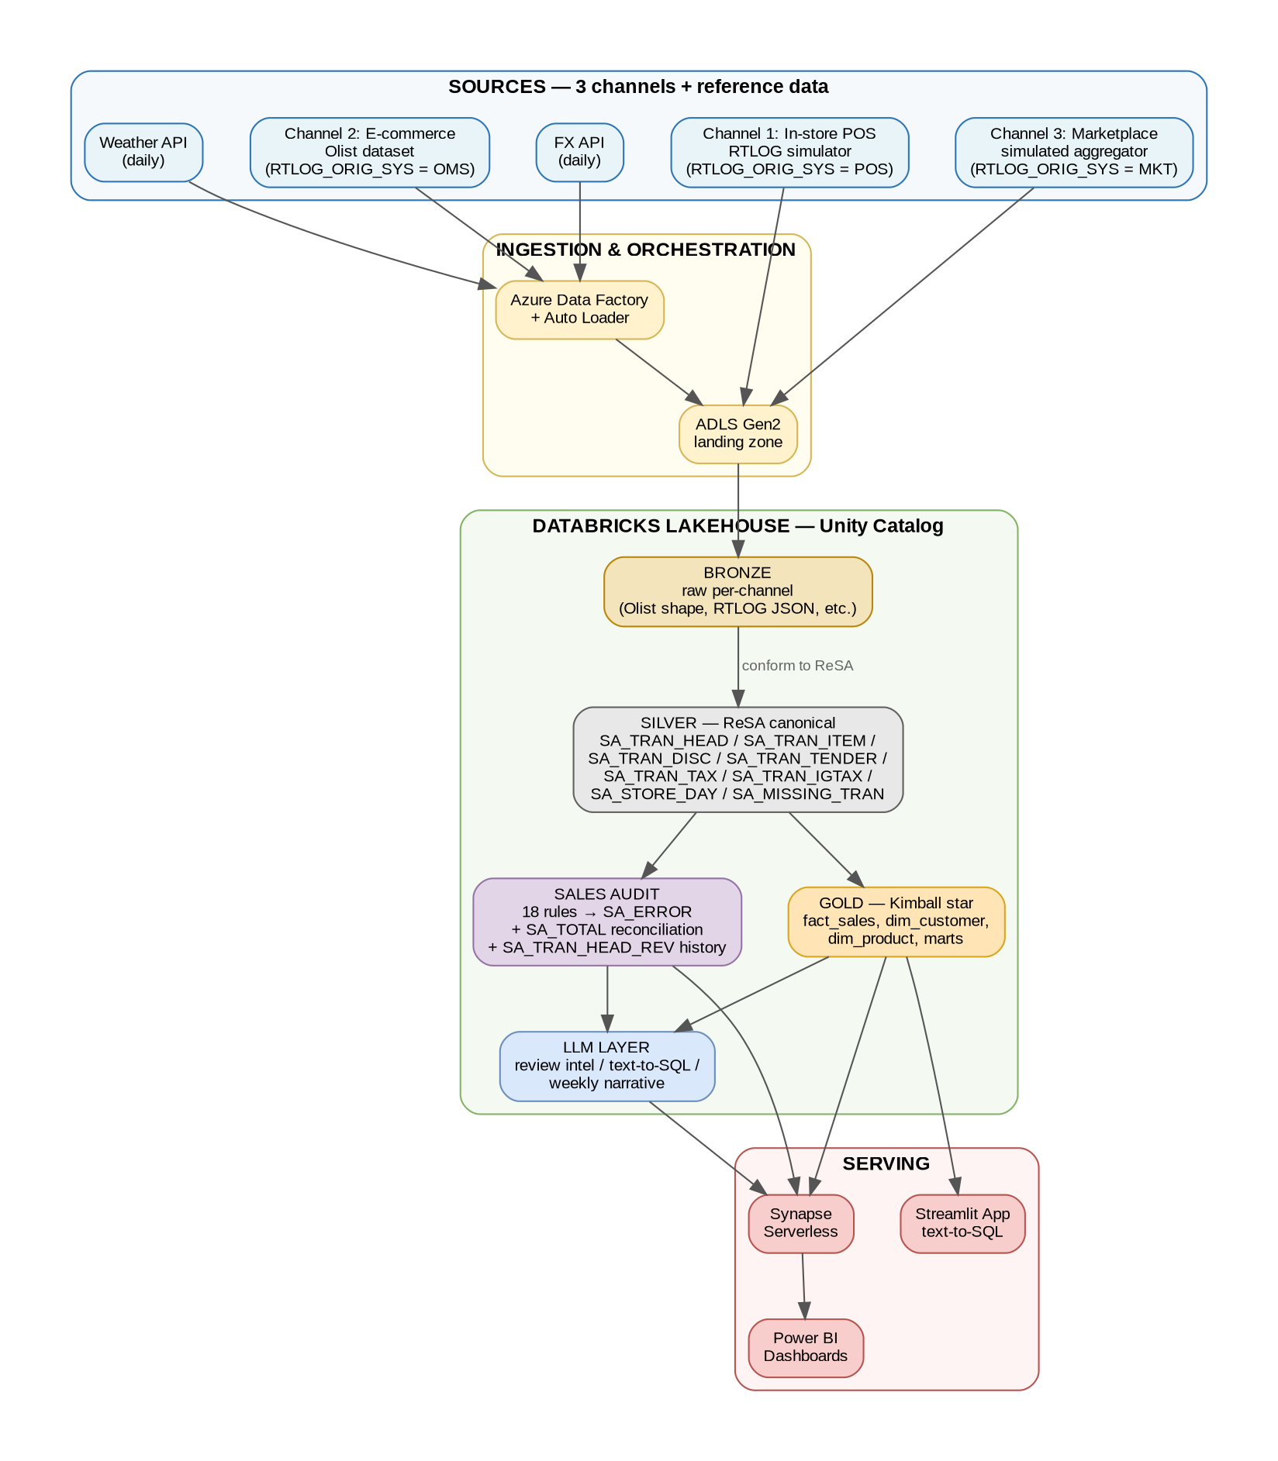
Figure 1 — End-to-end architecture

2.2 Design principles
- Governed by Unity Catalog — one source of truth for schemas, permissions, lineage
- Incremental everywhere — Auto Loader for files, CDC-style merges in Silver, materialized gold
- Quarantine, don't drop — bad records go to _quarantine tables with reason codes
- Separation of concerns — Sales Audit is its own schema, not mixed into Gold
- LLM is a consumer, not a hard dependency — the pipeline works fully without it

3. Technology Stack
The table below maps each architectural layer to the chosen technology, with a short rationale. Every choice is either Azure-native (for DP-700 alignment) or Databricks-native (to leverage the associate/professional certifications).
Layer | Technology | Why
Cloud | Azure (pay-as-you-go) | DP-700 alignment, industry standard
Storage | ADLS Gen2 | Hierarchical namespace, Databricks-native
Compute | Databricks on Azure | Associate + Professional certs alignment
Governance | Unity Catalog | Standard for 2025+ Databricks deployments
Streaming ingestion | Auto Loader | Incremental file processing with checkpointing
Transformations | Delta Live Tables + PySpark | Declarative pipelines with expectations
Orchestration | ADF + Databricks Workflows | ADF for external hops, DBX Workflows inside
Warehousing | Databricks SQL + Synapse Serverless | Cost-effective Power BI source
BI | Power BI | Mainstream, Microsoft ecosystem
LLM | Databricks Foundation Model APIs | Zero extra accounts, unified billing
Vector store | Databricks Vector Search | Native integration with Delta
Secrets | Azure Key Vault | Industry standard
IaC | Terraform | Most portable skill
CI/CD | GitHub Actions + DAB | 2025 recommended pattern
Testing | pytest + chispa | DataFrame unit testing
Observability | Azure Monitor + Log Analytics | Native Azure stack

4. Module Breakdown
Each module is designed to be independently demo-able. You should have something working at the end of every module, rather than a big-bang at the end.

4.1 Module 1 — POS RTLOG Simulator
Purpose: generate realistic retail transaction data that maps directly into the Oracle ReSA canonical tables (SA_TRAN_HEAD, SA_TRAN_ITEM, SA_TRAN_DISC, SA_TRAN_TENDER, SA_TRAN_TAX, SA_TRAN_IGTAX), so downstream modules consume real-shaped data from day one.
Why it matters: this is where the author's domain knowledge from Finance Foundations (UK retailer) and FS6/FS7 (Middle East retailer) shines brightest. Using the actual Oracle RMS 16.0 schema — not an invented one — makes the project instantly recognizable to any retail ETL hiring manager.

What it does
- Python service running as a scheduled job or Azure Container Instance
- Continuously writes JSON RTLOG records to an ADLS landing zone, partitioned by store_id/date/hour
- Simulates ~50 stores × 2 years of history = ~365M transaction lines (adjustable)
- Every record carries RTLOG_ORIG_SYS = 'POS' (channel discriminator in the ReSA model)
- Models realistic patterns: lunch rush, weekend peaks, Black Friday, seasonal trends
- Covers all major TRAN_TYPE values: SALE, RETURN, PVOID, PAIDIN, PAIDOUT, NOSALE, OPEN, CLOSE
- Injects ~2% "bad" records (missing tender, mismatched totals, duplicate TRAN_NO, off-hours voids) to exercise the Sales Audit layer

Record shape — RTLOG JSON (maps 1:1 to ReSA tables)
Each RTLOG record bundles one transaction with its child rows. The conformance job in Silver fans this out into the six SA_TRAN_* tables.
{
"rtlog_orig_sys": "POS",
"tran_head": {
"store": 45,
"business_date": "2024-03-15",
"tran_seq_no": "STR045-TILL02-20240315-001234",
"tran_datetime": "2024-03-15T12:34:22+05:30",
"register": "TILL02",
"tran_no": 1234,
"cashier": "CASH1089",
"salesperson": "SP0456",
"tran_type": "SALE",
"sub_tran_type": null,
"status": "IMPORTED",
"value": 594.82,
"pos_tran_ind": "Y",
"banner_no": 1,
"ref_no1": "LOYALTY-9988123",
"ref_no2": null
},
"tran_item": [
{
"item_seq_no": 1, "item_status": "ACTIVE", "item_type": "ITM",
"item": "SKU-12345", "dept": 21, "class": 3, "subclass": 1,
"qty": 2.0, "unit_retail": 299.00, "selling_uom": "EA",
"tax_ind": "Y", "unit_retail_vat_incl": "Y",
"total_igtax_amt": 26.82
}
],
"tran_disc": [
{
"item_seq_no": 1, "discount_seq_no": 1, "rms_promo_type": "PROMO",
"promotion": 500123, "disc_type": "PROMO",
"qty": 2.0, "unit_discount_amt": 15.00
}
],
"tran_tender": [
{
"tender_seq_no": 1, "tender_type_group": "CARD", "tender_type_id": 2,
"tender_amt": 594.82, "cc_no": "************4521",
"cc_auth_no": "A12345", "cc_entry_mode": "CHIP",
"orig_currency": "INR", "orig_curr_amt": 594.82
}
],
"tran_tax": [],
"tran_igtax": [
{
"item_seq_no": 1, "igtax_seq_no": 1, "tax_authority": "CGST",
"igtax_code": "GST9", "igtax_rate": 0.09, "total_igtax_amt": 13.41
},
{
"item_seq_no": 1, "igtax_seq_no": 2, "tax_authority": "SGST",
"igtax_code": "GST9", "igtax_rate": 0.09, "total_igtax_amt": 13.41
}
]
}

Key design decisions
- Column names and nullability match the Oracle RMS 16.0 data model exactly (see Appendix C)
- Credit card numbers are never stored in clear — only masked last-4, matching real PCI practice
- Uses inclusive tax (SA_TRAN_IGTAX) for Indian GST, not additive (SA_TRAN_TAX); simulator supports both modes via a config flag
- Unresolvable TRAN_NO gaps per register are reported into SA_MISSING_TRAN by the conformance job
- Configurable volume knob so you can scale down if costs pinch

Deliverables
- pos_simulator/ Python package with unit tests
- Dockerfile + deployment script
- Sample output files checked into repo (1K records for tests, not 365M)
- Conformance job that parses RTLOG JSON into the six child tables

4.2 Module 2 — Batch Sources & Additional Channels
Purpose: load the one-shot and periodically-refreshed reference data, plus provide the non-POS transaction channels (e-commerce and marketplace) that also get conformed to the ReSA canonical model in Silver.

Transaction sources (non-POS channels)
- Olist Brazilian E-commerce (Channel 2) — 9 tables loaded once via ADF into Bronze. Conformed to ReSA in Silver with RTLOG_ORIG_SYS = 'OMS'. CUST_ORDER_NO in SA_TRAN_ITEM provides the e-commerce linkage.
- Marketplace aggregator (Channel 3) — small simulated JSON feed mimicking a third-party aggregator (Uber Eats / Deliveroo style). Conformed to ReSA with RTLOG_ORIG_SYS = 'MKT'. Uses DROP_SHIP_IND = 'Y' on line items.

Reference data sources
- FX rates (BRL/USD/EUR/INR) — pulled daily from a free API (e.g., exchangerate.host). Used for SA_TRAN_TENDER.ORIG_CURRENCY conversion.
- Weather data — daily by city for correlation analysis (e.g., Open-Meteo)

Key design decisions
- ADF is used for these external hops, not Databricks, to demonstrate the full Azure stack
- FX and weather use ADF's REST copy activity with parameterized dates
- All sources land in ADLS Gen2 in their native shape before Databricks touches them
- Conformance happens in Silver, not Bronze — Bronze retains source-of-truth shape

Deliverables
- ADF pipelines exported as ARM templates (version-controlled)
- One Databricks notebook per source to load Bronze
- Three conformance notebooks in Silver: pos_to_resa, olist_to_resa, mkt_to_resa

4.3 Module 3 — Medallion Lakehouse
Purpose: the heart of the platform — clean, conformed, analytics-ready data, with Silver adopting the Oracle ReSA canonical model as the single shape all channels conform to.
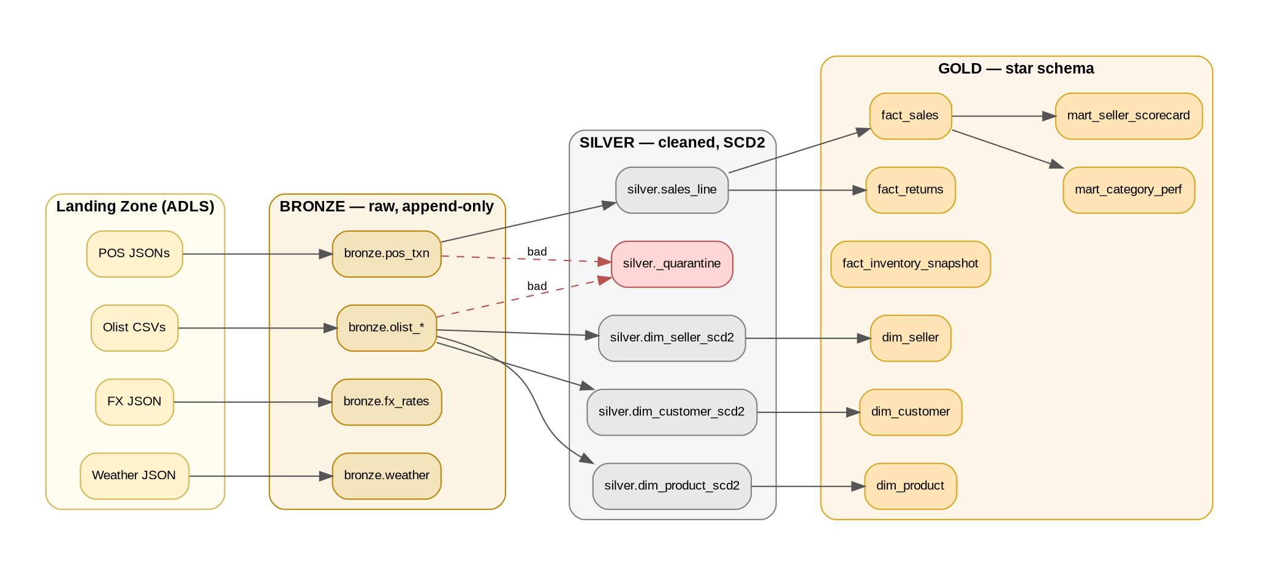
Figure 2 — Medallion layers (generic view)

Bronze layer
- Append-only, partitioned by ingestion date
- Each source retained in native shape (Olist stays Olist, RTLOG stays RTLOG)
- Schema evolution enabled via Auto Loader
- Retention: keep everything (cheap, enables re-processing)

Silver layer — ReSA canonical
Silver is NOT a generic cleaned schema — it is the Oracle ReSA canonical data model. All three channels are conformed into the same 8 transaction tables, differentiated only by RTLOG_ORIG_SYS. This is the single most important architectural decision in the project and directly mirrors how real Oracle Retail deployments work.
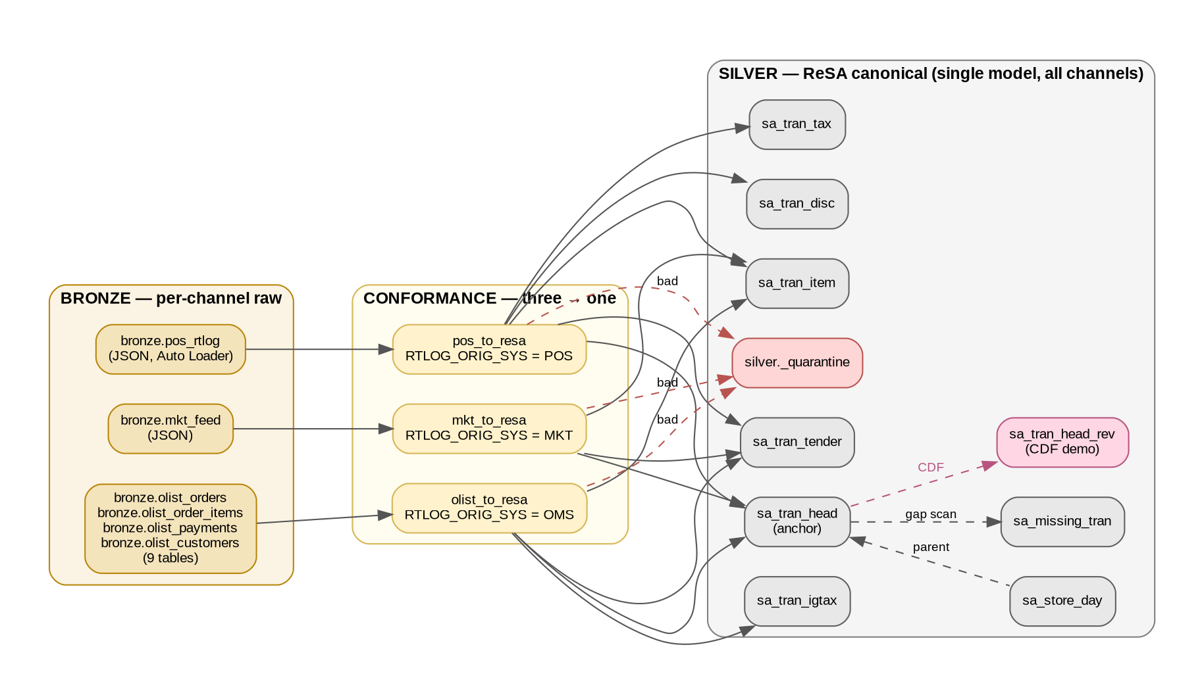
Figure 3 — Three channels conformed into ReSA canonical Silver

Silver table inventory (see Appendix C for full column specs)
- sa_store_day — parent row per store + business-date
- sa_tran_head — transaction anchor, 39 columns, PK (STORE, DAY, TRAN_SEQ_NO)
- sa_tran_item — line items, 51 columns
- sa_tran_disc — discounts per line (promo / coupon / manual)
- sa_tran_tender — tender payments (cash / card / voucher)
- sa_tran_tax — additive tax (sales tax / GST add-on)
- sa_tran_igtax — inclusive tax (VAT-style, price-inclusive GST)
- sa_missing_tran — gap detection for unaccounted TRAN_NOs per register
- sa_tran_head_rev — revision history of sa_tran_head (CDF demo)

Silver design decisions
- Column names and types match Oracle RMS 16.0 exactly — no drift
- Partitioning: STORE + DAY on all transaction tables, matching Oracle
- Y/N flag columns preserved (not booleans) for fidelity
- Bad records routed to silver._quarantine with rejection_reason
- DLT expectations enforce: referential integrity to sa_store_day, valid TRAN_TYPE, tender-sum = tran_head.VALUE

Revision history demo (sa_tran_head_rev)
To demonstrate the ReSA audit-trail pattern without building every _REV table, we implement it on SA_TRAN_HEAD only. Approach: enable Delta Change Data Feed (CDF) on silver.sa_tran_head; a small streaming job reads the CDF and appends snapshots into silver.sa_tran_head_rev with an incremented REV_NO. This showcases Delta CDF, a type-2-style audit trail without a custom MERGE pipeline, and supports 'who changed what, when' queries.

Gold layer
- Classic Kimball star schema, built FROM the ReSA Silver tables
- fact_sales derives from sa_tran_head + sa_tran_item joined with dims
- Z-ordered on high-cardinality hot predicates (customer_id, order_date)
- Materialized marts for common dashboards (pre-aggregated for dashboard speed)

Deliverables
- DLT pipeline definitions in /transformations/dlt/
- Three conformance pipelines: pos_to_resa, olist_to_resa, mkt_to_resa
- sa_tran_head_rev CDF streaming job
- Data dictionary (docs/data_dictionary.md) referencing Appendix C
- ERD diagrams: ReSA Silver cluster + Gold star schema

4.4 Module 4 — Sales Audit Layer (ReSA-style)
Purpose: the signature piece — a reconciliation and audit layer modeled on Oracle ReSA, implementing the kind of logic the author has validated for years at Capgemini.
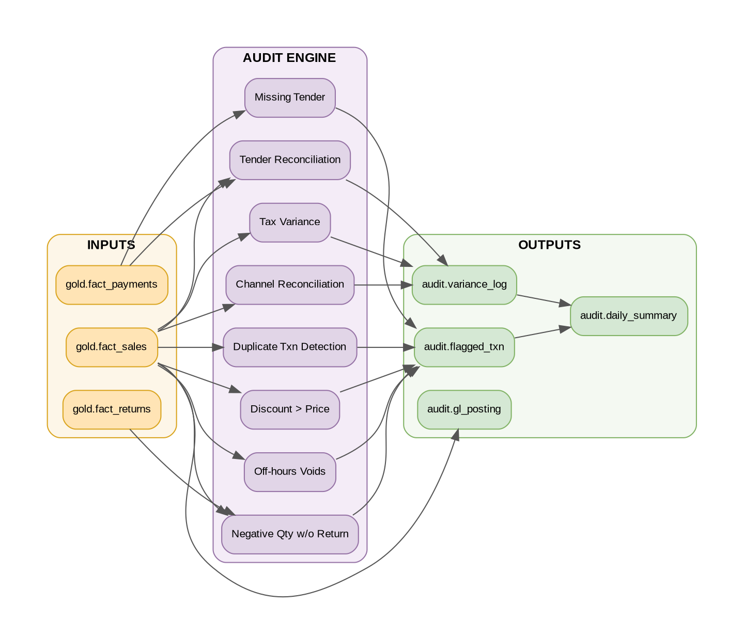
Figure 4 — Sales Audit rule engine

Audit rules catalog (target: 18 rules)
Each rule runs against the ReSA canonical Silver tables and, on failure, inserts a row into audit.sa_error with a distinct ERROR_CODE. ERROR_CODE values are seeded into audit.sa_error_codes on setup. This mirrors exactly how real ReSA handles rule failures — the ERROR_CODE becomes the join key between raw failures and their human-readable description.
# | Rule | Severity | ERROR_CODE | Trigger
1 | Tender total = tran_head.VALUE | Critical | TENDER_VAR_GT_01 | |Σ(tender_amt) − value| > 0.01
2 | Channel daily total matches count | Critical | CHANNEL_COUNT_VAR | POS count vs SA_TRAN_HEAD count per RTLOG_ORIG_SYS
3 | Duplicate TRAN_NO per register | High | TRAN_NO_DUP | Same (store, register, tran_no) twice
4 | Discount exceeds line price | High | DISC_GT_PRICE | Σ(tran_disc.unit_disc × qty) > tran_item.unit_retail × qty
5 | Negative qty without return | High | NEG_QTY_NO_REF | tran_item.qty < 0 AND tran_type ≠ RETURN
6 | Voids outside store hours | Medium | VOID_OOH | tran_type=PVOID outside 06:00-23:00
7 | Missing tender record | Critical | MISSING_TENDER | tran_head with zero SA_TRAN_TENDER rows
8 | Tax variance vs. expected rate | Medium | TAX_RATE_VAR | |tax_amt − qty×unit_retail×expected_rate| > 0.01
9 | Unmatched TRAN_NO gap | High | TRAN_NO_GAP | Populates SA_MISSING_TRAN
10 | Cash drawer over/short | Medium | CASH_OVER_SHORT | SUM(cash tenders) vs declared cash
11 | Credit card unmasked | Critical | CC_NOT_MASKED | CC_NO doesn't start with mask chars
12 | Invalid TRAN_TYPE | High | BAD_TRAN_TYPE | TRAN_TYPE not in code_type TRAT
13 | Orphan tran_item | Critical | ITEM_NO_PARENT | tran_item without matching tran_head
14 | Item price out of tolerance | Medium | PRICE_TOLERANCE | unit_retail deviates >20% from dim_product
15 | Store closed but tran present | High | TRAN_STORE_CLOSED | tran outside sa_store_day window
16 | IGTAX + TAX both present | Medium | DOUBLE_TAX | Both inclusive and additive tax on same line
17 | Loyalty ID format invalid | Low | LOYALTY_FMT | REF_NO1 fails regex
18 | Rounding variance too large | Medium | ROUND_VAR_GT_05 | |ROUNDED_OFF_AMT| > 0.05

How rules populate SA_ERROR
When rule N fires on a transaction, a row is inserted into audit.sa_error with: STORE, DAY, ERROR_SEQ_NO (generated), TRAN_SEQ_NO (the offending tran), ERROR_CODE (from the table above), KEY_VALUE_1 (item_seq_no if applicable), and REC_TYPE='SART'. In parallel, the ERROR_IND column on the source table (sa_tran_head, sa_tran_item, etc.) is flipped to 'Y'. This exactly mirrors the production ReSA pattern.

GL posting table
- Daily aggregated debits/credits per account
- Accounts: Sales, Tax Payable, COGS, Discount Expense, Inventory, Cash-in-Bank
- Exported as a file to a mock "SAP landing zone" to echo the real integration pattern

Deliverables
- DLT pipeline per audit rule, each writing to audit.sa_error
- audit.sa_error and audit.sa_error_codes Delta tables (seeded from the 18 rules above)
- audit.sa_total_head + SA_TOTAL reconciliation logic for channel-level daily balancing
- audit.gl_posting table exported to mock SAP landing zone
- Power BI variance dashboard reading sa_error joined to sa_error_codes
- Blog post: "Building a ReSA-style Sales Audit Layer on Databricks" — this is marketing gold

4.5 Module 5 — LLM Intelligence Layer
Purpose: integrate LLMs into the pipeline for genuinely useful analytics, demonstrating that we can build around LLMs — not just wrap them in a chatbot.
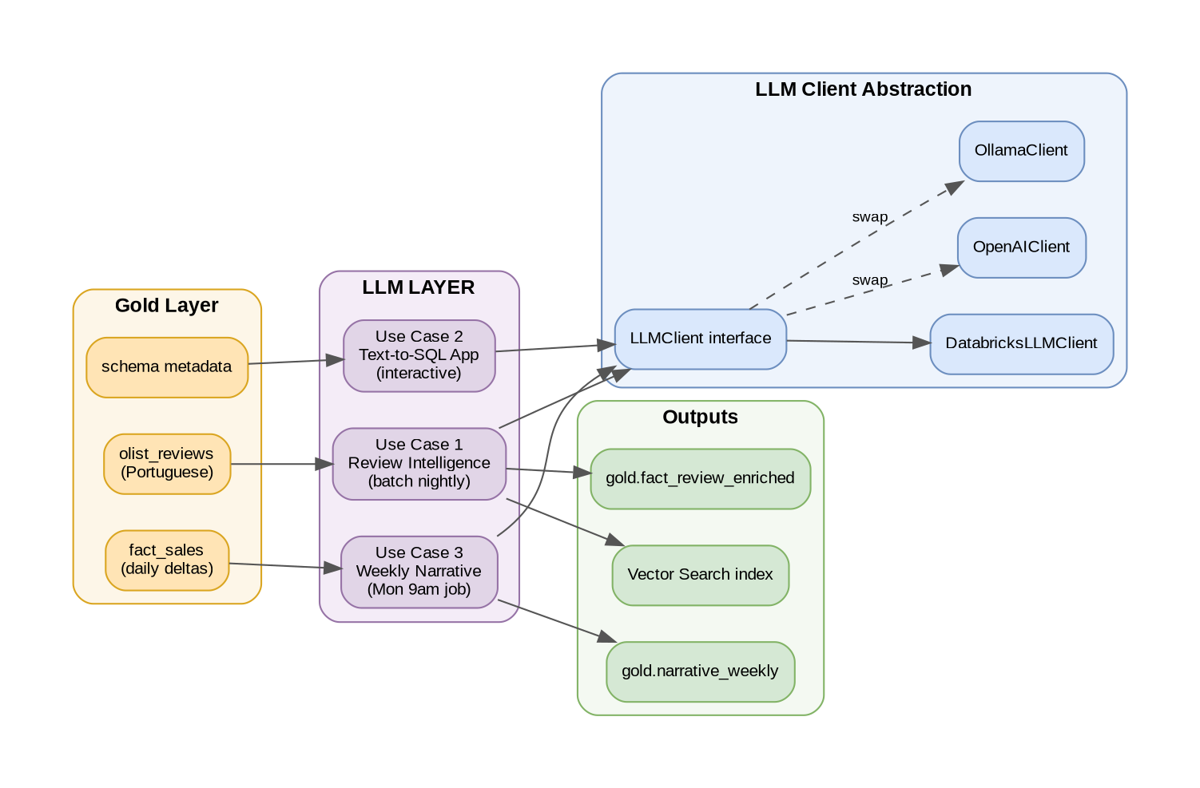
Figure 5 — LLM layer with provider abstraction

Use Case 1: Review Intelligence (batch)
- Nightly DLT job enriches new Portuguese reviews
- Each review → translated English, sentiment score, up to 3 theme tags from fixed taxonomy
- Taxonomy: delivery_speed, product_quality, packaging, price_value, seller_communication, accuracy_of_description
- Embeddings stored in Delta, indexed with Databricks Vector Search
- Feeds mart_seller_scorecard with sentiment aggregates

Use Case 2: Text-to-SQL Assistant (interactive)
- Streamlit app (deployed as a Databricks App)
- User types natural-language question; LLM generates SQL against Gold schema
- Guardrails: SELECT-only, schema-whitelist, row-limit cap
- Few-shot examples for common patterns (top-N, time-series, grouping)
- Every query logged for demo replay

Use Case 3: Weekly Narrative (scheduled)
- Monday 9am Databricks job
- Computes W-o-W deltas across key KPIs
- Feeds to LLM with prompt template: "You are a retail analyst. Write a 200-word Monday briefing..."
- Output to gold.narrative_weekly and optional Teams/Slack webhook

LLM Client abstraction (day-one design)
class LLMClient(Protocol):
def complete(self, prompt: str, **kwargs) -> str: ...
def embed(self, text: str) -> list[float]: ...

# Swap via config — no code changes elsewhere
Starting provider: Databricks Foundation Model APIs (Llama 3.3 70B Instruct endpoint for completions, bge-large-en for embeddings). Swappable to OpenAI gpt-4o-mini if cost or rate limits become an issue.

Deliverables
- /llm/clients/ with all three client implementations
- Streamlit app source + deployment config
- Sample weekly narratives checked in as illustration

4.6 Module 6 — Serving & Visualization
Purpose: make the platform usable by a business audience — the last mile.

Power BI dashboards (5 pages)
- Executive KPIs — revenue, AOV, order count, return rate, trend sparklines
- Category Deep-dive — revenue by category, top movers, margin view
- Seller Scorecard — sellers ranked by sales + sentiment themes from reviews
- Sales Audit Variance — daily variance trend, top-variance stores, flagged-txn drill-down
- AI Briefing — this week's narrative + text-to-SQL embed
Synapse Serverless sits in front of Gold as external tables — gives a "Fabric/Synapse" angle for DP-700 storytelling, and keeps Power BI queries cheap.

Deliverables
- .pbix file checked into repo
- Dashboard screenshots in README
- 3-minute demo video (critical for LinkedIn)

5. DevOps & Infrastructure as Code

5.1 Repository layout
retail-data-platform/
├── .github/workflows/ # GitHub Actions CI/CD
│ ├── pr-checks.yml # lint + test on PR
│ └── deploy.yml # DAB deploy on merge
├── infra/ # Terraform
│ ├── main.tf
│ ├── modules/
│ └── environments/
│ ├── dev/
│ └── prod/
├── pos_simulator/ # Module 1
├── ingestion/ # Module 2 (ADF JSONs)
├── transformations/ # Module 3 (DLT pipelines)
│ ├── bronze/
│ ├── silver/
│ └── gold/
├── audit/ # Module 4 (Sales Audit rules)
├── llm/ # Module 5
│ ├── clients/
│ ├── review_enrichment/
│ ├── text_to_sql/
│ └── weekly_narrative/
├── serving/ # Module 6 (Power BI)
├── tests/ # pytest
├── databricks.yml # DAB config
├── pyproject.toml
├── docs/
│ ├── architecture.md
│ ├── data_dictionary.md
│ └── runbook.md
└── README.md

5.2 CI/CD pipeline
Figure 6 — CI/CD pipeline from PR to prod deploy

5.3 Environment strategy
- Two Unity Catalog catalogs: dev and prod (single workspace is cheaper than two workspaces)
- Terraform manages: resource group, ADLS Gen2 account, Key Vault, Databricks workspace, ADF, Synapse Serverless pool
- Secrets (LLM API keys, SAS tokens) in Key Vault, referenced via Databricks secret scopes
- Branch protection on main: require PR + passing checks

6. Cost Management

6.1 Expected monthly cost (INR, pay-as-you-go)
Component | Estimate | Notes
Databricks DBUs | ₹3,000-5,000 | Job clusters only, spot instances, auto-terminate
Azure compute (ADF, containers) | ₹500-1,000 | Minimal usage
ADLS Gen2 storage | ₹200-500 | Few TB max
Synapse Serverless | ₹200-500 | Pay-per-query
LLM API calls | ₹500-1,500 | Depends on review volume
Key Vault, monitoring | ₹100-200 | Baseline
Total | ₹4,500-8,700 | Achievable with discipline

6.2 Cost controls
- Budget alerts at ₹5,000 and ₹10,000 on the resource group
- Auto-terminate all clusters after 10 min idle
- Spot instances for job clusters where possible
- Scale-down knob on the POS simulator (can drop from 365M to 50M if costs pinch)
- Single resource group for the entire project — nukeable in one command if pausing
- Photon enabled only where it pays back — not for tiny jobs

7. Build Timeline
Week | Focus | Demo-able output
1 | Azure setup, Terraform, Unity Catalog, Olist into Bronze/Silver/Gold | Basic Power BI dashboard
2 | Gold star schema, marts, Z-ordering, data dictionary | Complete batch pipeline
3 | POS simulator build + local testing | Simulator emitting valid records
4 | Auto Loader ingestion, DLT pipelines, expectations, quarantine | Streaming pipeline live
5 | Sales Audit rules 1-9, variance dashboard | Audit layer functional
6 | Sales Audit rules 10-18, GL posting, blog draft | Full audit layer complete
7 | LLM client abstraction, review enrichment job | Seller scorecard with sentiment
8 | Text-to-SQL app, weekly narrative job | All 3 LLM use cases live
9 | Polish: README, demo video, Medium post, LinkedIn write-up | Portfolio-ready
Each week boundary ends with something that works. At no point should the project be in a broken state for more than a day.

8. Deliverables Checklist

Code & infrastructure
- ☐ GitHub repo (public) with complete source
- ☐ Terraform infra reproducible end-to-end
- ☐ GitHub Actions CI/CD green
- ☐ pytest suite with DataFrame tests
- ☐ Databricks Asset Bundle config

Content
- ☐ README with architecture diagram + 3-min demo video
- ☐ Data dictionary in docs/
- ☐ Runbook in docs/
- ☐ Blog post: ReSA-style Sales Audit on Databricks (Medium)
- ☐ LinkedIn post with architecture image
- ☐ 60-second teaser video (for LinkedIn feed)

Artifacts
- ☐ Power BI .pbix file
- ☐ ERD diagram
- ☐ Architecture diagram (SVG/PNG in repo)
- ☐ Sample weekly narratives

Appendix A — Decisions Log
Date | Decision | Rationale
Apr 2026 | Use Azure + Databricks (not AWS) | DP-700 alignment, India market fit
Apr 2026 | Include streaming (not batch-only) | Portfolio differentiation
Apr 2026 | Include ReSA-style Sales Audit | Leverages author's domain expertise
Apr 2026 | Databricks Foundation Model APIs as starting LLM | Unified billing, zero extra accounts
Apr 2026 | Terraform for infra | Most portable IaC skill
Apr 2026 | Olist dataset as base (not H&M or M5) | Best balance of realism, size, multi-entity
Apr 2026 | Pay-out-of-pocket Azure | Full control, clean portfolio asset
Apr 2026 (v1.1) | Adopt Oracle ReSA canonical model in Silver | Biggest portfolio differentiator; matches author's day-job expertise; makes all 3 channels conform cleanly
Apr 2026 (v1.1) | Scope to 'ReSA Core 11' tables | Full ReSA is 50+ tables; 11 covers the transaction + audit story without bloat
Apr 2026 (v1.1) | Use RTLOG_ORIG_SYS as channel discriminator | This is the actual ReSA pattern; cleaner than a custom channel column
Apr 2026 (v1.1) | Implement _REV pattern on SA_TRAN_HEAD only | Demonstrates the audit-trail concept via Delta CDF without building every _REV table
Apr 2026 (v1.1) | Add simulated marketplace as 3rd channel | Makes the conformance story real — three channels → one canonical model

Appendix B — Open Questions
- Streaming source: file-drop-based (simpler) or Event Hub (more impressive)? Current plan: file-drop for v1, optional Event Hub for v2.
- Audit rule count: target 18 rules. Full list (10-18) to be catalogued in the Module 4 deep-dive.
- Text-to-SQL app hosting: Databricks Apps (cleanest) or a separate Azure Container App (more portable)?
- Demo data privacy: should customer_email in Olist be pseudonymized even though the dataset is public? Lean yes — shows privacy awareness.
- Retention policy: how long do we keep Bronze? Proposal: 90 days for cost, forever if budget allows.
- Monitoring deep-dive: do we build a Databricks SQL dashboard for pipeline health, or rely on Azure Monitor?

Appendix C — ReSA Canonical Model Reference
This appendix is the authoritative column spec for the 11 Silver-layer tables, extracted from the Oracle Retail Merchandising System (RMS) 16.0 data model. Our DLT / PySpark code must match these names, types, and nullability. The full extended reference is also maintained in docs/resa_reference.md in the repo.

Scope — the ReSA Core 11
# | Table | Role | Cols
1 | SA_STORE_DAY | Parent — one row per store + business-date | 13
2 | SA_TRAN_HEAD | Transaction header — the anchor | 39
3 | SA_TRAN_ITEM | Line items | 51
4 | SA_TRAN_DISC | Discounts per line | 22
5 | SA_TRAN_TENDER | Tender / payment | 29
6 | SA_TRAN_TAX | Additive tax (sales tax / GST add-on) | 11
7 | SA_TRAN_IGTAX | Inclusive (VAT-style) tax | 16
8 | SA_MISSING_TRAN | Gap detection for unaccounted TRAN_NOs | 6
9 | SA_ERROR | Every audit-rule failure lands here | 17
10 | SA_ERROR_CODES | Lookup for error types (seeded with our 18) | 12
11 | SA_TOTAL_HEAD | Named-total definitions for reconciliation | 31
demo | SA_TRAN_HEAD_REV | Revision history pattern (CDF-backed) | 39+REV_NO

C.1 SA_TRAN_HEAD (anchor table)
One row per transaction. PK: (STORE, DAY, TRAN_SEQ_NO). Parent: SA_STORE_DAY via STORE_DAY_SEQ_NO. The 39 columns include the channel discriminator RTLOG_ORIG_SYS (default 'POS'), the workflow STATUS, and 7 REF_NO* flex fields.
# | Column | PK/M | Type | Notes
1 | STORE | P/M | NUMERIC(10) | Partitioning
2 | DAY | P/M | NUMERIC(3) | Partitioning (SA_DATE_HASH)
3 | TRAN_SEQ_NO | P/M | NUMERIC(20) | Sales-audit tran ID
4 | REV_NO | M | NUMERIC(3) | Revision counter
5 | STORE_DAY_SEQ_NO | FK/M | NUMERIC(20) | → SA_STORE_DAY
6 | TRAN_DATETIME | M | Date(7)
7 | REGISTER |  | VARCHAR(5) | Till ID
8 | TRAN_NO |  | NUMERIC(10) | POS-assigned, unique per register
9 | CASHIER |  | VARCHAR(10)
10 | SALESPERSON |  | VARCHAR(10)
11 | TRAN_TYPE | M | VARCHAR(6) | SALE/RETURN/PVOID/PAIDIN/PAIDOUT/…
12 | SUB_TRAN_TYPE |  | VARCHAR(6) | code_type TRAS
13-15 | ORIG_TRAN_NO/TYPE/REG_NO |  | — | For post-void
16-19 | REF_NO1…REF_NO4 |  | VARCHAR(30) | Flex fields
20 | REASON_CODE |  | VARCHAR(6)
21-24 | VENDOR_NO, INVC_NO, PAYMENT_REF_NO, PROOF_OF_DELIVERY_NO |  | — | PAIDIN/PAIDOUT support
25 | STATUS | M | VARCHAR(6) | imported/validated/errored/approved/posted
26 | VALUE |  | NUMERIC(20,4) | Grand total
27 | POS_TRAN_IND | M | VARCHAR(1) | Y/N
28-29 | UPDATE_DATETIME, UPDATE_ID | M | — | Audit cols
30 | ERROR_IND | M | VARCHAR(1) | Y if SA_ERROR row exists
31 | BANNER_NO |  | NUMERIC(4) | Multi-banner retailers
32-33 | ROUNDED_AMT, ROUNDED_OFF_AMT |  | NUMERIC(20,4) | Rounding rules
34 | CREDIT_PROMOTION_ID |  | NUMERIC(10)
35-37 | REF_NO25…REF_NO27 |  | VARCHAR(30) | Flex fields
38 | RTLOG_ORIG_SYS | M | VARCHAR(3) | 'POS' | 'OMS' | 'MKT' — channel discriminator
39 | TRAN_PROCESS_SYS |  | VARCHAR(3)

C.2 SA_TRAN_ITEM (51 columns, abridged)
PK: (STORE, DAY, TRAN_SEQ_NO, ITEM_SEQ_NO). Child of SA_TRAN_HEAD. Notable columns beyond the obvious: CATCHWEIGHT_IND for variable-weight grocery, DROP_SHIP_IND for marketplace flag, CUST_ORDER_NO for e-commerce linkage, UNIT_RETAIL_VAT_INCL for inclusive-tax mode (default 'N').
# | Column | PK/M | Type | Notes
1-3 | STORE, DAY, TRAN_SEQ_NO | P/M | — | Parent key
4 | ITEM_SEQ_NO | P/M | NUMERIC(4) | Line number
5 | ITEM_STATUS | M | VARCHAR(6) | ACTIVE/VOIDED/REFUNDED
6 | ITEM_TYPE | M | VARCHAR(6) | ITM/GCN/REF/TND
7 | ITEM |  | VARCHAR(25) | SKU
11-13 | DEPT, CLASS, SUBCLASS |  | NUMERIC(4) | Merch hierarchy
14 | QTY |  | NUMERIC(12,4)
15 | UNIT_RETAIL |  | NUMERIC(20,4) | Sale price
17-19 | OVERRIDE_REASON, ORIG_UNIT_RETAIL, STANDARD_ORIG_UNIT_RETAIL |  | — | Price overrides
20 | TAX_IND | M | VARCHAR(1)
22 | ERROR_IND | M | VARCHAR(1) | Y if SA_ERROR row exists
23 | DROP_SHIP_IND | M | VARCHAR(1) | Marketplace flag
27 | RETURN_REASON_CODE |  | VARCHAR(6)
33-36 | REF_NO5…REF_NO8 |  | VARCHAR(30) | Flex fields
38 | CATCHWEIGHT_IND |  | VARCHAR(1) | Variable-weight grocery
42 | UNIT_RETAIL_VAT_INCL | M | VARCHAR(1) | Default 'N'
43 | TOTAL_IGTAX_AMT |  | NUMERIC(20,4) | Line-level inclusive tax
45 | CUST_ORDER_NO |  | VARCHAR(48) | E-commerce linkage
46-47 | CUST_ORDER_DATE, FULFILL_ORDER_NO |  | — | E-commerce linkage
… | (remaining 30 columns) |  |  | See docs/resa_reference.md

C.3 SA_TRAN_TENDER (29 columns)
PK: (STORE, DAY, TRAN_SEQ_NO, TENDER_SEQ_NO). Multi-tender per transaction (split tender). Multi-currency via ORIG_CURRENCY + ORIG_CURR_AMT.
# | Column | PK/M | Type | Notes
1-3 | STORE, DAY, TRAN_SEQ_NO | P/M | — | Parent key
4 | TENDER_SEQ_NO | P/M | NUMERIC(4)
5 | TENDER_TYPE_GROUP | M | VARCHAR(6) | CASH / CARD / CHECK / VOUCHER
6 | TENDER_TYPE_ID | M | NUMERIC(6)
7 | TENDER_AMT | M | NUMERIC(20,4)
8 | CC_NO |  | VARCHAR(40) | Store masked only
10-15 | CC_AUTH_NO, ENTRY_MODE, … |  | — | Card details
16-18 | VOUCHER_NO, COUPON_NO, COUPON_REF_NO |  | — | Non-card tenders
19-22 | REF_NO9…REF_NO12 |  | VARCHAR(30) | Flex
23 | ERROR_IND | M | VARCHAR(1)
24-25 | CHECK_ACCT_NO, CHECK_NO |  | — | Cheque details
28 | ORIG_CURRENCY |  | VARCHAR(3) | Multi-currency support
29 | ORIG_CURR_AMT |  | NUMERIC(20,4) | Amount in original currency

C.4 SA_TRAN_DISC, SA_TRAN_TAX, SA_TRAN_IGTAX, SA_MISSING_TRAN, SA_STORE_DAY
Condensed listings — full column specs in docs/resa_reference.md in the repo.

SA_TRAN_DISC (22 cols)
PK: (STORE, DAY, TRAN_SEQ_NO, ITEM_SEQ_NO, DISCOUNT_SEQ_NO, RMS_PROMO_TYPE). Key cols: PROMOTION, DISC_TYPE (PROMO/MANUAL/COUPON/EMP), COUPON_NO, QTY, UNIT_DISCOUNT_AMT, PROMO_COMP.

SA_TRAN_TAX (11 cols) — additive tax
PK: (STORE, DAY, TRAN_SEQ_NO, TAX_SEQ_NO). Key cols: TAX_CODE, TAX_AMT, plus REF_NO17-20 flex.

SA_TRAN_IGTAX (16 cols) — inclusive/VAT tax
PK: (STORE, DAY, TRAN_SEQ_NO, ITEM_SEQ_NO, IGTAX_SEQ_NO). Per-item per-tax-authority. Key cols: TAX_AUTHORITY (e.g. CGST, SGST), IGTAX_CODE, IGTAX_RATE, TOTAL_IGTAX_AMT.

SA_MISSING_TRAN (6 cols)
Populated during import reconciliation. Cols: MISS_TRAN_SEQ_NO (PK), STORE_DAY_SEQ_NO (FK), REGISTER, TRAN_NO (the missing number), STATUS, RTLOG_ORIG_SYS.

SA_STORE_DAY (13 cols) — parent
Cols: STORE_DAY_SEQ_NO (PK), BUSINESS_DATE, STORE, DAY, INV_BUS_DATE_IND, INV_STORE_IND, STORE_STATUS, STORE_CLOSED_DATETIME, DATA_STATUS (P=partial, F=full, G=purging), AUDIT_STATUS, AUDIT_CHANGED_DATETIME, FILES_LOADED, OMS_FILES_LOADED.

C.5 SA_ERROR & SA_ERROR_CODES
SA_ERROR (17 cols) holds every rule failure. PK: (STORE, DAY, ERROR_SEQ_NO). Exactly one of BAL_GROUP_SEQ_NO / TOTAL_SEQ_NO / TRAN_SEQ_NO is populated per row (check constraint). REC_TYPE distinguishes: SART=tran error, SABG=balance group error, SATT=total error.
SA_ERROR_CODES (12 cols) is the lookup. We seed it once with our 18 rule codes (TENDER_VAR_GT_01, DISC_GT_PRICE, etc.) — each row has ERROR_CODE (PK), ERROR_DESC, REC_SOLUTION, STORE_OVERRIDE_IND, REQUIRED_IND.

C.6 SA_TRAN_HEAD_REV — revision history demo
All 39 columns of SA_TRAN_HEAD plus REV_NO as the 4th PK column. Implementation: enable Delta CDF on silver.sa_tran_head; a streaming job reads the CDF and appends snapshots here with incremented REV_NO. Supports 'who changed what, when' queries as a demonstrator of the full ReSA audit-trail pattern.

C.7 RTLOG_ORIG_SYS — channel discriminator
Value | Channel | Source in our project
POS | In-store point-of-sale | Module 1 POS RTLOG simulator
OMS | Order management (e-commerce) | Olist dataset, conformed in Silver
MKT | Marketplace aggregator | Simulated feed (small) for third channel

C.8 Code Types we seed
ReSA uses CODES / CODE_DETAIL tables for enumerations. Not part of our Core 11 but populated as seed data. Minimum we need:
code_type | Meaning | Values
TRAT | Transaction types | SALE, RETURN, PVOID, PAIDIN, PAIDOUT, NOSALE, OPEN, CLOSE
SASS | Store statuses | OPEN, CLOSED
SAAS | Audit statuses | UNAUDITED, INPROGRESS, AUDITED, POSTED
SASI | Item statuses | ACTIVE, VOIDED, REFUNDED
SART | Error record types | SART=tran, SABG=bal group, SATT=total
Source: Oracle Retail Merchandising System 16.0 Data Model (rms-160-dm-02.pdf, 2017). Extracted for educational / portfolio use.
— End of document — v1.1. Open for edits. —

