Contents

Vending Machine Screenshots 1

API Testing Screenshots 7

## Vending Machine Screenshots

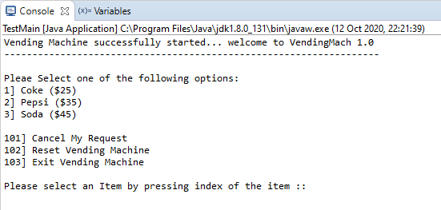

Give more than item price (until you given full price system keep asking for more coins)

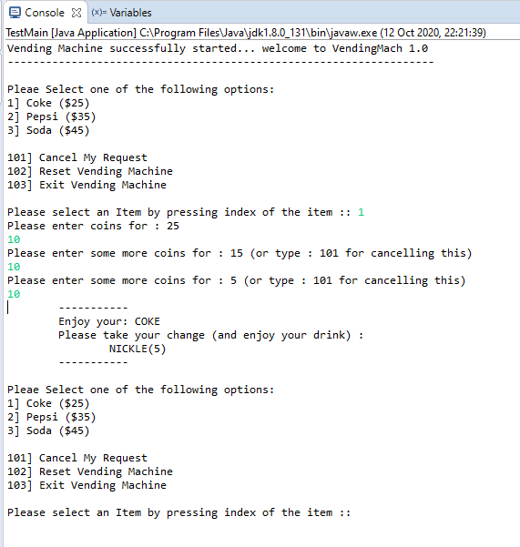

If you enter wrong denomination system asks for correct number

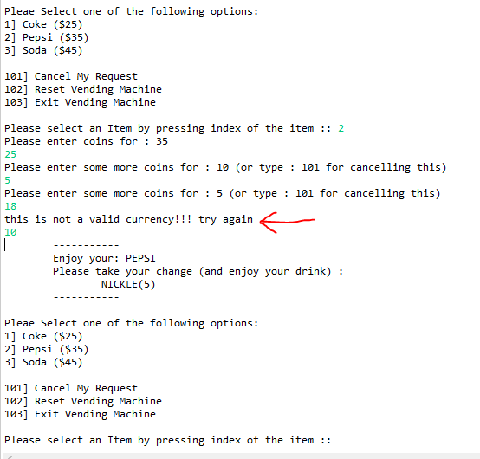

If you cancel the order in the middle you get refund nicely

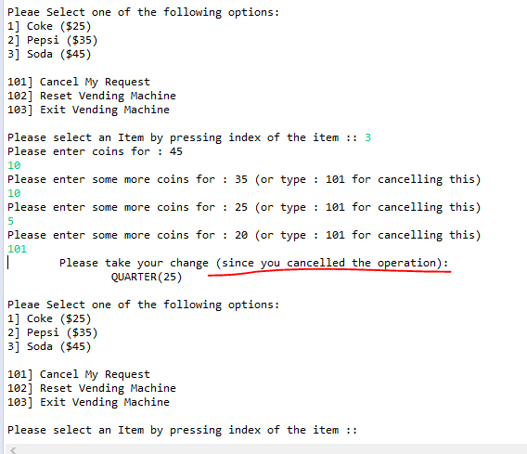

If it was asked to reset (here requirement is not clear so we are not asking any extra PIN/Password to make this operation accessible by admin only but for now we are allowing this operation to all users – though ideally we would like to restrict to admins)

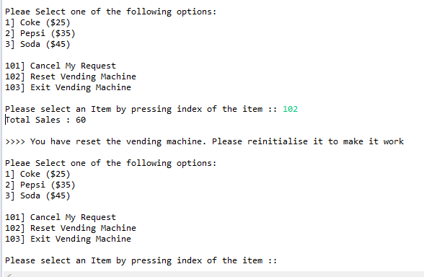

After reset is processed you cannot buy any new items unless administrator add new items back to machine.

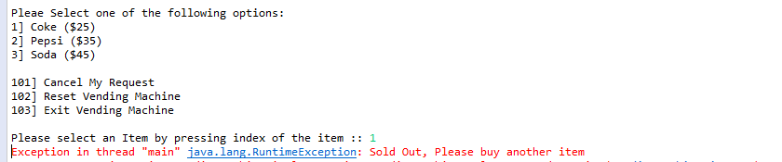

Corner cases are like, you cannot ask for refund when you did not pay anything:

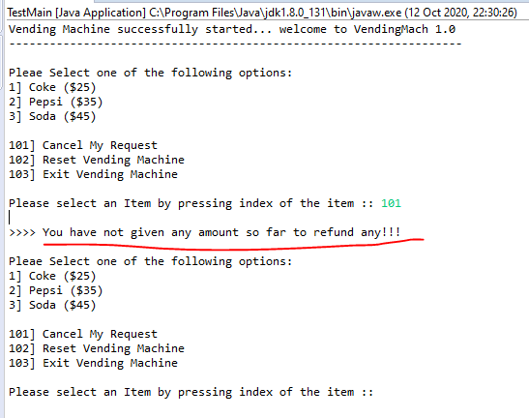

System detects if your selection is invalid (also detects invalid coins too)

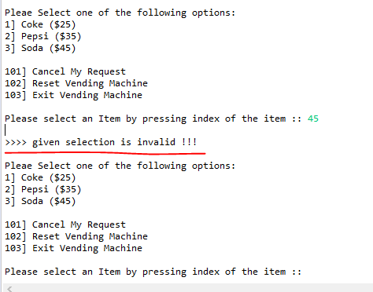

At the end there is an option to come out of forever loop:

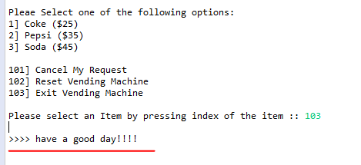

## API Testing Screenshots

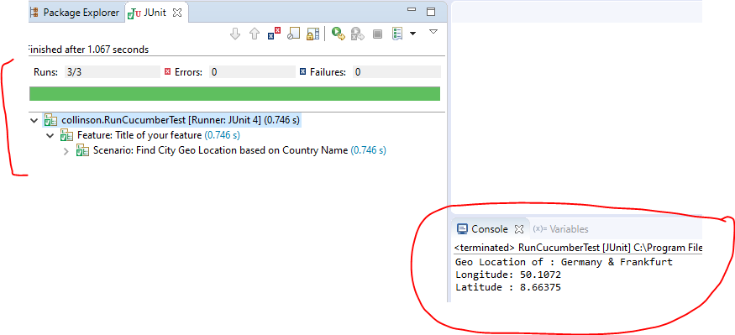

Feature and step files & dependencies

