nslookup [www.google.com](http://www.google.com/)

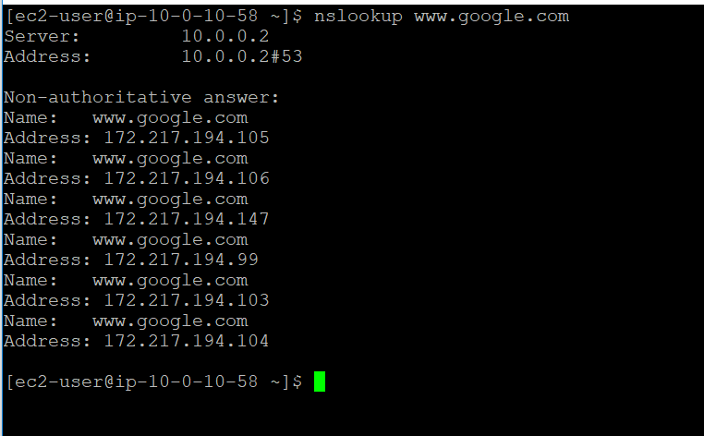

**curl**[**https://www.google.com**](https://www.google.com/)

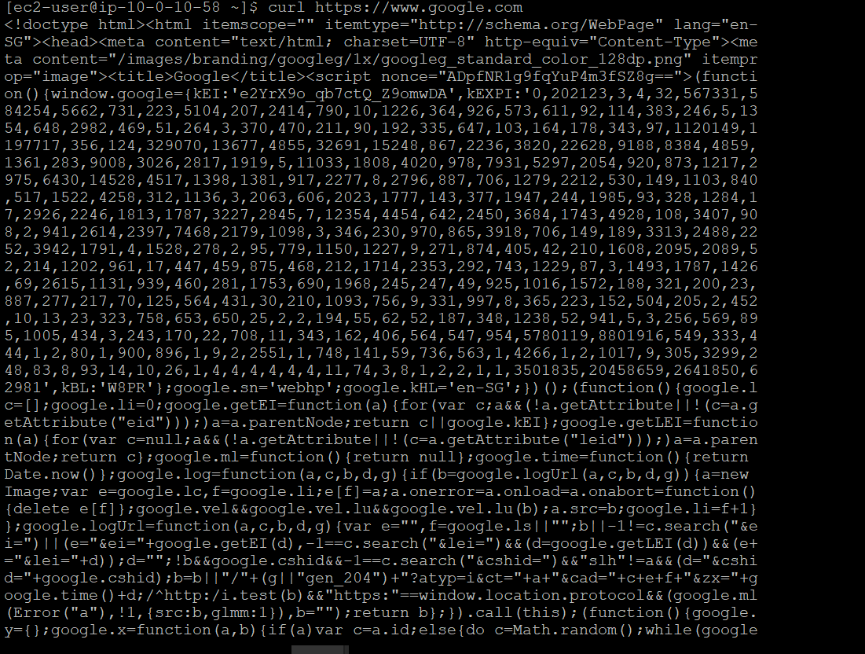

**telnet localhost 80**

