Solving Differential Equation using Op-amp

Prepared by : Satyam Yadav(15116052) Submitted to : Dr. Sudeb Dasgupta
Batch: O’7’ Date : 11th August, 2016

------------------------------------------------------------------------------------------------------------------
The differential equation to be solved is :
v”+2v'+v=10sin(4t)
with the initial conditions: v(0)=-4 and v'(0)=1

Approach:
The eqn. can be re-written as :
v”=-2v'-v'+10sin(4t)........(a)
The circuit is to be designed such that v'' comes as final output which is again fed to the initial input such that the RHS of eqn(a) can be realized.The block diagram for this can be shown as:
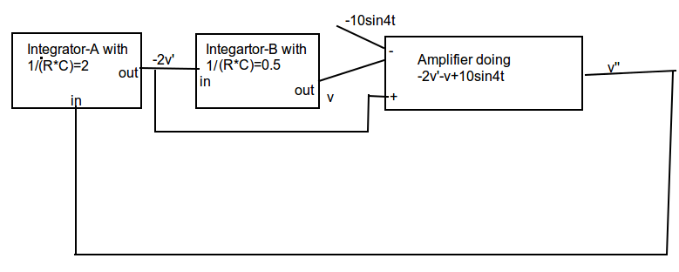

Now if we set the initial conditions as they should be,we can get the required output as the voltage output from Integartor-B.The initial voltage of ouptut of integrator-A should be -2V(the value of -2v'(0)).Similarly,the output of Integrator-b should be -4V(the value of v(0) )

Calculations:
For integrator-A, the value of RC should be 0.5.Taking R to be 1k ohm we get C as 0.5mF
For integrator-B,the value of RC should be 2. Again, taking to be 1k ohm we get c as 2 mF.
For the last amplifier (U3) realising the RHS of eqn(a).(See the circuit )
The value of V+=R4*(-2v')/(R4+R3)=-2v'/3.
Now V-=V+=-2v'/3
Applying nodal analysis at negative terminal of U3,we get Vout=(3V-)-Va+10sin4t
Va=v(from block diagram)
Substituting the values ,we get Vout=-2v'-v+10sin4t.

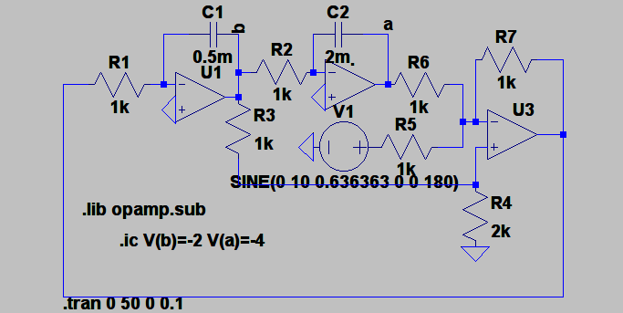
Circuit:

Conclusion:
Hence,the solution of differential equation is the V(a) .The eqn can be sucessfully solved using three op-amps.The transient analysis shows the solution of our diff. equation:

