Assignment 3

Task 1: JSON API Route
- Create a Flask application with an /api route. When this route is accessed, it should return a JSON list. The data should be stored in a backend file, read from it, and sent as a response.

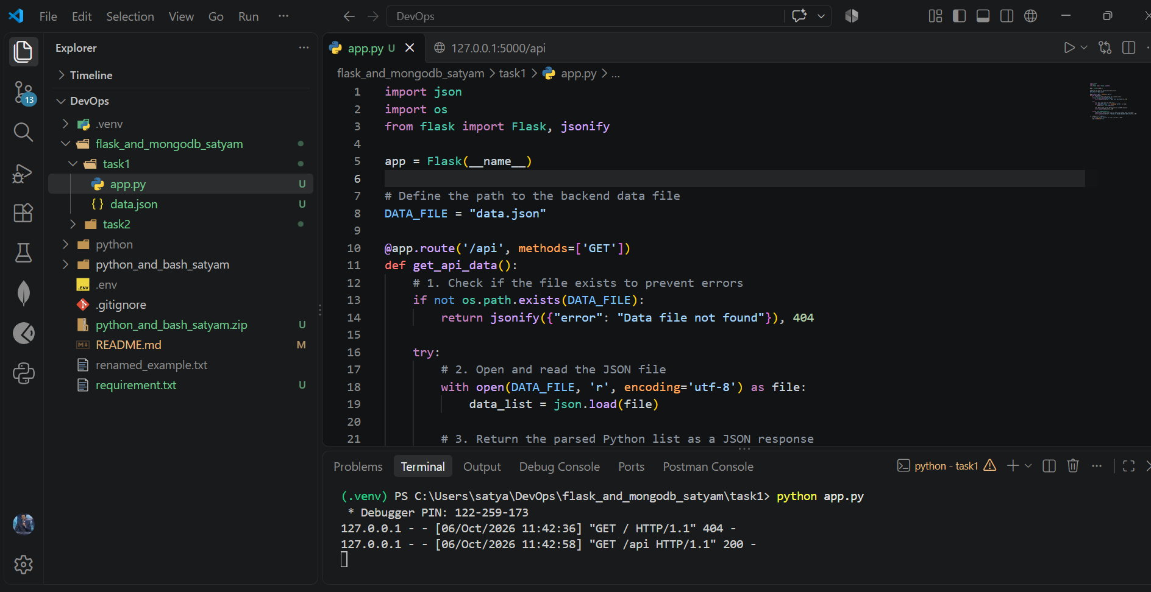

>> Data.json (file)

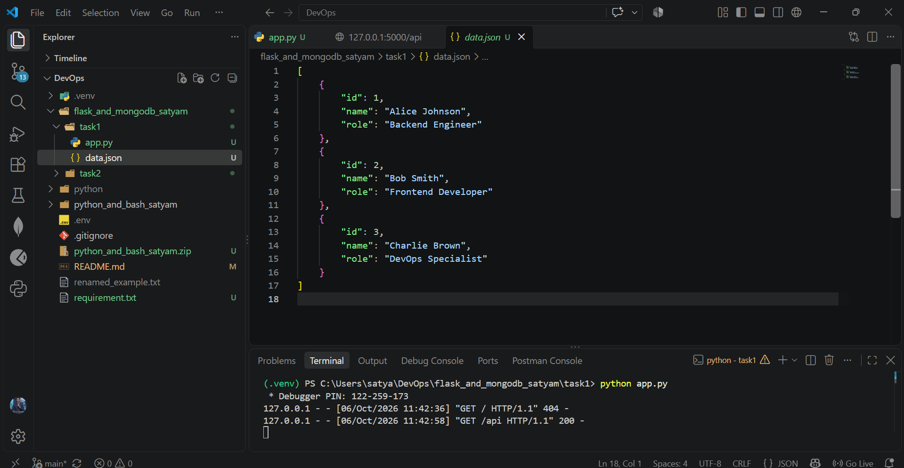

>> Output json response
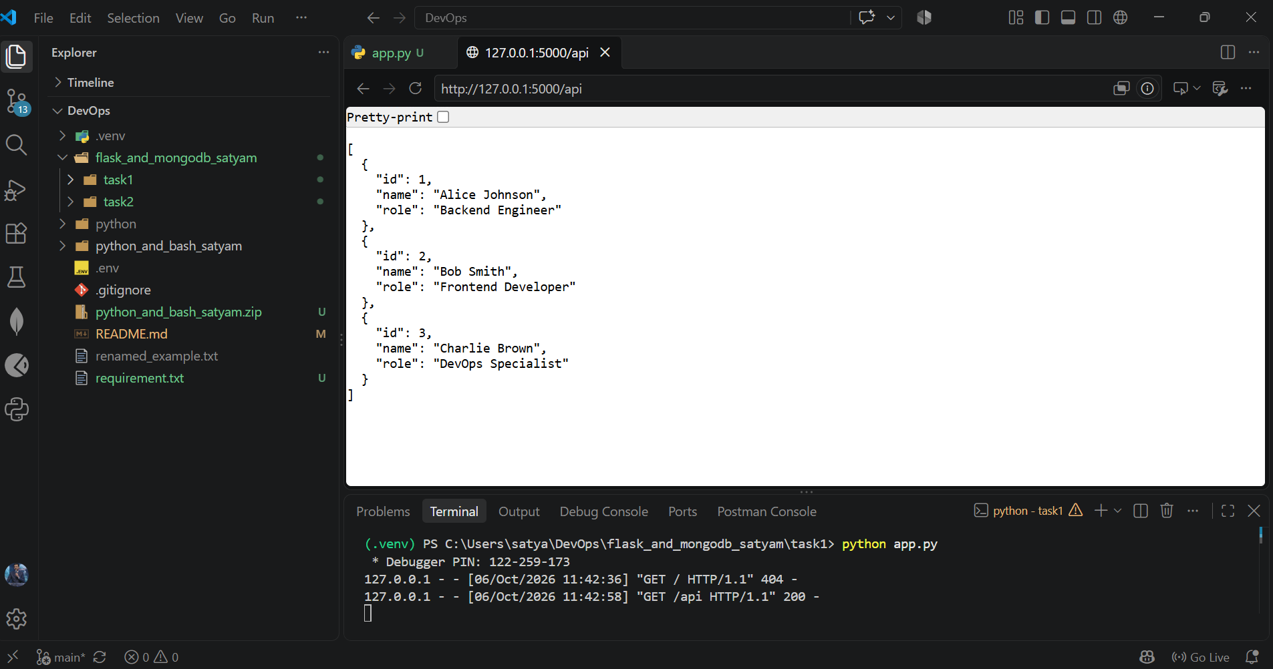

Task 2: Frontend Form with MongoDB Atlas
- Create a form on the frontend that, when submitted, inserts data into MongoDB Atlas.
- On success: the user should be redirected to another page displaying the message “Data submitted successfully”.
- On error: display the error on the same page without redirection.
>> Backend app file.
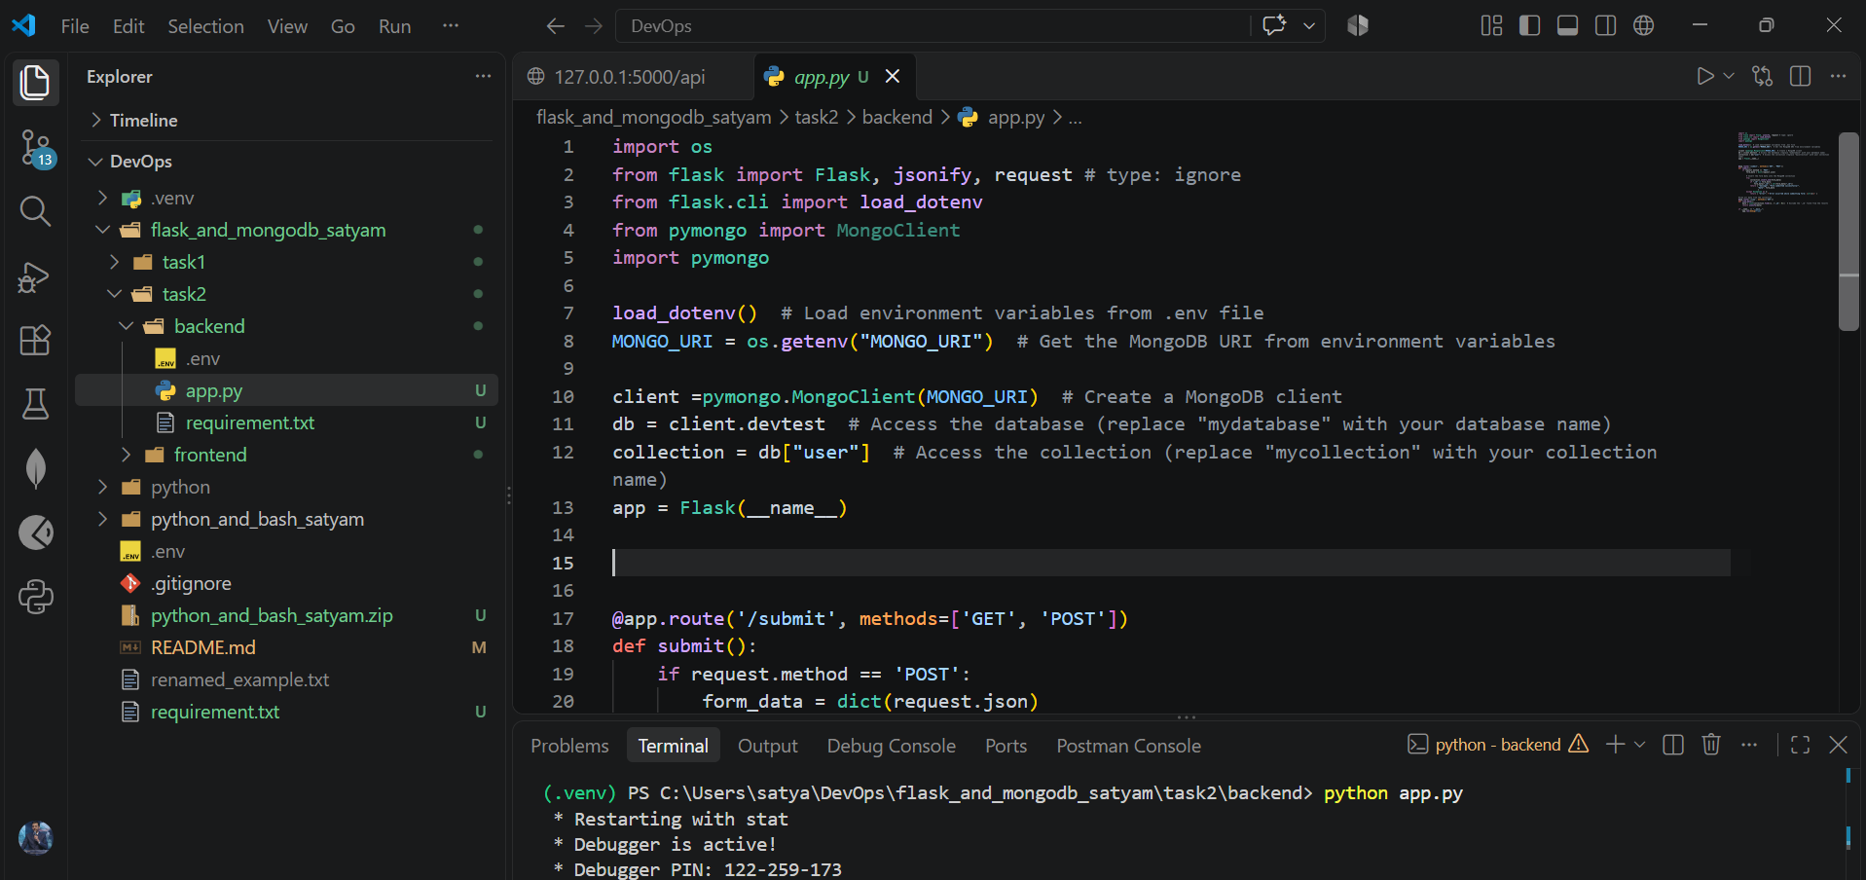

>> Frontend file app.py
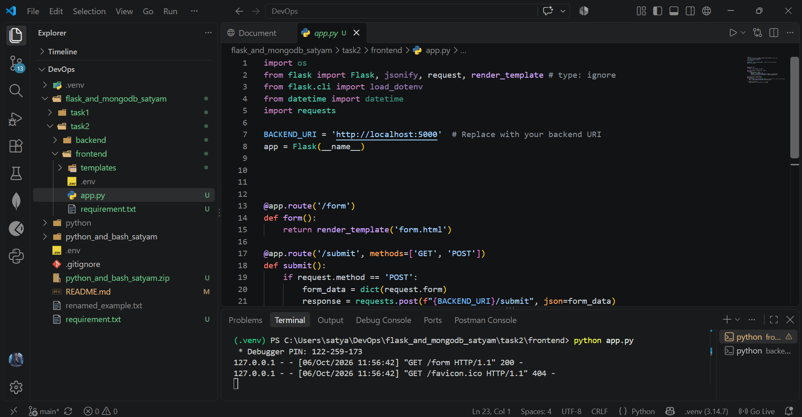
>> Output file (form)
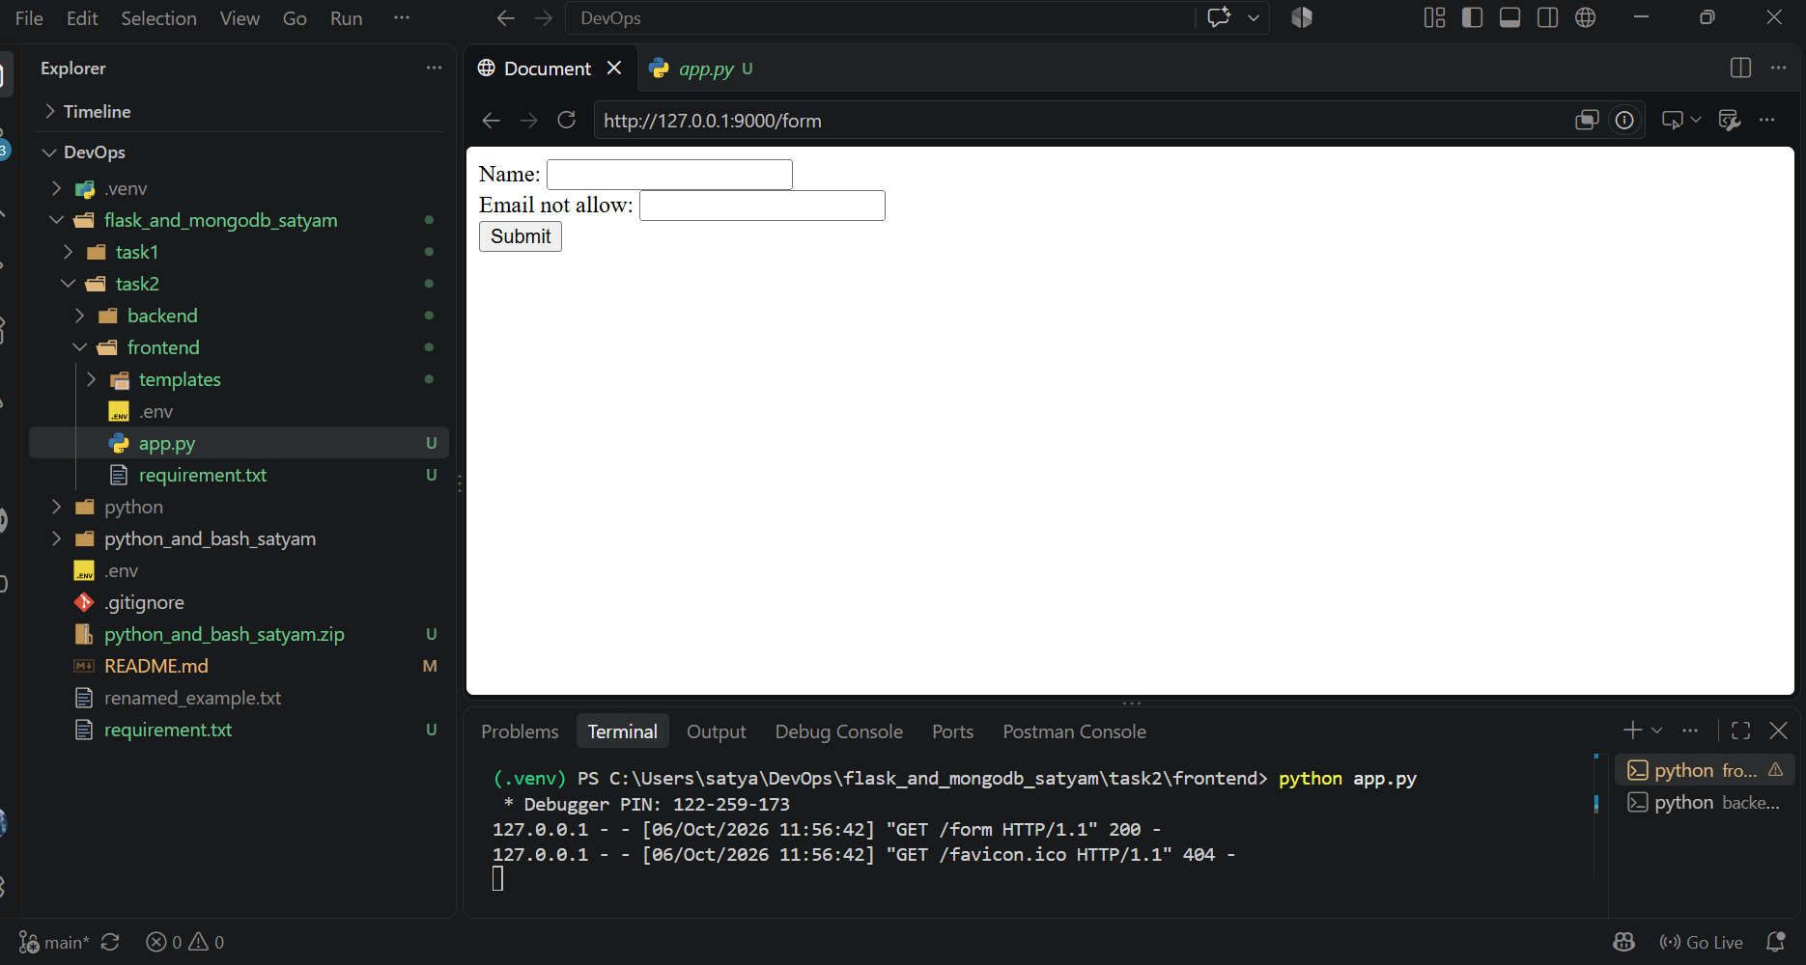
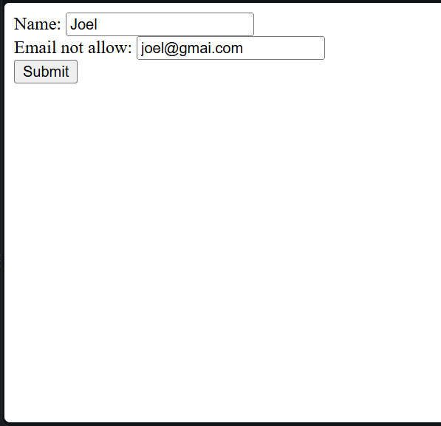
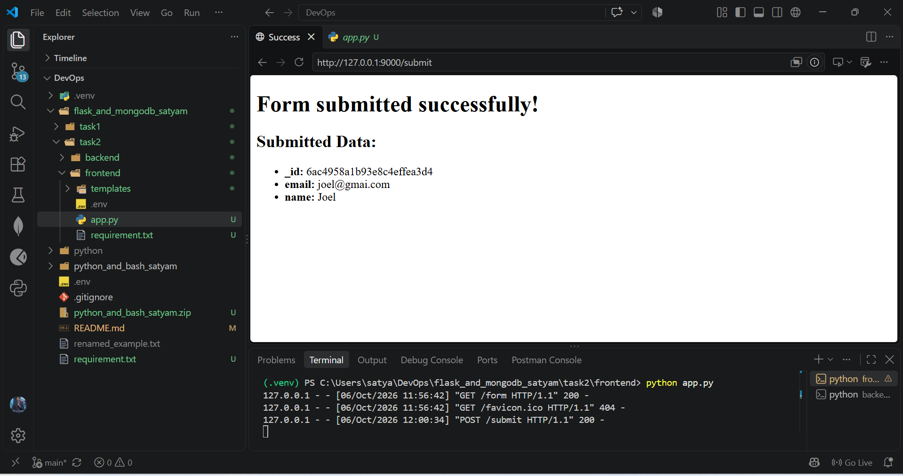
Error handling on the same page >>
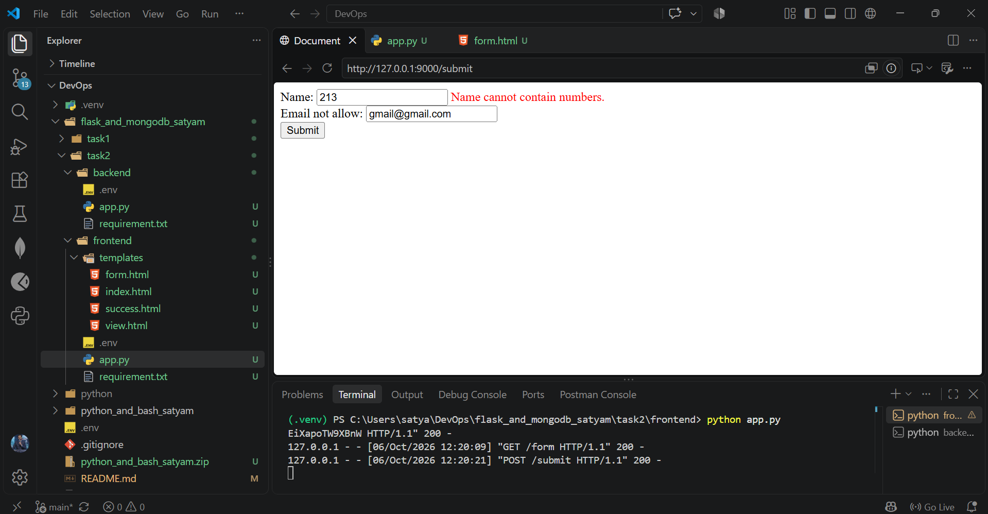

View all data >>
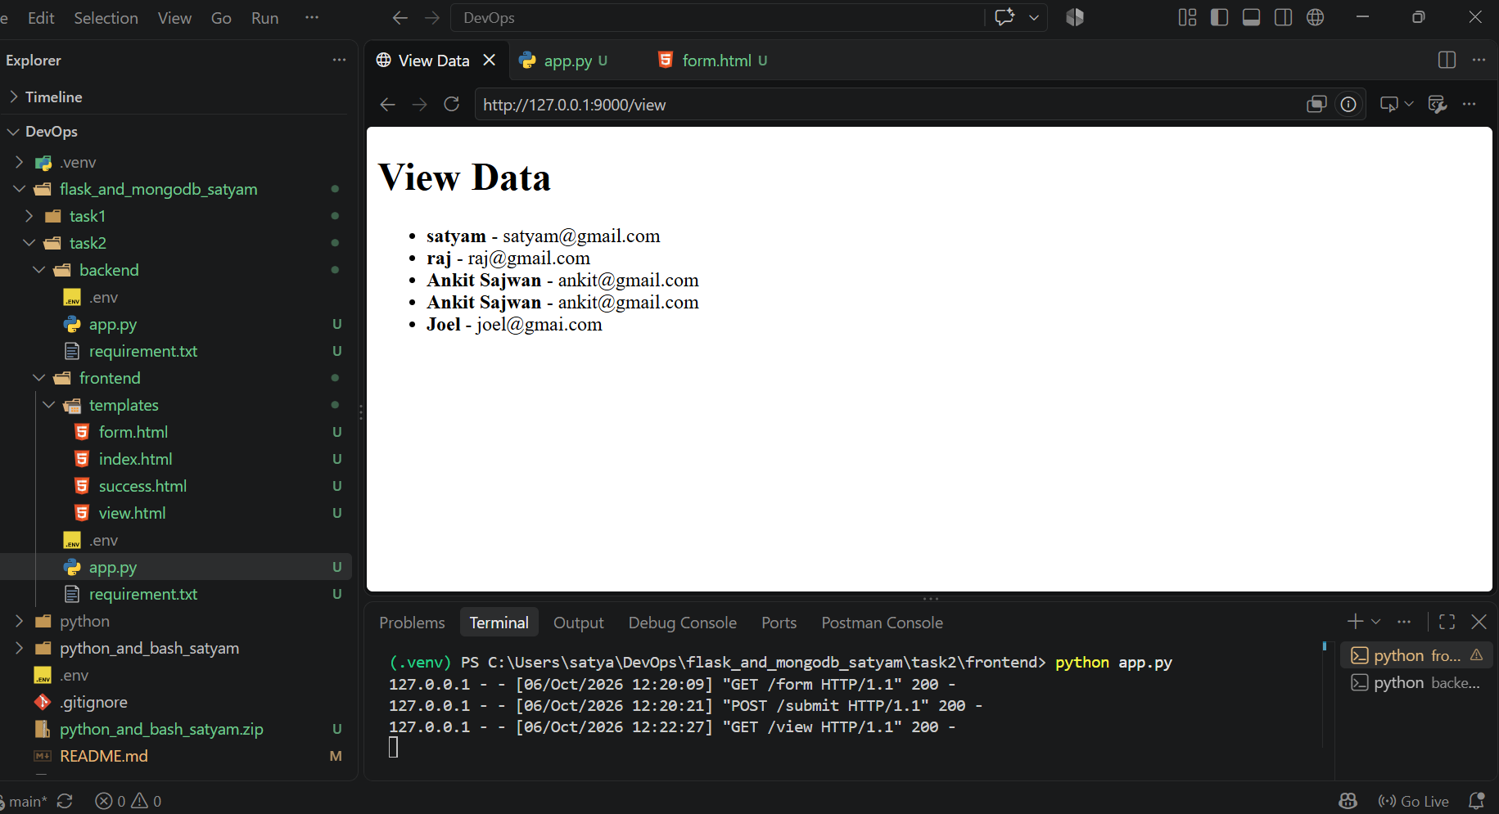
MongoDB
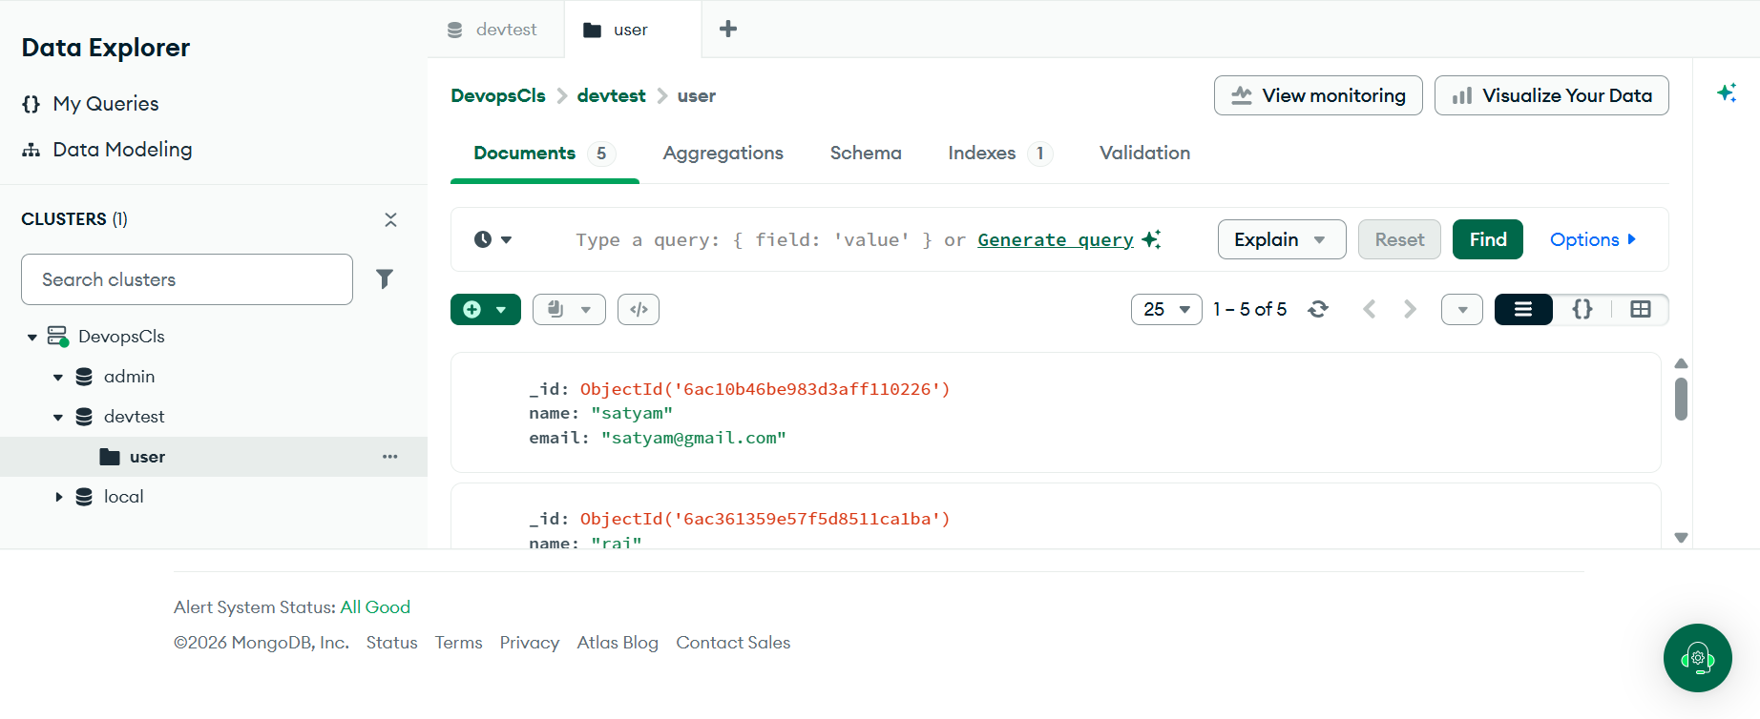

Explain the code:
Backend:
Below code creates a Flask API connected to MongoDB.
- load_dotenv() → loads .env variables.
- MONGO_URI → gets MongoDB connection URL.
- MongoClient() → connects to MongoDB.
- db = client.devtest → selects the devtest database.
- collection = db["user"] → selects the user collection.
Frontend:
Below is the frontend Flask application. It receives form data, validates it, sends it to the backend, and displays the result.
- BACKEND_URI → address of your backend Flask API (port 5000).
- app = Flask(__name__) → creates the frontend Flask app.
- /form → displays form.html.
- /submit → receives the form and validates the name.
- request.form → gets data submitted from the HTML form.
- name = ... → gets and cleans the name.
- not name → checks if the name is empty.
- any(char.isdigit()...) → checks if the name contains numbers.
- requests.post(...) → sends valid data to the backend.
- response.json() → gets the backend's JSON response.
- If "error" exists → shows the error.
- If successful → shows success.html.
- /view → calls backend /view and displays the returned users in view.html.
- port=9000 → your frontend runs on port 9000, while backend runs on 5000.

