Assignment - 2
Objective: Practise core Python programming — conditionals, dictionaries, and file handling (reading and writing files).
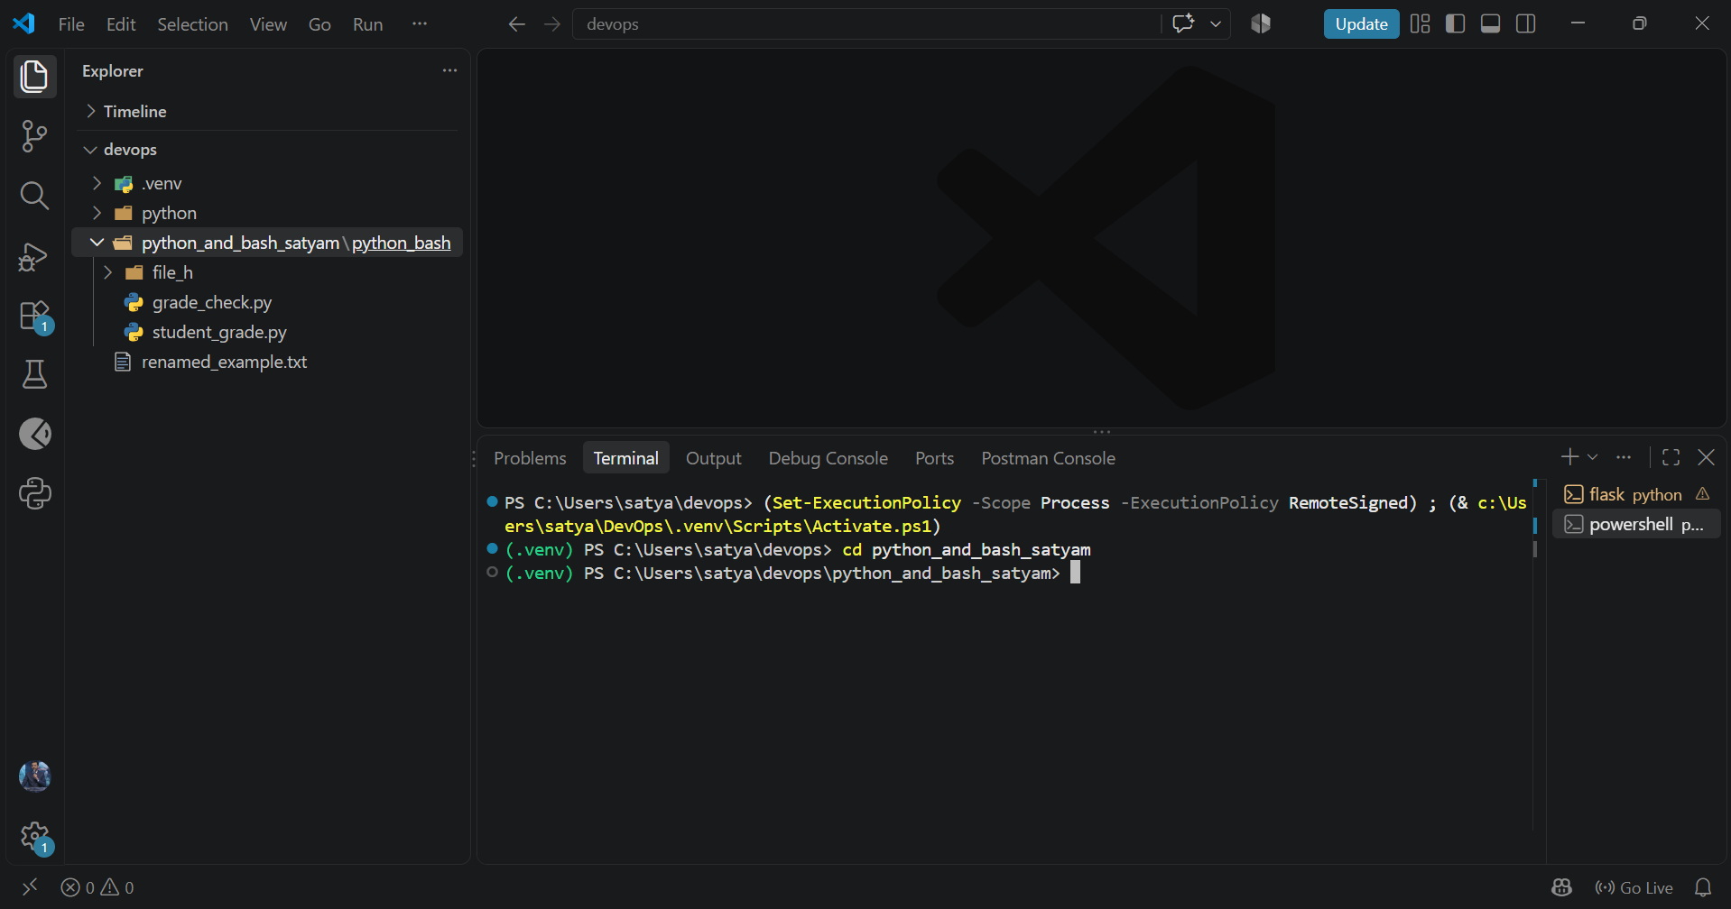

#. Assignment, which required a menu-driven calculator with separate arithmetic functions and division-by-zero error handling.
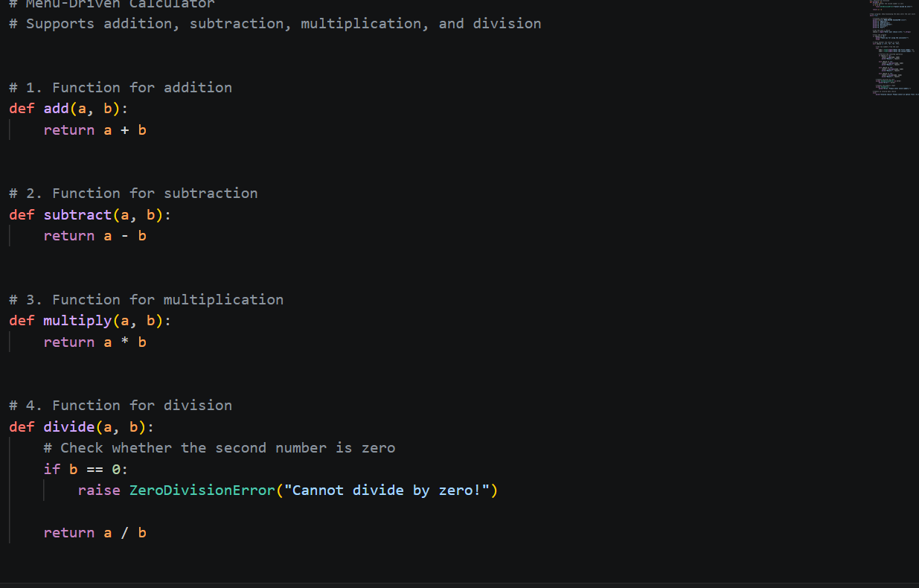
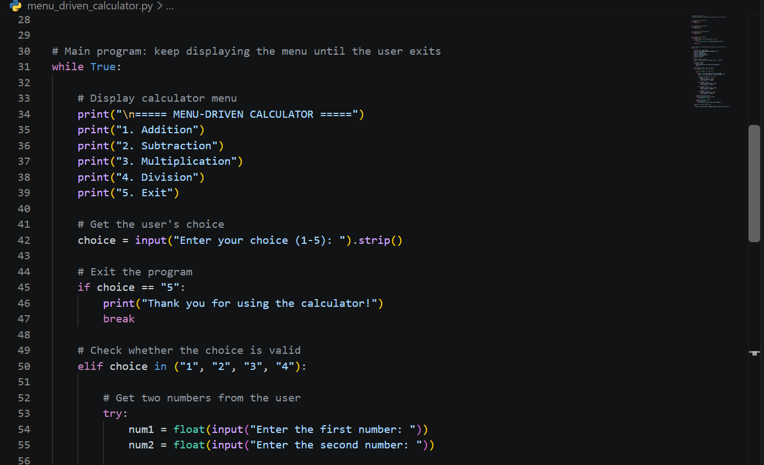
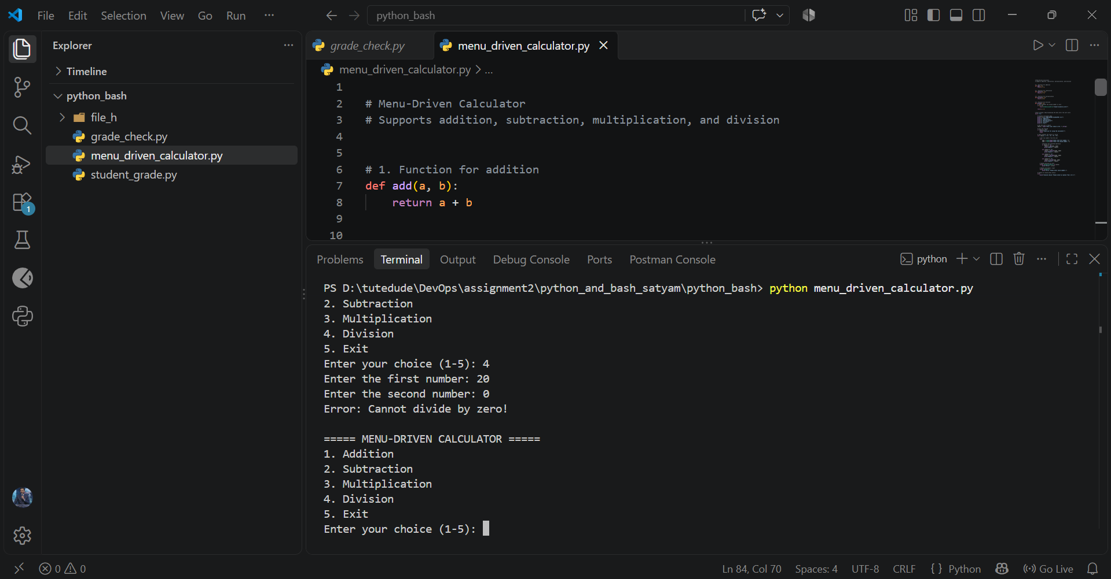
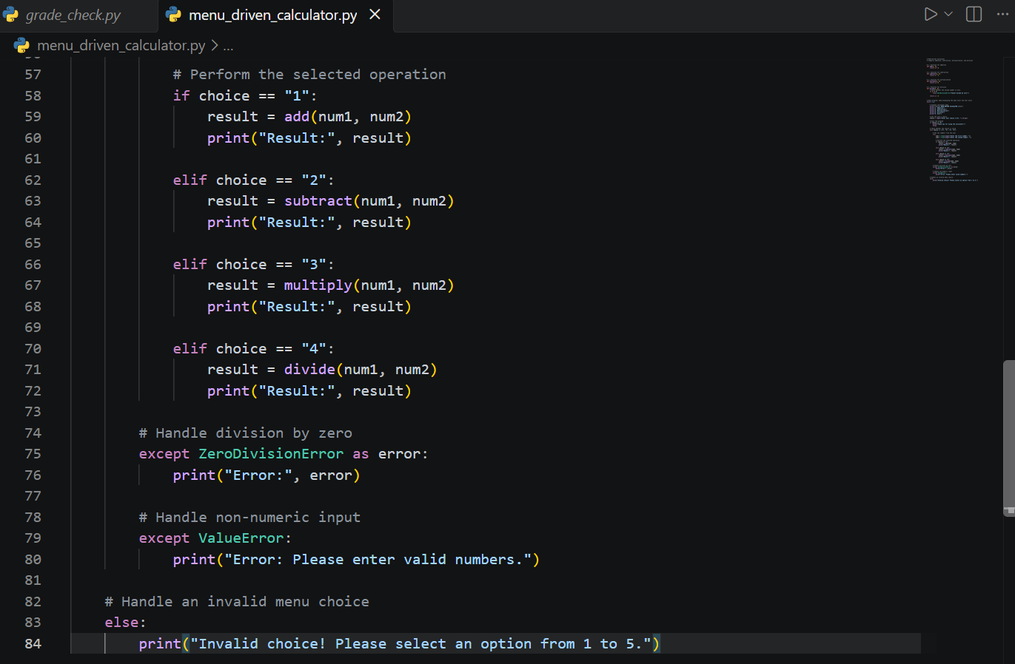
1. Grade Checker
Take a score as input and print the grade based on the following:
- 90+ : “A”
- 80–89 : “B”
- 70–79 : “C”
- 60–69 : “D”
- Below 60 : “F”
- Use a basic if / else statement to determine the grade.
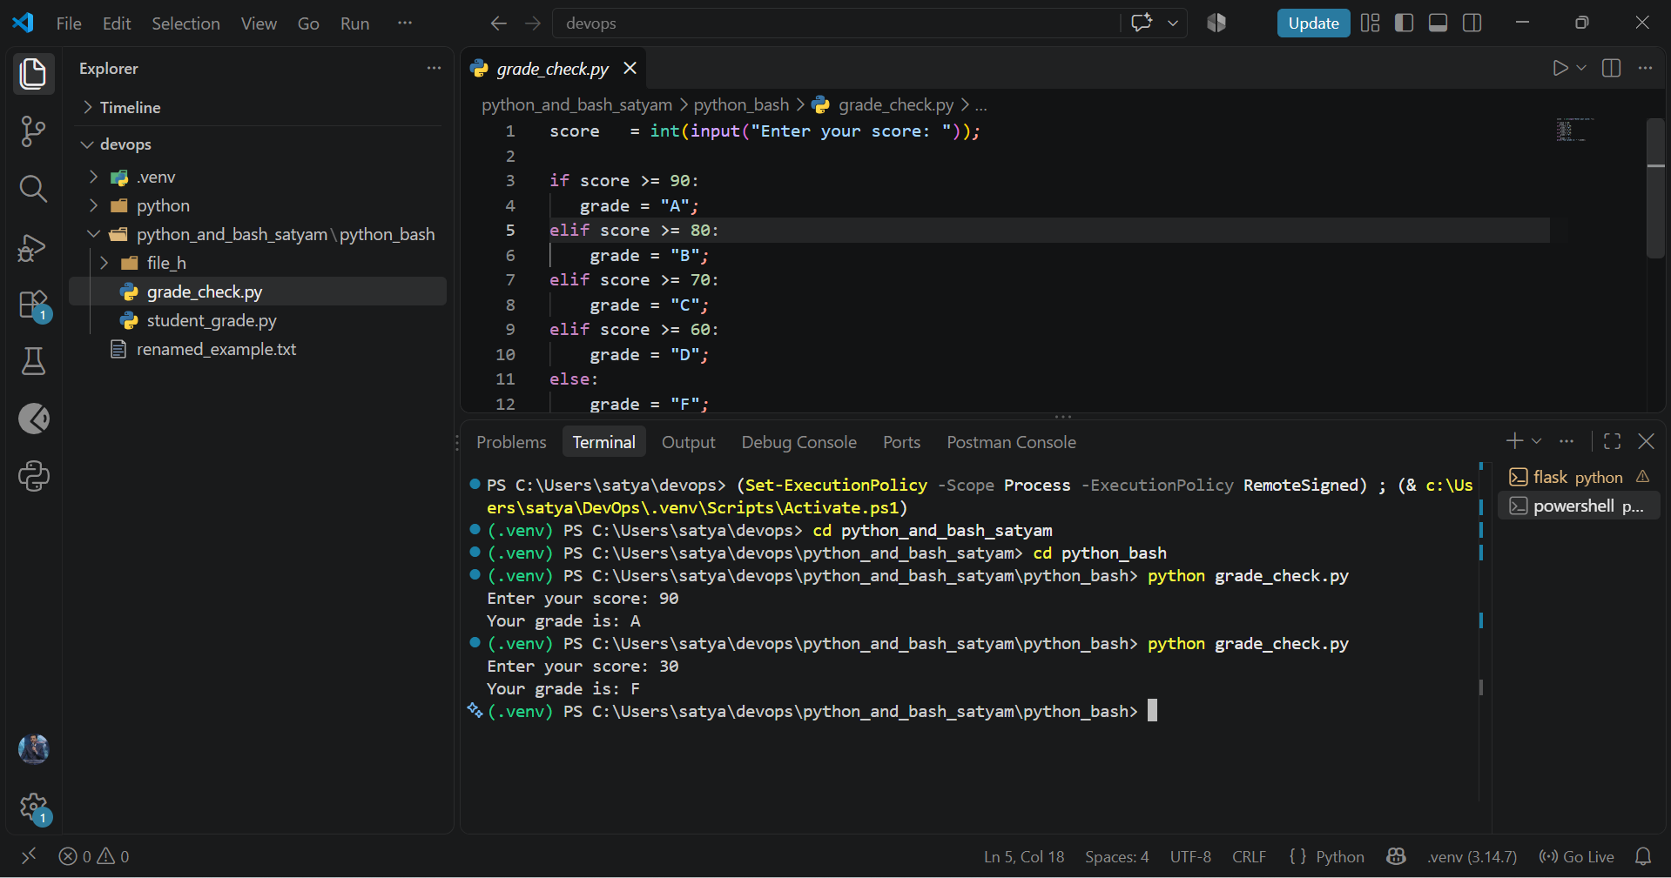

2. Student Grades
Create a dictionary where the keys are student names and the values are their grades. Allow the user to:
- Add a new student and grade.
- Update an existing student's grade.
- Print all student grades.
- Use a dictionary and basic operations with if / else.

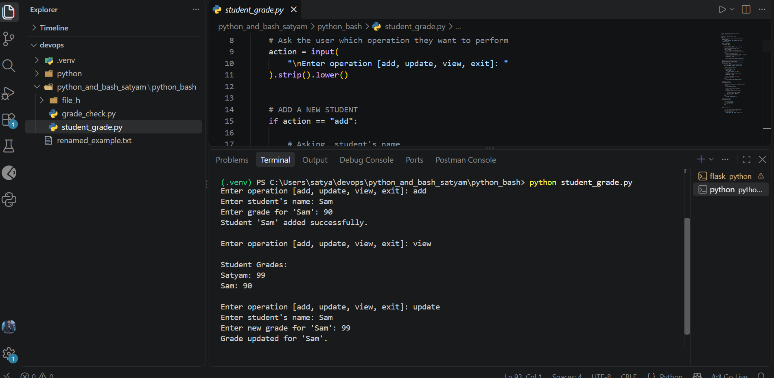
3. Write to a File
- Write a program to create a text file and write some content to it, using file functions like open() and write().
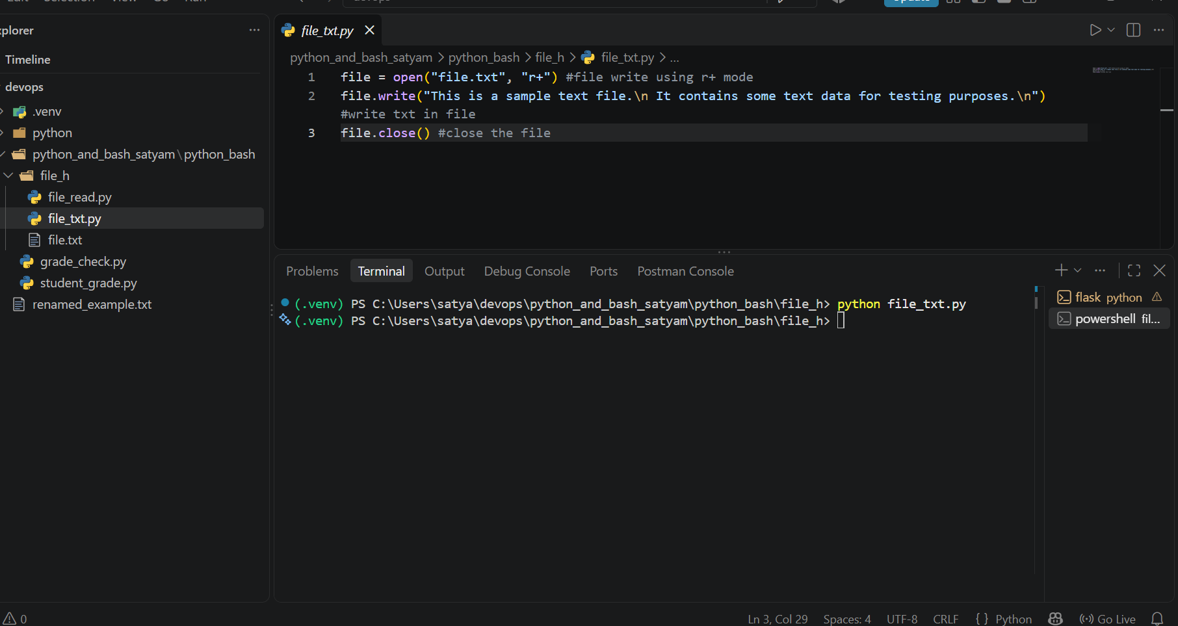
4. Read from a File
- Open the file in read mode and use file.read() to read and display its content.
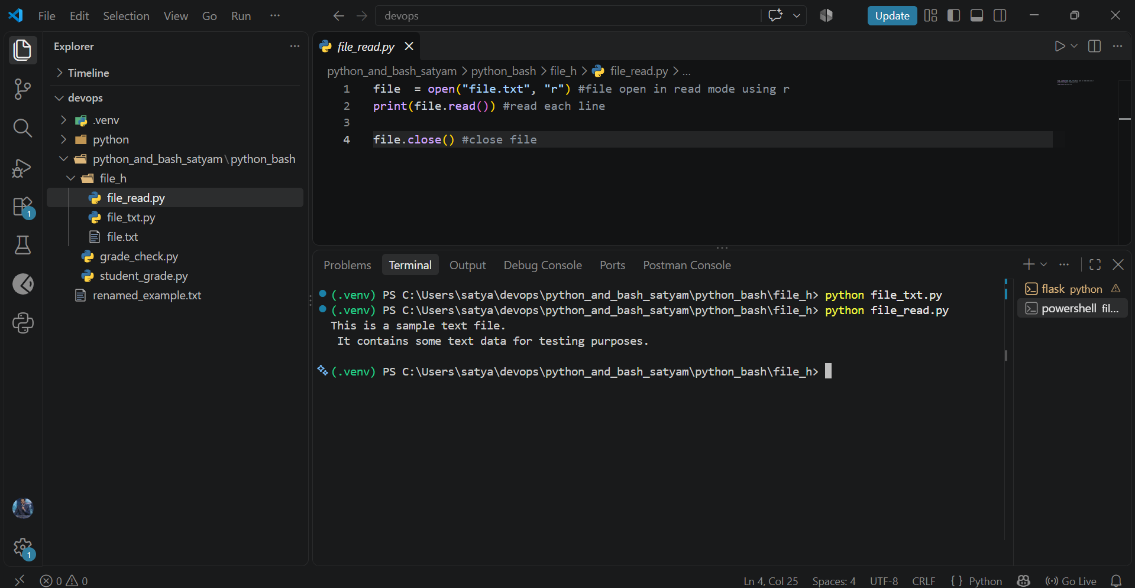

GitHub Link: https://github.com/satyam-javascript/DevOps

