MINI-PROJECT

(2020-2021)

**Online mobile shopping website(mobifyy)**

**PROJECT REPORT**

Department of Computer Engineering &

Applications

**Institute of Engineering & Technology**



**SUBMITTED TO:**  **SUBMITTED BY:**

Dr. Viabhav Deevan ***ShivanshSharma(18150082)***

***Senior Technical Trainer***

***Satyam Merothiya(181500628)***

***Pushpendra (181500512)***

***ayush gupta()***

**TABLE OF CONTENTS**

**Certificate……………………………………………………… Synopsis……………………………………………………….. Acknowledgement……………………..…………………….. Abstract…………………………………………………………**

**1. Introduction….……………………………………………**

1.1 Overview……………..…………………………………...

1.2 Motivation………………………………………………....

1.3 Problem Statement….…………………………………..

1.4 Objective………………………………………………….

**2. Software Requirement Analysis…………………………..**

2.1 System Analysis……………………………………………..

**2.1.1 The Convenience Aspect**

**2.1.2 The Merchandise Aspect**

**2.1.3 The Cost Aspect**

2.2 Role of System Analyst……………………….…………….

2.2.1 Main roles of System Analyst……………………………………..

2.3 Users………………………………………………………….

2.4 Methodology………………………………………………….

2.5 Dependencies /External Systems………………………...

2.6 DFD…………………………………………………………..

2.7 ER Diagrams……………………………………………….

2.8 Use-case Diagram…………………………………………..

**3. Implementation details ………………………**

**4. Contribution Summary………………**

**5. Tables…………………………………**

**6.Project Work…………………………**

**7.Future Scope…………………………….**

**References………………………..**

**Certificate**

This is to certify that Shivansh Sharma,Satyam Merothiya,Pushpendra, ayush gupta of B.Tech (CSE) 3rd year has ***successfully*** Completed the MINI PROJECT named Online mobile shopping website on Web Development during 2020-21.

Signature:

(Mentor)

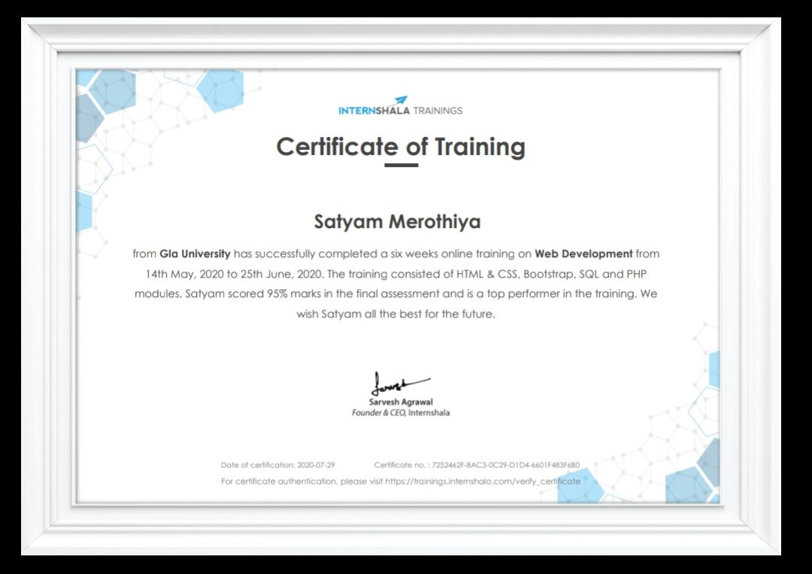

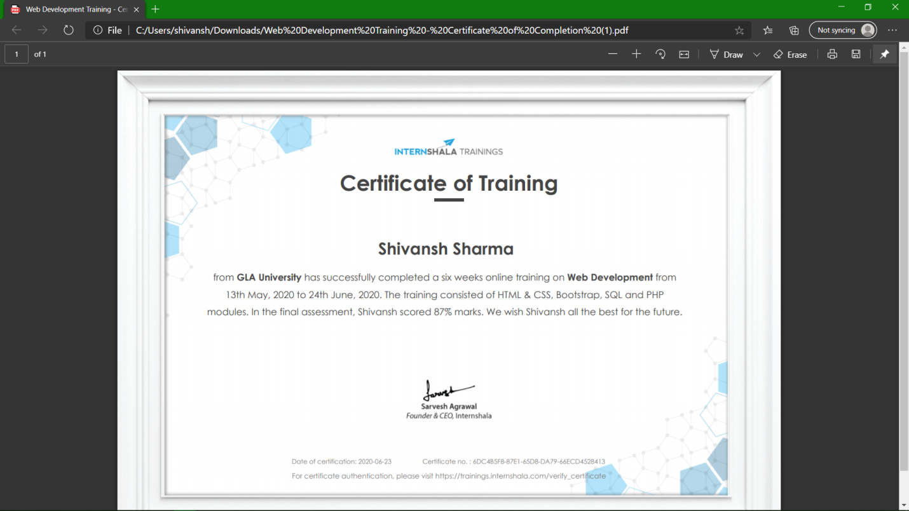

**Acknowlegment**

We take this opportunity to express our sincere gratitude to all those who helped us in various capacities in undertaking this project and devising the report. We are privileged to express our sense of gratitude to our respected teacher Dr. Vaibhav Deevanfor his guidance.

We are also grateful to __***DR.ANAND SINGH JALAL SIR__*** ,the Head of Department, Information Technology, for the brainwave and encouragement given.

We take this opportunity also to thank our friends and contemporaries for their cooperation and compliance.

**Abstract**

The purpose of the project entitled as “ Online mobile shopping website(mobifyy)” is to computerize the Front Office Management of online store to develop software which is user friendly simple, fast and cost – effective,for personal use and makes the data processing very fast. Shopping Cart System is the Simple shopping Solution.It’s a full featured website and shopping cart system that bends over backwards to give us the flexibility we need to run our online store.The basic concept of the application is to allow the customer to shop virtually using the Internet and allow customers to buy the items and articles of their desire from the store. The information pertaining to the products are stores on an DBMS at the server side (store). The Server processes the customers and the items are shipped to the address submitted by them.

Our project has been completed successfully and results were according to expectations.The most challenging task was the domain knowledge, to understand the language. It is one of the major areas and really need very fundamental and conceptual knowledge of HTML, CSS, Bootstrap,MySql.

**1.Introduction**

**1.1 Overview**

The project Online mobile shopping website has been developed on HTML,PHP,CSS and My SQL.An online shopping store which will allow formal and informal merchants to advertise and sell their good on the internet.This would permit local retailers to make their products available to the rest of the world via the World Wide Web.The objective of this project is to creat an e-commerce web portal which would allow product information to be updated securely.

The web portal will have an online interface in the form of an e-commerce website that will allow users to buy mobiles from the merchants.Customers user have limited access right to access the system.I have used PHP for business logic,MySQL as a database,HTML for structure designing,CSS for web page formatting.

**1.2 Motivation**

Since, this is our first mini project, I want to create a project which is easy but also challenging.Then I decided to work online mobile shopping website

**1.3 Problem Statement**

During the time of covid-19 people can not go to offline market place to buy mobile but they can order it from online marketplace.

**1.4 Objective**

The project objectives are :

1.To make the shopping easier and comfortable

2.To serve the customers without wasting their precious time

3.To reach the products to the customer’s address with great care

4.To represent as a compete in the e-commerce of ***INDIA.***

**2.System and Requirement Analysis**

**2.1 System Analysis**

System analysis is a process of collecting and interpreting facts, identifying the problems, and decomposition of the system into its components.

It is a process of studying a system in order to define its goals or purposes and to discover operations and procedures for accomplishing them most efficiently.

Here the problem is people face a problem when they want to buy any phone ,they have to go to offline market and then they select their product,but in our case they first select their product and order online.

People can get these informations with the help of our website very easily.It will save the time ,energy,money of customer.

**2.1.1 The Convenience Aspect** :

**Online marketplace :** We never have to leave our home and the stores never close.There are also no overworked sales clerks.We never have to wait for service and there are no worries about parking.We can shop anyting we want from here.Women are more anticipated and research online,when come by product online or in-store.

**In-Store :** It’s crowded,it’s noisy.We physically have to be there when it’s open and we have to wait in long lines to pay for everything.Men are less likely to researcg online,before buy product,compared women.

**2.1.2 The Merchandise Aspect** :

**Online marketplace** : We can generally get a more extensive view of every product on offer,whereas stores have limited shelf space.It may also be easier to get specifies on each item we are interested in.We can also read the online reviews of others.

**In-Store** : We can physically see what we are getting,pick it up and even have it demonstrated.A lot depends on what we are purchasing.Buying an iPod online is easy because we know what we are getting.But choosing clothes or shoes that way is problematic,because we can’t try them on first.

**2.1.3 The Cost Aspect :**

**Online marketplace :** Because they don’t have to hire sales staff or pay rent,some online deals can be found much cheaper than in a mall.And the range of products is wider too.

**In-Store :** Unless there’s a sale,we may wind up paying more if we are buy it at a retail outlet.But if we are into dickering,we can at least argue down the price with a manager-something we can’t do on our computer,unless we are buying something on eBay.

**2.2 Role of System Analyst**

The system analyst is a person who is thoroughly aware of the system and guides the system development project by giving proper directions. He is an expert having technical and interpersonal skills to carry out development tasks.

**2.2.1 Main Roles of System Analyst:**

1.Defining and understanding the requirement of user through various fact finding techniques.

2.The system should be more user friendly.

3.Draw certain specifications which are easily understood by users and programmer in precise and detailed form.

**2.3 Users**

The User of the website would be the customer(who want to book an appointment or want to read information,they can give feedback too) and Admin of this website only.

**2.4 Methodology**

In this project we divide the project into different tasks and then use the following methods to complete the task.

1. Gathered information about the problems during the pandemic.

2. We decided to develop this project.

3. List all the tasks.

4. Analyse all the problems that we faced while working on the project.

5.Duration of task.

6.Deadline of task.

7.Task Dependencies.

8.End point of the task.

**Requirements analysis**

The first step for us is to analyse your and your target market’s requirements. Who will be visiting your website, what will be the purpose of their visit, what is the primary goal of your website, how can your organisation best cater to their needs etc. Many such questions are analysed.

**What is mobifyy?**

Online shopping is a form of electronic shopping store where the buyer is directly online to the seller’s computer usually via the internet. There is no intermediary service.The sales and purchases transaction is completed electronically and interactively in real-time.The development of this new system contains the following activities which try to develop on-line application by keeping the entire process in the view of database integration approach. User gets its email id and password to access their account.Administrator of Shopping Cart System has multiple features such as Add, Delete, Update shopping Items.

**Features of mobifyy** :

1.Secure registration and profile management facilities for Customers. 2.Browsing through the website to see the items

3. Creating a Shopping cart so that customer can Shop N number of items and checkout finally with the entire shopping cart .

4. Customers should be able to call the Shop about the items they would like to see on the website.

**Functionality performed by customer user :**

1. Registration for customer.

2. Login for customer.

3. Forgot password for customer

4. Change password for customer.

**Manage Products :**

1. Add products in the website

2.View details of the products

3.Listing of all products

**2.5 Dependencies/External Systems**

**User Interfaces:**

The webpages of Online Sanitization Booking System will provide very user friendly space.Starting from login,signup pages,page on which customer give feedback in which they can give suggestions to the admins.The website will universally accessible on almost all PCs and smart phones.

**Hardware Interfaces:**

There are two external machines/devices used by the website, each related to a user interface.These are a server machine at the admin end,hosting the website, keeping log of the appointment made to them and another one is one is a PC or a smart phone at user’s end to access the website.The devices at the user end behave as terminals and not for storing any type of data. All appointments will stored on server.

**HARDWARE REQUIREMENT**

● Laptop with minimum 2GB of RAM

● 2GB free harddisk space

●Processor i3 (7th Gen)

●1024 x 768 Display

**SOFTWARE REQUIREMENT**

● code editor

● Xamp Server

● Web Browser

● Github

**TECHNOLOGIES USED**

Overview of the technology :

**Front End: HTML, CSS**

**HTML**: HTML is used to create and save web document. E.g. Notepad/Notepad++.

**CSS** : (Cascading Style Sheets) Create attractive Layout.

**Back End : PHP, MySQL.**

**PHP**: Hypertext Preprocessor (PHP) is a technology that allows software developers to create dynamically generated web pages, in HTML, XML, or other document types, as per client request. PHP is open source software.

**MySQL Serve**r : MySQL is developed, distributed and supported by Oracle Corporation. MySQL is a database system used on the web it runs on a server. MySQL is ideal for both small and large applications. It is very fast, reliable, and easy to use. It supports standard SQL. MySQL can be compiled on a number of platforms.

The data in MySQL is stored in tables. A table is a collection of related data, and it consists of columns and rows. Databases are useful when storing information categorically. MySql is a database, widely used for accessing querying, updating, and managing data in databases.

**Features of MySQL** :

Internals and portability :

1. Written in C and C++.

2.Tested with a broad range of different compilers.

3. Works on many different platforms.

4.Tested with Purify (a commercial memory leakage detector) as well as with Val grind, a GPL tool.

5.Uses multi-layered server design with independent modules.

**Security:**

1.A privilege and password system that is very flexible and secure, and that enables host-based verification.

2.Password security by encryption of all password traffic when you connect to a server.

**Why To Use MySQL :**

1.Leading open source RDBMS

2.Ease of use – No frills

3.Fast

4.Robust

5.Security

6.Multiple OS support

7.Free

8.Technical support

9.Support large database– up to 50 million rows, file size limit up to 8 Million TB

**3.Implementation Details**

We are creating a website in which i am using HTML, CSS and other web development languages and for backend i m using PHP. For server and database we are using XAMPP (Apache server and MySQL database).

**4.Contribution Summary**

**OUR TEAM:**

**Founder:-shivansh sharma**

**Database manager and Documentation:-Ashwini bansal**

**Frontend Developer:Satyam mehrotiya**

**Design ideas:-Pushpendra and ayush**

**SCREENSHOT WITH PROJECT DETAIL**

**5.Tables:**

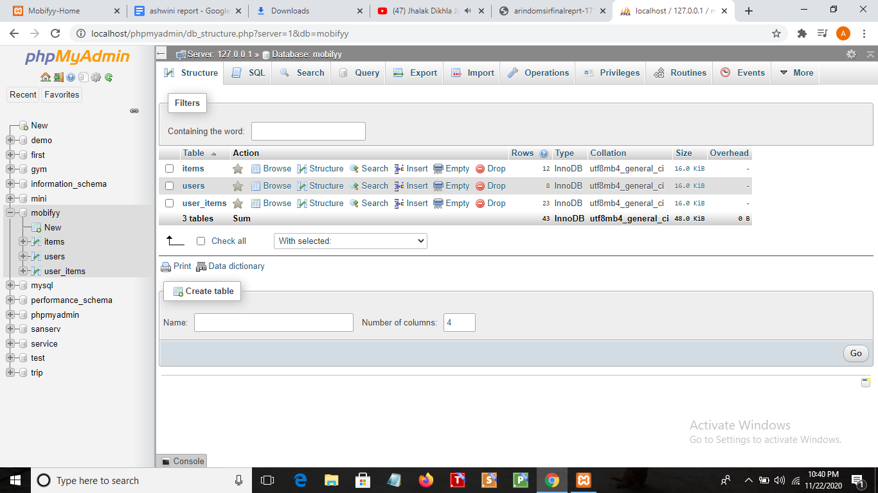

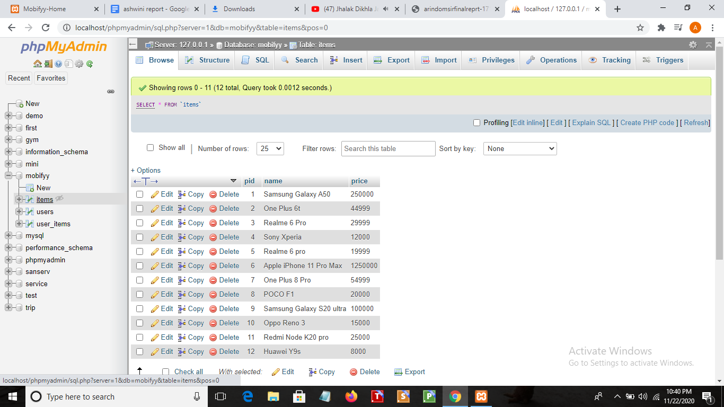

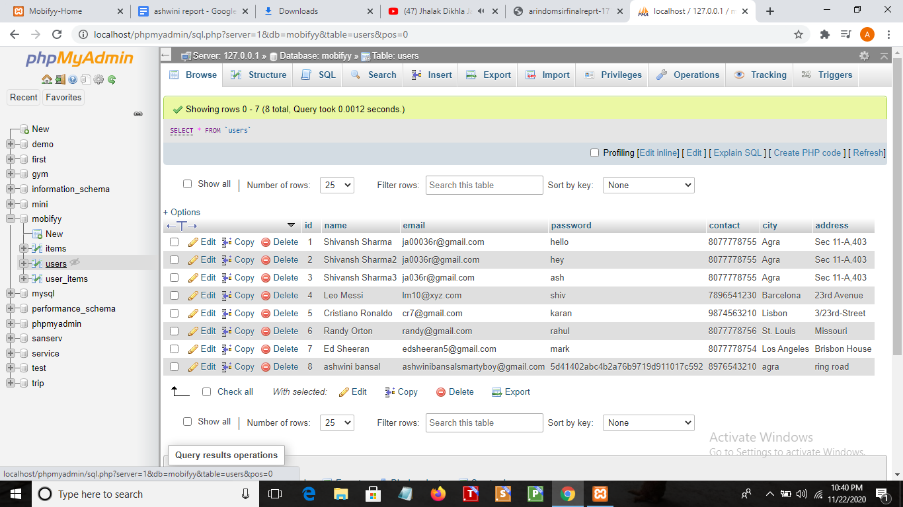

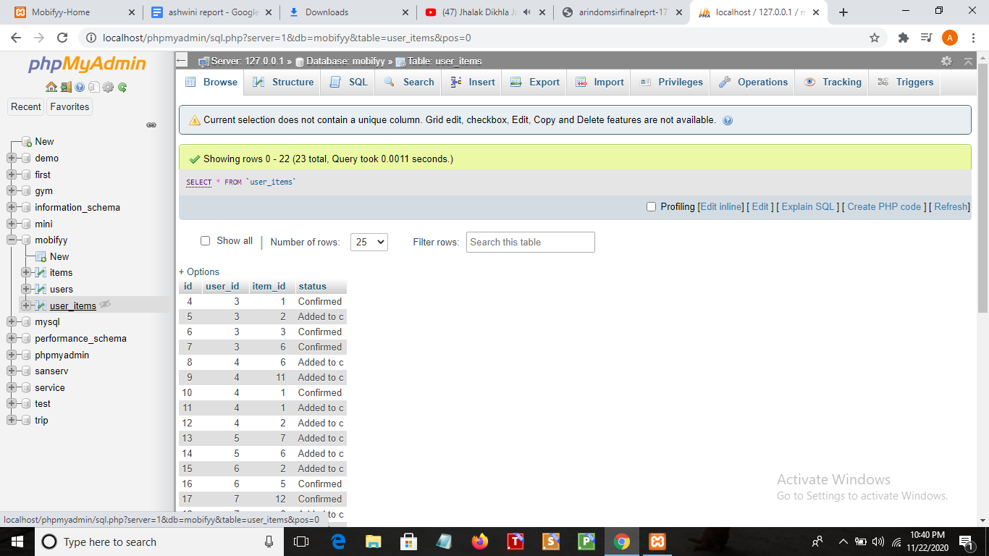

**6.Project Work:**

**Main Interface :**

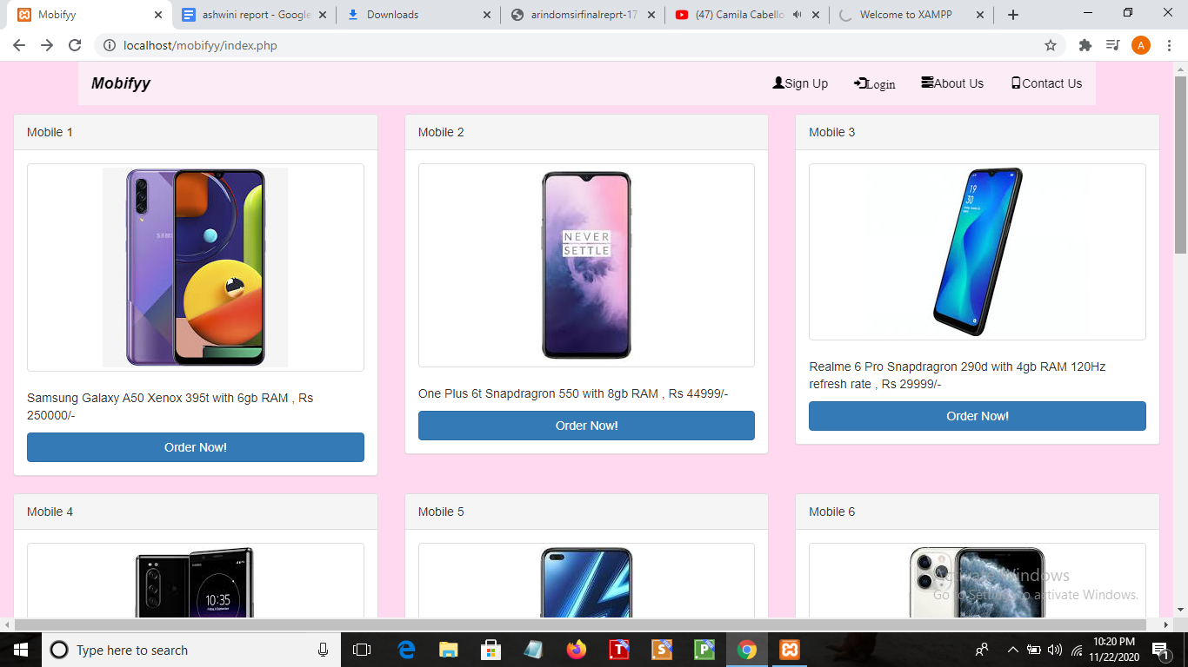

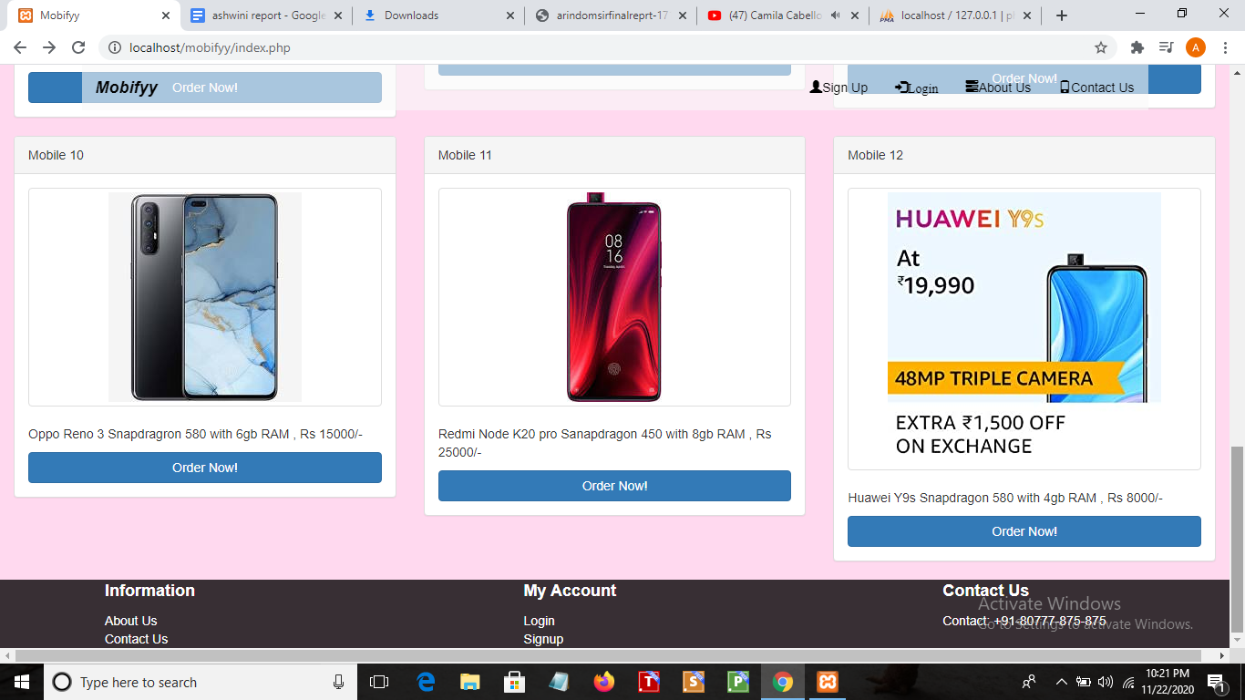

**User Sign Up And Login Panel Interface :**

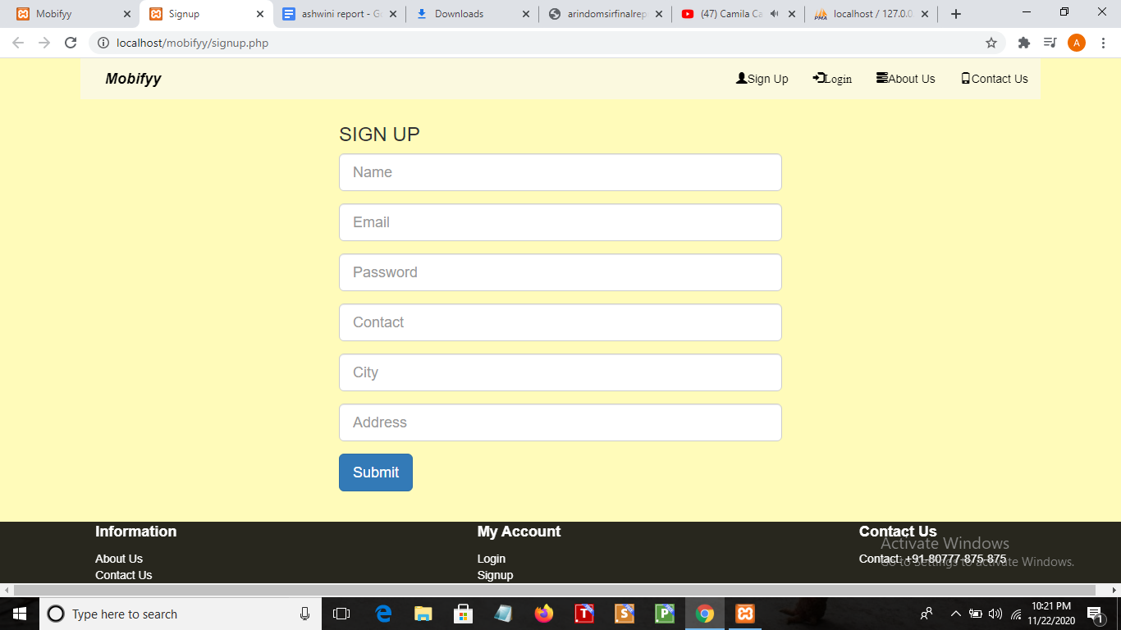

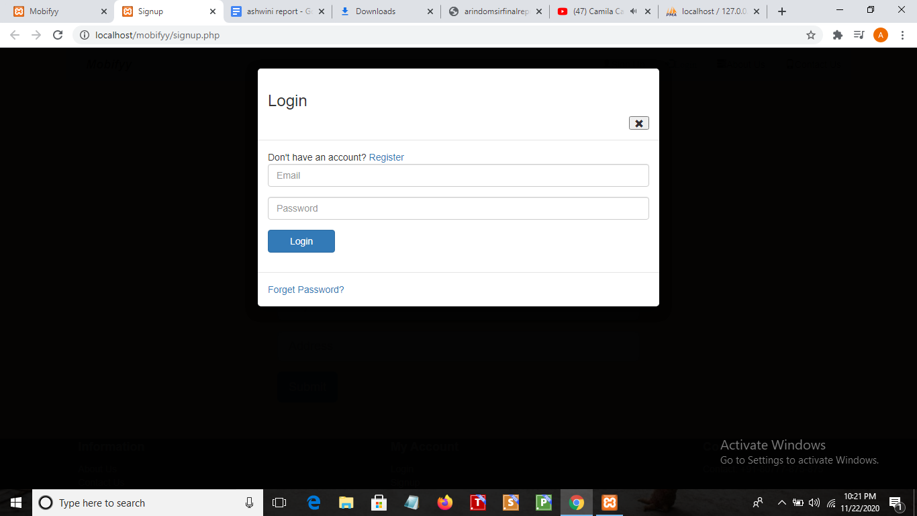

**About us and contact us interface:**

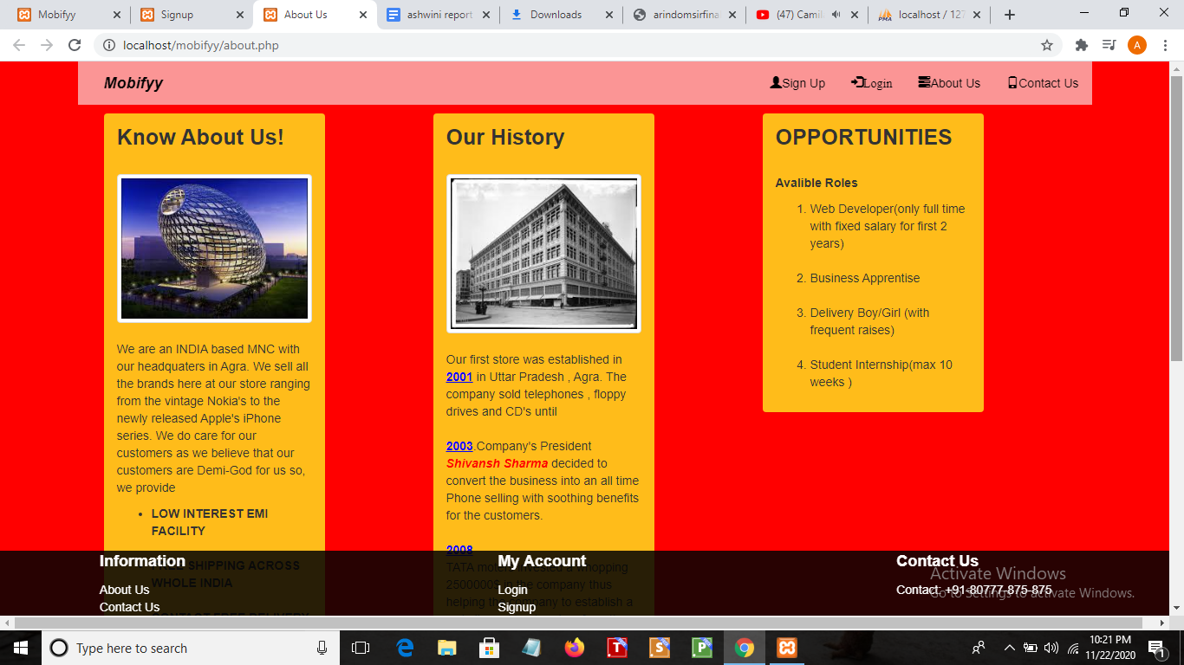

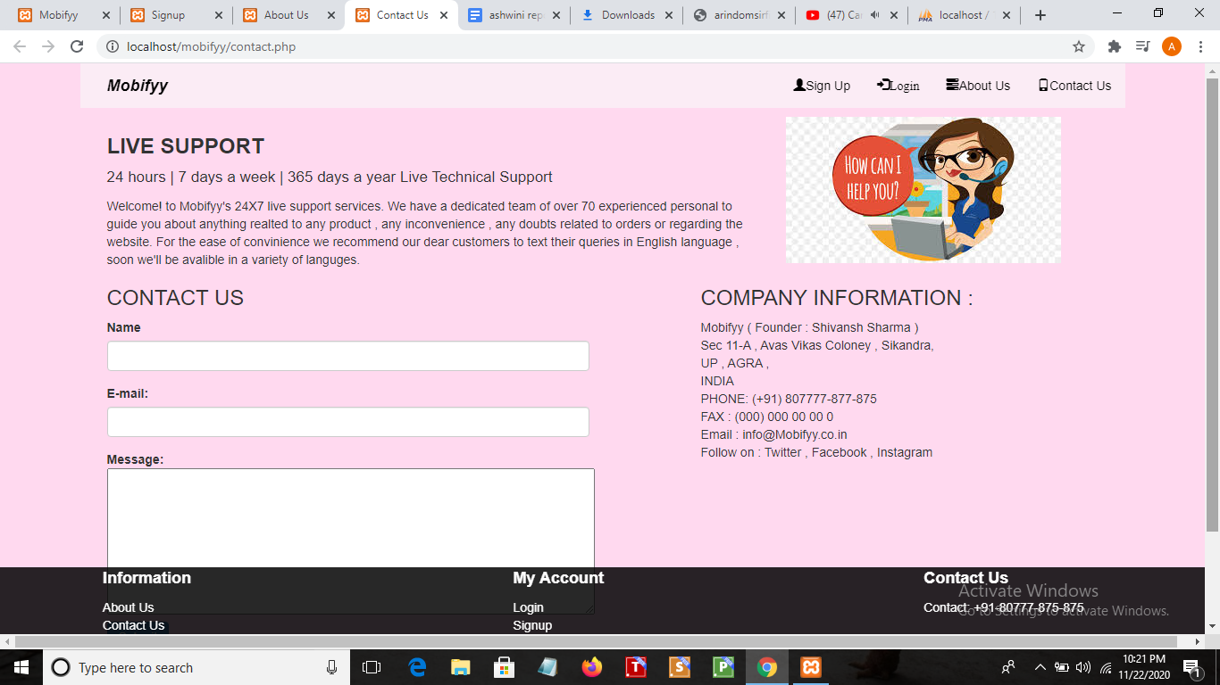

**Setting interface:**

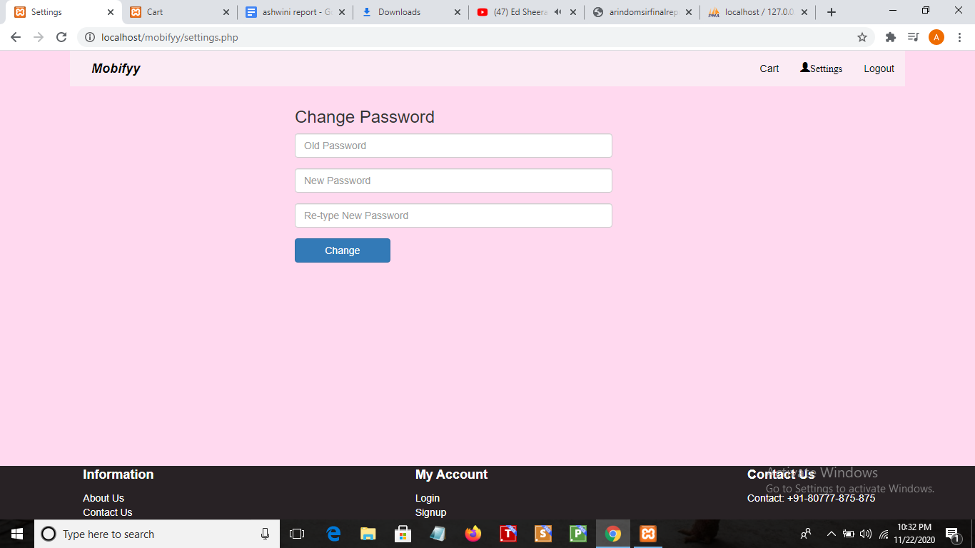

**7.Future Scope:**

1.Want to Increase facilities of this project.

2.Want to add printing option.

3.Want to develop graphical design.

4.Want to publish this website in online.

5.Want to remove all the limitation .

**8.Conclusion :**

After having detail study on online shopping,We can see a great change in the behavior of people in many manners like their attitude,buying pattern.In earlier times people use to do manual shopping bt now as time chnged,people are becoming busy and due to which technology has brought a new revolution i.e. online shopping.

As we started doing survey,it came to in notice that young age group people i.e. 15-30 uses of prefer online shopping because it is time and energy saving.But middle age group does not prefer much because they have wrong perception that by seeing the product one can get the goods of proper quality.And even some people does not prefer using plastic money i.e. credit cards.

But online shopping has a great future but to be successful it is necessary to spread awareness about it’s benefit.

**9.Website Reference :**

https://www.w3schools.com/html/

https://www.google.com https://www.slideshare.net/dulamkomal/online-shopping-24694373

https://www.wikipedia.com