IntelliSource
P2P Intelligence & Analytics Platform
Application Demo

KPMG India | Confidential | July 2026

This document provides a screen-by-screen walkthrough of IntelliSource, demonstrating real-time P2P analytics, compliance monitoring, vendor management, data upload, and admin capabilities.

01 Procurement Dashboard
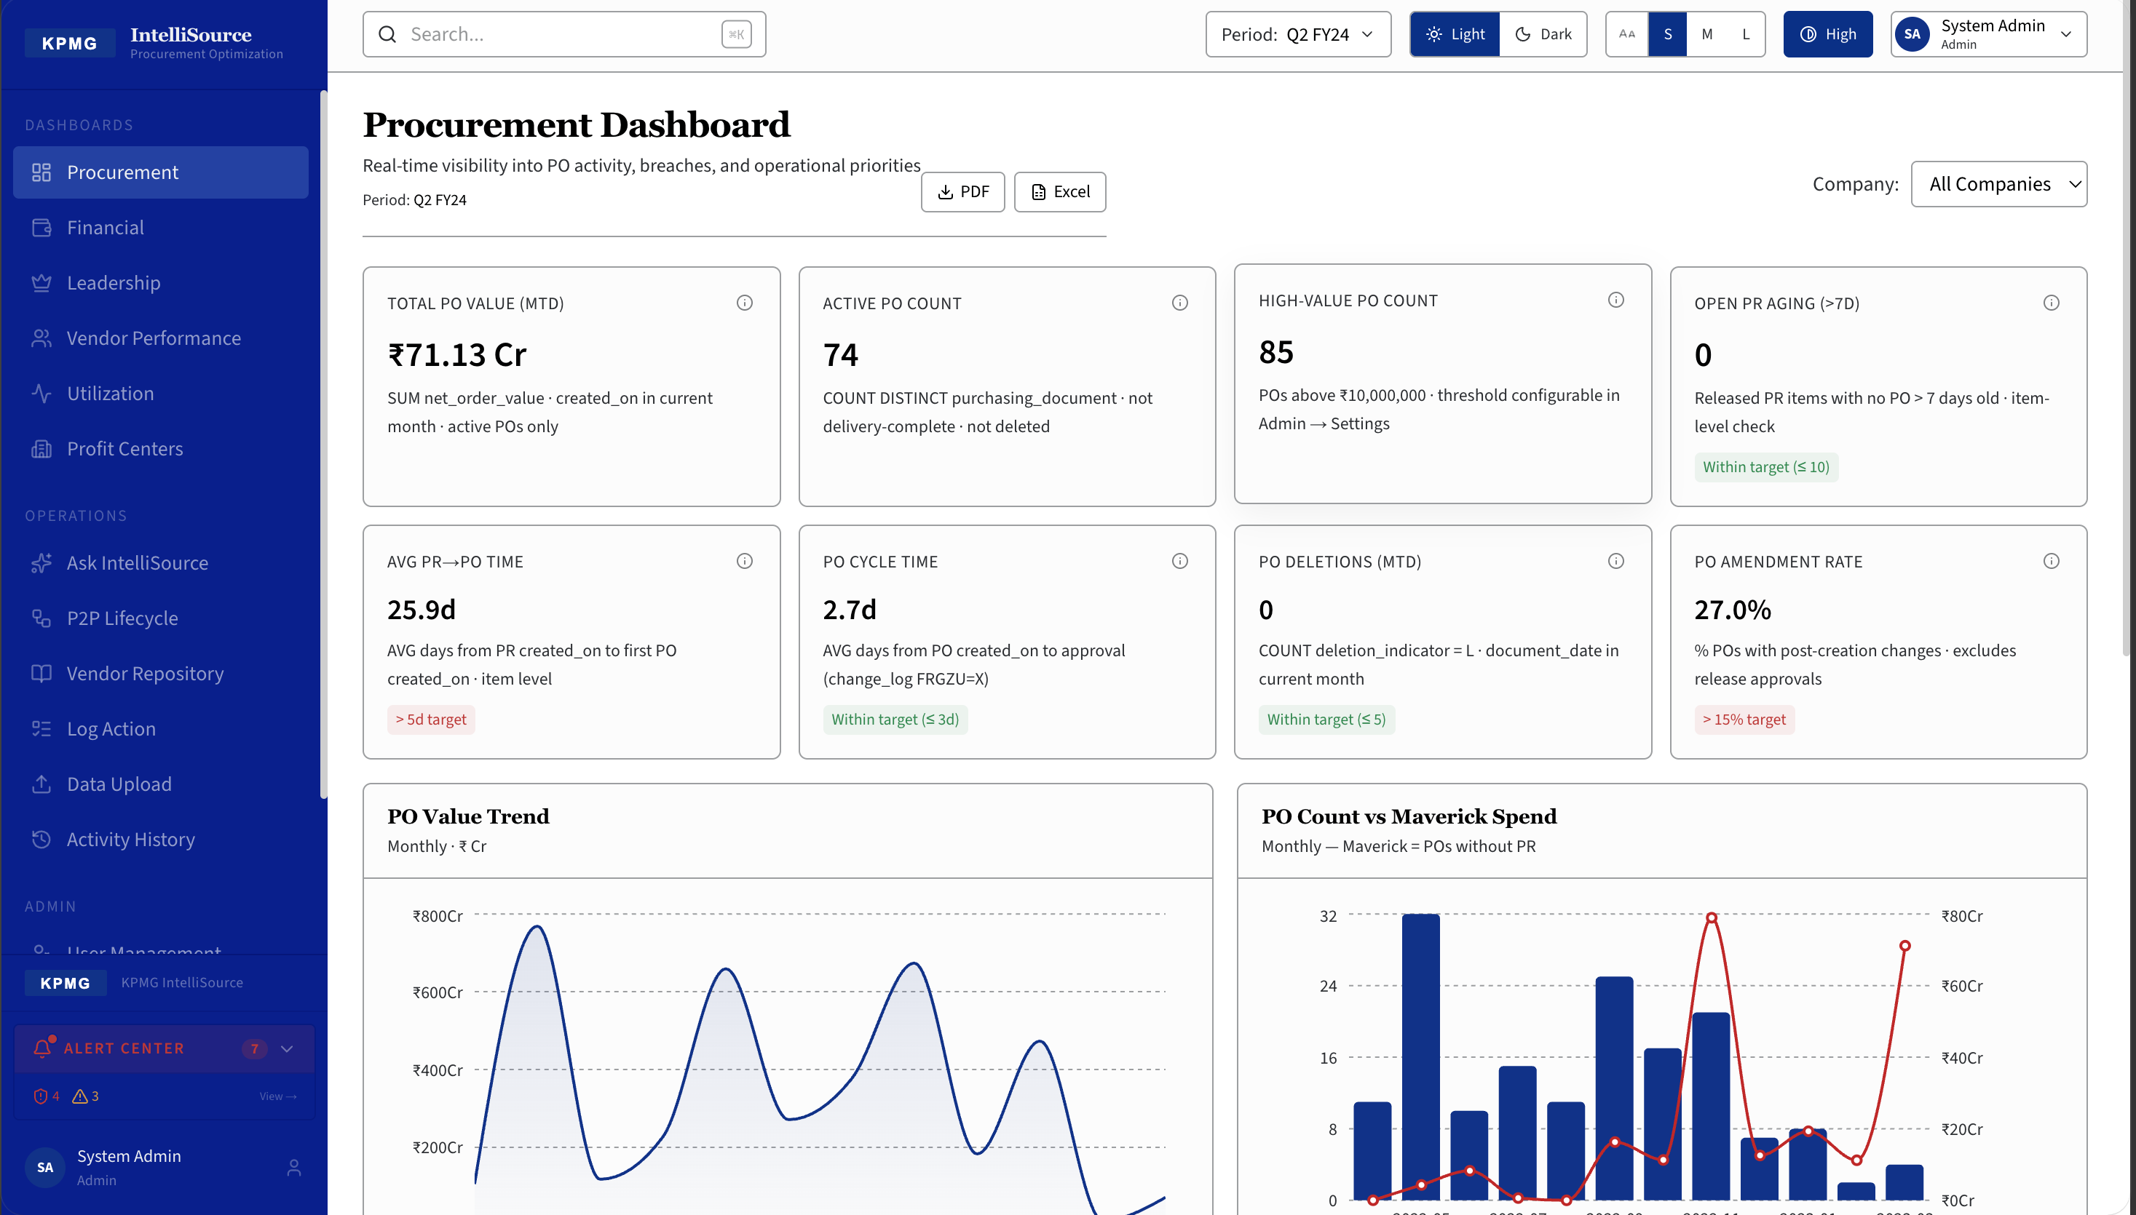
Real-time visibility into P2P activity, breaches, and operational priorities. Key KPIs: Total PO Value (Rs.71.13 Cr), Active POs (74), High-Value PO Count (85), PO Cycle Time (2.7d), PO Amendment Rate (27.0%). Charts: PO Value Trend and PO Count vs Maverick Spend.

02 Financial Dashboard
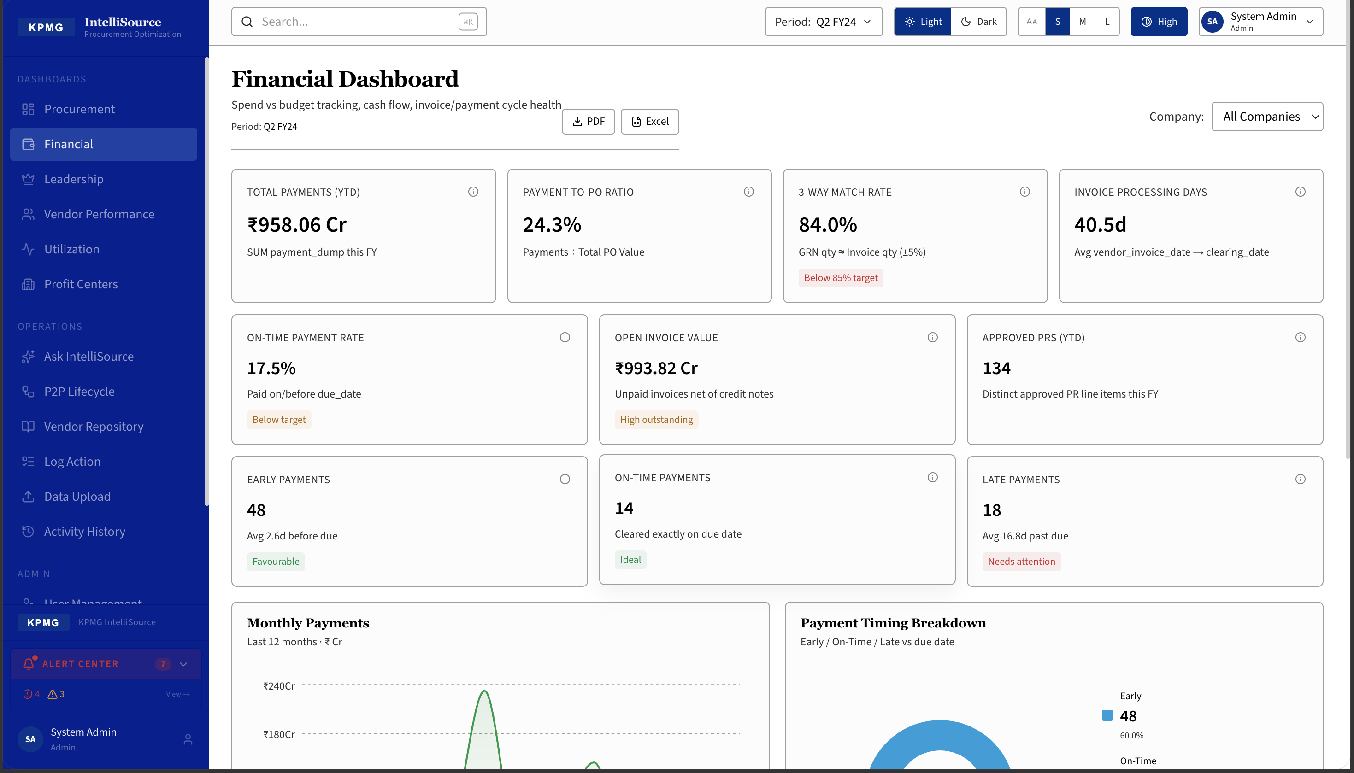
Spend vs budget tracking, cash flow, and invoice/payment cycle health. Total Payments YTD: Rs.958.06 Cr | Payment-to-PO Ratio: 24.3% | 3-Way Match Rate: 84.0% | Invoice Processing Days: 40.5d | On-Time Payment Rate: 17.5% | Open Invoice Value: Rs.993.82 Cr.

03 Financial Dashboard — Payment Analytics
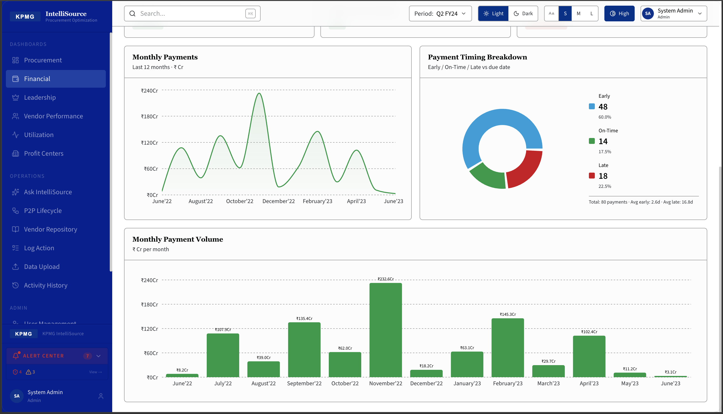
Detailed payment timing analytics. Monthly Payments trend (last 12 months), Payment Timing Breakdown donut (Early 60% | On-Time 17.5% | Late 22.5%), and Monthly Payment Volume bar chart showing month-by-month cash outflow patterns.

04 Leadership Dashboard — Executive Overview
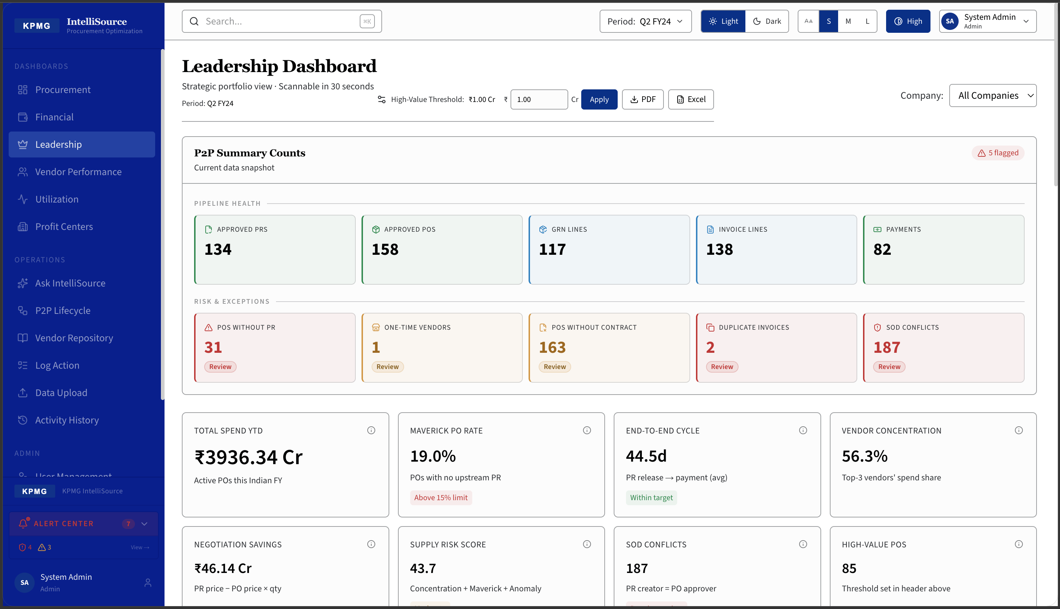
Strategic portfolio view. P2P Summary: Approved PRs (134), Active POs (158), GRN Lines (117), Invoice Lines (138), Payments (82). Risk & Exceptions: POs without PR (31), Duplicate Invoices (2), SOD Conflicts (187). Total Spend YTD: Rs.3,936.34 Cr | Maverick PO Rate: 19.0% | Cycle: 44.5 days.

05 Leadership Dashboard — Spend & Risk Analytics
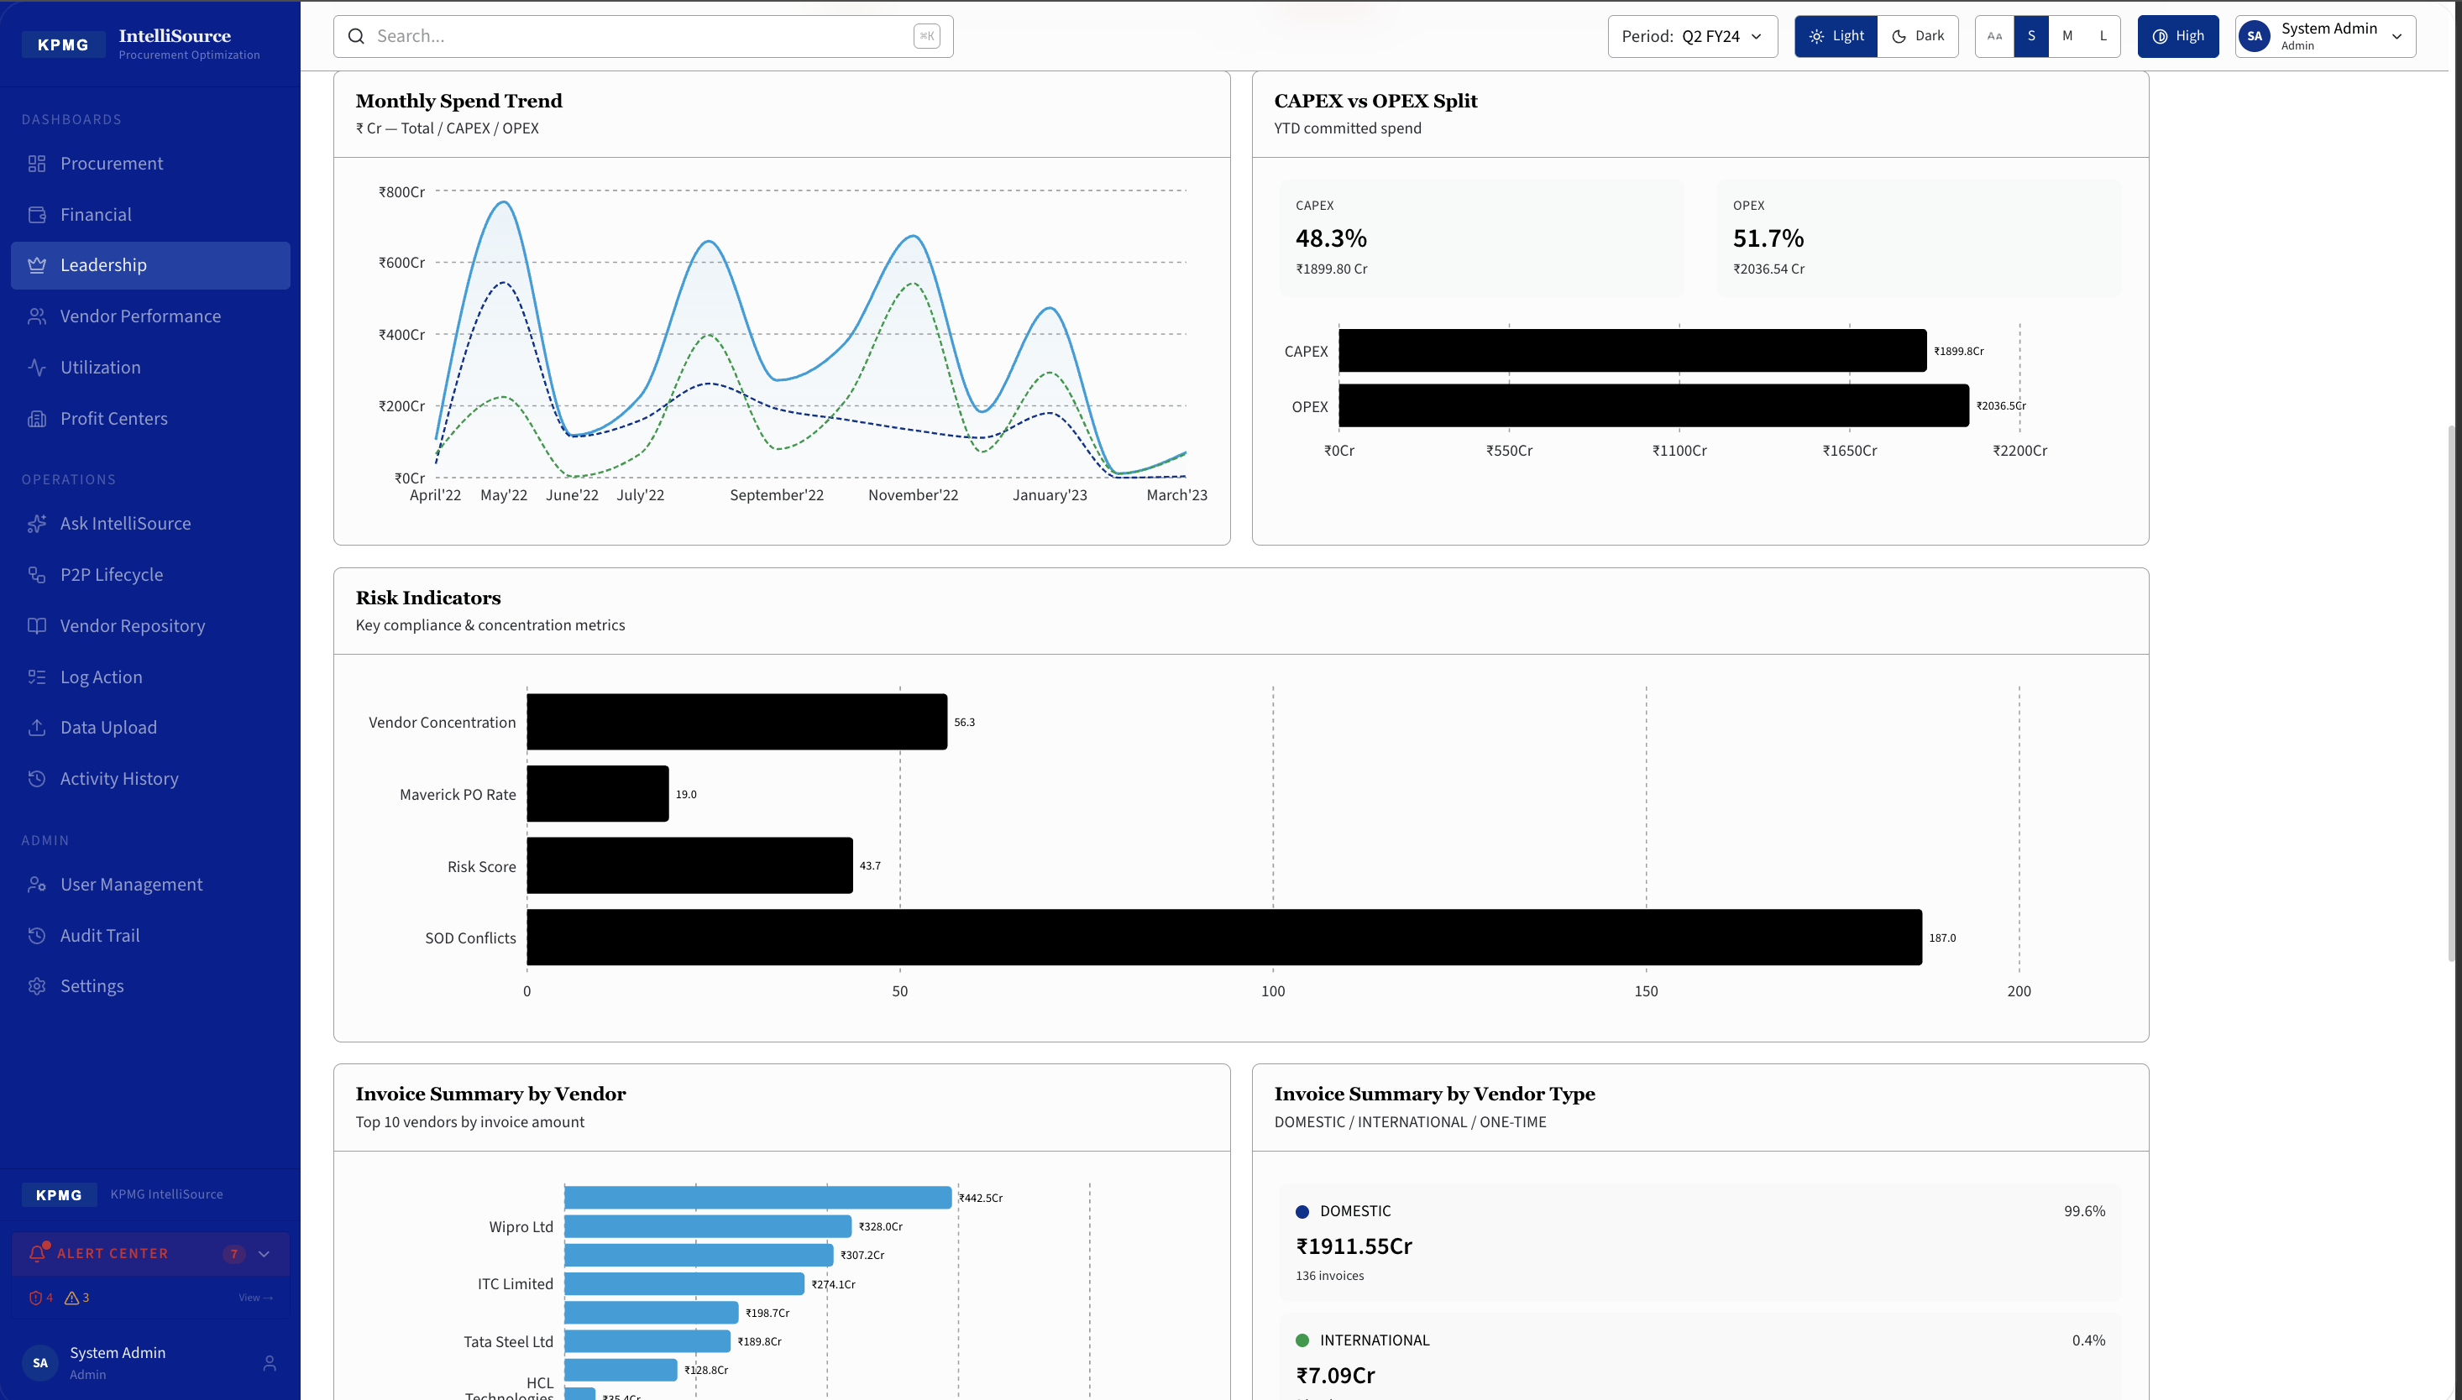
Monthly Spend Trend (CAPEX vs OPEX), CAPEX vs OPEX Split (48.3% vs 51.7%), Risk Indicators bar chart (Vendor Concentration, Maverick PO Rate, Risk Score, SOD Conflicts). Invoice Summary by Vendor and Vendor Type breakdown.

06 Vendor Performance Dashboard
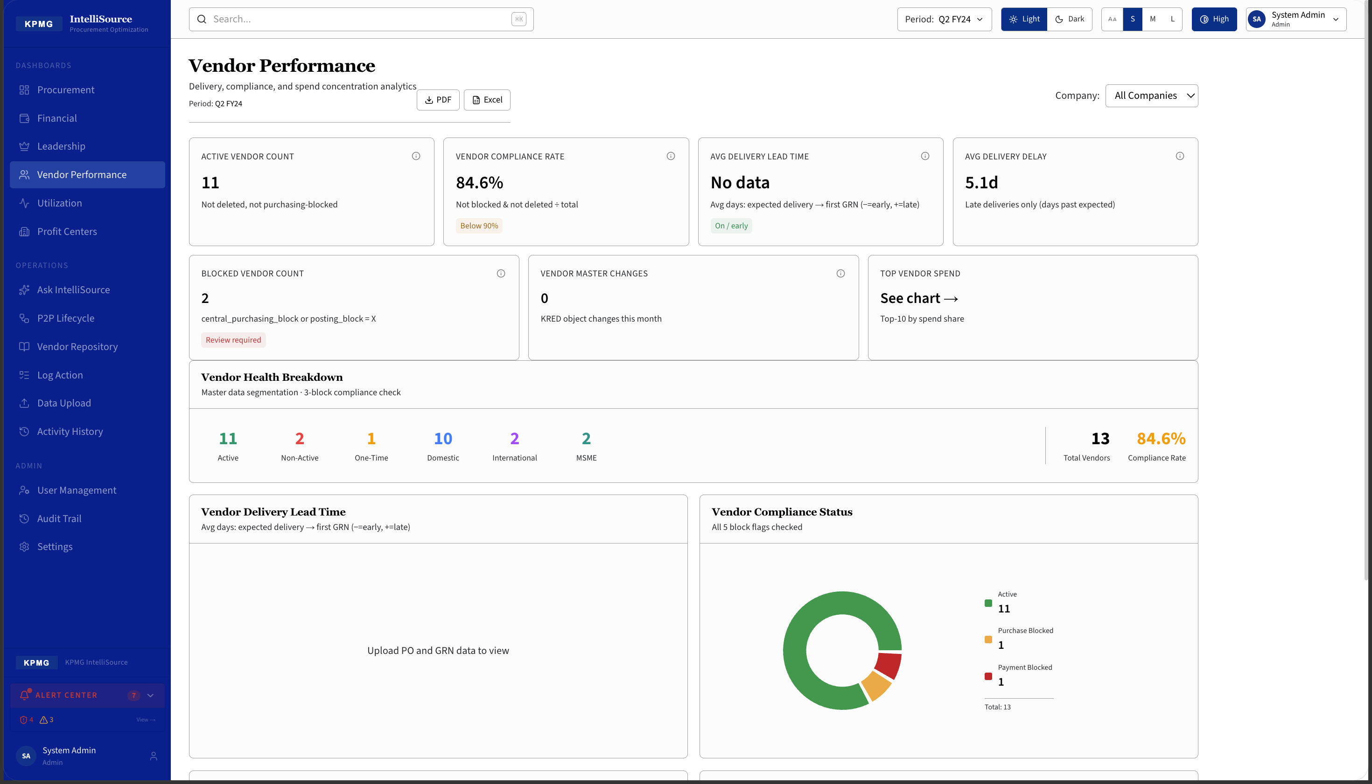
Delivery, compliance, and spend concentration analytics. Active Vendor Count: 11 | Vendor Compliance Rate: 84.6% | Blocked Vendor Count: 2. Vendor Health Breakdown: 11 Active | 2 Non-Active | 1 One-Time | 10 Domestic | 2 International | 2 MSME.

07 Vendor Performance — Top Vendors & Type Breakdown
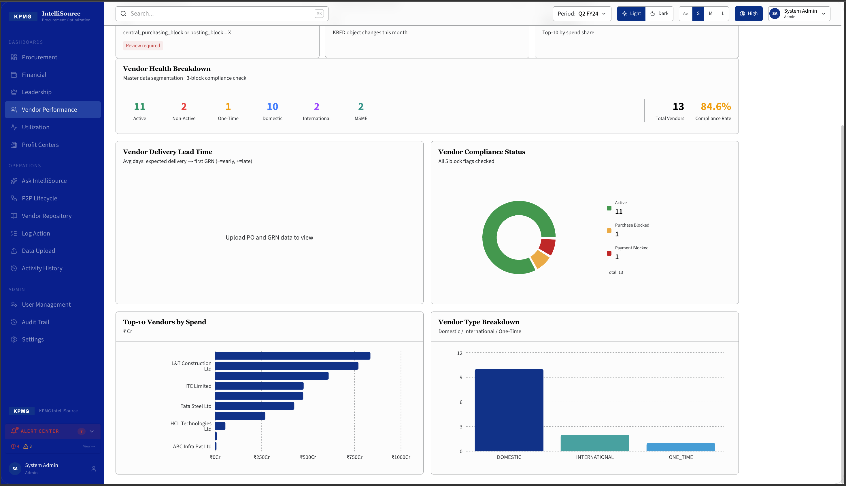
Top-10 Vendors by Spend (Rs. Cr): L&T Construction, ITC Limited, Tata Steel, HCL Technologies, ABC Infra. Vendor Type Breakdown: Domestic vs International vs One-Time. Vendor Delivery Lead Time and Compliance Status charts.

08 CAPEX / OPEX Dashboard
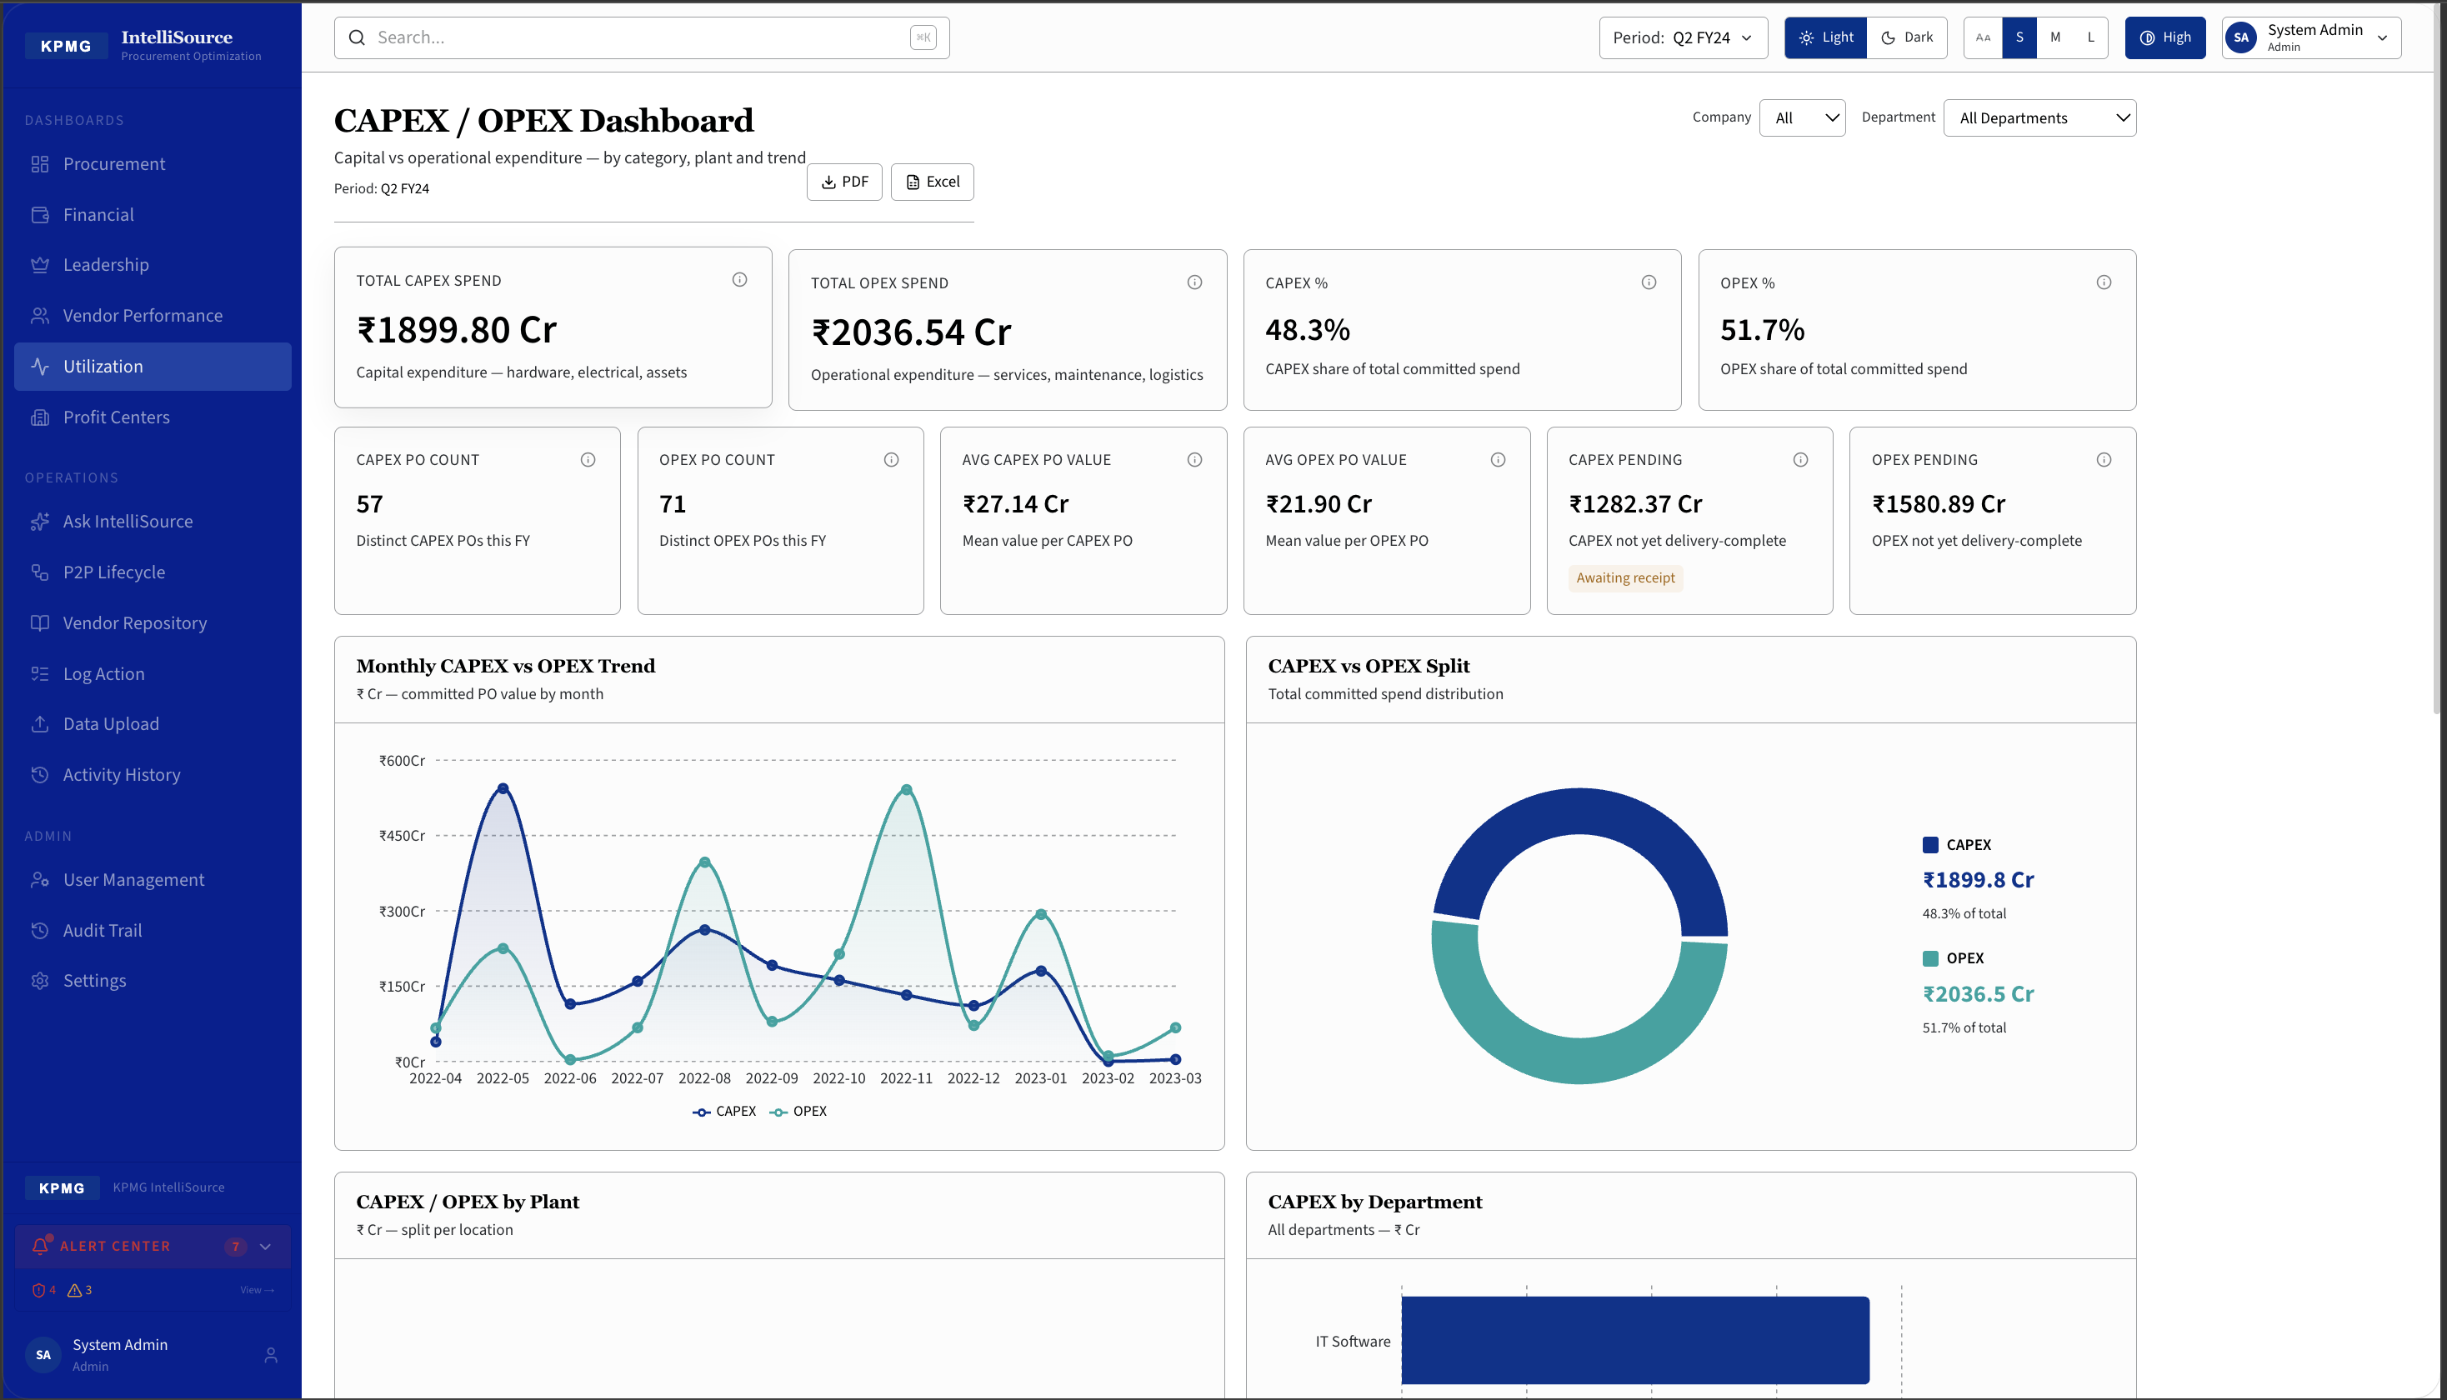
Capital vs operational expenditure by category, plant and trend. Total CAPEX Spend: Rs.1,899.80 Cr (57 POs) | Total OPEX Spend: Rs.2,036.54 Cr (71 POs). CAPEX %: 48.3% | OPEX %: 51.7%. Monthly CAPEX vs OPEX Trend line chart and Split donut chart.

09 Utilization Dashboard — Materials & GRN Analytics
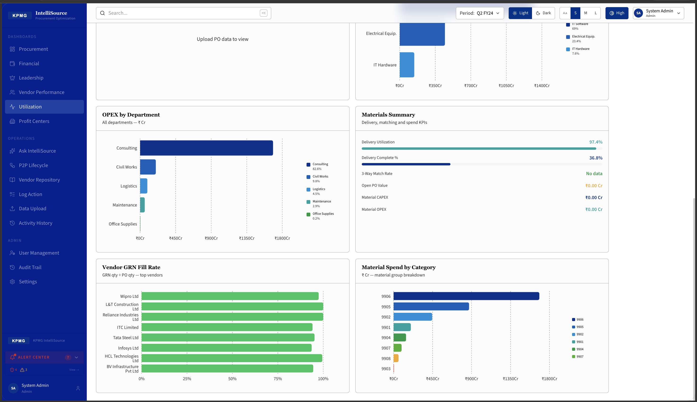
Delivery utilisation and materials spend. OPEX by Department (Consulting, Civil Works, Logistics, Maintenance). Materials Summary: Delivery Utilisation 97.4%, Delivery Complete % 30.8%. Vendor GRN Fill Rate (top vendors). Material Spend by Category horizontal bar chart.

10 Profit Center Management
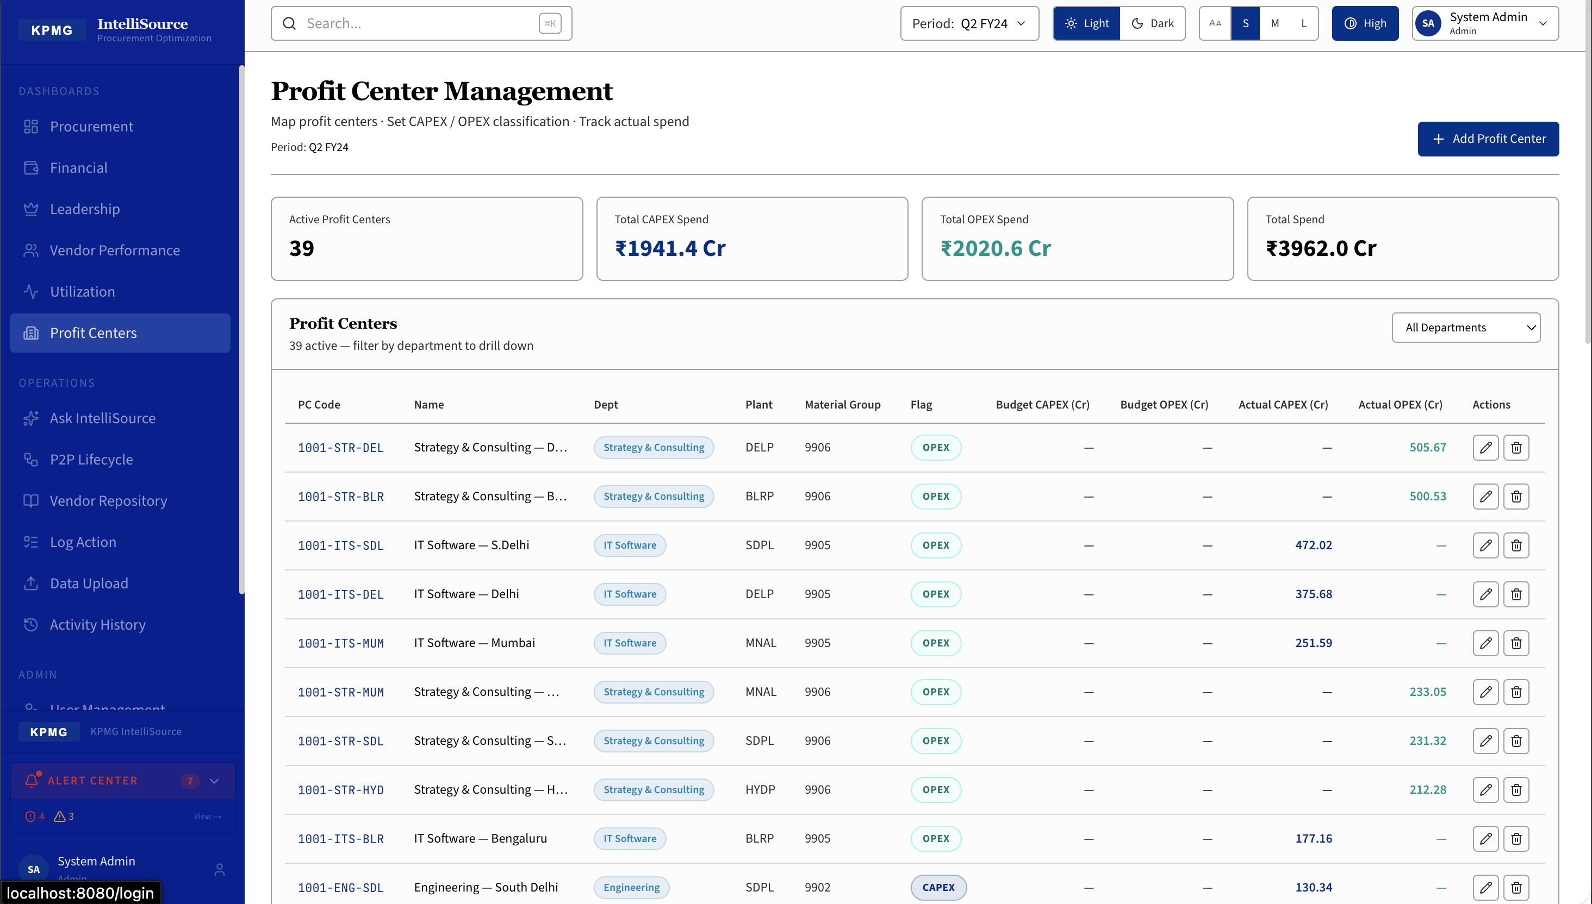
Map profit centers, set CAPEX/OPEX classification, and track actual spend. 39 active profit centers. Total CAPEX: Rs.1,941.4 Cr | OPEX: Rs.2,026.6 Cr | Total: Rs.3,962.0 Cr. Table: PC Code, Name, Department, Plant, Material Group, Budget vs Actual, Edit & Delete actions.

11 P2P Lifecycle Tracker
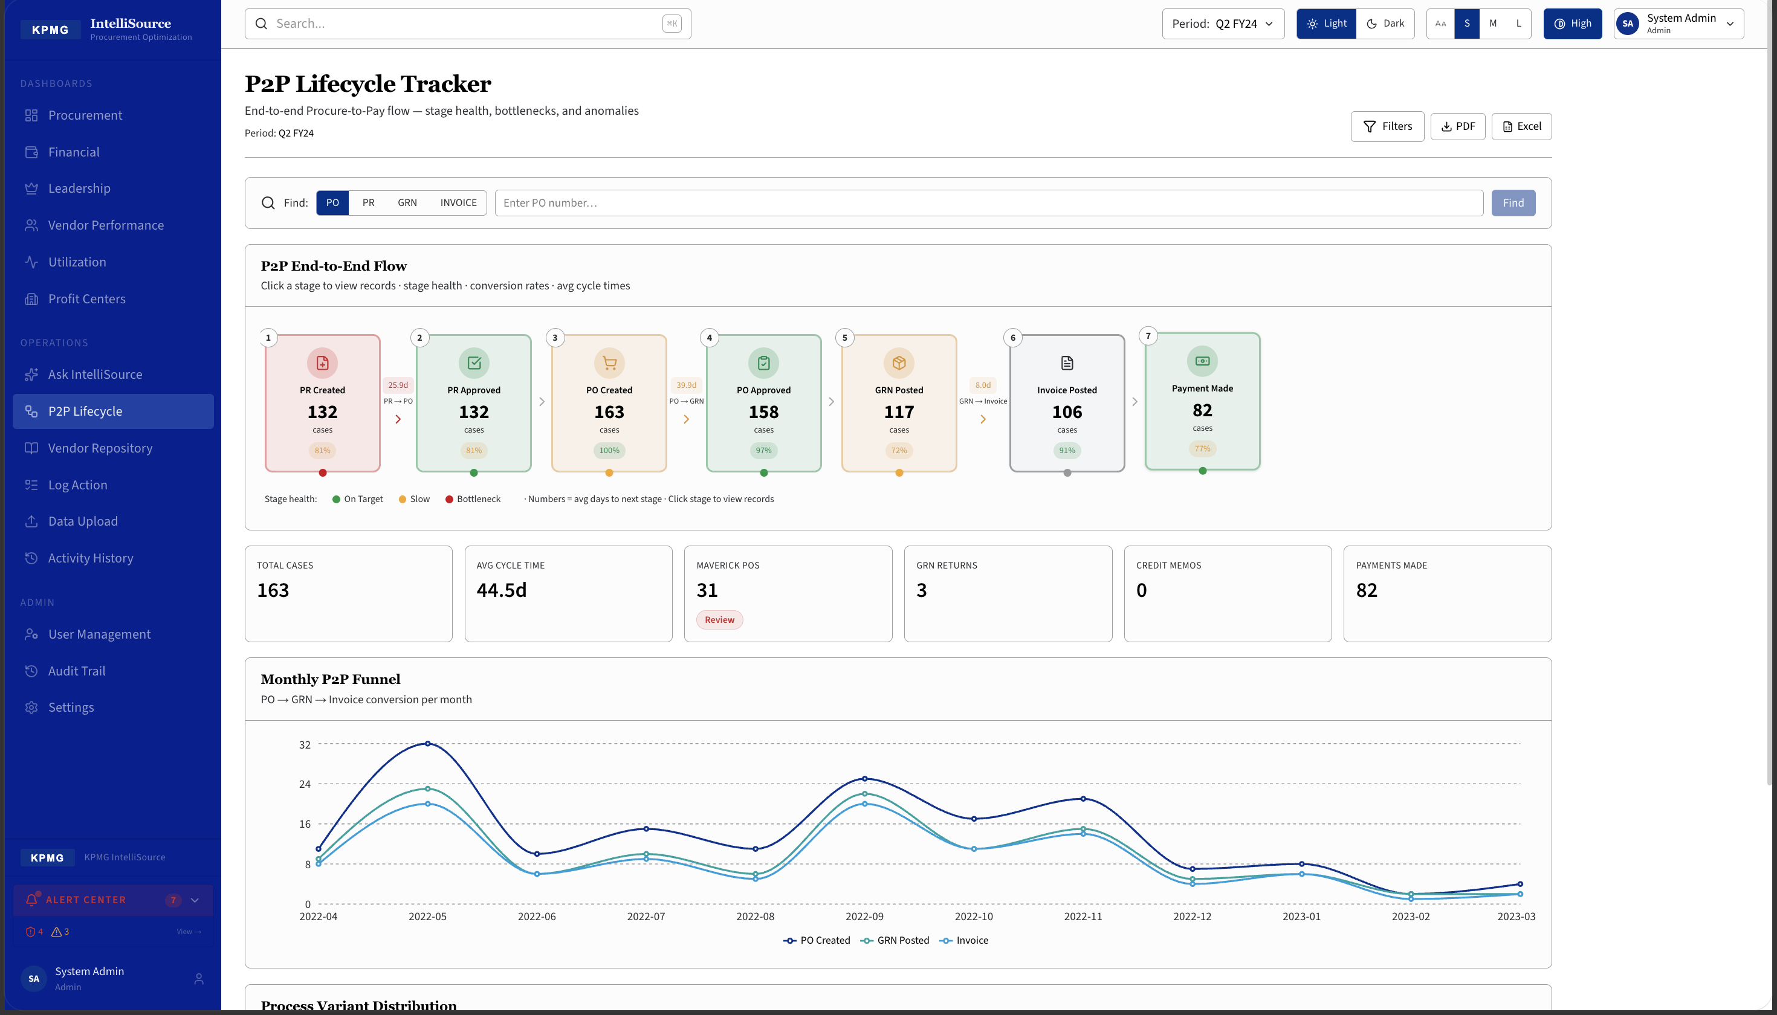
End-to-end Procure-to-Pay flow with stage health, bottlenecks, and anomalies. Pipeline: PR Created (132) > PR Approved (132) > PO Created (163) > PO Approved (158) > GRN Posted (117) > Invoice Posted (106) > Payment Made (82). Total Cases: 163 | Avg Cycle: 44.5 days | Maverick POs: 31. Monthly P2P Funnel chart.

12 Vendor Repository
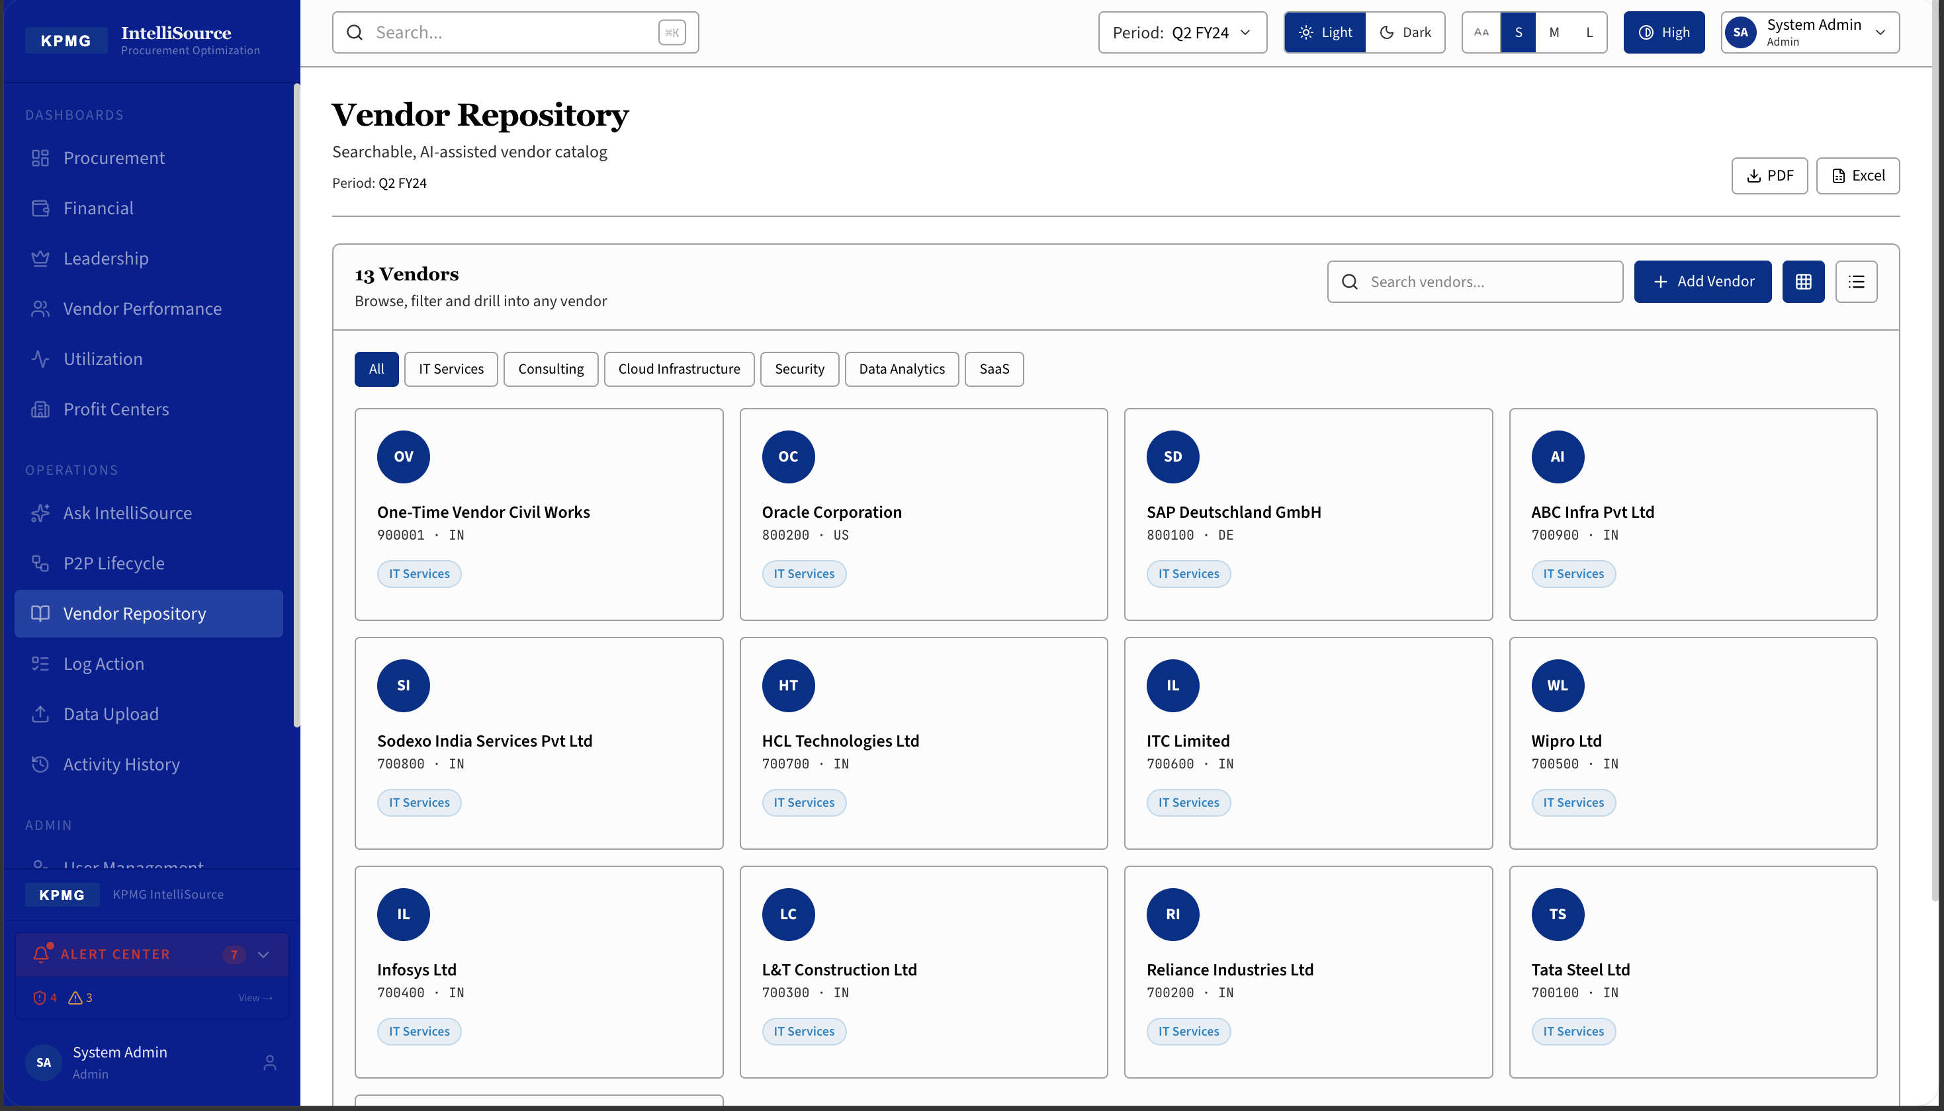
Searchable vendor catalog with 13 vendors in grid view. Category filters: All | IT Services | Consulting | Cloud Infrastructure | Security | Data Analytics | SaaS. 'Add Vendor' button registers new vendors with 10 fields: Vendor Code, Address, Name, Country, SPOC Contact, PAN, Added By, MSME Flag, Payment Terms, and Service Description.

13 Data Upload
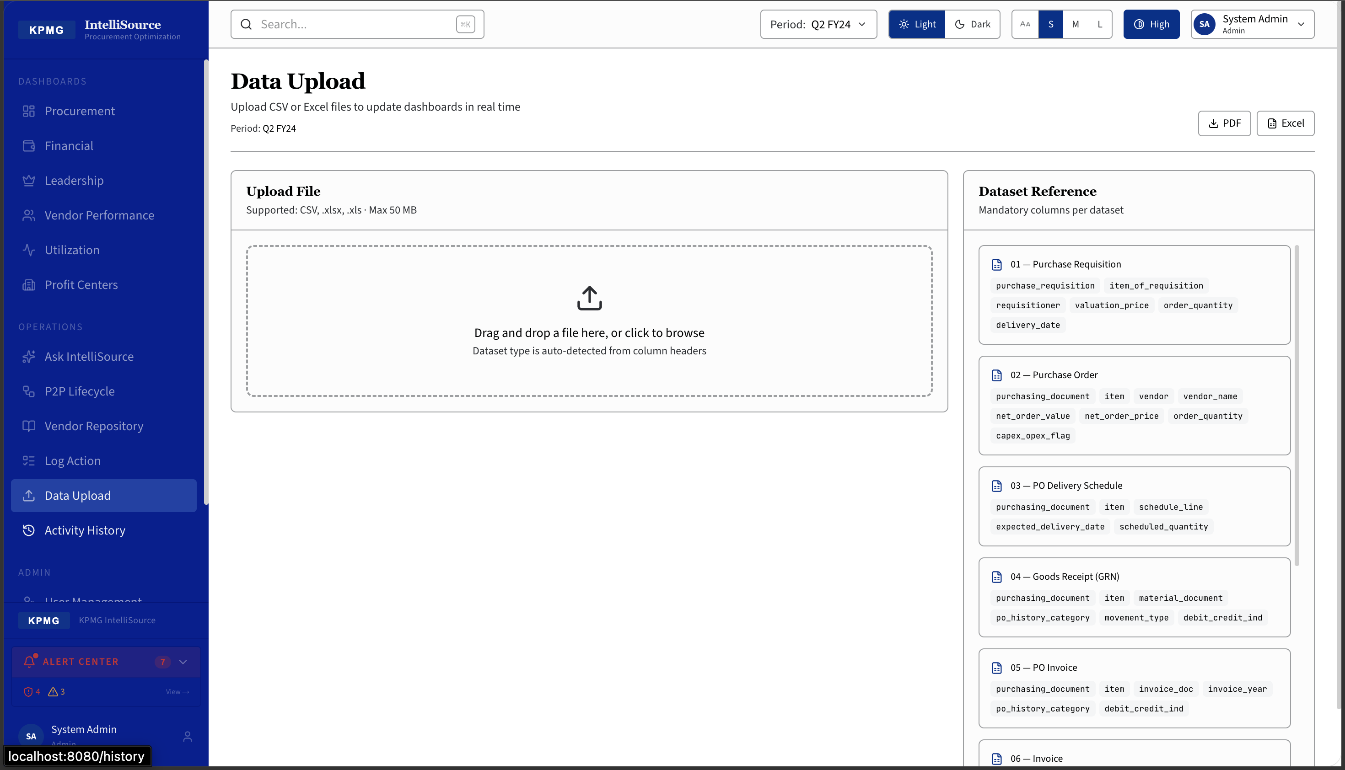
Upload CSV or Excel files to update all dashboards in real time. Drag-and-drop zone supports CSV, .xlsx, .xls up to 50 MB. Dataset auto-detected from column headers. Dataset Reference lists mandatory columns for all 10 datasets: PR, PO, PO Delivery, GRN, PO Invoice, Invoice, Payment, Vendor Master, Change Log, and Company/Plant Master.

14 Activity History
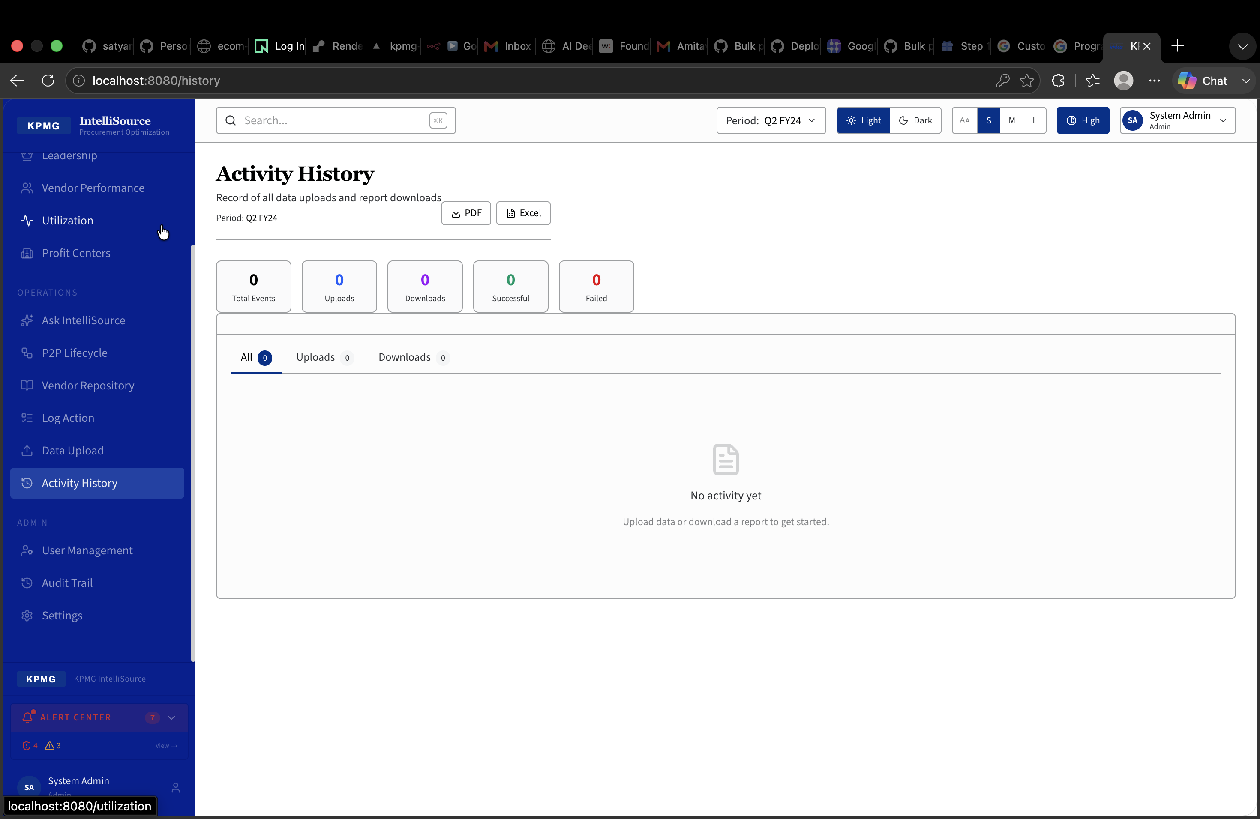
Complete record of all data uploads and report downloads. Counters: Total Events | Uploads | Downloads | Successful | Failed. Tabbed view: All | Uploads | Downloads. Full audit trail of data ingestion activity for compliance and traceability.

15 User Management (Admin)
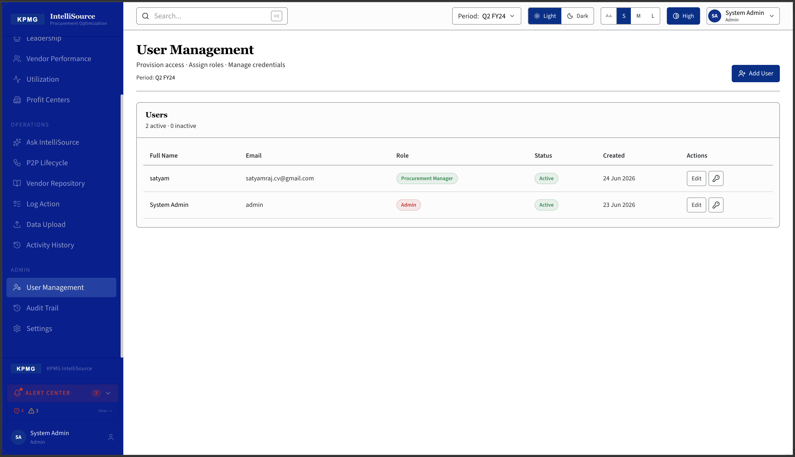
Provision access, assign roles, and manage credentials — Admin only. 2 active users shown. Columns: Full Name, Email, Role badge, Status, Created date, Actions. 12 supported roles. 'Add User' generates a secure temporary password displayed once.

