Professional Video Production Company in Noida: Why Red Hot Media House Pvt. Ltd. Is the Right Choice for Your Brand
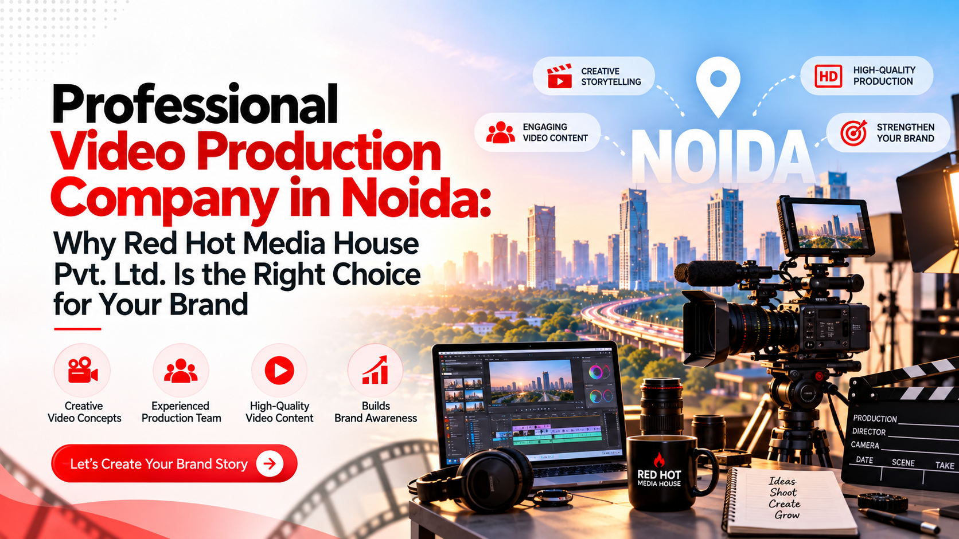
Or

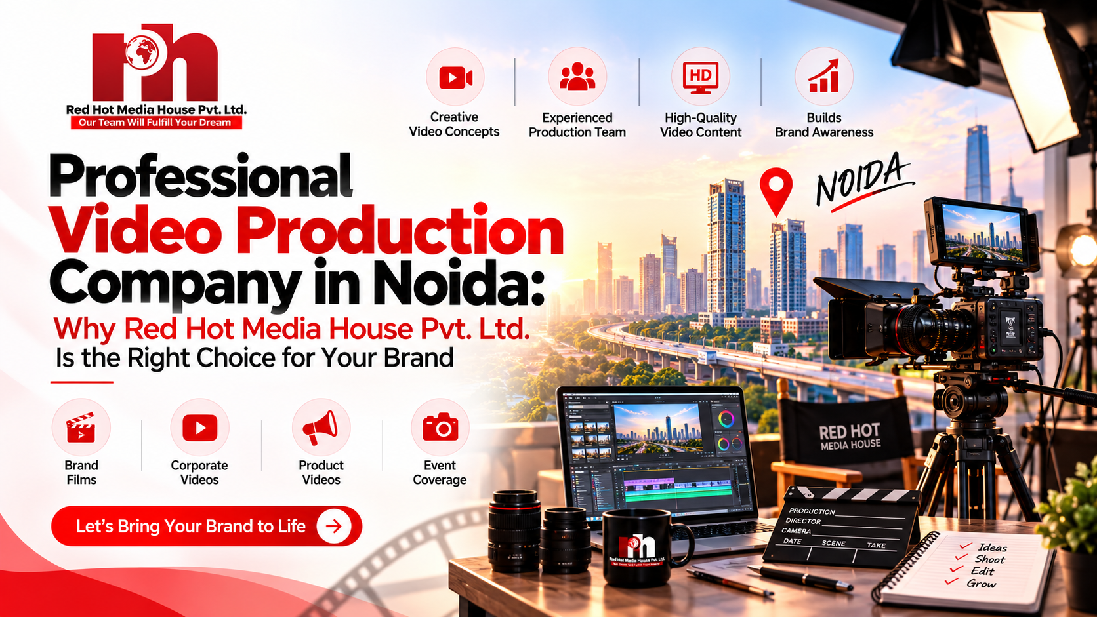
If you're searching for a professional video production company in Noida, chances are you already know that video is no longer optional for business growth — it's essential. From founder podcasts to corporate films, ad campaigns to Instagram reels, video content is how modern brands build trust, generate leads, and stand out in a crowded digital market.
At Red Hot Media House Pvt. Ltd., based in Noida Sector 63, we specialize in helping businesses, startups, healthcare brands, real estate developers, and creators produce cinematic, strategy-driven video content that doesn't just look good — it performs. In this blog, we'll break down what makes a truly professional video production company in Noida, and why brands across industries trust us for their video needs.
Show Image

Why Businesses in Noida Need a Professional Video Production Company
Noida has rapidly become one of North India's biggest business and startup hubs — home to real estate developers, IT companies, healthcare providers, D2C brands, and coaching institutes. With this growth comes intense digital competition, and video content has emerged as the single most effective way to cut through the noise.
A video production agency in Noida Sector 63 like Red Hot Media House Pvt. Ltd. helps businesses:
- Build brand credibility through high-quality visuals
- Increase engagement across Instagram, YouTube, and LinkedIn
- Improve conversion rates with performance-focused ad films
- Establish founder authority through podcast content
- Generate qualified leads through property and healthcare videos
Simply put, a best video production house in Noida doesn't just film — it creates content designed around your business goals.

What Makes Red Hot Media House Pvt. Ltd. a Professional Video Production Company in Noida

1. Corporate Video Production
We produce company profile films, founder interviews, office and team shoots, and brand credibility videos that position your business as trustworthy and established. Our corporate video production Noida services are built for companies that want polished, professional content without the guesswork.

2. Podcast Production Studio in Noida
Our in-house podcast production studio in Noida Sector 63 offers full-service podcast creation — multi-camera recording, professional lighting and audio, editing, and YouTube-ready cuts along with reels. If you're building founder authority or launching a business podcast, this is where it happens.

3. Commercial & Ad Film Production
As an experienced ad film production company, we create performance-focused creatives designed specifically for Meta Ads, Google Ads, and YouTube campaigns — content built to convert, not just impress.

4. Social Media Reels Production
Short-form video drives reach today. Our team produces scroll-stopping Instagram Reels, YouTube Shorts, and Facebook video content optimized for retention and platform algorithms.

5. Real Estate Video Production
Property walkthroughs, drone and aerial visuals, and builder branding films — our real estate video production in Noida services are designed to generate qualified buyer and investor interest faster.

6. Healthcare Video Production
From doctor branding films to hospital promotional videos, our healthcare video production company services help medical brands build patient trust and improve engagement.

Why Choose Red Hot Media House Pvt. Ltd.
Strategic Production Approach — We don't just shoot videos; we combine production, branding, content strategy, and performance marketing so every video contributes to measurable business growth.
Modern Studio Infrastructure — Our Noida Sector 63 studio is equipped with professional cameras, cinematic lighting, podcast infrastructure, and multi-camera editing systems.
Marketing-First Thinking — Unlike traditional production houses, we understand audience psychology, platform algorithms, and conversion optimization — so your videos don't just look great, they actually perform.
If you'd like to see how this approach works in practice, take a look at our video production services page for a full breakdown of what we offer, or check our client case studies for real results.

Industries We Serve
Our video production expertise spans multiple sectors, including:
- Real Estate Marketing — cinematic property tours and builder branding
- Healthcare Marketing — patient trust and hospital promotion videos
- FMCG Marketing — brand campaign creatives
- Education Marketing — enrollment-focused authority content

Frequently Asked Questions
Why choose Red Hot Media House as a video production company in Noida?
We combine cinematic production quality with branding, social media strategy, and performance marketing expertise — so your videos improve engagement and drive real business growth, not just views.
Do you offer podcast production services in Noida?
Yes. Our Noida Sector 63 studio provides complete podcast production, including shoot setup, editing, and content optimization for YouTube and social platforms.
What types of videos does Red Hot Media House produce?
Corporate videos, podcasts, reels, ad films, promotional content, healthcare videos, real estate shoots, and full social media content.
How much does professional video production cost in Noida?
Pricing varies based on shoot duration, production scale, editing complexity, and video type. We provide customized quotes based on your specific goals — get in touch for a free consultation.

SEO Meta Properties
Meta Title (58 characters):
Professional Video Production Company in Noida | RHMH
Meta Description (155 characters):
Looking for a professional video production company in Noida? Red Hot Media House creates cinematic ad films, corporate videos & podcasts. Book now!
URL Slug:
https://www.redhotmediahouse.com/blog/professional-video-production-company-in-noida

Image Purpose | File Name | Alt Tag
Hero/banner image | professional-video-production-company-in-noida-red-hot-media-house.jpg | Professional video production company in Noida — Red Hot Media House studio
Podcast studio shot | podcast-production-studio-noida-sector-63.jpg | Podcast production studio in Noida Sector 63 by Red Hot Media House
Corporate shoot | corporate-video-production-services-noida.jpg | Corporate video production services in Noida for businesses
Ad film shoot | commercial-ad-film-production-noida-agency.jpg | Commercial ad film production by video production agency in Noida
Real estate shoot | real-estate-video-production-noida-drone-shoot.jpg | Real estate video production in Noida with drone and aerial visuals
Healthcare shoot | healthcare-video-production-company-noida.jpg | Healthcare video production company in Noida for hospitals and doctors

