Google Ads Agency in Noida: How to Generate More Business Enquiries
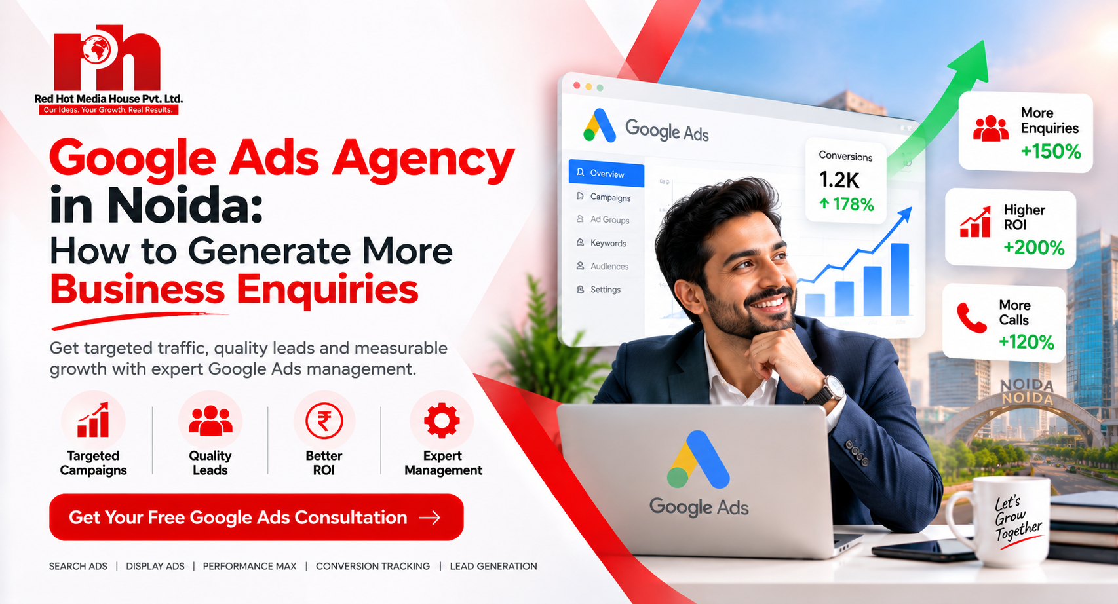

Option
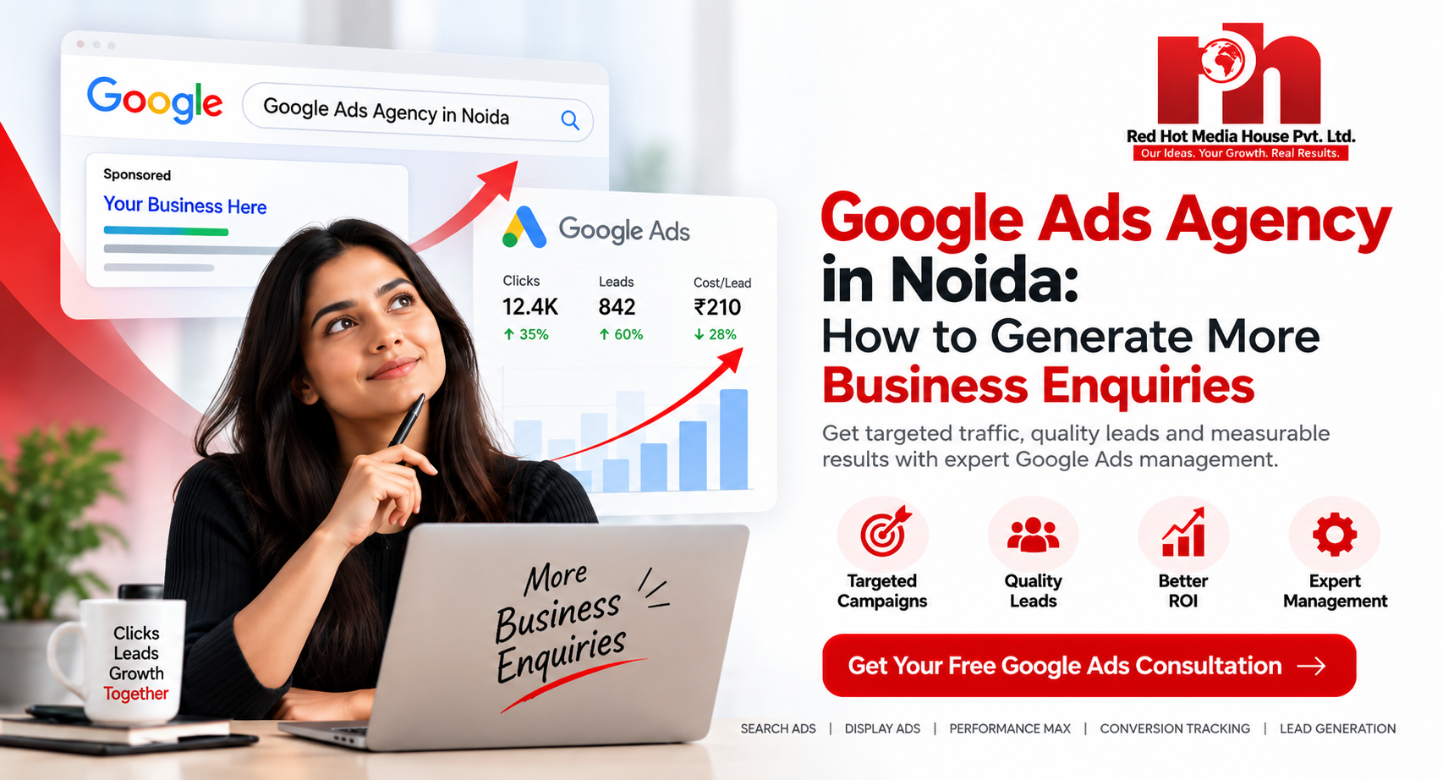
Are you investing in online advertising but struggling to generate consistent business enquiries? Google Ads can help businesses reach potential customers who are actively searching for relevant products or services. However, results depend on the right targeting, relevant advertisements, effective landing pages and accurate conversion tracking.
Working with a Google Ads agency in Noida can help businesses develop a structured advertising strategy focused on attracting relevant prospects and measuring meaningful results.

Why Businesses in Noida Need Google Ads
Businesses across Noida and Delhi NCR compete for customers across industries such as real estate, healthcare, education, IT, manufacturing and professional services. Google Ads can help businesses appear for relevant searches when potential customers are looking for solutions.
Unlike marketing activities focused primarily on awareness, search advertising can connect your business with users who already demonstrate an interest in a service.
However, receiving clicks does not automatically mean generating qualified leads. Campaigns need to be planned around business objectives, customer intent and the quality of enquiries.

How a Google Ads Agency in Noida Can Help

1. Target the Right Keywords
Keyword research helps identify the searches most relevant to your services. A well-planned campaign focuses on search intent rather than simply choosing keywords with high search volume.
For example, a business offering digital marketing services may target relevant searches for Google Ads management, lead generation or PPC services.
Reviewing search-term reports and using suitable negative keywords can help reduce irrelevant clicks and improve campaign relevance.

2. Create Relevant Google Ads Campaigns
Effective advertisements communicate the service, highlight relevant benefits and give users a clear next step.
Depending on your objectives, campaigns may focus on phone calls, enquiry forms, consultation requests or online purchases. The campaign structure and bidding strategy should align with your goals and available conversion data.

3. Optimise Landing Pages for Conversions
A relevant advertisement should lead to a page that matches the visitor's expectations. If someone clicks an advertisement for a specific service, they should not have to search through an unrelated homepage to find it.
A conversion-focused landing page should include clear service information, a strong headline, credible business details, an easy-to-find call to action and a simple enquiry form.
Mobile usability and page speed also matter because visitors may leave when a website is difficult to use.

4. Track Leads and Campaign Performance
A professional Google Ads management process should measure meaningful actions rather than clicks alone.
Conversion tracking can help businesses understand which campaigns generate enquiry submissions, calls, bookings or purchases. For lead generation, reviewing lead quality and sales outcomes provides additional context.
Tools such as Google Ads conversion tracking, Google Analytics 4 and Google Tag Manager can support measurement when configured correctly.

How to Choose the Right Google Ads Agency in Noida
Before hiring an agency, evaluate its approach to campaign planning, optimisation and reporting.
Ask whether the team will:
- Understand your business goals and target audience.
- Conduct relevant keyword and competitor research.
- Explain advertising budgets and management fees separately.
- Set up and test conversion tracking.
- Review search terms and campaign performance regularly.
- Report qualified enquiries alongside advertising metrics.
Avoid choosing an agency based only on promises of guaranteed leads or instant results. Advertising performance depends on competition, budget, customer demand, landing-page quality and sales follow-up.

Why Choose Red Hot Media House Pvt. Ltd.?
Red Hot Media House Pvt. Ltd. provides digital marketing services that can include Google Ads, lead generation, SEO, social media marketing and performance marketing.
Our approach focuses on understanding business objectives, selecting suitable marketing activities and measuring campaign performance. The appropriate strategy depends on your industry, target audience, budget and current online presence.
Explore our digital marketing services in Noida to learn more about our services and discuss your business requirements.

Frequently Asked Questions

1. What does a Google Ads agency in Noida do?
A Google Ads agency plans, manages and optimises advertising campaigns. Services may include keyword research, ad creation, landing-page recommendations, conversion tracking and performance reporting.

2. How much does Google Ads management cost in Noida?
Costs depend on campaign complexity, advertising budget, competition and the scope of agency services. Ask for a clear breakdown of advertising spend and management fees before starting.

3. How quickly can Google Ads generate enquiries?
Campaigns may begin receiving traffic once eligible to serve, but enquiry volume and quality depend on targeting, budget, competition and landing-page performance. No specific result or timeline can be guaranteed.

4. How can I improve lead quality from Google Ads?
Refine keyword targeting, exclude irrelevant search terms, improve advertisement relevance, optimise landing pages and track qualified leads rather than counting every enquiry equally.

Conclusion
Google Ads can help businesses reach relevant customers, but sustainable performance requires more than running advertisements. A clear strategy, appropriate targeting, effective landing pages and reliable conversion tracking can help businesses make better-informed advertising decisions.
If you are looking for a Google Ads agency in Noida, focus on transparent reporting, measurable objectives and a strategy aligned with your business goals. Contact Red Hot Media House Pvt. Ltd. to explore your digital marketing requirements.

SEO Title
Google Ads Agency in Noida | Generate More Leads

Meta description
Looking for a Google Ads agency in Noida? Learn how targeted campaigns, conversion tracking and landing-page optimisation can generate business enquiries.

Suggested URL slug
/blog/google-ads-agency-in-noida

Featured image SEO
Filename: google-ads-agency-noida-lead-generation.webp
Alt text: Google Ads agency in Noida helping businesses generate enquiries
………………………………………………………………………………………………………

BlogPosting schema
Add this JSON-LD to the blog page. Replace the placeholder URL and dates with the actual published details.

{
"@context": "https://schema.org",
"@type": "BlogPosting",
"headline": "Google Ads Agency in Noida: How to Generate More Business Enquiries",
"description": "Looking for a Google Ads agency in Noida? Learn how targeted campaigns, conversion tracking and landing-page optimisation can generate business enquiries.",
"image": "https://www.redhotmediahouse.com/REPLACE-WITH-ACTUAL-IMAGE.webp",
"datePublished": "REPLACE-WITH-PUBLISH-DATE",
"dateModified": "REPLACE-WITH-MODIFIED-DATE",
"author": {
"@type": "Organization",
"name": "Red Hot Media House Pvt. Ltd.",
"url": "https://www.redhotmediahouse.com/"
},
"publisher": {
"@type": "Organization",
"name": "Red Hot Media House Pvt. Ltd.",
"url": "https://www.redhotmediahouse.com/"
},
"mainEntityOfPage": {
"@type": "WebPage",
"@id": "REPLACE-WITH-FINAL-CANONICAL-URL"
},
"inLanguage": "en-IN"
}

