Digital Marketing Services in Noida: Which Ones Does Your Business Actually Need?
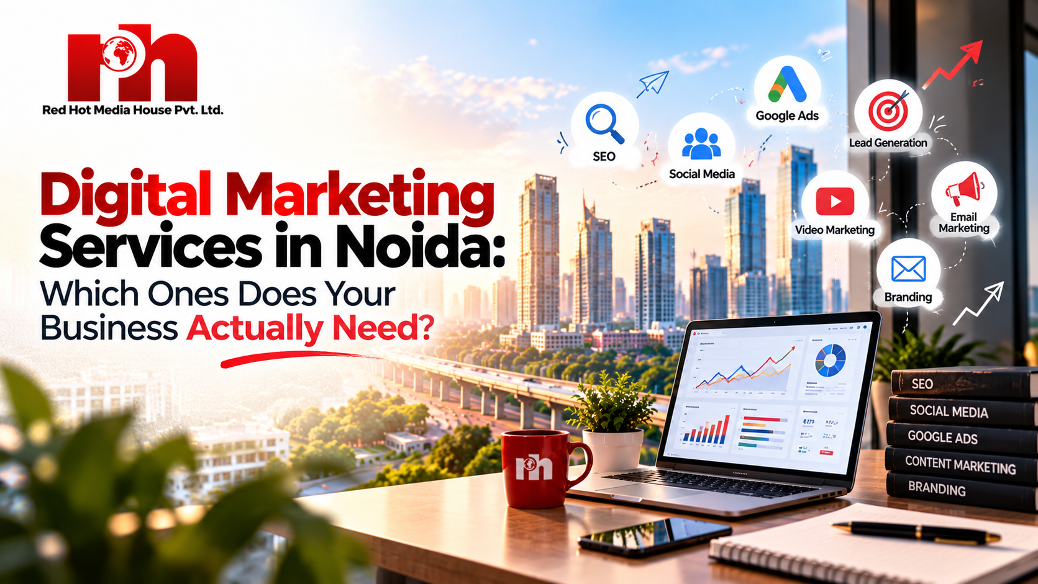
Or option
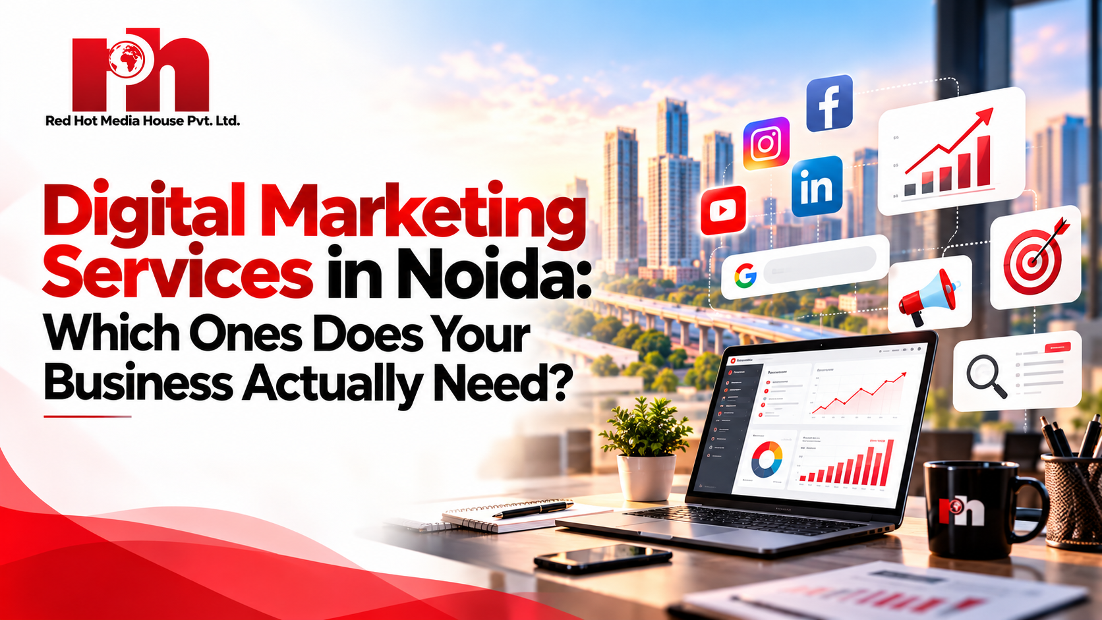
By Red Hot Media House Team | October 2026 | Category: Digital Marketing
[Insert featured image: digital-marketing-services-in-noida.webp]
Businesses in Noida can choose from SEO, Google Ads, social media, content, video, web development and much more. But using every channel at once rarely works. The smarter approach is to pick the digital marketing services in Noida that match your business model, your customers and your growth goals.
This guide explains what each service does, who it suits, and how to combine them into a practical plan. At Red Hot Media House Pvt. Ltd., we call this a revenue-first approach: every channel must connect to leads, sales or authority, not just clicks and likes.

Why Noida Businesses Need the Right Digital Marketing Mix
Noida is home to IT companies, real estate developers, hospitals and clinics, schools and coaching institutes, manufacturers, startups, e-commerce brands and professional service firms. Each one reaches customers differently.
• A local clinic depends on Google Maps, reviews and appointment calls.
• A B2B software company needs SEO, content and LinkedIn to reach decision-makers.
• An e-commerce brand leans on paid ads, product visibility and conversion optimisation.
• A real estate developer needs high-quality lead generation and strong project visibility.
That is why a fixed package for everyone does not work. Digital marketing should start with the business, not with a list of services.

1. SEO Services for Long-Term Search Visibility
SEO services help your website show up in organic results when customers search for what you offer. Done well, SEO builds steady, compounding traffic that does not stop the day you pause a campaign.

What a practical SEO campaign includes
• Keyword research and search intent analysis
• Technical SEO: speed, crawlability, indexing and mobile usability
• On-page optimisation: titles, meta descriptions, headings, URLs, image alt text
• Content optimisation and internal linking
• Search Console monitoring and reporting
• Relevant, quality authority-building activity
SEO works best when people already search for your product or service. One honest note: no agency can promise a fixed ranking position. Results depend on competition, content quality, website health and how Google's systems evaluate your pages. Google's own Search Central documentation is a good place to understand the basics.

2. Local SEO and Google Business Profile
If you serve customers in a specific area, local SEO deserves its own focus. Searches like "service near me" or "company in Noida" are influenced by relevance, distance and prominence.
• Complete and accurate Google Business Profile with the real business name, address, phone and hours
• Consistent business details across directories
• Location-focused service pages
• Genuine review collection and professional replies
• Photos, services and regular profile updates
Never stuff keywords into your business name or buy fake reviews. Both go against Google's guidelines and damage trust.

3. Google Ads and PPC Advertising
SEO takes time. PPC advertising lets you appear in front of people who are searching right now. It is useful for capturing existing demand quickly, especially for high-value services.
A strong Google Ads setup includes keyword and location targeting, negative keywords, conversion tracking, landing page testing and regular search-term analysis. Do not judge it by clicks alone. Track:
• Leads and qualified leads
• Phone calls and form submissions
• Cost per lead and customer acquisition cost
• Sales and revenue

4. Performance Marketing
Performance marketing goes beyond running ads. It connects Google Ads, Meta Ads, landing pages, funnels and tracking into one system focused on measurable outcomes such as qualified leads, conversion rate and return on ad spend (ROAS).
For example, Red Hot Media House has reported a real estate campaign that generated 1,200+ qualified leads with a 42% lower cost per lead, and an FMCG campaign that reached 6.5X ROAS. You can see more in our case studies. Results always vary by industry, budget and market, but these show what a measured, funnel-based approach can aim for.

5. Social Media Marketing
Social media marketing builds awareness, distributes content, supports retargeting and keeps you visible with customers. But not every platform fits every business.
• LinkedIn: best for B2B, founders and professional services
• Instagram: strong for visual consumer brands, retail and lifestyle
• Facebook: useful for local audiences, community and paid lead generation
• YouTube: ideal when you can explain or demonstrate your service on video
Choose platforms based on where your audience spends time, not on trends.

6. Content Marketing and Founder Authority
Content answers the questions customers ask before they buy: What does it cost? Which service do I need? How long does it take? Blogs, guides, case studies, FAQs and videos all help you earn trust early in the decision process.
Authority-led content goes a step further. Founder podcasts, personal branding and short-form clips position the leaders of a business as the go-to voice in their category. Trust built through real conversations often converts better than a standard advertisement. Make sure every piece has a purpose, and avoid publishing many near-identical pages just to chase keyword variations.

7. Website Development and Landing Pages
Every channel above sends visitors to your website, so it must do its job. Good web development for marketing means a fast, mobile-friendly, secure site with clear navigation and an obvious next step.
Dedicated landing pages work even harder. A page built for one service, one location or one ad campaign should quickly explain what you offer, who it is for, why to choose you and what to do next. The path becomes simple: Search, Ad, Landing Page, Enquiry.

8. Conversion Rate Optimisation (CRO)
If your site gets relevant traffic but few enquiries, more traffic is not the answer. CRO improves the share of visitors who call, fill a form, book an appointment or buy. It looks at headlines, calls to action, forms, trust signals, page structure and mobile experience.

9. Video Production
Video production helps you explain services, show your work and build credibility. One good video can be turned into short clips, social posts, a blog section and a website resource, so your production effort goes further.

10. Analytics, Funnels and Marketing Automation
Marketing becomes smarter when you can see what happens after the click. Track visitors, leads, qualified leads, customers and revenue. Then read the funnel:
• Low traffic? Work on visibility through SEO, ads or content.
• Traffic but few leads? Fix the website, offer or landing page.
• Leads but few sales? Review lead quality and your sales follow-up.
Automation such as lead capture, WhatsApp and email follow-ups and nurture sequences keeps prospects warm without manual effort.

Which Digital Marketing Services Does Your Noida Business Need?
Use this table as a starting point. It is a guide, not a rule.
Business Situation | Services to Consider
Local service business | Local SEO, Google Business Profile, Google Ads, website optimisation
B2B company | SEO, content marketing, LinkedIn, founder authority, lead tracking
E-commerce brand | SEO, Google Ads, Meta Ads, content, conversion optimisation
Real estate | Performance marketing, Google and Meta lead ads, landing pages, video
Healthcare and clinics | Local SEO, Google Business Profile, Google Ads, reputation management
Education and coaching | SEO, Meta Ads, authority content, enrolment-focused landing pages
New business | Website, tracking, local SEO, SEO foundation, selected paid ads
Established business | SEO, performance marketing, CRO, analytics, remarketing, automation

Why Choose Red Hot Media House for Digital Marketing in Noida?
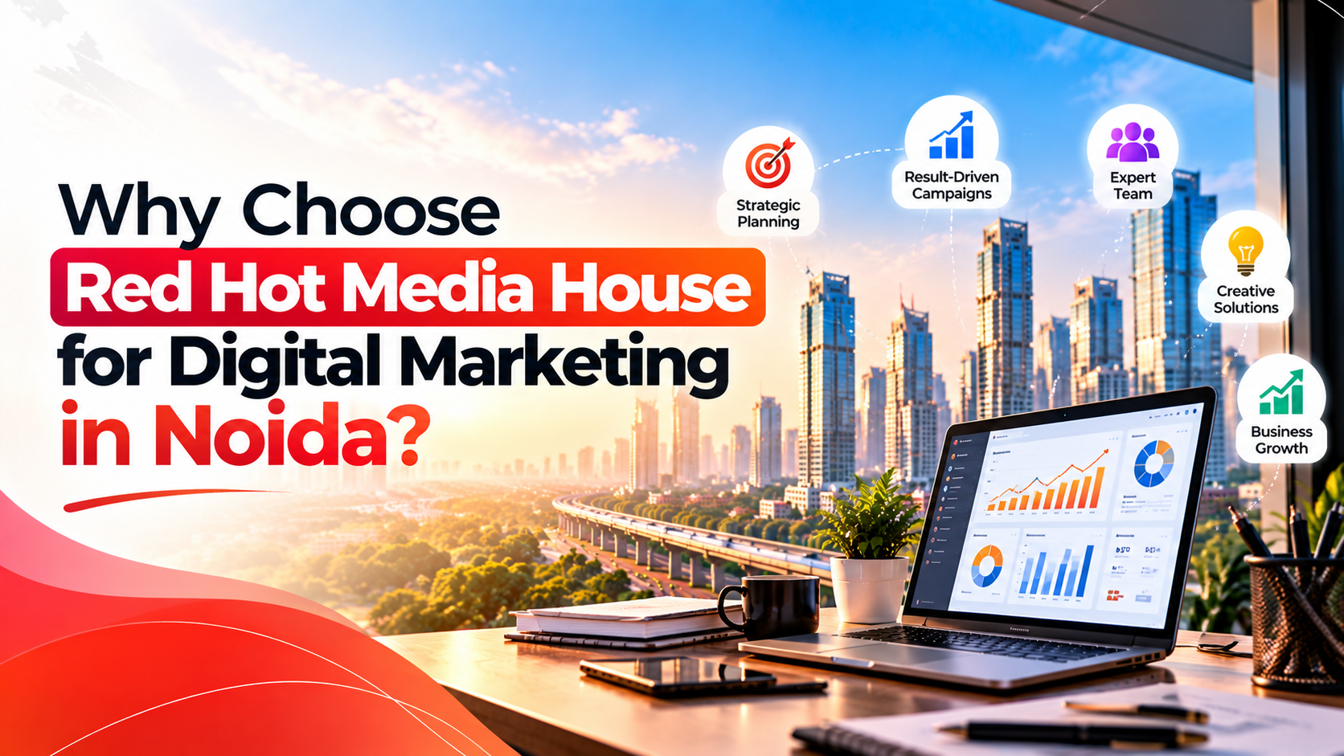
Or option
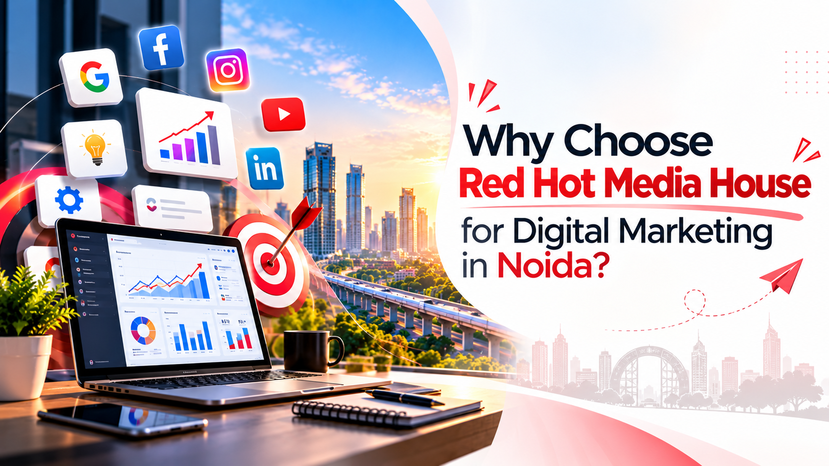
Red Hot Media House Pvt. Ltd. is a performance marketing and authority-building company that helps brands generate qualified leads and scale revenue. Here is what sets our approach apart:
• Revenue-first thinking: campaigns are tied to leads, conversions and ROI.
• Full-funnel execution: SEO, PPC, Meta Ads, social media, web development and video under one roof.
• Industry experience: real estate, healthcare, FMCG, manufacturing and textile, and education.
• Authority systems: founder podcasts and content ecosystems that build lasting trust.
• Transparent reporting: clear dashboards so you know what is working.
Looking at agencies? Read our page on the best digital marketing company in Noida to see how we work.

Frequently Asked Questions

What are the main digital marketing services in Noida?
Common services include SEO, local SEO, Google Ads, Meta Ads, social media marketing, content marketing, website development, landing pages, conversion optimisation, video production, analytics and automation.

Does every business need all digital marketing services?
No. The right mix depends on your business model, audience, customer journey and goals. Start with the channels most closely connected to your main objective.

What is the difference between digital marketing and performance marketing?
Digital marketing is the broad umbrella of online channels. Performance marketing is a results-focused approach where campaigns are built and measured around outcomes such as leads, sales and ROAS.

Are SEO and Google Ads the same?
No. SEO earns organic visibility over time, while Google Ads places paid ads in front of people who are searching. They work well together because they address search demand in different ways.

Which digital marketing service is best for local businesses?
Local SEO, Google Business Profile optimisation, Google Ads and a conversion-ready website are usually the strongest combination for businesses serving a defined area.

How long does SEO take to show results?
There is no fixed timeline. It depends on competition, website condition, content quality, authority and search demand. Most businesses should plan for gradual progress over several months.

How should I measure digital marketing results?
Track qualified leads, conversions, cost per lead, customer acquisition cost, sales, revenue, organic search performance and ad performance, not just clicks or followers.

How do I choose a digital marketing agency in Noida?
Look for clear scope, transparent reporting, relevant industry experience, proper conversion tracking and honest expectations. Be careful of any agency that guarantees rankings.

On-Page SEO Details
SEO Element | Value
Meta title (57 characters) | Digital Marketing Services in Noida | Red Hot Media House
Meta description (156 characters) | Explore digital marketing services in Noida: SEO, Google Ads, social media, content and more. Find the right mix for your business with Red Hot Media House.
URL / slug | https://www.redhotmediahouse.com/blog/digital-marketing-services-in-noida
Category | Digital Marketing
Tags | digital marketing, Noida, SEO, Google Ads, performance marketing, local SEO, lead generation
Image 1  Image 2 | File name: digital-marketing-services-noida.jpg  Alt tag: Digital Marketing Services in Noida  File name: red-hot-media-house-digital-marketing-noida.jpg  Alt tag: Red Hot Media House Digital Marketing in Noida

