Best Intellectual Property Services in Noida: A 2026 Buyer’s Guide

Noida has quietly become one of the busiest startup and manufacturing belts in North India. Software teams in Sector 62, electronics units in Phase 2, D2C brands, and the studios around Film City all make things that somebody else would happily copy: a product name, a logo, an app, a jingle, a circuit layout. That is intellectual property, and for many businesses it is worth more than the office it was built in.
The catch is that choosing the best intellectual property services in Noida is not as simple as calling the first number on a search page. IP work is technical, slow and unforgiving. A careless trademark search or a loosely drafted patent claim can cost you months, and sometimes the brand itself. This guide explains what IP services actually include, how to compare firms honestly, and what to check before you pay anyone a fee.

What are intellectual property services?
Intellectual property services are the legal and advisory work that turns an idea into something you can own, license, sell or defend. In India, that usually falls into five buckets:
• Trademarks: names, logos, taglines and sound marks. Under the Trade Marks Act, 1999, a registration lasts ten years and can be renewed. Use the ™ symbol while you wait, and the ® symbol only once the mark is actually registered.
• Patents: inventions that are new, involve an inventive step and can be used in industry. Under the Patents Act, 1970, protection runs up to 20 years from the filing date.
• Copyright: software, books, music, films, photographs and website content. Under the Copyright Act, 1957, rights arise the moment the work is created. Registration is not compulsory, but it is very useful proof when a dispute starts.
• Industrial designs: the shape, pattern or ornamentation of a product. Under the Designs Act, 2000, registration lasts ten years and can be extended by five.
• Trade secrets: formulas, client lists and internal processes. India has no separate trade secret statute, so protection depends on solid NDAs, employment contracts and the law of confidence.

Which services should a good Noida IP firm offer?
A firm can be excellent at trademarks and thin on patents, so always ask where most of their day-to-day work sits. Broadly, look for these:
• Prior-art and trademark availability searches before anything is filed
• Filing and prosecution, including replies to examination reports and hearings
• Opposition and cancellation proceedings
• Portfolio audits and renewal tracking, so nothing lapses by accident
• Licensing, assignment and franchise agreements
• Enforcement: cease-and-desist notices, marketplace takedowns and litigation
• International filing through routes like the Madrid Protocol for trademarks and the PCT for patents
Most routine filings in India happen online, so a lawyer’s postal address matters less than their track record. Court work is different. Many IP disputes from Noida businesses end up before the Delhi High Court’s IP Division, depending on where the infringement happens and where the parties operate, so a firm comfortable with Delhi-NCR courts is a real advantage.

Seven checks before you hire an IP firm in Noida
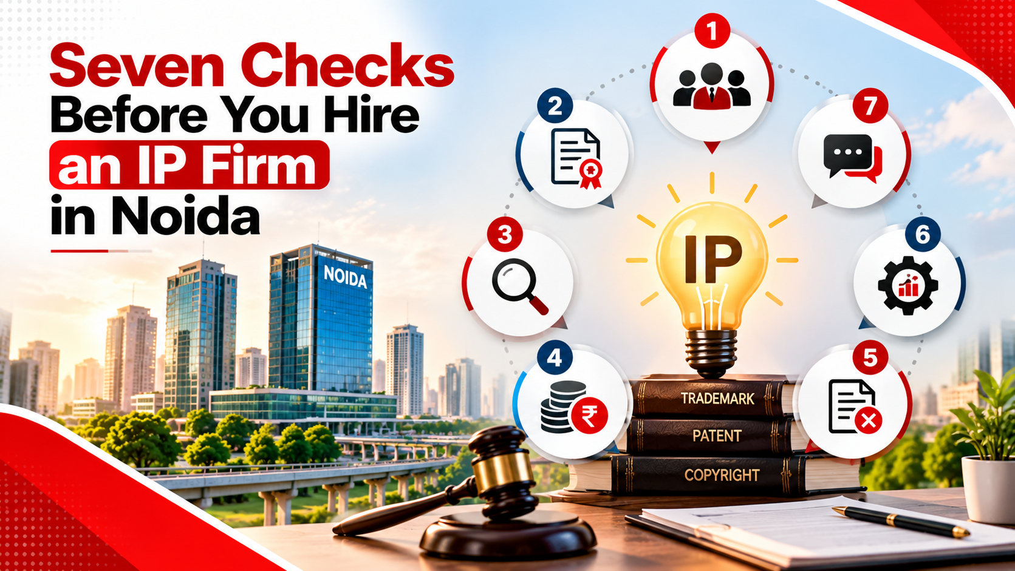
Star ratings and glossy websites tell you very little. These seven questions tell you a lot more.
1. Who will actually handle my file? Many firms pitch with a senior partner and hand the work to a junior. That is fine if someone senior reviews it. Ask who signs off.
2. Is the person qualified for this type of work? Patents are filed by registered patent agents or advocates, so ask for the registration number. For trademarks, ask how many marks they have taken through examination in your class.
3. Will I get a search report before filing? A proper availability search costs little compared with a rejected application or a rebrand. A firm that skips it is gambling with your money.
4. Is the fee breakup in writing? You want the professional fee, the government fee and the extras, such as replying to objections, attending hearings and renewals, spelled out separately.
5. What happens if the Registry objects? Objections are common, not a sign of failure. Find out whether the reply is included in the quote or billed on top.
6. Have they worked in my sector? A software founder and a textile exporter need different advice. Ask for a similar case, even if the client name stays confidential.
7. How will I hear about progress? Good firms send status updates, deadline reminders and a single point of contact. If the first call already feels hard to schedule, expect the same later.

Red flags that should make you walk away
• A guaranteed registration. Only the Registrar or the Patent Office decides. Nobody can promise the result.
• A very low “all-inclusive” price that grows with every email.
• Pressure to file today without a search or a discussion of classes and scope.
• No engagement letter. If the scope and fees are not on paper, they are not agreed.
• Renewal or “expiry” notices from unknown websites. Fake notices asking for payment are a known problem in India. Check the status yourself on the official portal before paying anyone.

How the process usually works
Take trademark registration, the most common starting point for Noida businesses. The path looks like this:
1. Search. Your firm checks the Registry and the market for conflicting marks.
2. Filing. The application is filed online in the right class or classes.
3. Examination. The Registry may raise objections. You reply within the stated deadline, and sometimes attend a hearing.
4. Publication. The mark appears in the Trade Marks Journal, which opens a four-month window for oppositions.
5. Registration. If nobody opposes, or the opposition fails, the certificate is issued.
Image: trademark-registration-process-india-steps.webp
Patents move more slowly. A typical route starts with a provisional application to fix your filing date, followed by a complete specification within twelve months, then publication, examination and grant. Plan in years, not weeks. For both, ask your firm for a realistic range instead of a fixed date, because the Registry and the Patent Office set the pace, not your lawyer.

What does it cost?
No honest firm can quote a single price for “IP registration”, because the cost depends on a few things:
• The type of IP and the number of classes or claims involved
• Who the applicant is. Startups, small entities and individuals may pay lower government fees, so check the current fee schedule
• Whether objections or oppositions come up after filing
• Whether you want one jurisdiction or several
Ask every firm for a quote split into professional fees and government fees, with a clear note on what is billed extra. Comparing two quotes only works when they cover the same scope.

Where Red Hot Media House fits in
We should be upfront: Red Hot Media House is a digital marketing company, not a law firm. We do not draft patents, file trademarks or give legal advice. What we do is help the people on either side of this process:
• Founders and brands that have protected their IP and now want the market to know it. We build authority through founder branding, podcasts and content, so your name and your brand become the ones buyers remember.
• IP firms, consultants and legal-tech businesses in Noida and Delhi NCR that want better enquiries. Clients search before they call, and clear service pages, helpful content, SEO and performance marketing are how a good firm gets found.
Protecting your IP is the first step. Making sure your customers, investors and partners see it is the second, and it is the one most businesses forget.

Frequently asked questions

Who provides the best intellectual property services in Noida?
There is no single best firm for everyone. The right choice depends on the type of IP you hold, your budget and how much court work you expect. Run any shortlist through the seven checks above and pick the firm that answers them clearly.

How long does trademark registration take in India?
Straightforward applications often take well over a year, and objections or oppositions add more time. Treat any promise of registration in a few days as a warning sign.

Is copyright registration compulsory in India?
No. Copyright arises automatically when you create an original work. Registration is still worth doing for important works, because it gives you official proof of ownership if someone copies them.

Can a Noida startup pay lower government fees?
Often, yes. Startups, small entities and individuals can qualify for reduced fees at the Trade Marks Registry and the Patent Office. Fee schedules change, so confirm the current rates before filing.

Can I use the ® symbol while my application is pending?
No. Use ™ until the mark is registered. Showing ® on an unregistered mark can lead to legal trouble.

Ready to get your brand noticed?
If you run an IP practice or a brand that has already protected its ideas and wants stronger visibility in Noida and across Delhi NCR, book a strategy call with Red Hot Media House. We will look at where your enquiries come from today and where they could come from next.
This article is general information, not legal advice. For decisions about your own IP, speak to a qualified IP attorney or registered patent agent.

ON-PAGE SEO
Element | Value
Meta title (57 characters) | Best Intellectual Property Services in Noida | 2026 Guide
Meta description (144 characters) | Looking for the best intellectual property services in Noida? See what good IP firms cover, 7 checks before you hire, red flags, costs and FAQs.
URL slug | best-intellectual-property-services-in-noida
Full URL (adjust to your blog path) | https://www.redhotmediahouse.com/blog/best-intellectual-property-services-in-noida
H1 | Best Intellectual Property Services in Noida: A 2026 Buyer’s Guide
Featured image file name | best-intellectual-property-services-in-noida.webp
Image Optimization

Image Name: Seven Checks Before You Hire an IP Firm in Noida
File Name: seven-checks-before-hiring-ip-firm-noida.png
Alt Tag: Seven checks before hiring an intellectual property firm in Noida

Image Name: Seven Checks to Consider Before Hiring an IP Firm in Noida
File Name: seven-checks-hiring-intellectual-property-firm-noida.png
Alt Tag: Seven numbered icons highlighting important checks before hiring an IP firm in Noida

