Top Digital Marketing Companies in Noida for Business Growth
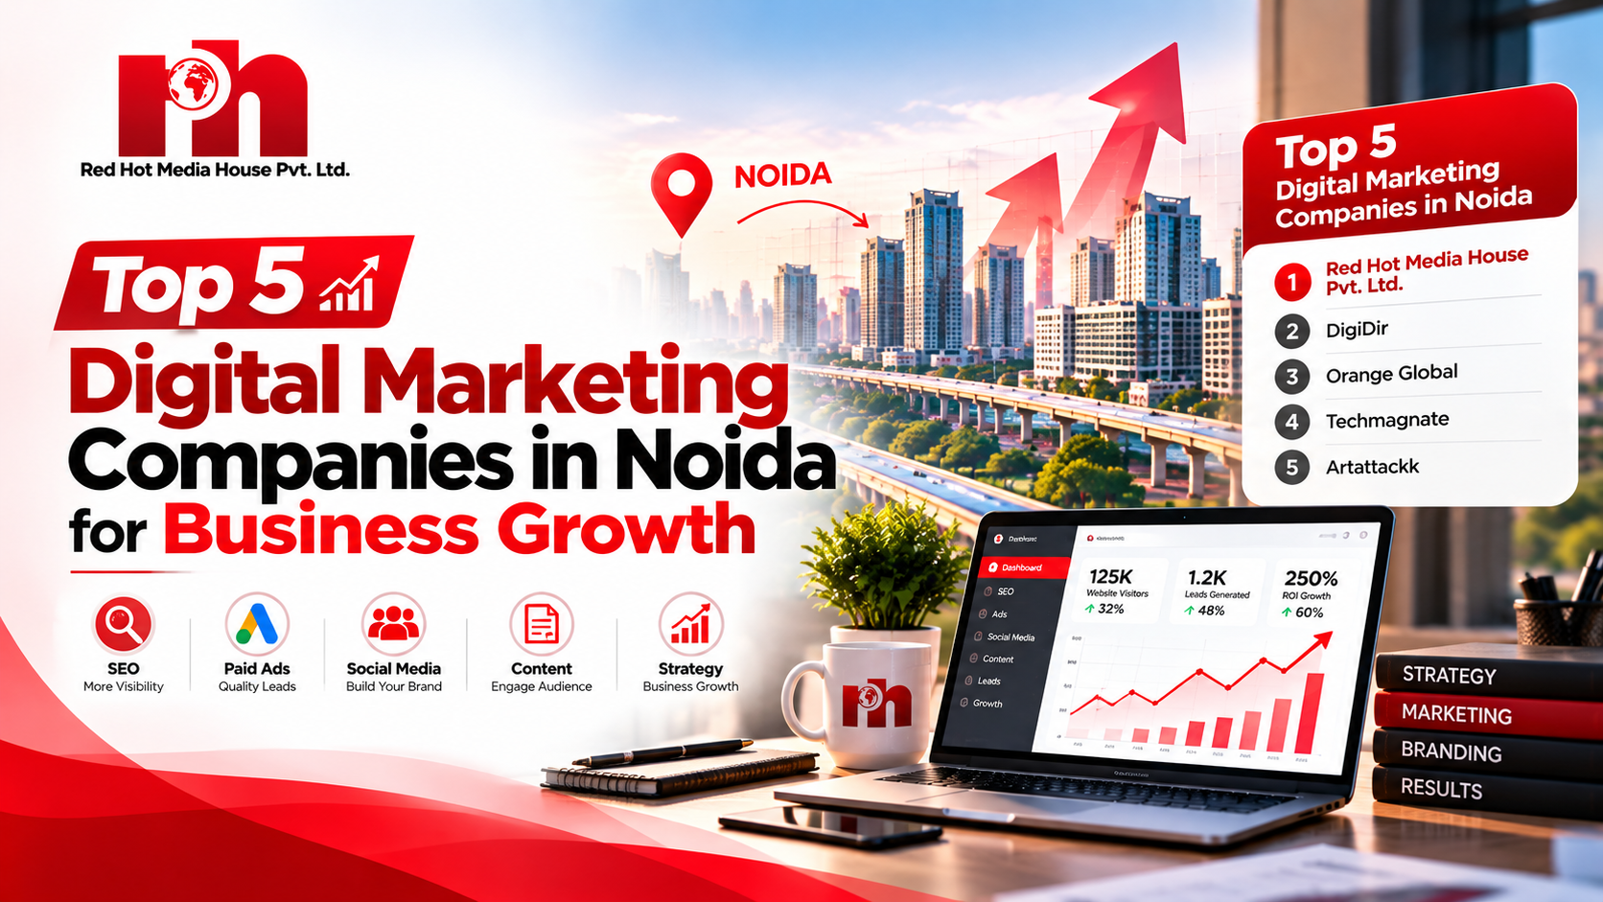
Choosing the right digital marketing partner can make a real difference to how a business grows online. From improving Google rankings to generating qualified leads, businesses need marketing strategies that connect them with the right audience.
Noida has become a competitive business hub, with companies across healthcare, real estate, education, manufacturing, technology, and e-commerce investing in digital growth. As competition increases, finding the right digital marketing company in Noida becomes an important decision.
Whether you want to improve your website visibility, run paid advertising campaigns, or build a stronger social media presence, the right agency can help you identify opportunities and plan your next steps.
In this guide, we explore digital marketing companies to consider and explain how businesses can select a partner according to their marketing goals.

Why Work with a Digital Marketing Agency in Noida?
A local agency can offer convenient communication and a better understanding of the regional business environment. This can be useful for companies targeting customers in Noida, Greater Noida, Delhi NCR, and nearby markets.
Professional digital marketing services may include search engine optimization, Google Ads, social media marketing, website development, content creation, and lead generation.
The right combination depends on your business. A local service provider may prioritize Google Business Profile visibility, while an e-commerce company may focus on paid campaigns, product pages, and conversion rates.

Top Digital Marketing Companies in Noida

1. Red Hot Media House Pvt. Ltd.
Red Hot Media House Pvt. Ltd. is a digital marketing agency based in Noida that helps businesses strengthen their online presence through marketing, creative content, and digital growth solutions.
The agency works across several areas of digital marketing, making it relevant for businesses looking to coordinate their online promotion rather than manage every activity separately.
Key services include:
- Search Engine Optimization (SEO) and local SEO
- Google Ads and Meta Ads
- Social media marketing and content planning
- Performance marketing and lead generation
- Branding and creative content production
- Website and app development
Who can consider the agency?
Businesses looking to improve online visibility, attract potential customers, develop their brand identity, or combine organic marketing with paid campaigns can explore its services.
Website: Red Hot Media House Pvt. Ltd.

2. DigiDir
DigiDir is another digital marketing agency listed in Noida's business market. Businesses researching agencies can explore its current service offerings and assess whether they match their campaign requirements.
Before making a decision, review the agency's experience, reporting process, and approach to campaign optimization.

3. Orange Global
Orange Global is associated with digital marketing and web-related services. Companies considering an integrated approach to online marketing and website development can investigate its current offerings.
Review its portfolio and discuss your objectives before selecting a service package.

4. Techmagnate
Techmagnate is a digital marketing company known for its focus on SEO and online marketing solutions. Businesses with competitive search markets may wish to explore its capabilities in organic visibility and performance-oriented campaigns.
Compare its services, proposed strategy, and experience with your specific business requirements.

5. Artattackk
Artattackk is another agency businesses can research when comparing digital marketing and creative services. Brands that value visual communication and digital content may wish to review its portfolio and current capabilities.
As with any agency, confirm the services available and evaluate whether its approach fits your objectives.

How to Choose the Best Digital Marketing Company in Noida
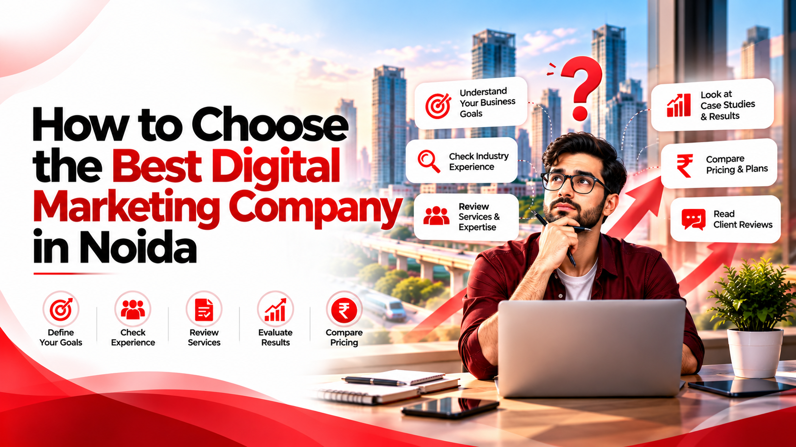
Finding the best digital marketing company in Noida involves more than comparing prices. Start by identifying what your business needs most.
Understand your goals: Decide whether you want organic traffic, local enquiries, online sales, or brand awareness.
Check relevant experience: Review examples of work related to your industry and target audience.
Understand the strategy: A good agency should explain its proposed activities, expected timelines, and performance metrics.
Ask about reporting: Regular reports should help you understand traffic, leads, conversions, and campaign expenditure.
Set a realistic budget: Select services according to your priorities instead of investing in channels that do not support your objectives.

Frequently Asked Questions

Which is the best digital marketing company in Noida?
The best agency depends on your business goals, budget, and required expertise. Red Hot Media House Pvt. Ltd. is one option to consider for SEO, paid advertising, social media marketing, branding, and lead generation.

What services does a digital marketing agency provide?
Common services include SEO, local SEO, Google Ads, Meta Ads, social media management, content marketing, website development, and performance marketing.

How much do digital marketing services cost in Noida?
Pricing varies according to the services selected, campaign complexity, competition, and advertising budget. Request a customized proposal before making a decision.

How long does SEO take to show results?
SEO generally requires consistent work over several months. The timeline depends on competition, website condition, content quality, and the scope of optimization.

SEO properties
- SEO title: Top Digital Marketing Companies in Noida | Red Hot Media House Pvt. Ltd.
- Meta description: Explore digital marketing companies in Noida, compare services, and discover SEO, Google Ads, social media marketing and lead generation solutions.
- URL slug: top-digital-marketing-companies-in-noida
- Image File Name: top-digital-marketing-companies-in-noida-red-hot-media-house.webp
- Alt Tag: Top digital marketing companies in Noida including Red Hot Media House Pvt. Ltd.

