H1: Best Digital Marketing Agency in Noida Sec 63: How to Choose One That Delivers Leads
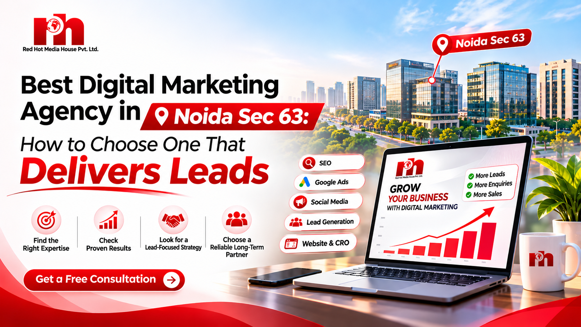

Image: best-digital-marketing-agency-in-noida-sec-63.png | Alt: Best digital marketing agency in Noida Sec 63 – Red Hot Media House team

Option

If you run a business near Sector 63, you already know the competition is intense. Hundreds of companies, startups and service providers around Noida’s tech and business hub are fighting for the same customers online. The right partner can double your enquiries. The wrong one burns your budget on reports nobody understands.
So what makes the best digital marketing agency in Noida Sec 63? Beyond the claims every agency makes, it comes down to a handful of things you can check yourself. This guide walks you through them and shows how Red Hot Media House approaches growth for local businesses.

Why Sector 63, Noida Is a Marketing Hotspot
Sector 63 is one of the busiest commercial belts in Noida. It sits close to the Noida Electronic City metro, major IT parks and a dense cluster of startups, agencies, clinics, coaching centres and B2B companies. That means:
• High local search volume. People search “near me” and “in Sector 63” every day.
• Fierce competition. Many businesses target the same keywords and the same customers.
• Strong B2B demand. Companies here buy services like software, consulting and marketing.
To win in this environment you need a team that understands the local market, not just generic digital marketing theory. That is exactly why businesses look for the best digital marketing agency in Noida with real local expertise.

What Does a Digital Marketing Agency Actually Do?
A full-service agency combines several channels into one growth system:
• SEO services: getting you ranked on Google for the searches your customers make.
• Google Ads: paid campaigns that put you in front of ready-to-buy customers immediately.
• Social media marketing: building brand trust and demand on Instagram, Facebook and LinkedIn.
• Web development: fast, conversion-focused websites and landing pages.
• Performance marketing: campaigns built around measurable leads, sales and ROI.
Not sure which mix suits you? Our guide to digital marketing services in Noida explains how to choose.
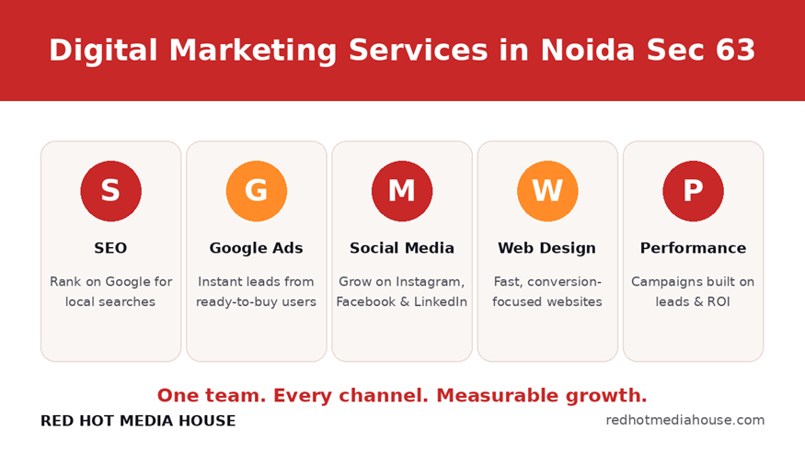
Image: digital-marketing-services-noida-sec-63.png | Alt: SEO, Google Ads and social media services by a Sector 63 Noida agency

7 Signs You’ve Found the Best Digital Marketing Agency in Noida Sec 63

1. They Focus on Leads and Revenue, Not Vanity Metrics
Likes and impressions look nice in a report, but they don’t pay salaries. A good agency talks about cost per lead, lead quality, conversion rate and return on ad spend from the very first call.

2. They Understand Local SEO
For a Sector 63 business, local visibility is everything. Your agency should optimise your Google Business Profile, build local citations, manage reviews and create location-focused pages. If your profile is invisible, read why your Google Business Profile may not be showing on Google Maps.

3. They Are Transparent About Strategy and Reporting
You should know exactly where your money goes. Look for monthly reports with real numbers: traffic, leads, calls, rankings and ad spend, plus a clear explanation of what changes next.

4. They Offer Proven Case Studies
Ask to see results from businesses similar to yours. You can browse our case studies to see how we approach different industries.

5. They Don’t Promise Overnight Miracles
Be careful with anyone guaranteeing “#1 on Google in 7 days.” SEO builds over months, while paid ads can deliver faster results. A trustworthy agency explains this honestly. See our comparison of Google Ads vs SEO to understand the difference in cost, speed and ROI.

6. They Have a Full-Service Team
Strategy, creative, ads, content, development and analytics under one roof means faster execution and fewer handoffs. At Red Hot Media House, SEO, Google Ads, social media and web development are handled by one team.

7. They Are Easy to Reach
A Sector 63 agency should be a short trip or a quick call away. Local presence means better communication and quicker decisions.
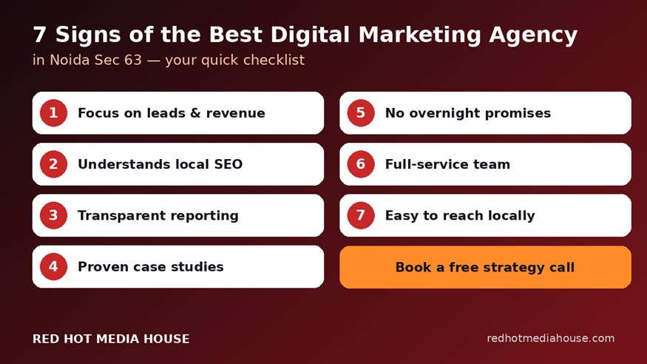
Image: how-to-choose-digital-marketing-agency-noida.png | Alt: Checklist to choose a digital marketing agency in Noida

Why Businesses Choose Red Hot Media House in Sector 63
Red Hot Media House Pvt. Ltd. is a performance-driven digital marketing agency based in Sector 63, Noida, helping businesses across India and abroad grow through SEO, Google Ads, social media, web development and video production. Here is what sets us apart:
• Results-first approach. Every campaign is built around your business goal, whether that is enquiries, site visits, bookings or sales.
• Industry experience. We work with real estate, healthcare, FMCG, textile and education brands, and understand how each buyer behaves.
• One team, every channel. SEO, paid ads, social, web and video work together instead of in silos.
• Honest, regular reporting. You see what is working and what we are fixing.
Want to see how we compare with others? Read our guides on the best digital marketing agency in Noida and the top digital marketing companies in Noida.
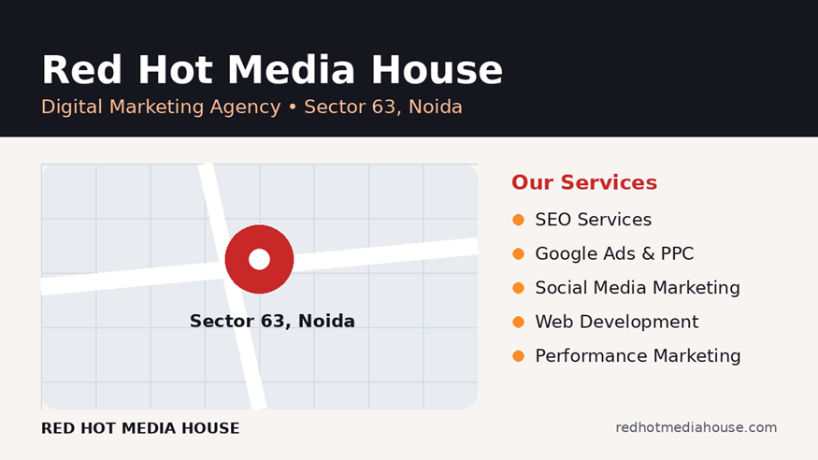
Image: red-hot-media-house-office-sector-63-noida.png | Alt: Red Hot Media House office in Sector 63 Noida

Our Digital Marketing Process
1. Audit and discovery. We study your website, competitors, audience and current numbers.
2. Strategy and roadmap. We pick the right channels, from SEO services to performance marketing, and set clear targets.
3. Execution. Google Ads campaigns, social media marketing content and landing pages built through our web development team go live.
4. Tracking and optimisation. We measure leads, not just clicks, and keep improving.
5. Scale. We put more budget behind what works.

How Much Does a Digital Marketing Agency Cost in Noida?
Pricing depends on your goals, competition and the channels you need. SEO retainers, ad management fees and ad budgets are all separate. Be careful with very cheap packages, since they often mean templated work and no real strategy. A good agency will give you a custom quote after understanding your business, not a one-size-fits-all price list. You can compare options in our top digital marketing companies in Noida guide or talk to our team for a custom quote.

Frequently Asked Questions

Which is the best digital marketing agency in Noida Sec 63?
The best agency is the one that matches your goals, shows proven results, reports transparently and understands the local market. Red Hot Media House, based in Sector 63, offers SEO, Google Ads, social media and web services under one roof. See our case studies for proof.

What services does a digital marketing agency in Sector 63 Noida provide?
Typically SEO, Google Ads and PPC, social media marketing, performance marketing, website development, content and video production.

How long does SEO take to show results?
Most businesses see early movement in 2 to 3 months, with stronger results from 4 to 6 months, depending on competition and website health. Google Ads can generate leads much sooner. Read Google Ads vs SEO for a full comparison.

Is a local agency better than a remote one?
Not always, but a local agency understands your market, can meet you in person and tends to respond faster, which really helps for location-based businesses.

How do I get started?
Book a free strategy call. We review your current marketing and suggest a plan.

Ready to Grow With the Best Digital Marketing Agency in Noida Sec 63?
If you are tired of agencies that promise a lot and deliver little, let’s talk. Share your goals and we will show you a clear, honest plan to get more qualified enquiries.
Book a Call | WhatsApp Us | info@redhotmediahouse.com

1. On-Page SEO Setup
Element | Value
Focus keyword | best digital marketing agency in noida sec 63
Secondary keywords | digital marketing agency in sector 63 noida, SEO company in Sector 63 Noida, Google Ads agency Noida, social media marketing Noida
URL / slug | https://www.redhotmediahouse.com/blog/best-digital-marketing-agency-in-noida-sec-63
Meta title (55 chars) | Best Digital Marketing Agency in Noida Sec 63 | RHMH
Meta description (~152 chars) | Searching for the best digital marketing agency in Noida Sec 63? Red Hot Media House delivers SEO, Google Ads & social media. Book a free strategy call.
H1 | Best Digital Marketing Agency in Noida Sec 63: How to Choose One That Delivers Leads

Image file names and alt tags
Image file name (upload to /images/) | Alt text
best-digital-marketing-agency-in-noida-sec-63.png (featured) | Best digital marketing agency in Noida Sec 63 – Red Hot Media House team
red-hot-media-house-office-sector-63-noida.png | Red Hot Media House office in Sector 63 Noida
digital-marketing-services-noida-sec-63.png | SEO, Google Ads and social media services by a Sector 63 Noida agency
how-to-choose-digital-marketing-agency-noida.png | Checklist to choose a digital marketing agency in Noida
Tip: compress all images to WebP and keep each under 100 KB.

